Four Seasons Hotel Atlanta Blooms with Floral Design Company Fresh Structures and Designer Kimberlee Mitchell

August 19, 2016, Atlanta, U.S.A

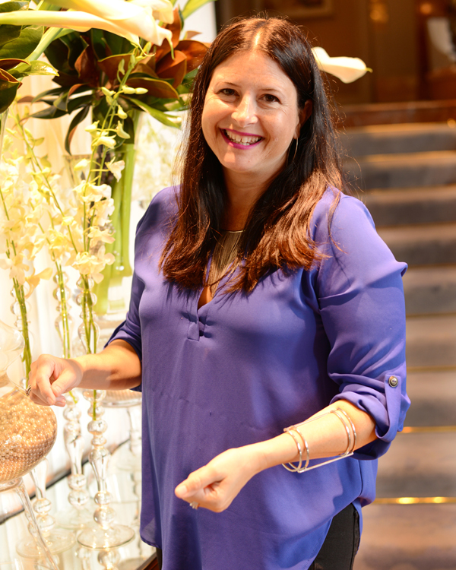
On the heels of a guest room, restaurant and lobby makeover,
Four Seasons
Hotel Atlanta announces its floral partnership with celebrated floral design company Fresh Structures and designer Kimberlee Mitchell.
Kimberlee Mitchell has been obsessed with gardening since an early age, and with that love, she began working for Fresh Structures, a flourishing Atlanta floral business. Since the company secured the design appointment at
Four Seasons
Hotel Atlanta in May of 2016, Mitchell has been adorning the Hotel with gorgeous, eye-catching designs. Mitchell says that the opportunity to work with
Four Seasons
feels like winning the lottery and she couldn’t be more elated by the relationship.
‘With all of the recent enhancements across the Hotel, we’re delighted that Fresh Structures has joined our team and vision. Their floral decor is a focal point of our lobby and reflects our design aesthetic. We wanted to expand our sensory welcome experience across the Hotel and Fresh Structures has helped us achieve that,” says General Manager Yvette Thomas-Henry.
Mitchell attended college to pursue an art degree and soon after, started a career in the jewellry industry – buying, selling and travelling the country as a jeweller. She eventually grew tired of the jewellry industry and longed to do something that she was passionate about. Leaving her job behind, she turned to gardening, transforming her long time hobby into a thriving career with Fresh Structures.
Today, after nearly 18 years of working as a floral designer, Mitchell attributes her floral inspiration to literature, magazines or a simple stroll through the streets of Atlanta. In her spare time, one might find her perusing the collections at the Atlanta Botanical Garden or the High Museum, seeking a fresh outlook to spark her creativity.
Each week, Kimberlee creates a new floral landscape for
Four Seasons
, designed to reflect the time of year or events taking place in the Hotel and city. Her passion for her job is evident in her adventurous and whimsical aesthetic, a signature to all of her creations.

RELATED

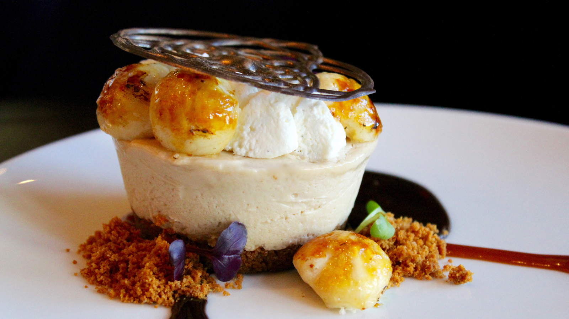 | March 1, 2017, Atlanta, U.S.A  Bar Margot's Newest Dessert is "Pie in the Sky" Idea for Chef Lasheeda Perry at Four Seasons Hotel Atlanta  http://publish.url/atlanta/hotel-news/2017/biscoff-cream-pie.html
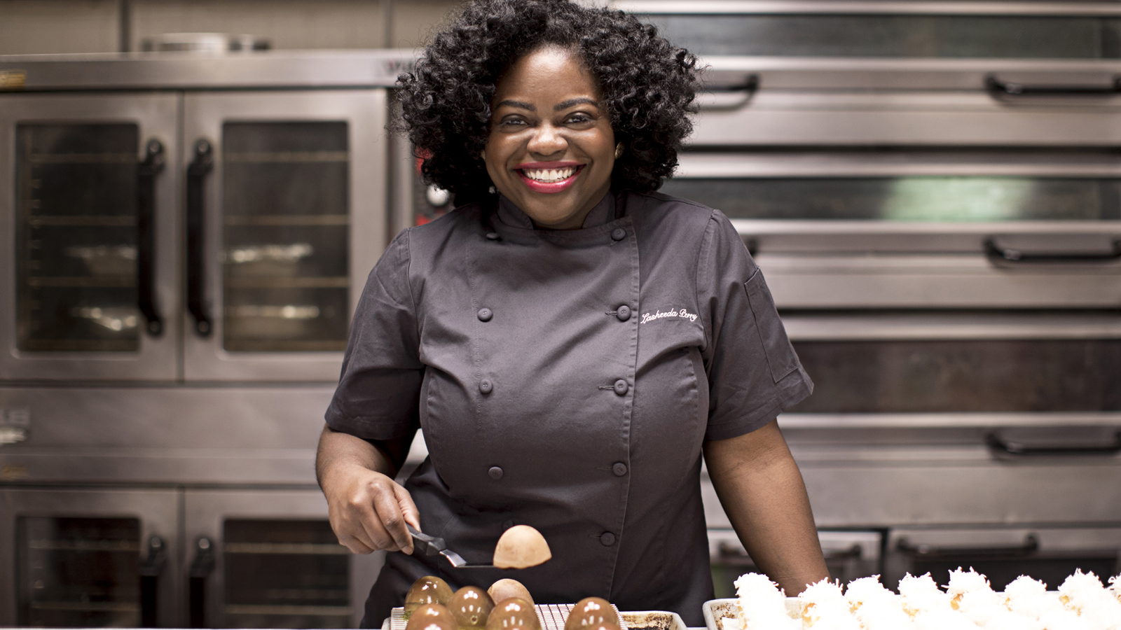 | January 9, 2017, Atlanta, U.S.A  New Pastry Chef Lasheeda Perry Appointed at Four Seasons Hotel Atlanta  http://publish.url/atlanta/hotel-news/2017/new-pastry-chef-lasheeda-perry.html

PRESS CONTACTS

Marsha Middleton
Consulting Director of Public Relations, M-Squared Public Relations
241 W. Wieuca Rd., Suite 260
Atlanta
U.S.A.
marsha@msquaredpr.com

1 (404) 303-7797

