Four Seasons Hotel Ritz Lisbon Takes Part in Peixe em Lisboa: Lisbon Fish and Flavours 2017

Executive Chef Pascal Meynard showcases signature dishes and launches new product line
February 14, 2017, Lisbon, Portugal

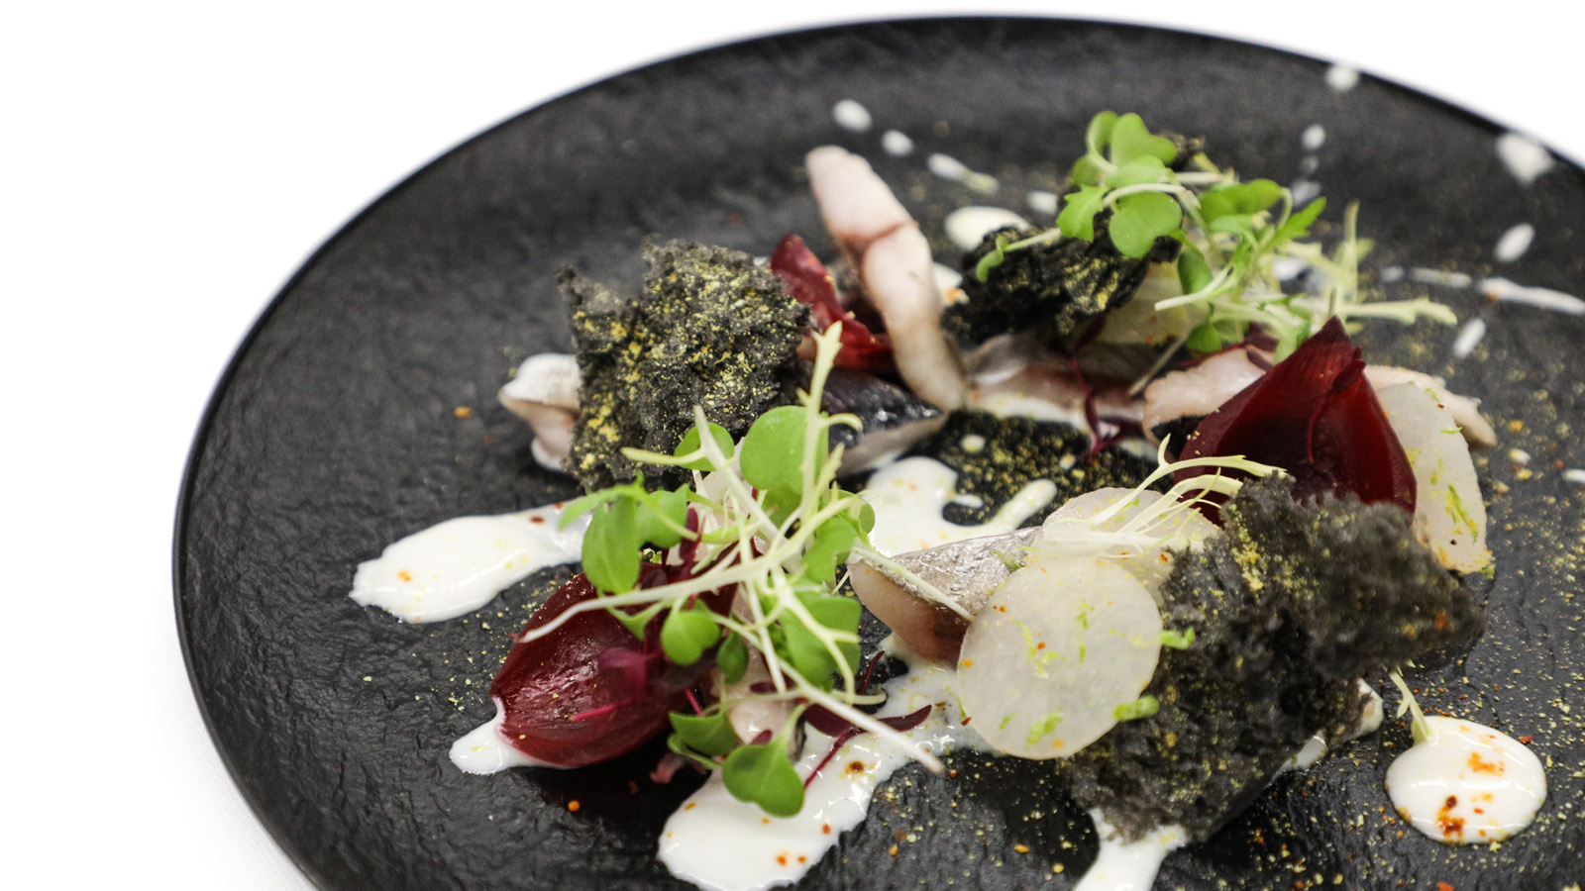
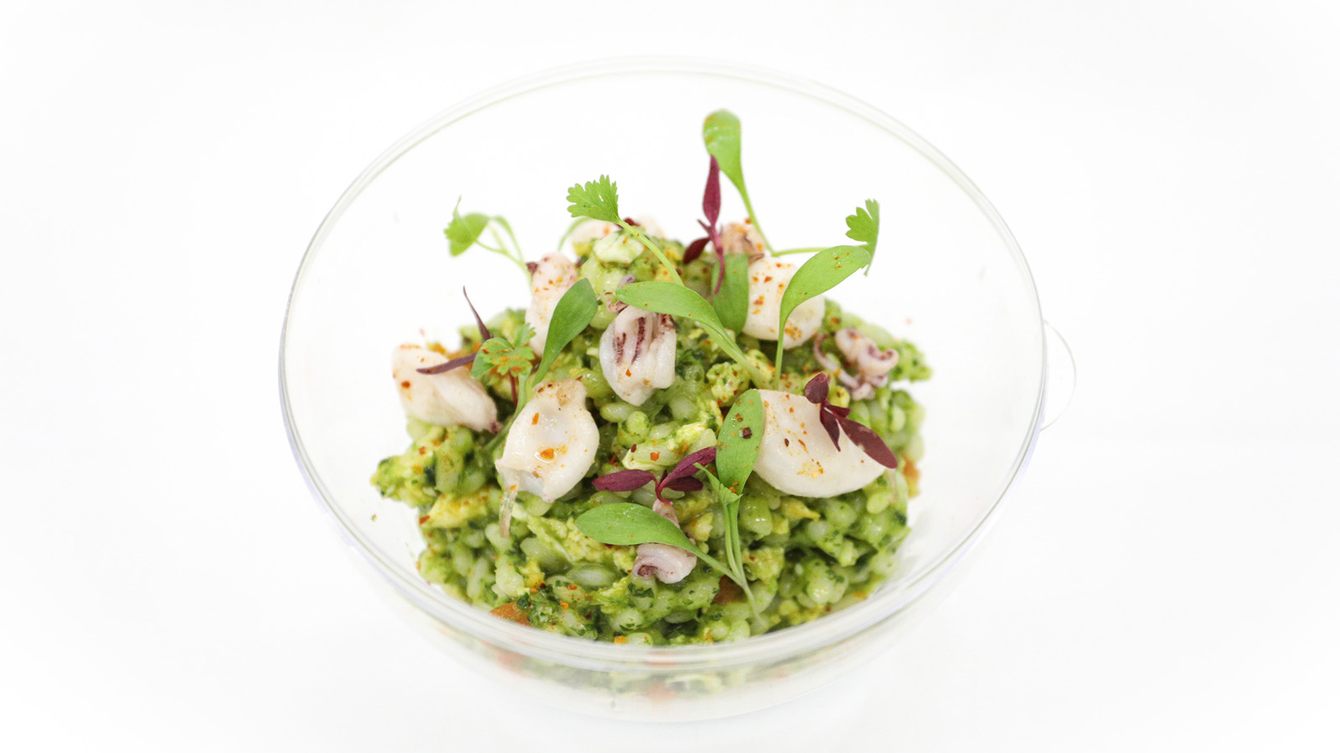 | 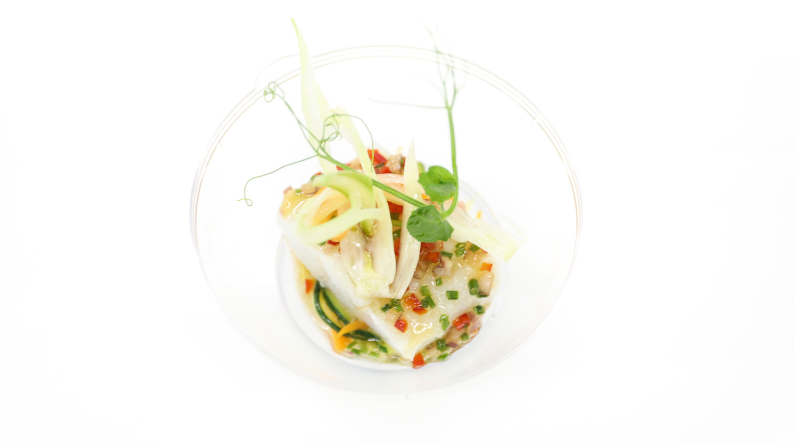 | 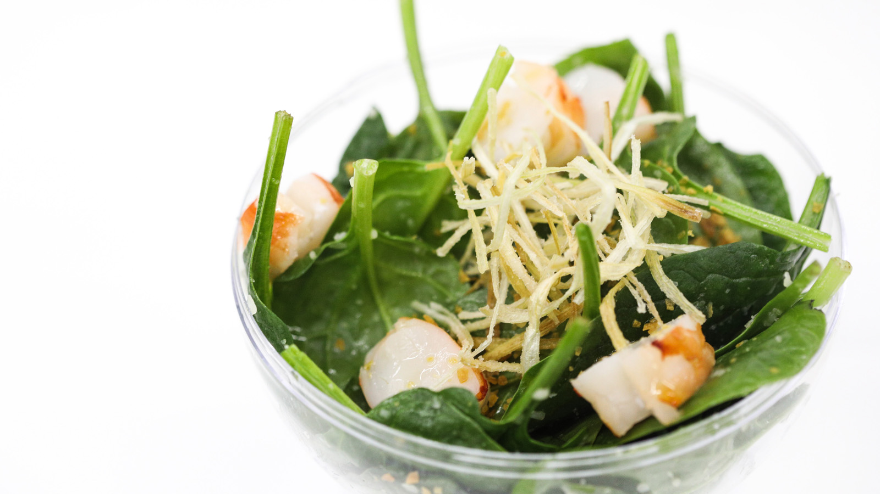
Four Seasons
Hotel Ritz Lisbon Executive Chef Pascal Meynard is again poised to be one of the Portuguese pros showcasing his skills at the 10th annual Peixe em Lisboa (Lisbon Fish and Flavours) from March 30 to April 9, 2017.
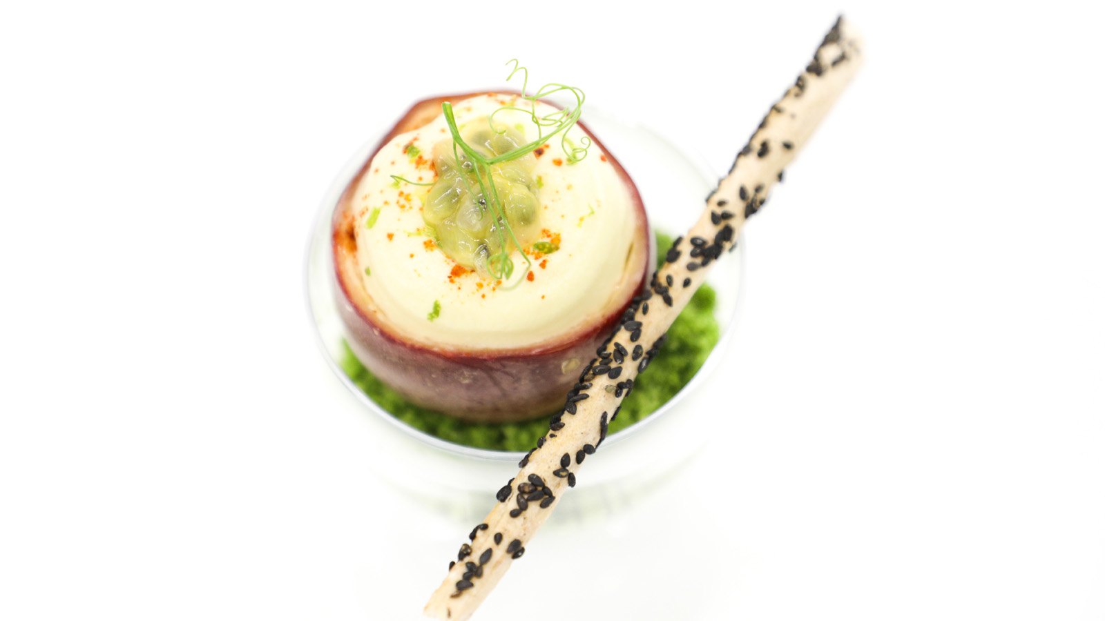 | 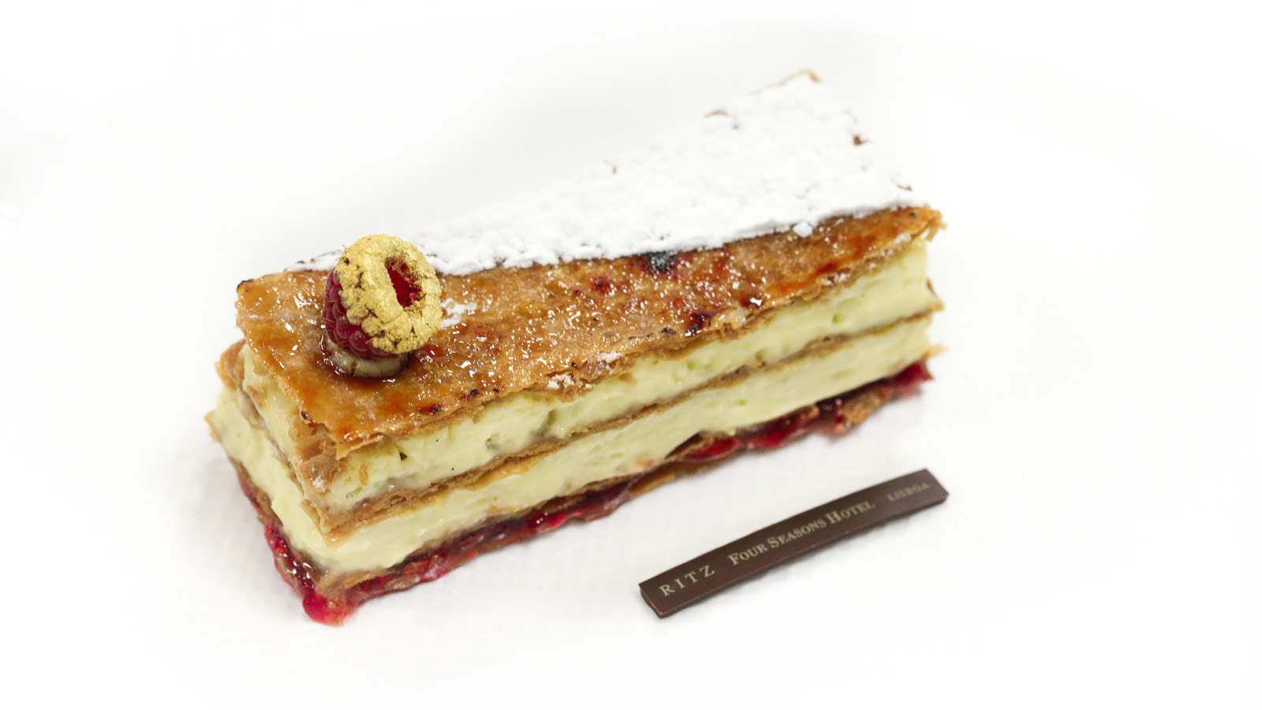
Celebrating the delights of Portugal’s Atlantic waters (widely considered to produce the world’s finest fish and seafood) the event is arguably one of the globe’s greatest gastronomic events devoted to the ocean’s bounty: a flavourful festival featuring a gourmet market, cooking demonstrations, wine and fish pairings, pop-up restaurants, live entertainment and special events – including this year’s much-anticipated launch of Chef Pascal Meynard’s new product line.
It is Chef Pascal Meynard’s second year at the festival, which this year has a stunning new venue within walking distance from
Four Seasons
Hotel Ritz Lisbon: the recently restored Carlos Lopes Pavilion at Eduardo VII Park.
Visitors to Chef Meynard’s stand will have the opportunity to sample a tantalising selection of signature flavours straight from Varanda’s kitchen, including a prawn and spinach salad with black truffle vinaigrette and parmesan, complemented by desserts including the devilishly delicious raspberries millefeuille prepared by the Hotel’s beloved Pastry Chef Fabian Nguyen.
In addition to sampling a selection of dishes and picking up some key tips and techniques, visitors to Chef Meynard’s stand will be the first in the world to sample one of his three brand new signature products – two salt seasonings and an olive oil – created in partnership with Loja do Sal, an exclusive salt purveyor, and CARM, a family-run olive oil producer.
Each of the two salt seasonings – one for fish and the other for meats – incorporates a secret blend of Chef Meynard’s favourite spices to bring out the best in the ingredients, while his signature "liquid gold" olive oil – best described as delicate and aromatic – gives a distinct "Midas touch" to any dish.
“Portuguese cuisine is an exciting celebration of local ingredients combined with global seafaring influences,” comments Chef Meynard. “It’s a lifelong dream to produce my own range of products and an auspicious start to be launching them at such a prestigious celebration of Portuguese ingredients.”
Four Seasons
Hotel Ritz Lisbon Menu
Main courses
- Salmon tartar, passion fruit foam, black sesame crust, EUR 8
- Prawns and spinach salad, black truffle vinaigrette and parmesan, EUR 10
- Cod demi-sel, green shiso vinaigrette, crispy vegetables, EUR 8
- Smoked mackerel, lemon and espelette pepper gel, camarinha sponge cake, EUR 7
- Asian coriander rice, yuzu and puntillitas, EUR 7
Desserts
- Choco Ritz, EUR 6
- Raspberries millefeuille, EUR 5
Products - available to purchase upon request only
- Fish Seasoning by Pascal Meynard and Loja do Sal
- Meat Seasoning by Pascal Meynard and Loja do Sal
- Olive Oil by Pascal Meynard and CARM
About Peixe em Lisboa
- Daily from 12:00 noon to 12:00 midnight, March 30-April 9, 2017
- Pavilhão Carlos Lopes, Eduardo VII Park, 1100 Lisboa﻿
- By the venue entrance, attendees get a magnetic card to register their consumptions at the venue and only have to pay in the exit.

RELATED

February 14, 2017, Lisbon, Portugal
Peixe em Lisboa Está de Regresso
http://publish.url/pt/lisbon/hotel-news/2017/peixe-em-lisboa-2017-2.html

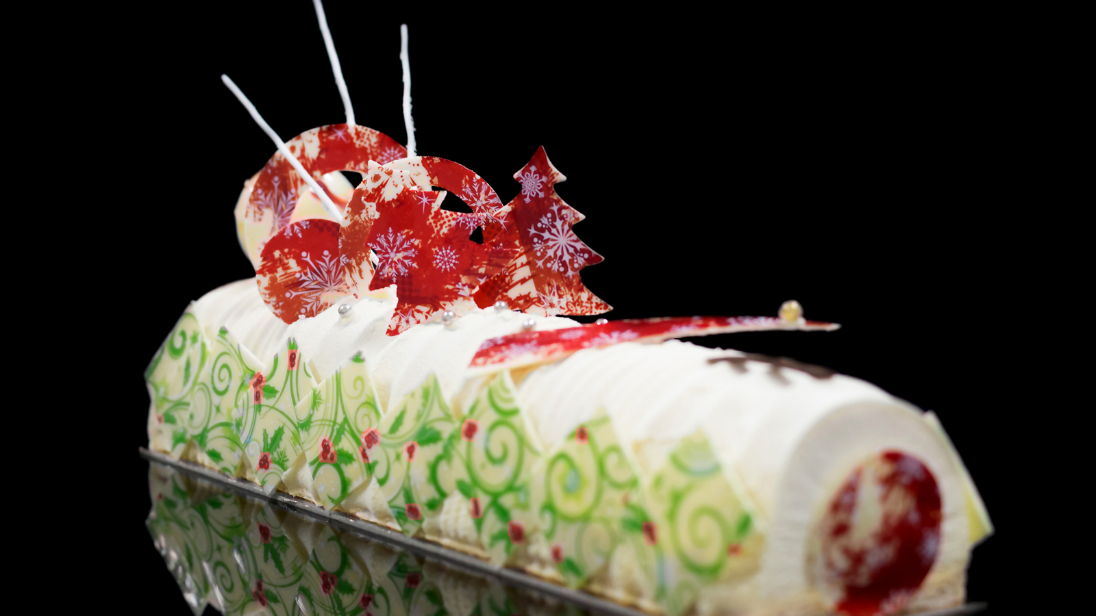 | November 9, 2016, Lisbon, Portugal  Acertar no presente para aquela pessoa especial nunca foi tão fácil com as sugestões do Ritz Four Seasons Hotel Lisboa  http://publish.url/pt/lisbon/hotel-news/2016/holiday-gift-ideas.html

PRESS CONTACTS

Catarina Mendonça
Social Media & Marketing Coordinator
Rua Rodrigo da Fonseca, 88
Lisboa
Portugal
catarina.mendonca@fourseasons.com

+351 21 381 1400

