FOUR SEASONS Dubai
Tel: NOT_SETEmail: NOT_SET

OPENING DATE: November 2014
GENERAL MANAGER: Leonardo Baiocchi

Physical Features
Architect:

The Pearl Spa
Number of Treatment Rooms: 10
- Includes luxurious Couple's Spa Suite
Product Lines:
- Sodashi, Dr Burgener Switzerland, Knesko, Biologique Recherche
Special Facilities:
- Deluxe aqua thermal experiences
- Indoor swimming pool topped by a glass canopy
- Full men’s and women’s changing and relaxation areas
- Juice bar
- La Sirene Coiffure plus men’s grooming lounge

Dining
Restaurant: Suq

Recreation
On-site Activities
Beach: 270 metre (886 foot) natural beach; offers kayaks, dinghies and catamarans, paddleboards for use by guests

Meetings and Events
Total size: 12,906 sq.ft. / 1,992 sq. m.
Largest Ballroom: 6,351 sq.ft. / 590 sq. m.
Banquet Capacity: 360
Additional Meeting Rooms: 4 additional spaces accommodating sit-down events from 20 to 60

PRESS CONTACTS
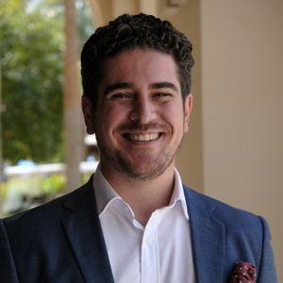 | Ghaith Adnan  Senior Director of Public Relations and Communications  Jumeirah Road  Dubai  United Arab Emirates  ghaith.adnan@fourseasons.com  + 971 4 270 7884

