Celebrate St. Valentine's Day at Four Seasons Hotel Istanbul at Sultanahmet, Surrounded by Layers of History

Discover the charm of Istanbul and indulge in the romantic offerings at Seasons Restaurant
February 9, 2017, Istanbul at Sultanahmet, Turkey

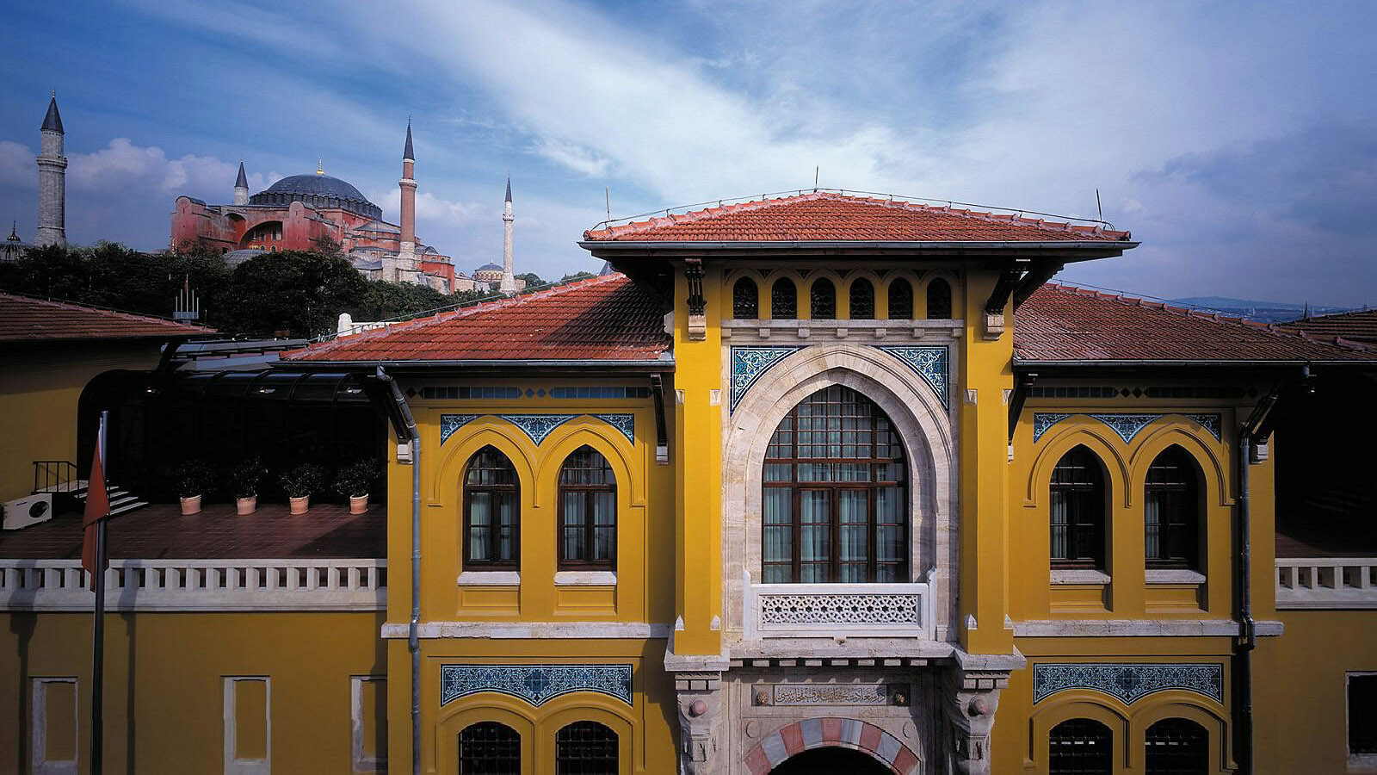
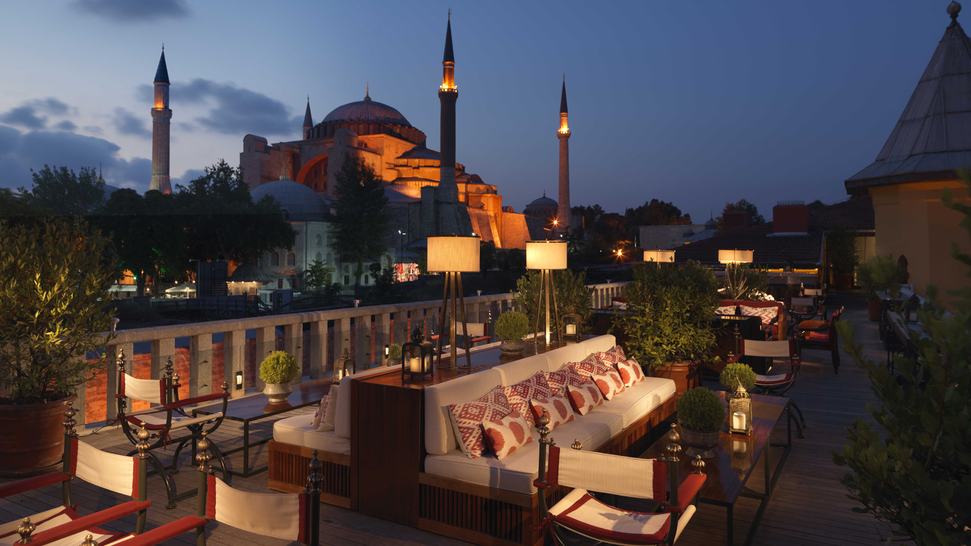
February is the time to say seni seviyorum - "I love you" in Turkish - and feel the love in the air. Being the capital city of three empires, Istanbul has been home to many love stories in history and has sparked a lot of artists, poets and writers to share this love in their everlasting creations. Inspired by its historical setting at the heart of the Old City,
Four Seasons
Hotel Istanbul at Sultanahmet offers an authentic St. Valentine’s experience.
Located inside a cosy glass pavilion in the Hotel’s courtyard, Seasons Restaurant welcomes guests with a special menu and live entertainment. The culinary team has prepared all dishes just in the mood for love. The menu starts with salmon medallion and tartar marinated beetroot followed by ricotta and grape ravioli. The main course offers two options: it won’t be easy to choose between pan roasted cod or roasted beef ribs and medallion. The sweetest part comes at the end, tempting strawberry.
Live performance by İstanbul’s renowned jazz performer Seçil Akmirza will appeal to both eye and ear, making the whole experience even more romantic this year. If weather permits, Hotel’s one-and-only rooftop terrace A’YA Lounge will be a perfect spot to enjoy after dinner drinks.
TRY 240 per person; for reservations call Seasons Restaurant; +90 212 402 31 50

RELATED

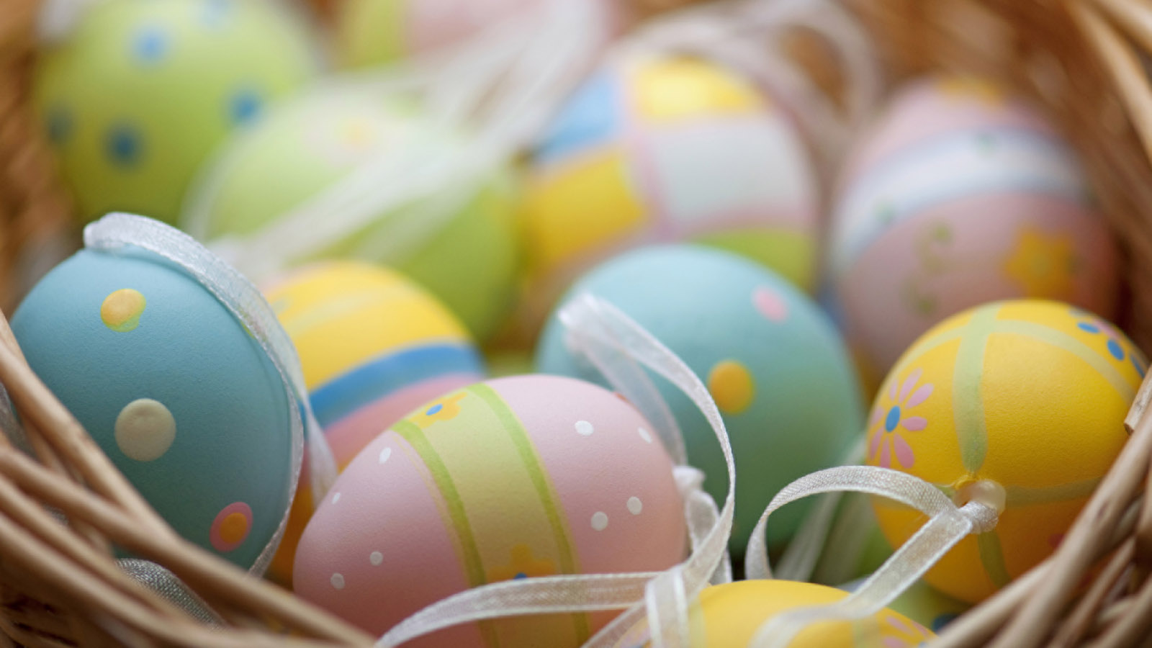 | March 13, 2017, Dubai, U.A.E.  New Activities and Offers at Four Seasons Hotels and Resorts in Europe, Middle East and Africa for an Exciting Easter This Year  http://publish.url/news-releases/2017/easter-in-emea.html
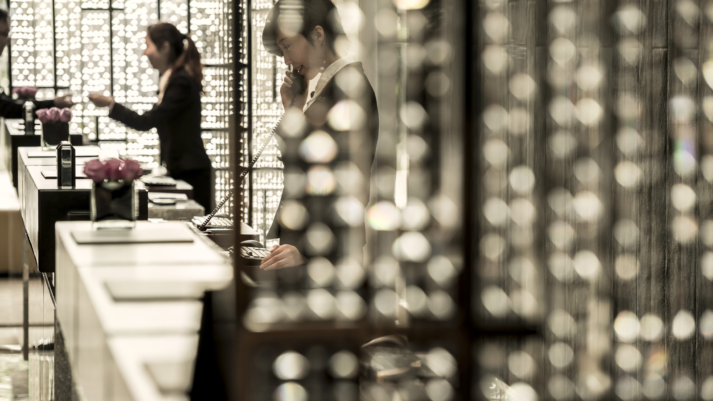 | March 1, 2017, Toronto, Canada  Four Seasons Awards and Accolades  http://publish.url/news-releases/awards-and-accolades-for-four-seasons-hotels-and-resorts.html

