Four Seasons Hotel Milano Unveils New Chocolate Themed Room

A tropical forest entirely made of chocolate created by Pastry Chef Daniele Bonzi, in partnership with Valrhona
September 5, 2017, Milan, Italy

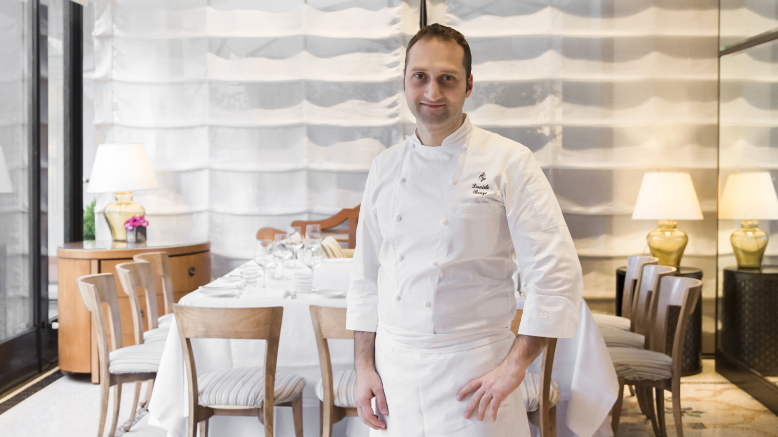
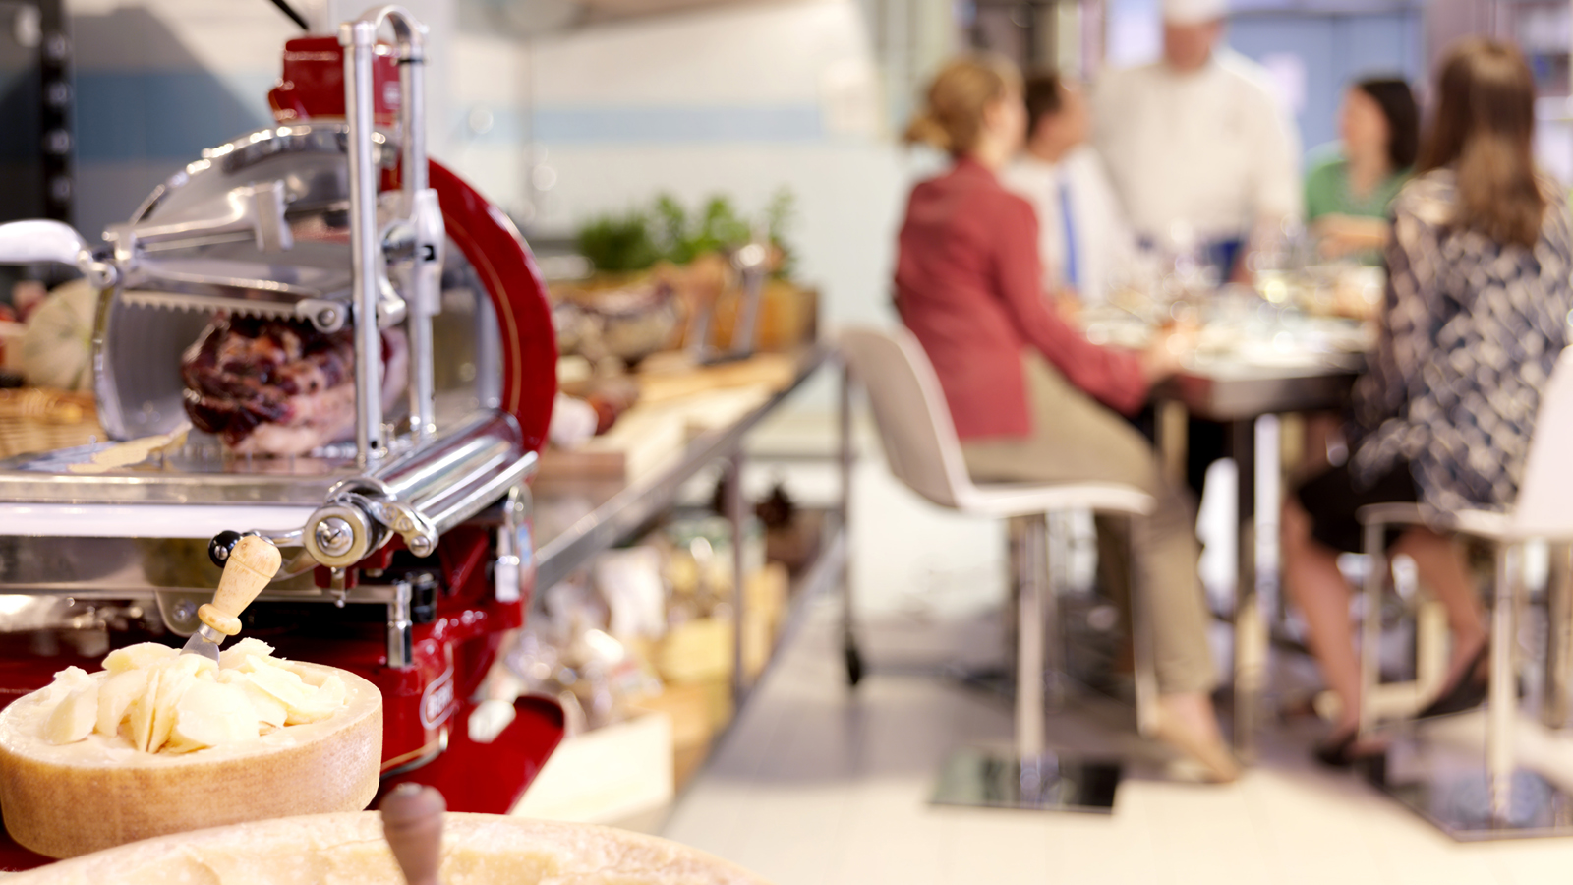 | 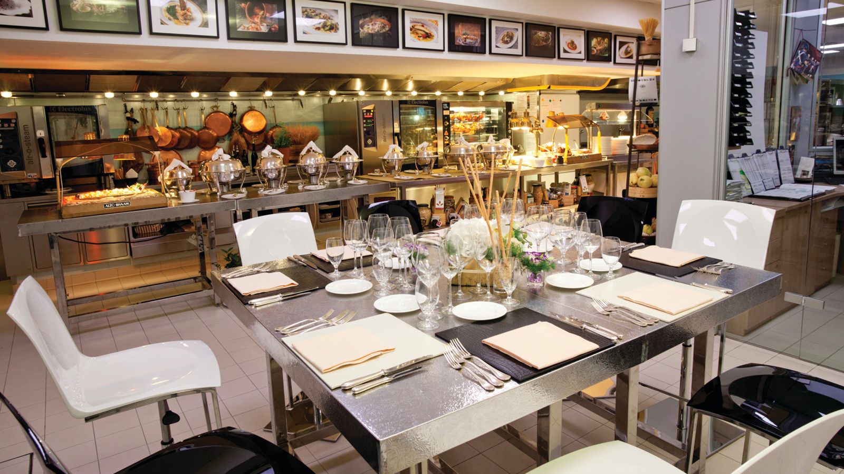 | 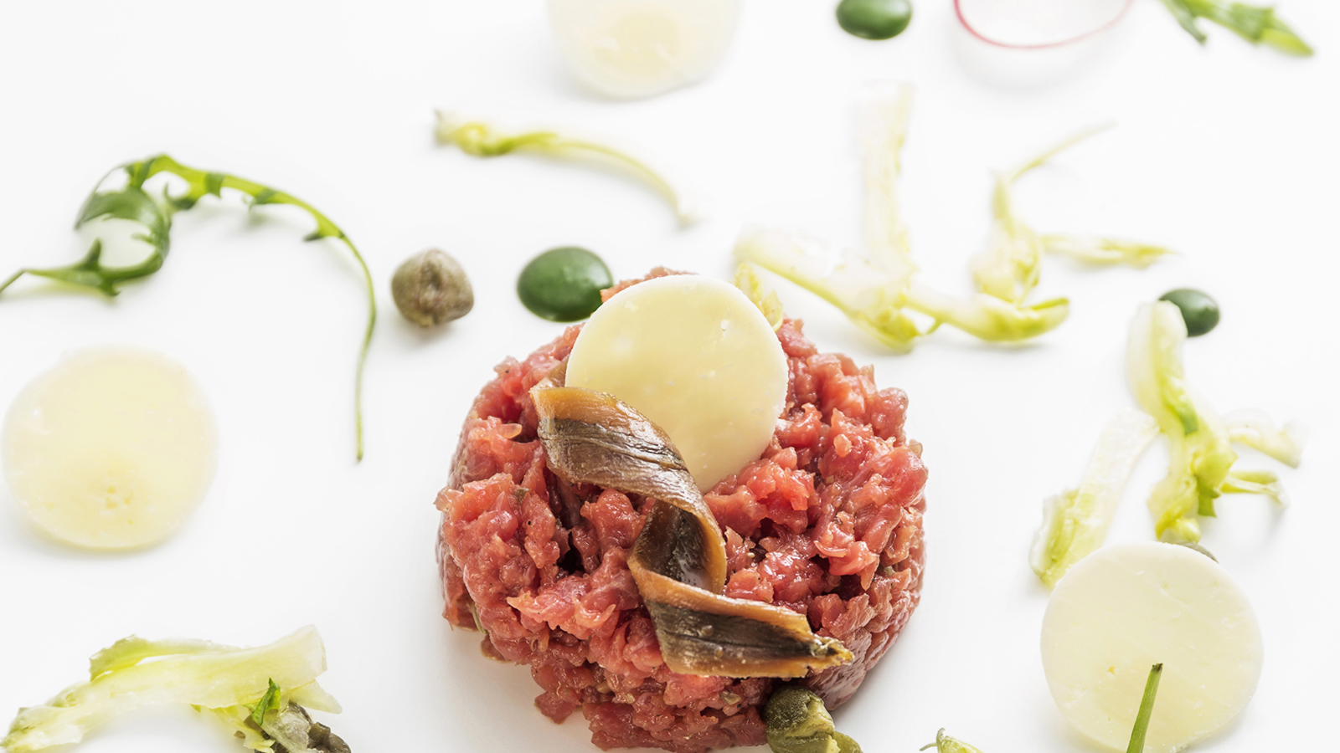
As the summer ends, an exciting event awaits little onesand grown ups in Milan, the highly anticipated new chocolate room at
Four Seasons
Hotel Milano.
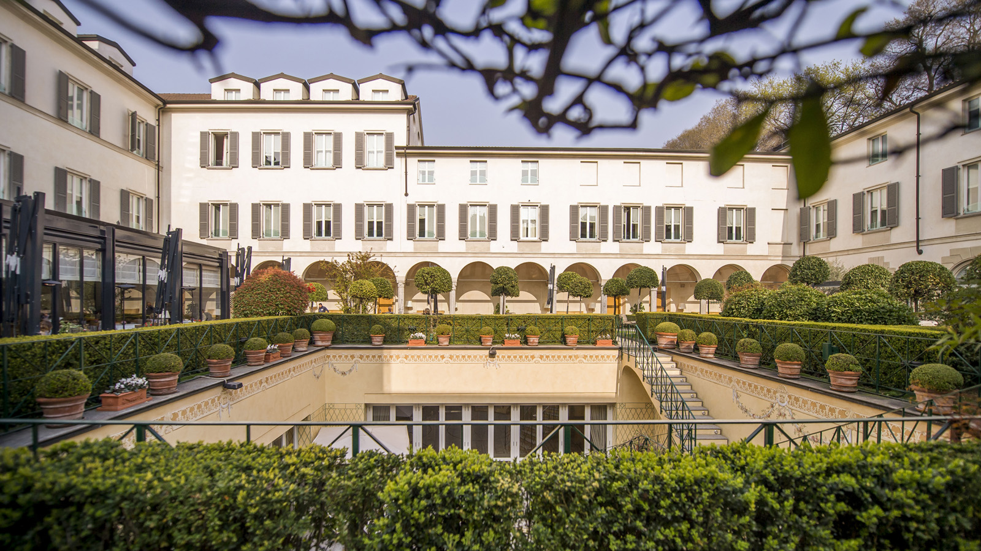 | 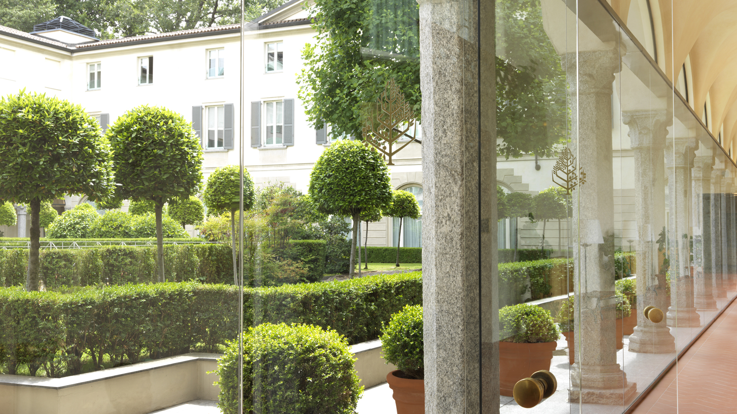 | 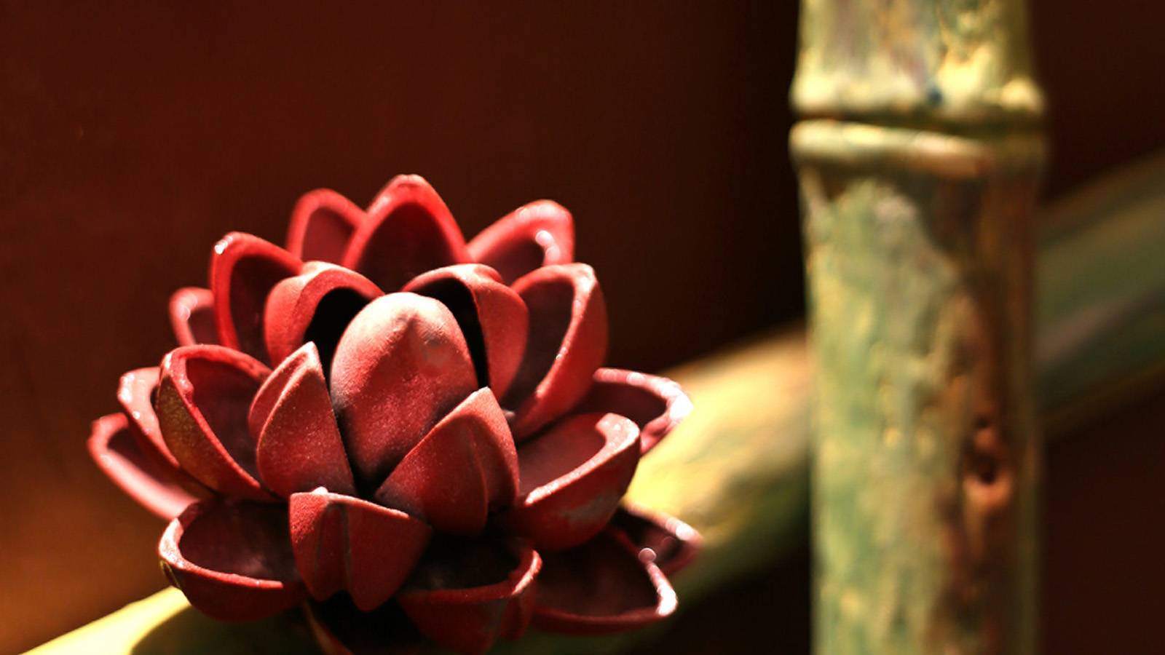
Since its creation in 2007, this chocolate attraction has become a must-see for Hotel guests and locals alike during the weekly Sunday Brunch. This room, entirely made of chocolate, has successively taken the form of a cinema set, a Ratatouille-themed lounge, and more recently, a chocolate factory. This year, thanks to a partnership with the French chocolate master Valrhona, the Hotel's Pastry Chef Daniele Bonzi has created a tropical forest, to be unveiled on September 17, 2017 for the reopening of the seasonal Sunday Brunch.
The new theme features jungle-inspired vegetation and décor with exotic animals, all entirely made of chocolate - including the walls. As they step in, guided by the appetising smell of chocolate, guests are greeted by colourful butterflies, toucans and ladybirds who have comfortably settled into their home among the bamboo, tropical plants and water lotus flowers.
No less than 300 hours of work and 300 kilograms (660 pounds) of chocolate were needed to bring this chocolate masterpiece to life. The result is breathtaking and seems so real, temptation is high to touch and taste to believe it is all 100 percent chocolate.
The new chocolate room can be visited upon request or on the occasion of the Hotel Brunch, a landmark rendez-vous for all gourmets. Resident Chef Marco Veneruso and his culinary team welcome guests to their open kitchen every Sunday, where they can taste traditional Italian dishes served buffet-style and interact with the chefs. Featuring handpicked local ingredients, a gourmet selection of cold cuts, cheeses, salads, fish and roasted meats, the Sunday Brunch offers a full immersion into Italy’s rich soil and best products.
A children’s play area and a babysitter service make this moment a delectable and relaxed occasion for the entire family.
Brunch at
Four Seasons
Hotel Milano
- Every Sunday from 12:15 to 3:00 pm
- EUR 80 per person (EUR 95 beverages included); EUR 40 for children from 5 to 12 years; complimentary for children under 4 years
- Reservations at 0039 02 77081416 or mil.events@fourseasons.com

RELATED

September 5, 2017, Milan, Italy
La Nuova Chocolate Room da Scoprire Durante il Brunch di Four Seasons Hotel Milano
http://publish.url/it/milan/hotel-news/2017/brunch-chocolate-room-2.html

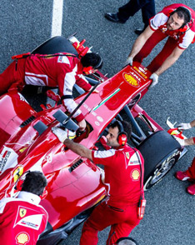 | August 2, 2017, Milan, Italy  Four Seasons Hotel Milano Invites Formula 1 Fans to Enjoy the Legendary Grand Prix of Italy  http://publish.url/it/milan/hotel-news/2017/grand-prix-of-italy-2.html

PRESS CONTACTS

Anita Ruozzi
Public Relations and Marketing Communication Coordinator
Via Gesu, 6/8
Milano
Italy
anita.ruozzi@fourseasons.com

+39 02 7708 1123

Caroline Mennetrier
Director of PR and Marketing Communication
Via Gesù 6/8
Milano
Italy
caroline.mennetrier@fourseasons.com

+39 02 7708 1795

