Konrad Gstrein Appointed General Manager of Four Seasons Hotel Toronto

February 14, 2017, Toronto, Canada

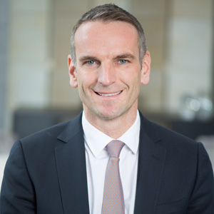
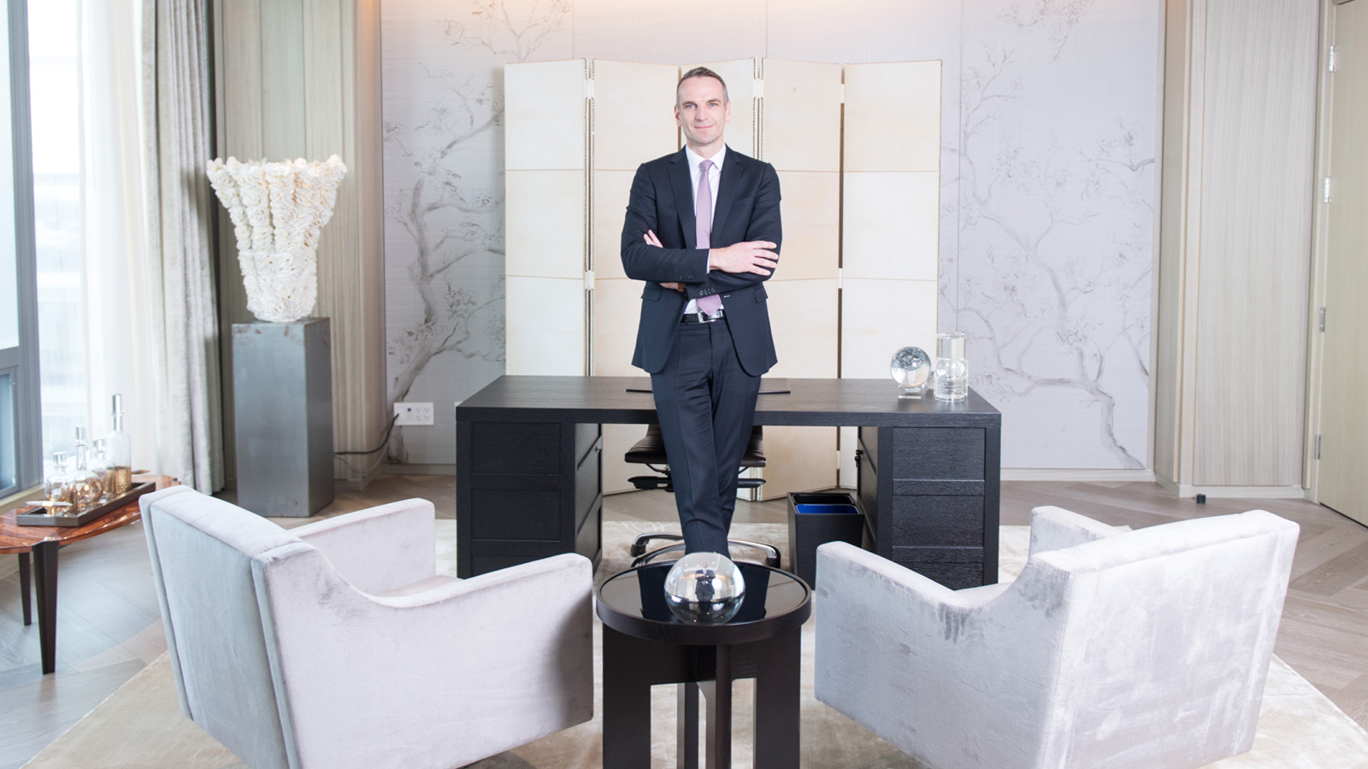
Konrad Gstrein has been named General Manager of
Four Seasons
Hotel Toronto. A true leader in the industry, this is his sixth appointment with the company.
Gstrein’s illustrious career started with
Four Seasons
in 2001 as Assistant Guest Services Manager at
Four Seasons
Resort Maui at Wailea. His journey has been fast paced and nonstop with assignments in Sydney and New York, where he worked in several management positions. In 2008, Gstrein was promoted to Director of Rooms at
Four Seasons
Hotel Philadelphia (formerly a
Four Seasons
hotel). In 2010, Gstrein headed to
Four Seasons
Resort Hualalai and then back to Maui in 2012 when he was promoted to Resort Manager. Beverly Wilshire, Beverly Hills (A
Four Seasons
Hotel) was Gstrein's most recent assignment, where he was the Hotel Manager since 2014 before making his way to Toronto.
“Konrad brings a wealth of experience to his new role and is a true champion of the values and commitment to service excellence that define
Four Seasons
,” says Vince Parrotta, President, Hotel Operations - Americas,
Four Seasons
Hotels and Resorts. “We are delighted to welcome him to Toronto, one of our global flagship hotels and the birthplace of Four Seasons, where his love for hospitality is only outweighed by his passion for the guest experience.”
Hailing from the village of Längenfeld, Austria, Gstrein has a love of travel, tennis and running, having competed in multiple marathons and triathlons. He attended Handelsschule Business School in Telfs, Austria, after which he entered the hospitality industry. Gstrein's unwavering dedication and his strong people skills enable him to continuously make a positive impact on guests and employees alike.

RELATED

February 7, 2017, Toronto, Canada
Four Seasons Hotel Toronto Makes March Break a Breeze with Special Offer and Top 10 Activities Guide
http://publish.url/toronto/hotel-news/2017/march-break.html

January 16, 2017, Toronto, Canada
Four Seasons Hotel Toronto Welcomes Senior Spa Director for the Americas Victoria Nickle
http://publish.url/toronto/hotel-news/2017/new-senior-spa-director-victoria-nickle.html

PRESS CONTACTS

Halla Rafati
Public Relations Director
60 Yorkville Avenue
Toronto
Canada
halla.rafati@fourseasons.com

1 (416) 928-7319

