Introducing the Most Stylish Sunday Brunch on the Island at Four Seasons Resort Koh Samui

August 4, 2017, Koh Samui, Thailand

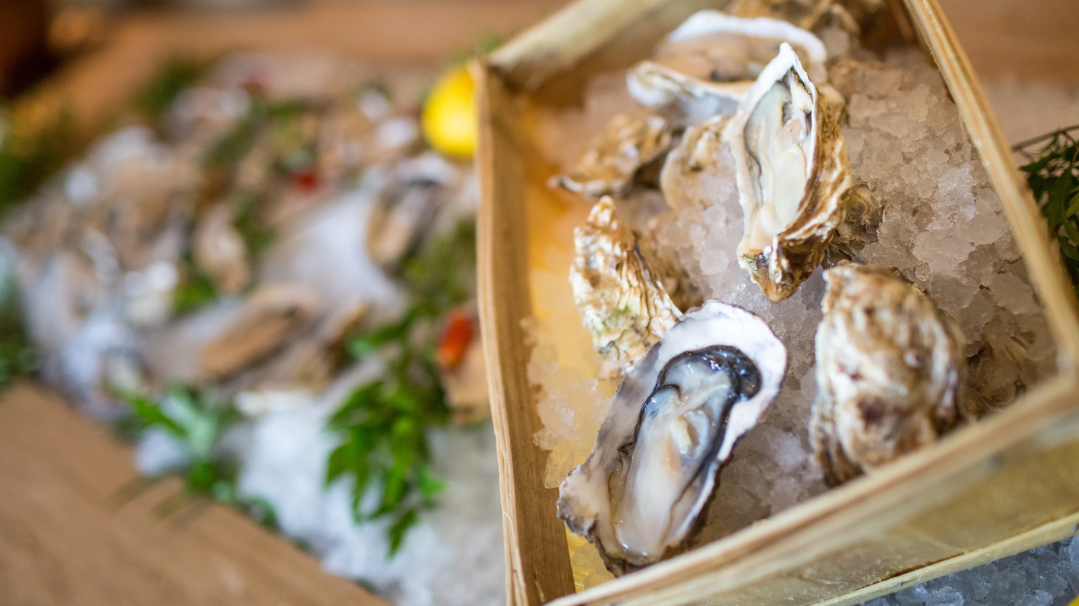 | 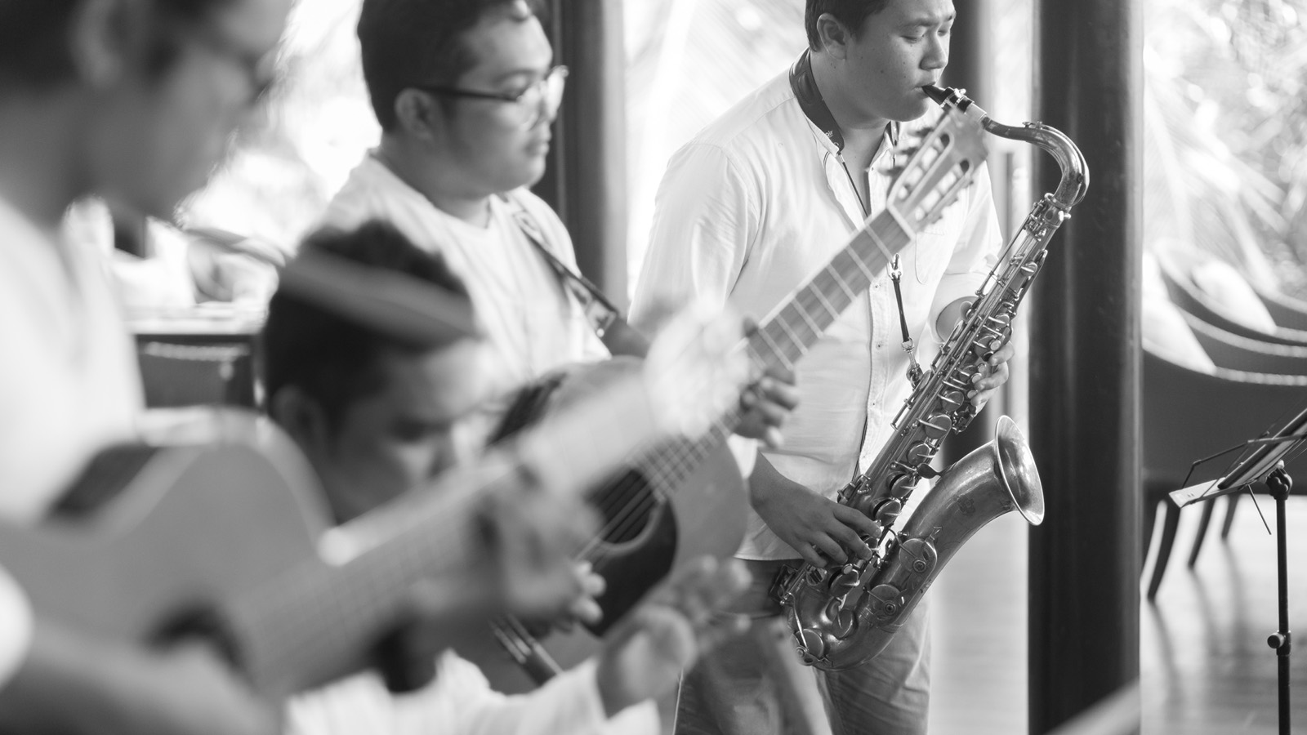 | 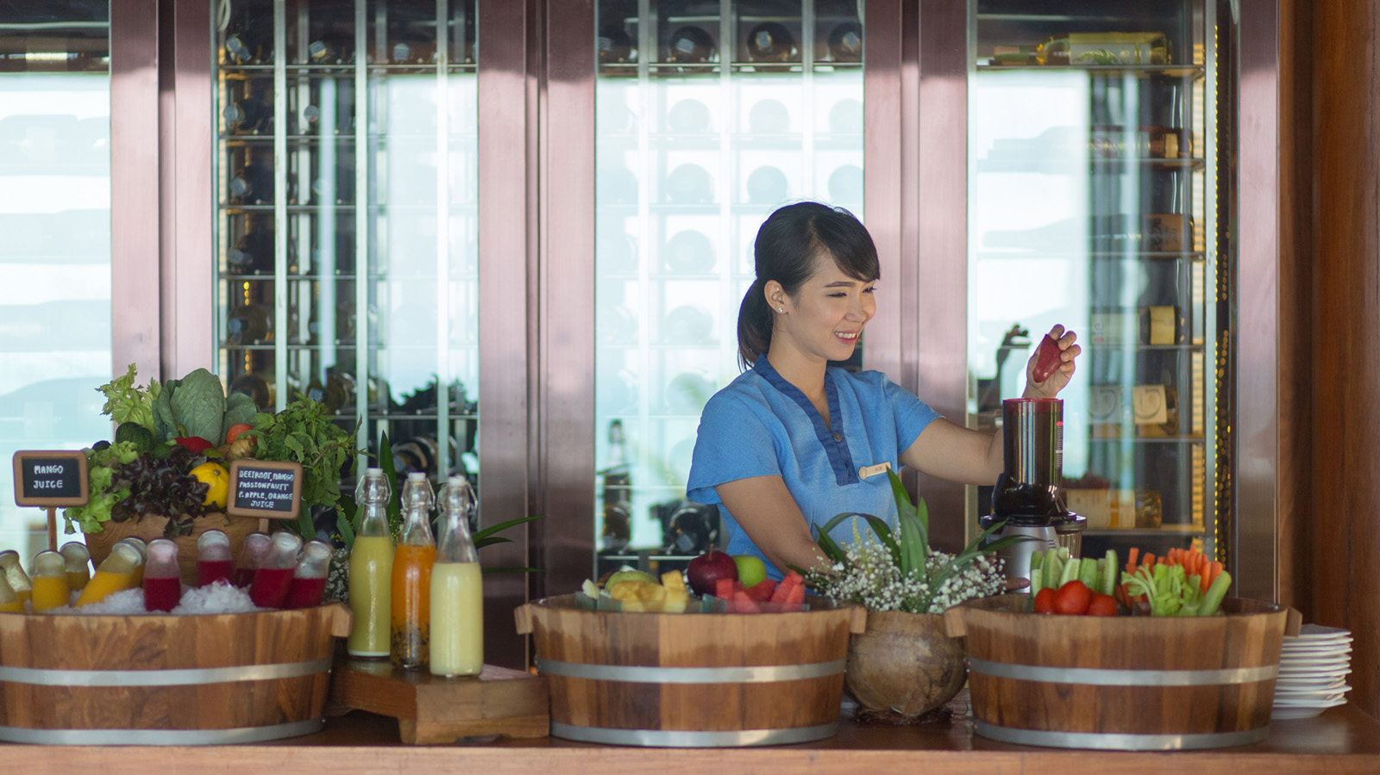
Celebrate the weekend in style with the new and exclusive Sunday Brunch at
Four Seasons
Resort Koh Samui. Enjoy an afternoon of exquisite culinary pleasures, complemented by fine vintages and handcrafted cocktails - not to mention the incredible tropical vistas.
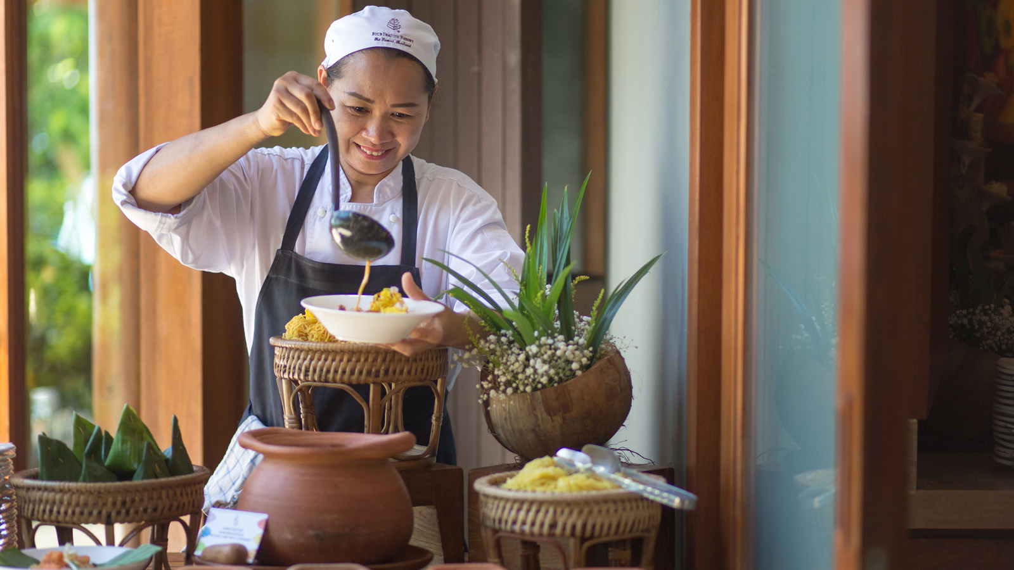 | 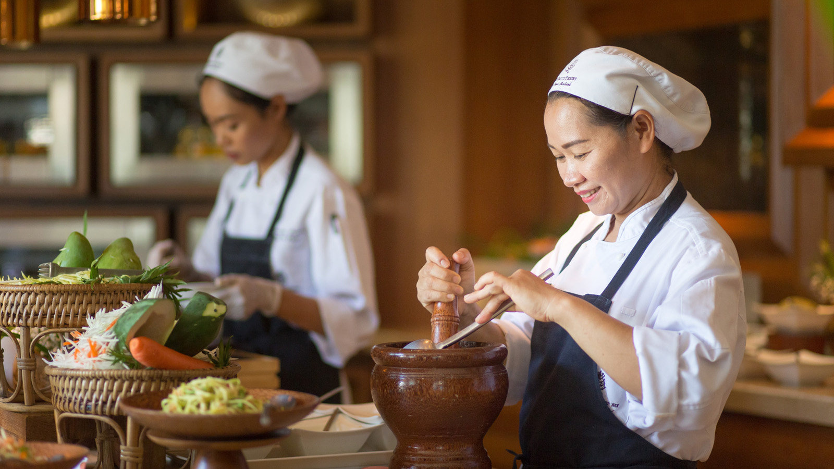
The venue is KOH Thai Kitchen, perched atop a palm-clad hill and cooled by pure sea breezes. This chic restaurant makes the most of its fabulous location by blending open-air seating with contemporary Thai design. Infinite views of the Gulf of Thailand form the backdrop to a memorable meal, while live jazz provides the perfect Sunday soundtrack.
Indulge the Taste Buds
Savour delectable specialties from around the world, from Japanese sashimi and Thai-style BBQ pork ribs to French lobster bisque and Italian panna cotta. Live cooking stations offer spicy local favourites, as well as authentic Latin American delights from the CoCoRum menu, including Peruvian ceviche and Jamaican criola salad.
Sunday Brunch features the finest produce, be it oysters from coastal France or succulent grass-fed beef from the pristine Australian island of Tasmania. For made-to-order mains, served hot at the table, choose from the Chef’s selection of brunch mainstays - fresh, flavourful and utterly satisfying. Think poached eggs served with Parma ham and chervil-spiced hollandaise, lobster seared in mustard butter with a side of tomato salsa, or homemade pasta with prawns and bone marrow. The impressive buffet spread also includes an array of salads, breads, roasts, hot pots, cheeses and desserts.
The Resort's careful attention to food certainly doesn’t mean the drinks get left behind. Enhance the afternoon-long vacation with a curated selection of wines, as well as cocktails chosen by the Resort's mixologist. Enjoy classics such as the Bloody Mary and Margarita with a twist of island creativity, or simply relax with an old and familiar companion, be it a refreshing gin and tonic, or a smoky single malt.
Live the Island Dream
Complete the perfect laid back Sunday experience with thoughtfully chosen add-ons from the Resort. Parents can relax and spend some uninterrupted quality time together as the Kids’ Club offers complimentary babysitting services, so the children will be in good hands. Beach buffs are invited to unwind on the Resort’s private stretch of palm-fringed sands and take a dip in the crystal-clear waters. For some well-deserved pampering, book an express spa treatment in the private sala.
Choose a Sunday Brunch:
- THB 2,700++ (food only)
- THB 3,300++ (food and a glass of sparkling wine)
- THB 4,200++ (food and free-flowing beverages, including house wines, selection of five cocktails by our mixologist, live stations, standard house pour of alcohol mixes, beers, soft beverages and water)
Choose add-ons:
- Kids’ Club babysitting service: complimentary
- Beach access: THB 500 per person (complimentary for overnight guests)
- Express spa treatments: THB 900 for 20 minutes (scalp, neck and shoulder massage)

RELATED

January 10, 2018, Koh Samui and Chiang Mai, Thailand
Celebrate Love at Thailand’s Most Romantic Dining Destinations This Valentine’s Day at Four Seasons Resorts Thailand
https://publish.url/chiangmai/hotel-news/2018/valentines-day.html

January 5, 2018, Koh Samui, Thailand
Experience the All-New Intuitive Massage at The Secret Garden Spa Four Seasons Resort Koh Samui
https://publish.url/kohsamui/hotel-news/2018/intuitive-massage.html

PRESS CONTACTS

Karuna Amarnath
Director of Public Relations and Communications
3/F, 159 Rajadamri Road
Bangkok
Thailand
karuna.amarnath@fourseasons.com

+66 2207 8916

Pitchanan Tongsuk
Public Relations Executive
219 Moo 5, Angthong,
Koh Samui, Surat Thani
Thailand
pitchanan.tongsuk@fourseasons.com

+66 077 243 000

