Four Seasons Resort and Residences Vail Seasonal Promotion Welcomes Guests to Drive Around in New 2018 SL 550 Mercedes-Benz Convertible to Take in Beautiful Fall Foliage

“Color”ado is in full effect with the arrival of Fall
September 5, 2017, Vail, U.S.A.

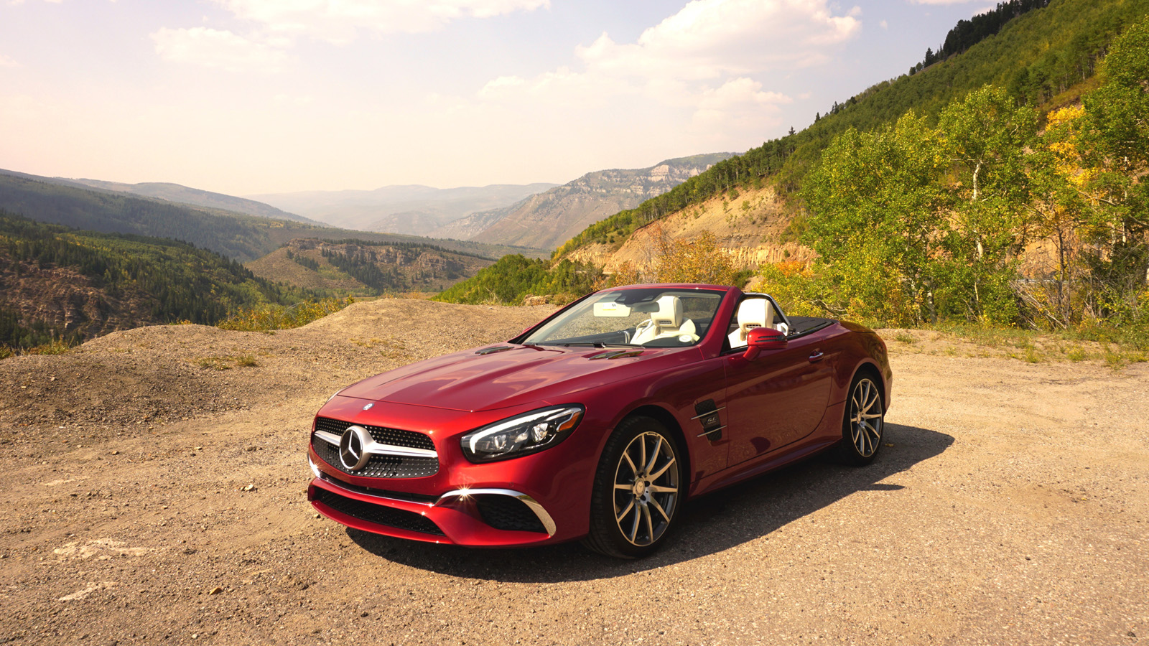
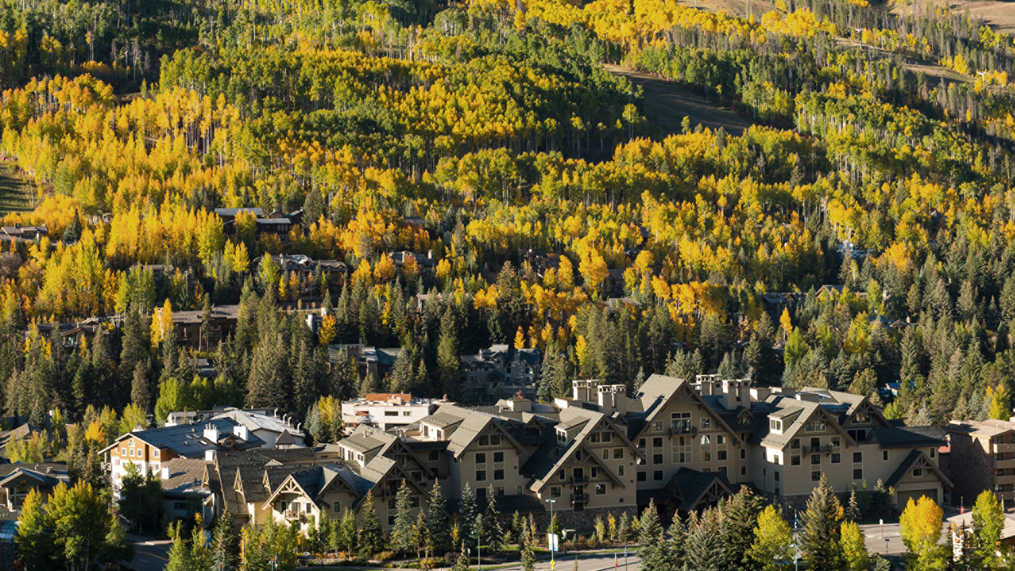 |  | 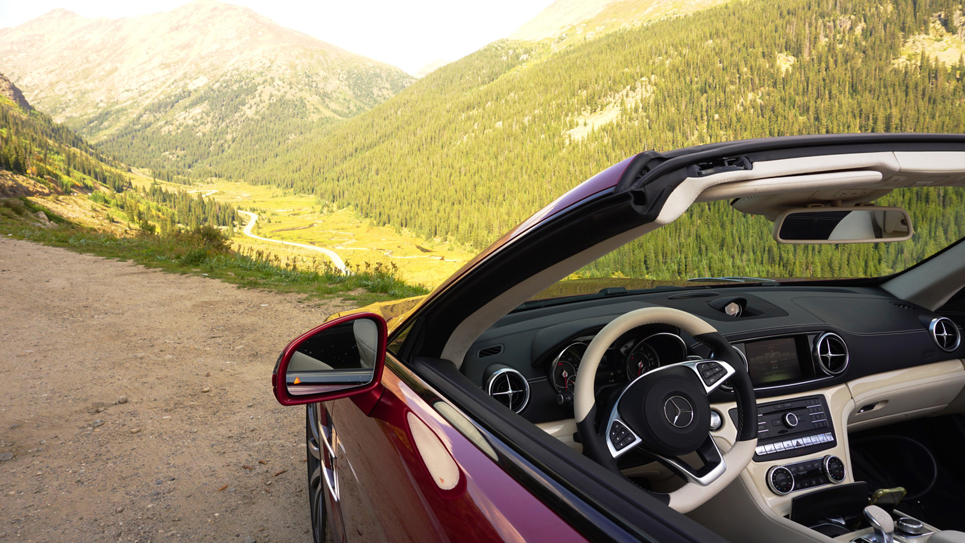
Change is in the air, and in the mountains that can only mean one thing: the beloved winter season is close at hand. But until then, a local’s favourite season is autumn. As the leaves begin to fall, head for the hills and enjoy a retreat filled with the unique beauty that surrounds
Four Seasons
Resort and Residences Vail.
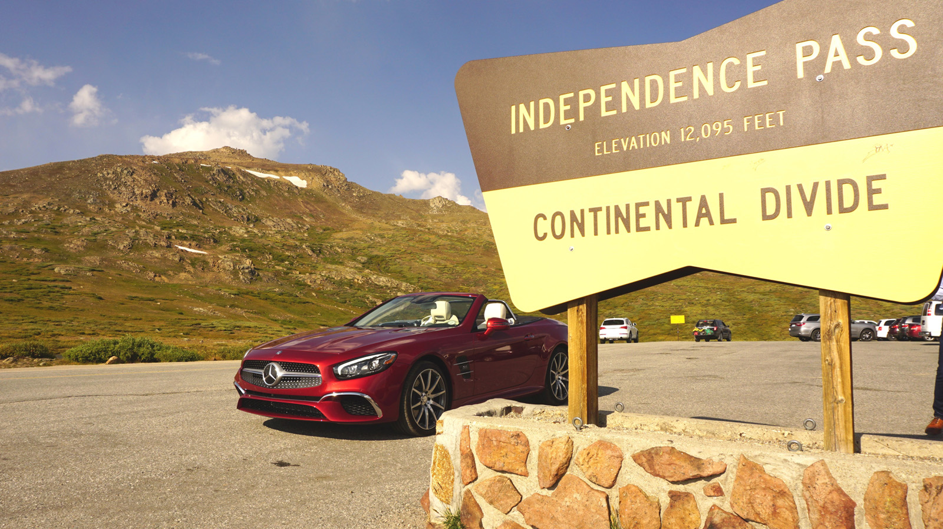
This fall, in partnership with Mercedes-Benz,
Four Seasons
Resort and Residences Vail is offering guests an exclusive opportunity to take in the beautiful fall foliage from a convertible. From September through the end of October 2017, enjoy a scenic drive in and around Vail in a new 2018 SL 550 Mercedes-Benz convertible. The Mercedes-Benz SL-Class convertibles are elegant yet graceful with the performance of a sports car. This two-seater offers the best Mercedes-Benz has to offer.
Complimentary to guests staying at the Resort on a first come, first served basis, guests are encouraged to take these vehicles out for various drives, as curated by the Resort’s knowledgeable Concierge team. Let the roof down and drive around enjoying the breathtaking alpine scenery. Stay local and take in the stunning views in Eagle County, or head over to Colorado’s Caves and Caverns through Glenwood Canyon. Enjoy a historic tour of an old railroad town, or drive over the Continental Divide through the famous Independence Pass. there are limitless drives to marvel in "Colorful Colorado."
Guests are encouraged to purchase a “starter pack,” which includes
Four Seasons
Vail hats, a chef-curated picnic backpack, Go Pro HERO 5 Black to document the trip, sunblock, a curated music playlist by the Concierge, and a map for the trip.
Don’t just look at this auto masterpiece, experience it. Book in advance to enjoy 40 percent off the room rate with the Vail Getaway offer. Follow the adventure using @FSVail #FSVailFallDrive and @MBUSA on Instagram.

RELATED

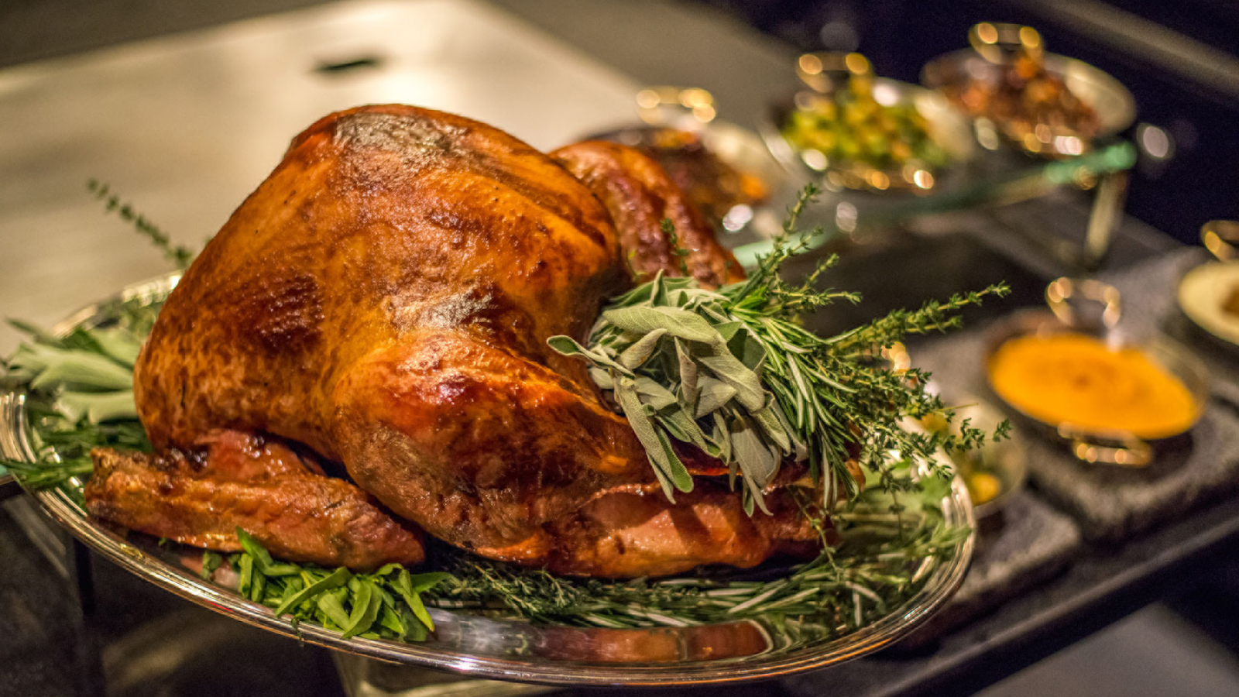 | October 4, 2017, Vail, U.S.A.  Eat, Drink and Give Thanks This Thanksgiving at Four Seasons Resort and Residences Vail  https://publish.url/vail/hotel-news/2017/thanksgiving.html
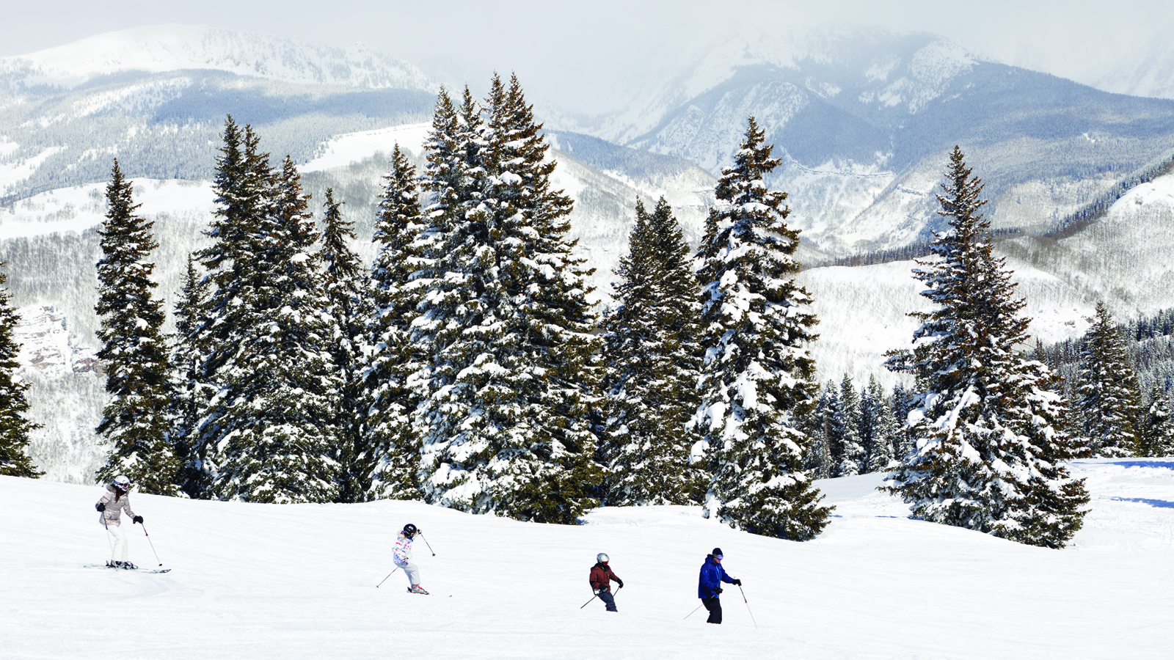 | July 31, 2017, Vail, U.S.A.  The 2017–2018 Winter Season Welcomes Epic Experiences for Four Seasons Resort and Residences Vail Guests  https://publish.url/vail/hotel-news/2017/2017-18-winter-experiences.html

PRESS CONTACTS

Kiersten Dunn
Director of Public Relations and Communications
One Vail Road
Vail
U.S.A.
kiersten.dunn@fourseasons.com

+1 (970) 477-8687

