Global Wellness Day at Four Seasons Resort and Residences Jackson Hole

May 19, 2017, Jackson Hole, U.S.A.

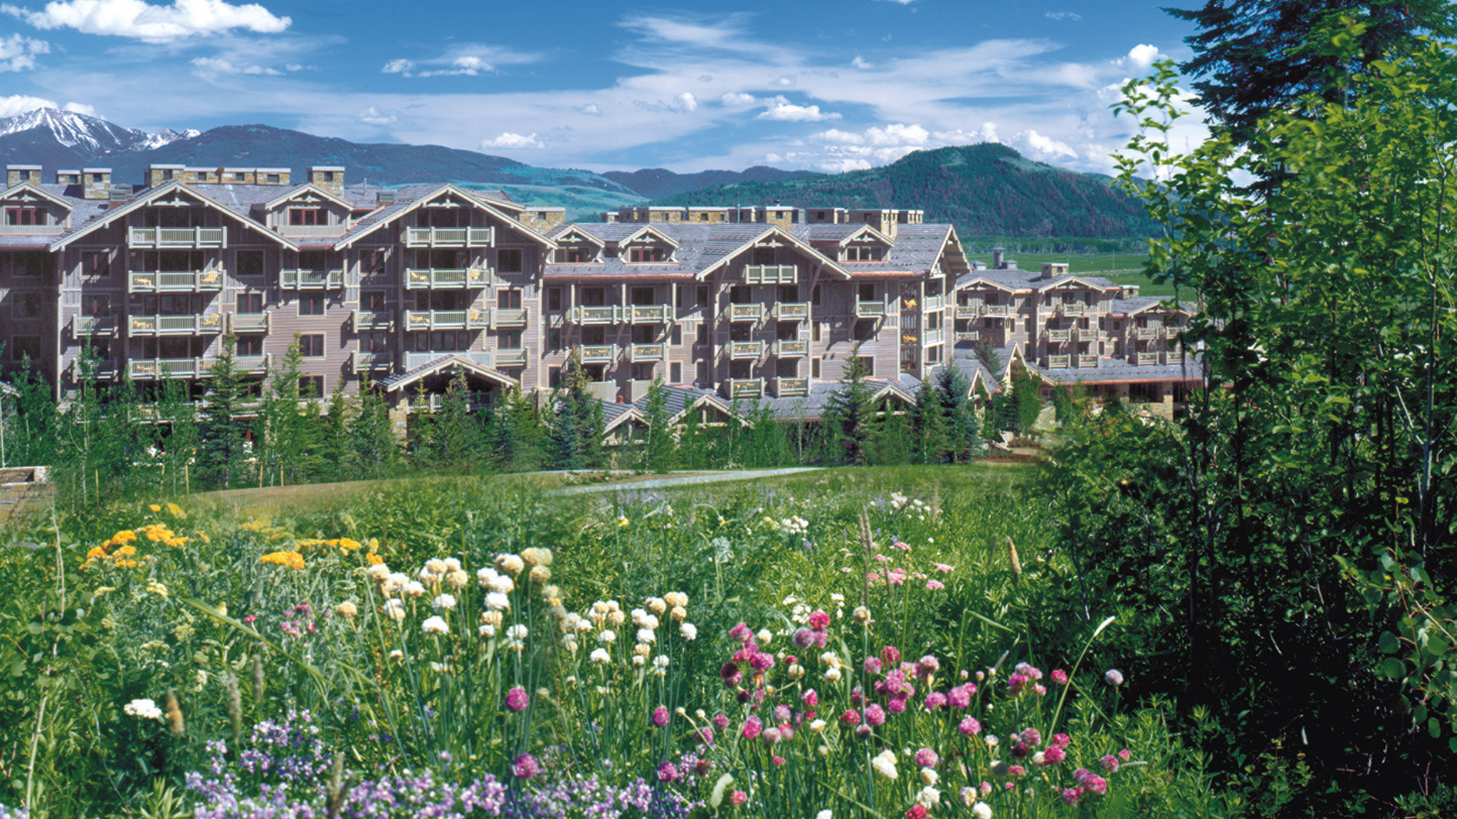
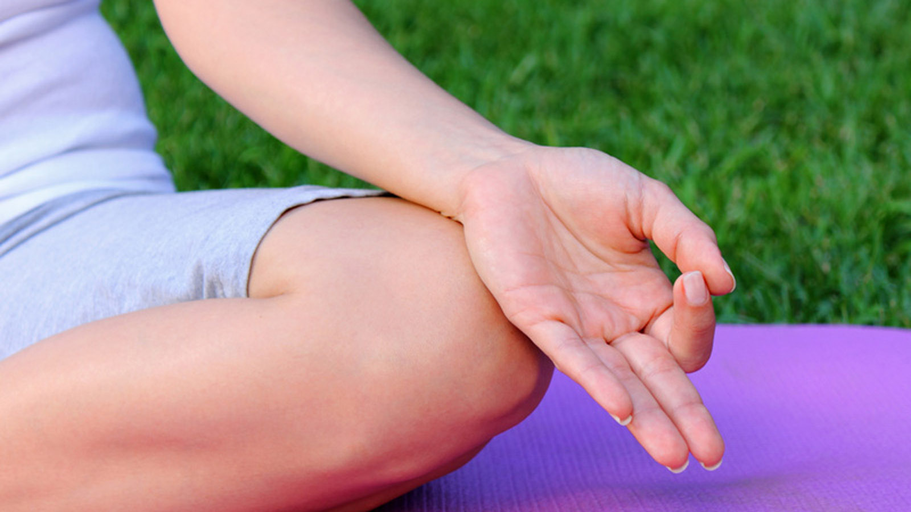 | 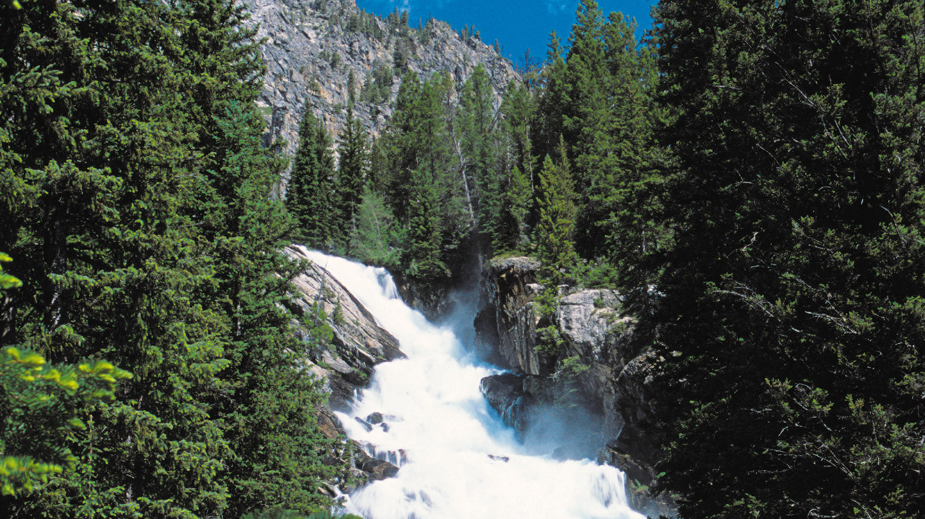
Celebrate Global Wellness Day at
Four Seasons
Resort and Residences Jackson Hole, which is joining forces with other sister properties on Saturday, June 10, 2017 for a full day focused on promoting health and wellbeing. Start the day with a yoga session in the parks, head out on scenic bike ride or enjoy a hike up the wildflower trail, followed by an afternoon of poolside activities, all while enjoying healthy, green cuisine offered throughout the day in the Resort's various outlets.
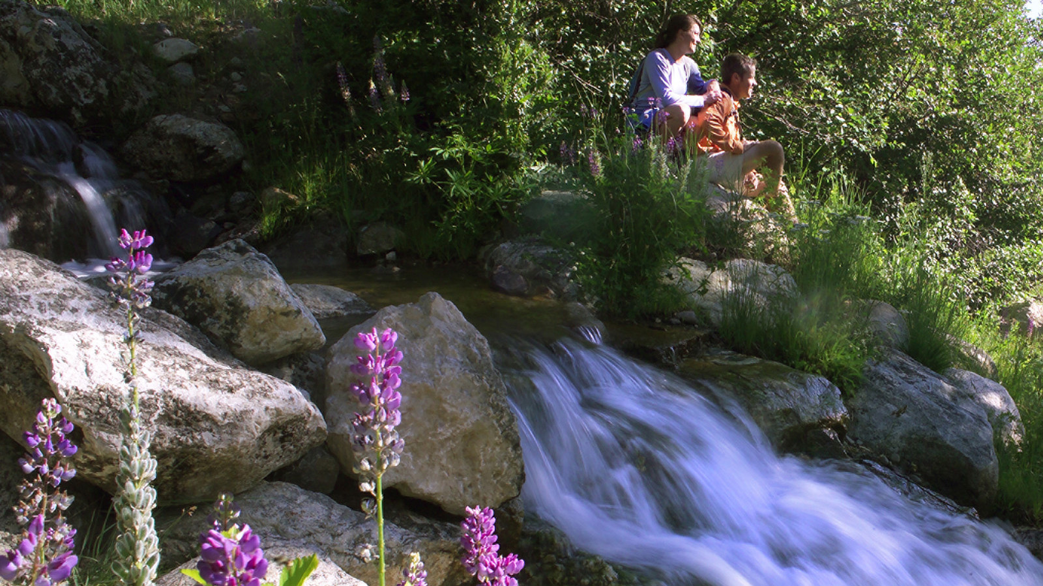 | 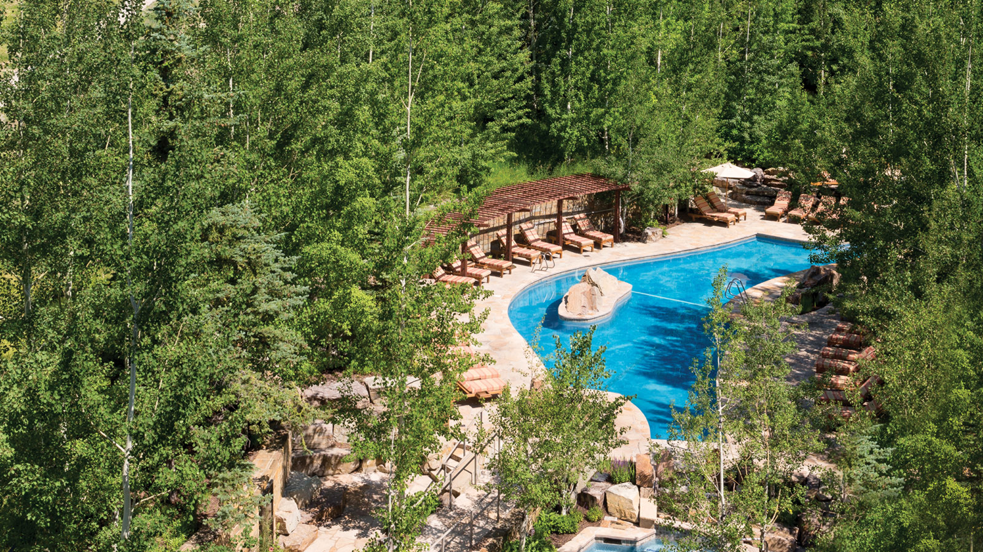 | 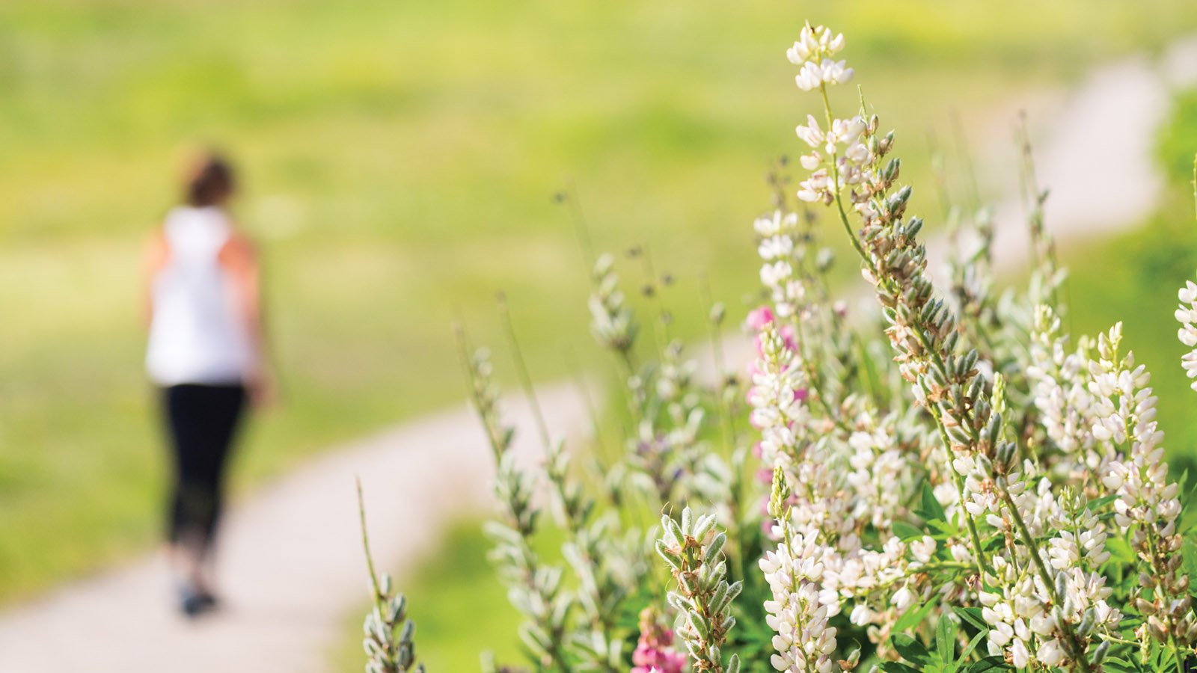
Morning Yoga & Breakfast
The morning will start at 9:00 am with poolside yoga led by one of the on-property yoga instructors. The serene sounds of moving water and sweeping views of Rendezvous Mountain will be the perfect way to bring in the morning practice. After yoga, complimentary coffee, tea and healthy snacks such as green juice, and goji berry and chia seed muesli parfait will be served on the pool terrace. For a full breakfast, guests are encouraged to visit the Westbank Grill for healthy specials such as tofu and egg white scramble and the Teton berry muesli bowl.
The Handle Bar will also be featuring healthy lunch specials such as smoked salmon toast with avocado, caper berries, breakfast radish, onion and local herbs.
Hike or Bike
Bikes are available for rent in base camp and may be taken for a late morning or afternoon ride down the many pathways available right outside the Resort doors. Guests may even ride to Rendezvous Park located a few miles from the property. Rendezvous Park has ponds, meadows, knolls and trails for visitors to explore.
Another option is a self-guided hike up the Wildflower trail. One of the most popular trails in Teton Village, this hike runs from the base of Jackson Hole Mountain Resort to the top of the Bridger Gondola. It runs through the heart of the mountain and has plenty of opportunities for spectacular views as well as wildlife sightings.
Poolside Wellness
For the ultimate in relaxation, guests won’t want to miss the complimentary poolside massages offered from 1:00 to 2:00 pm by the Resort’s massage therapists. Afterwords guests are invited to sample a complimentary amenity, such as an antioxidant-packed smoothie. Full side options will be available for purchase at the pool café.
The Spa will also be offering a one day sale on all Athletica wear.
Customised Chakra Sprays
Focus on setting positive intentions and aligning chakras with personalised aromatherapy sprays. Local healing practitioner Daniela Botour, owner of Lotus Vibes, will be on the pool patio from 4:00 to 5:00 pm. She will assist guests as they make their own sprays made from pure essentials oils, flower essence and crystals. Sprays are USD 28 per bottle.
About Global Wellness Day
Global Wellness Day is a special day that reminds the entire world of the importance of living well, encompassing everything from exercise and beauty treatments, spiritual teachings and ways of thinking to the harmony between body and spirit. This is a social movement without any commercial purpose, celebrated around the world on the second Saturday of June every year. Four Seasons Hotels and Resorts is partnering with Global Wellness Day to highlight the company’s vast wellness initiatives and outstanding spas within the portfolio.

RELATED

May 3, 2017, Jackson Hole, U.S.A.
Four Seasons Resort and Residences Jackson Hole to Host Summer Artist-in-Residence Borbay
http://publish.url/jacksonhole/hotel-news/2017/artist-in-residence-borbay.html

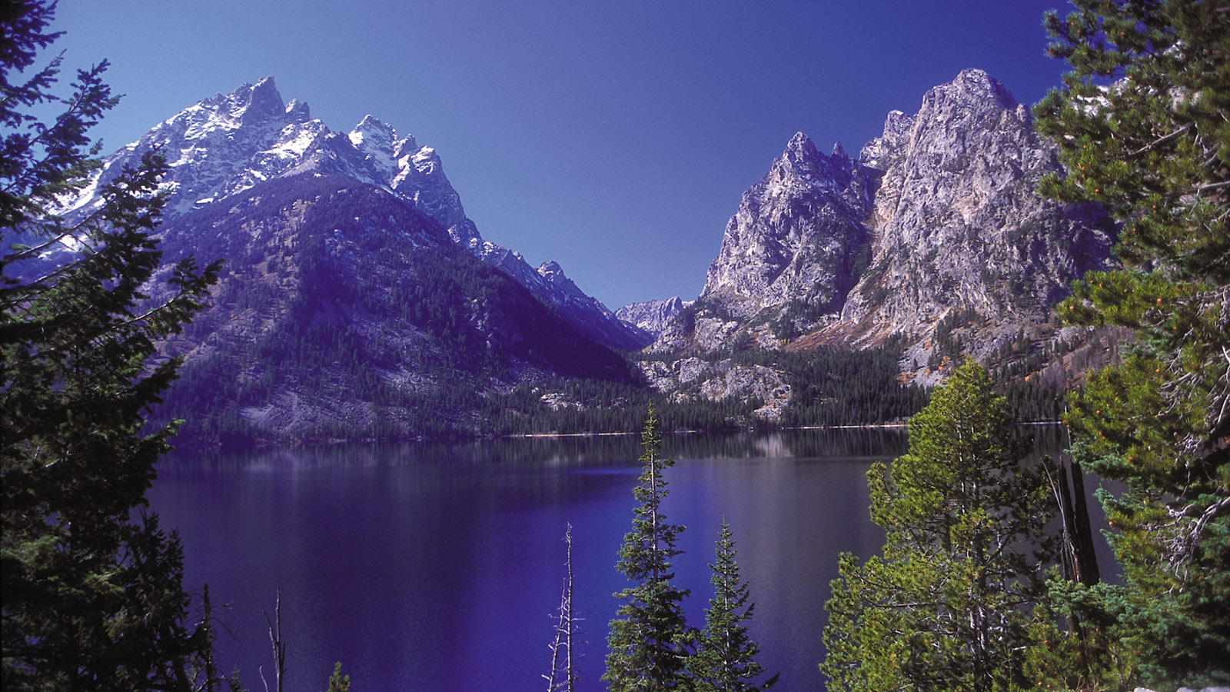 | April 28, 2017, Jackson Hole, U.S.A.  Four Seasons Resort and Residences Jackson Hole Launches a New Volunteer Option for Guests with Grand Teton Trail Stewardship Program  http://publish.url/jacksonhole/hotel-news/2017/grand-teton-train-stewardship-volunteer-program.html

PRESS CONTACTS

Nina Braga
Public Relations Director
7680 Granite Loop Road, P.O. Box 544
Teton Village
U.S.A.
nina.braga@fourseasons.com

+1 (307) 732-5062

