Four Seasons Hotel Gresham Palace Budapest Named Best City Hotel in Europe in Travel + Leisure's World's Best Awards Annual Readers' Survey

July 13, 2017, Budapest, Hungary

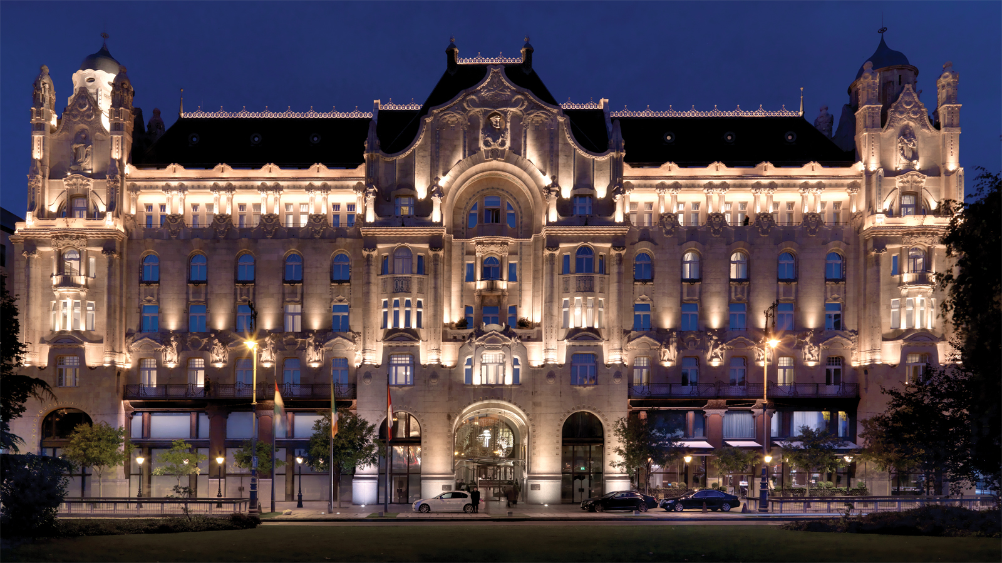
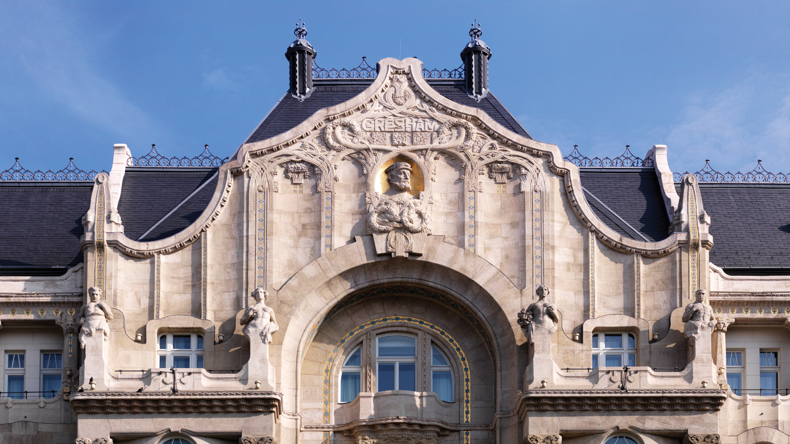 | 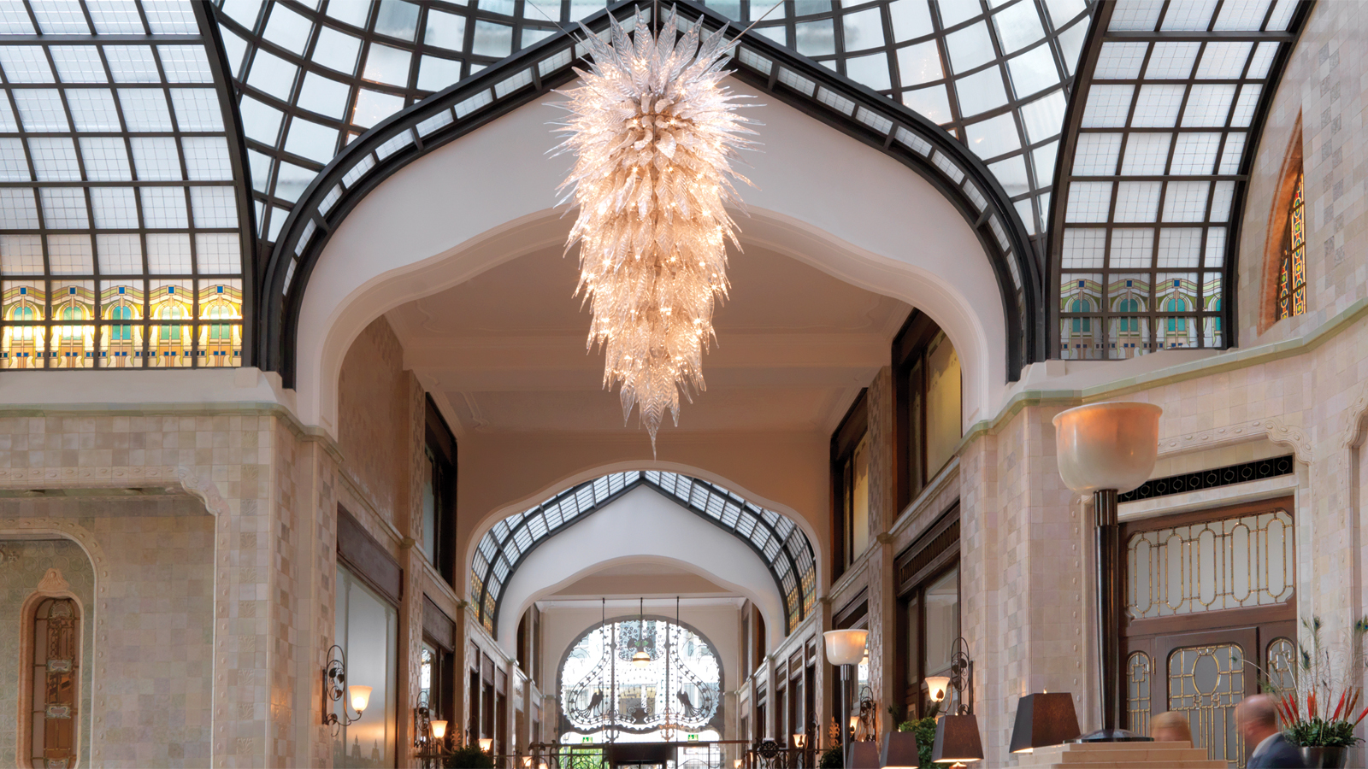 | 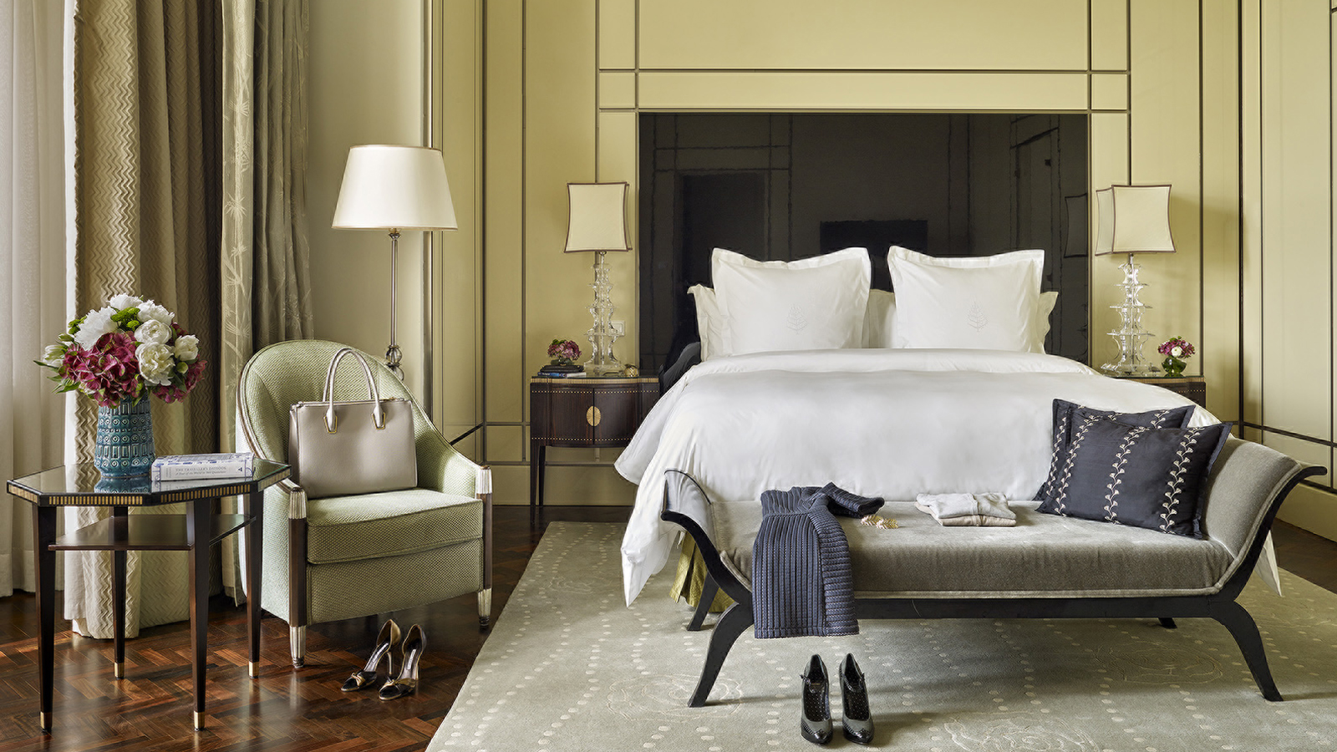
Four Seasons
Hotel Gresham Palace Budapest has been named Top City Hotel in Europe in the Travel + Leisure World's Best Awards 2017 readers' survey with a score of 96.26. The Hotel is one of just two ranked in Central and Eastern Europe, and was also ranked #49 in the Top 100 Hotels in the World.
Travel + Leisure’s World’s Best Awards are a leading measure of the places and companies most favoured by today’s most passionate and sophisticated travellers.
In naming Four Seasons Hotel Gresham Palace Budapest the #1 City Hotel in Europe, Travel + Leisure shared the following reader comments:
When readers tried to describe the experience of staying at this
Four Seasons
, it seemed few superlatives were enough to do the property justice. “Couldn't be more magnificent,” said one. “Great view, great food, great service, and stunningly beautiful.”
The 1906 Art Nouveau building, which overlooks the Danube River, was commissioned by the London-based company Gresham Life Assurance, and originally served as offices and apartments for the firm’s staff. During World War II it was used as barracks for the Red Army, then spent much of the next 60 years in a state of disrepair. After several rounds of renovation, it finally opened its doors as a
Four Seasons
hotel in 2004. Since then, visitors have been won over not only by the grand Art Nouveau architecture but also by the hotel’s extraordinary staff.
As respondent Bruce Christian put it, “The best service I have ever experienced in a hotel, from the front desk to the concierge to housekeeping to the doormen.”
To experience why
Four Seasons
Hotel Gresham Palace Budapest continues to earn accolades from guests and industry experts alike, reserve the Budapest Escape package, which includes 15 percent savings on the room rate when booking 15 days or more in advance, plus daily breakfast for two.
Travel + Leisure’s World’s Best Awards are a leading measure of the places and companies most favoured by today’s most passionate and sophisticated travellers. Editor-in-Chief Nathan Lump will host a celebration in New York City on July 26 in honour of the World’s Best Awards 2017 winners.

RELATED

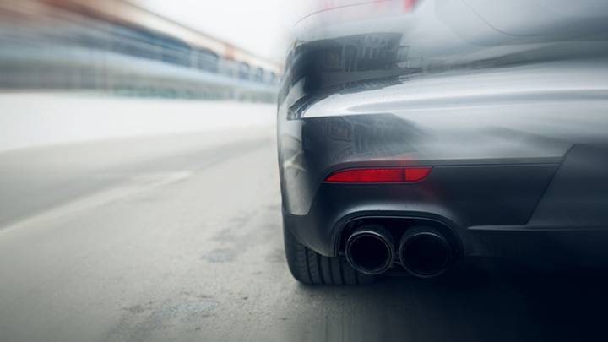 | May 31, 2017, Budapest, Hungary  Green Still Means Go: BMW Hungary Joins Forces with Four Seasons Hotel Gresham Palace Budapest  http://publish.url/budapest/hotel-news/2017/green-car-service.html
April 24, 2017, Budapest, Hungary
Omorovicza Anyák Napi Pop Up Spa a Four Seasons Hotel Gresham Palace-ben
http://publish.url/hu/budapest/hotel-news/2017/mothers-day-pop-up-spa-2.html

PRESS CONTACTS

Fanni Bakos
Public Relations Manager
Széchenyi István tér 5-6
Budapest
Hungary
fanni.bakos@fourseasons.com

36 1 268 5452

