Dream Weddings at Four Seasons Resort Maui

March 28, 2017, Hawaii, Maui, U.S.A.

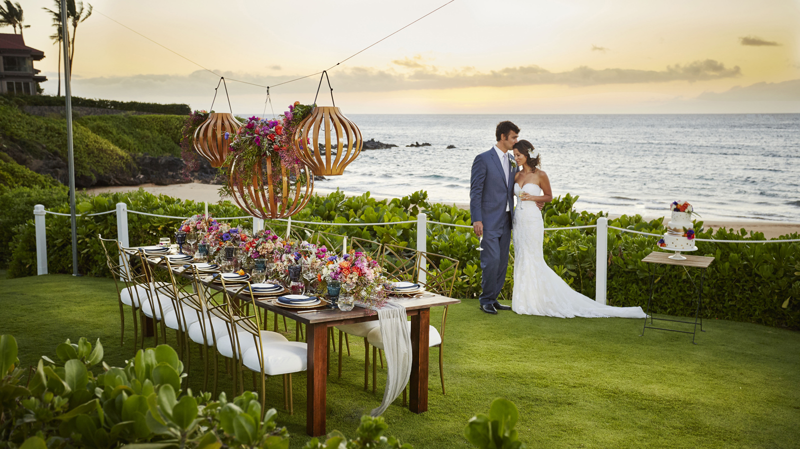
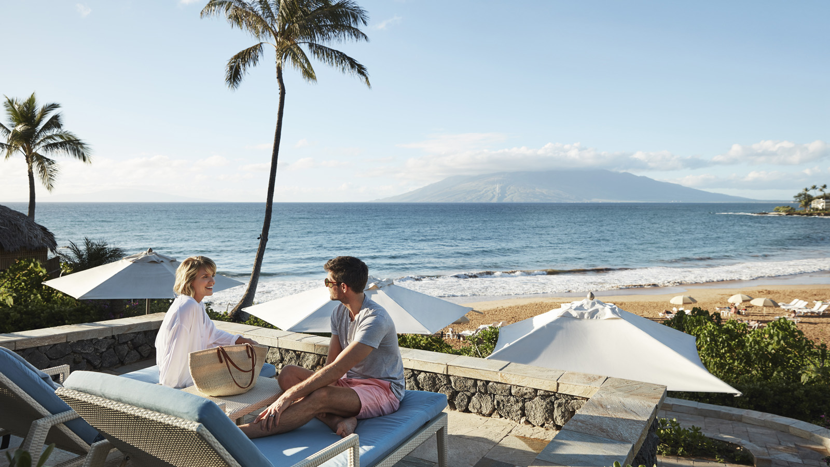 | 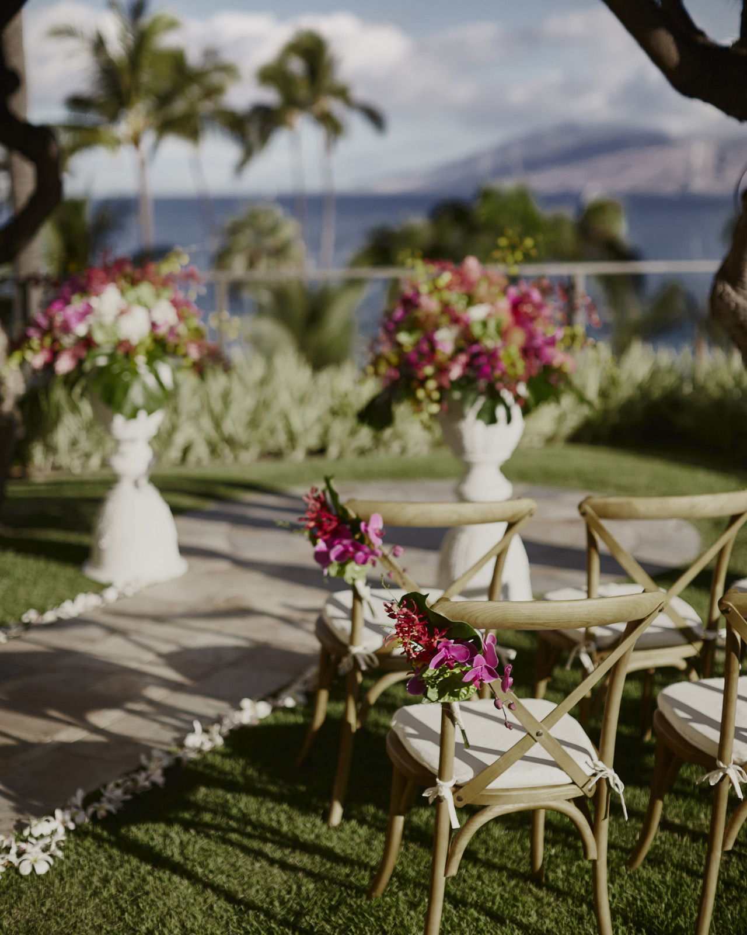 | 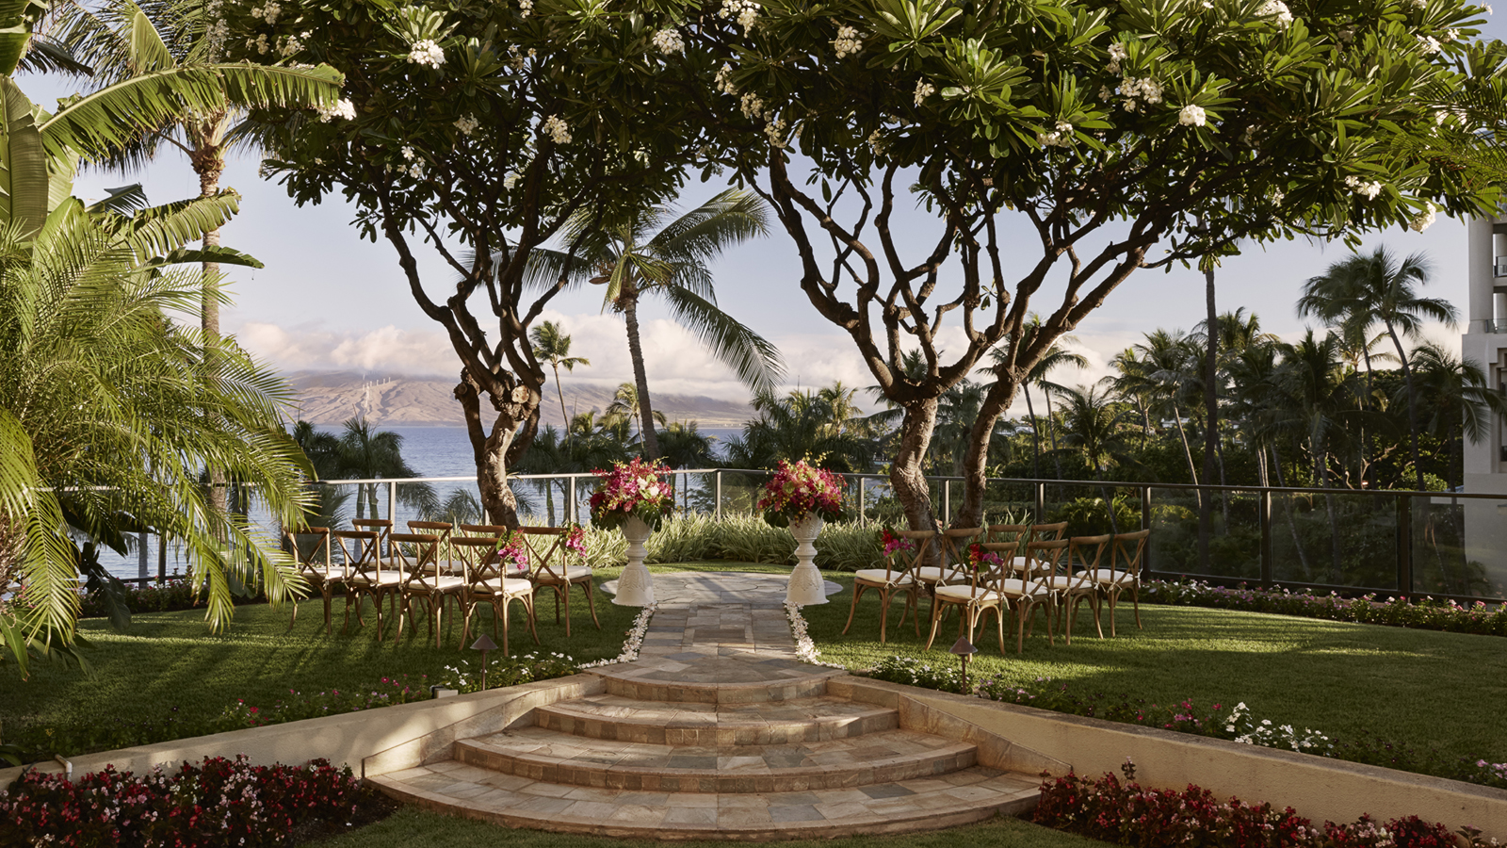
The essence of a wedding at
Four Seasons
Resort Maui is to be seen by family, friends, admirers and well-wishers, and to be “unseen” in the stunningly just renovated suites, at the award winning Spa, in the refreshing Wailea Bay, and in the Resort’s cleverly designed sanctuaries sprinkled around the oceanview landscape.
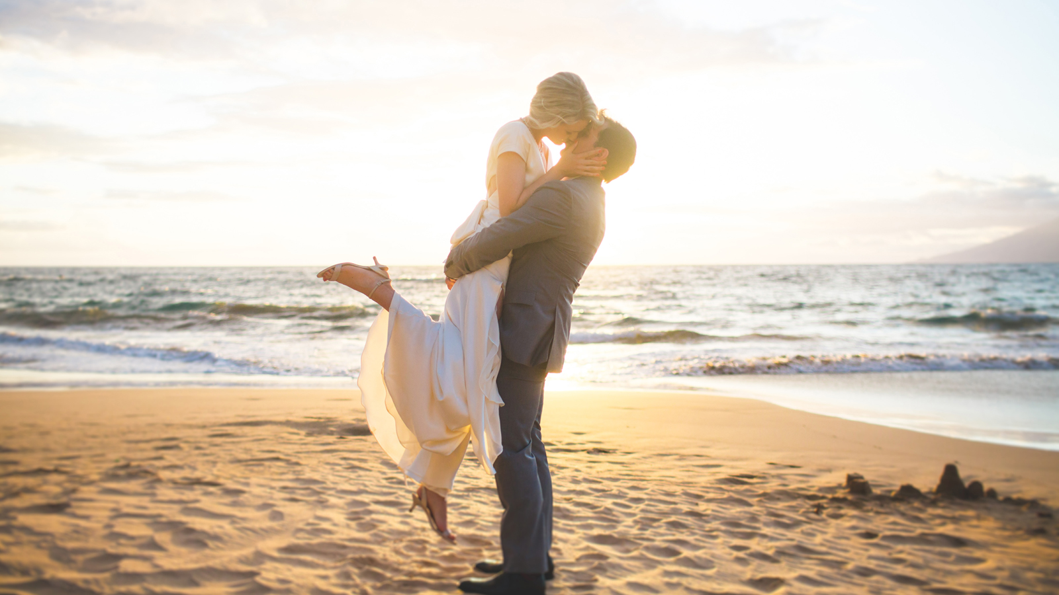 | 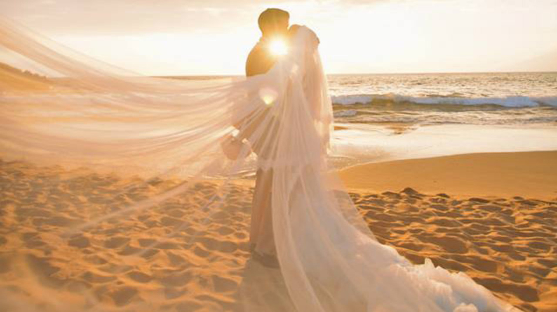 | 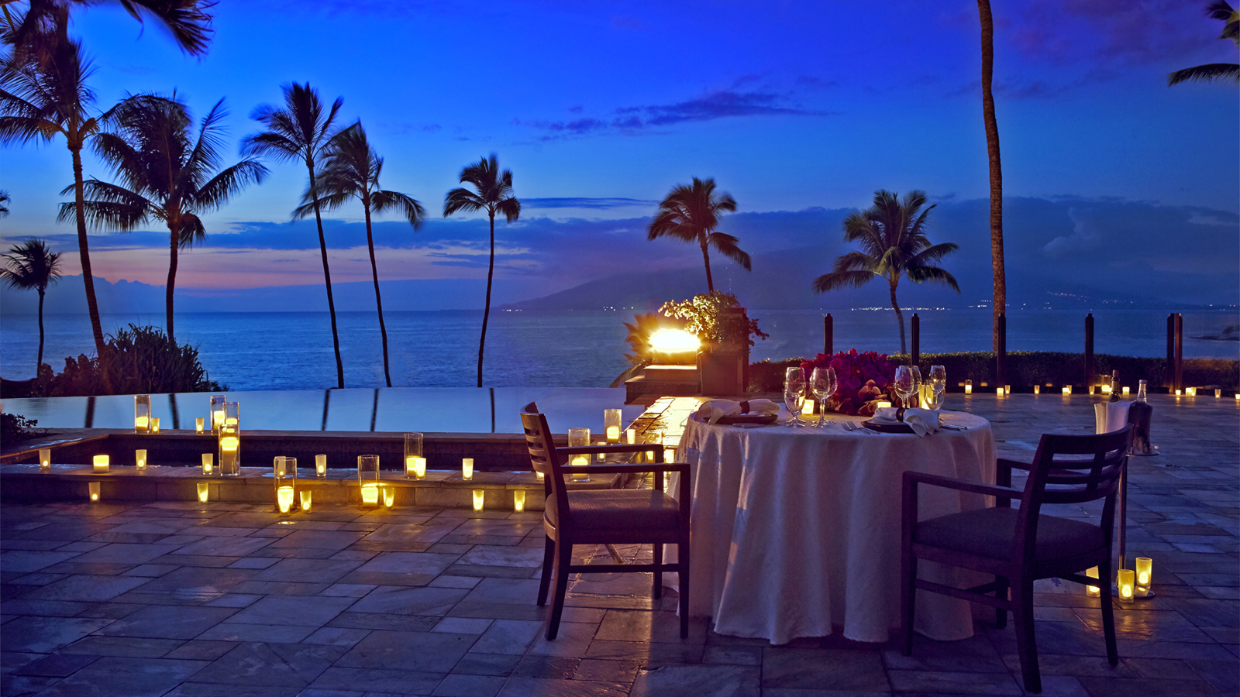
Our top wedding coordinators report that many wedding couples opt for the Serenity Pool After Hours -- an extremely special and private use of the Resort’s exclusive adults only pool, cabanas and pool deck. Elevated above Wailea Beach, with unparalleled panoramic views of neighbouring islands and the West Maui Mountains, the Resort’s Serenity Pool is now available from dusk to dawn for guests who are seeking a once-in-a-lifetime Unforgettable Experience. A personally prepared multi-course dinner by the Resort's masterful culinary team will be customised for you in private consultation. From a couple's massage in a private luxury cabana outfitted by Missoni to a cooling dip in a saltwater pool lined with flickering candles, every whim can be accommodated to create your ultimate fantasy.
While
Four Seasons
Resort Maui wedding coordinators are planning every imaginable wedding detail, they have arranged for entire wedding parties to take advantage of the Resort’s one-of-a-kind experiences and an opportunity to discover Maui with Unforgettable Experiences, which include these adventures: Maui Photo Adventure, Kona Coffee Tour, or a Whale Watch Photo Excursion.
With the promise of uncompromised attention to the wedding by hosting just one wedding a day, the
Four Seasons
Resort Maui wedding planner will be personally dedicated to making wedding dreams a reality, with a background of spectacular Maui scenery, legendary service and stunning event venues all coming together to create lifetime memories. And since there is only one wedding on the property each day, couples are sure to enjoy their big day to the fullest.

RELATED

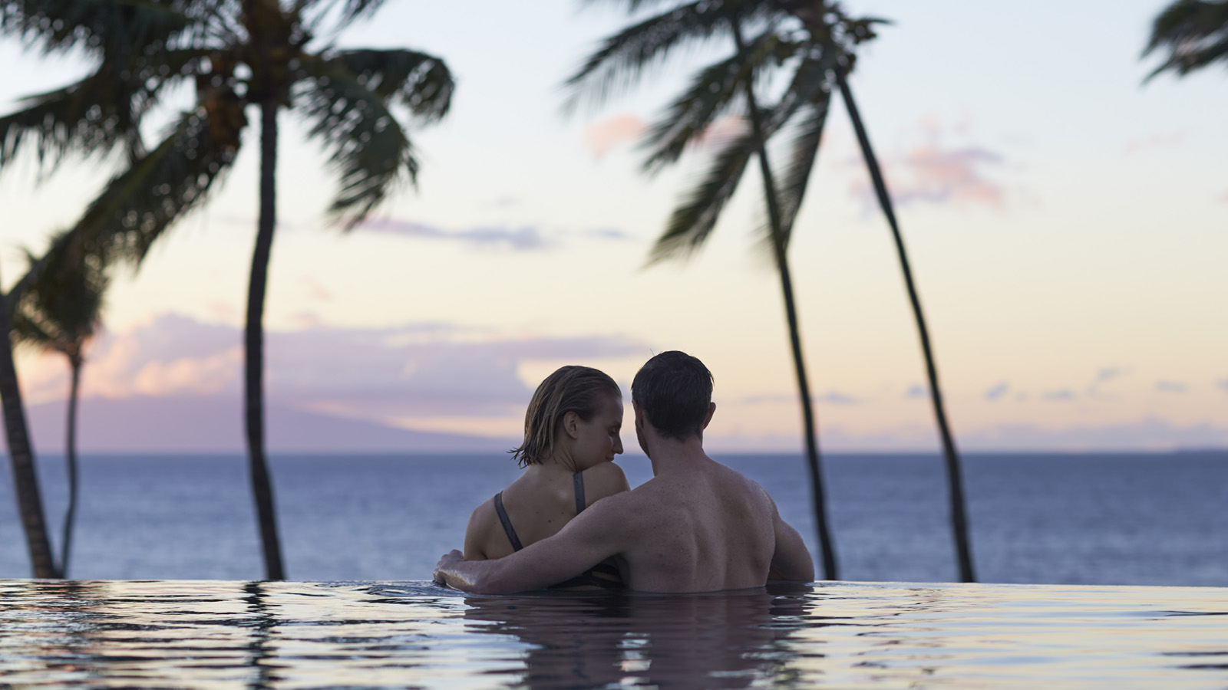 | April 10, 2017, Hawaii, Maui, U.S.A.  Four Seasons Resort Maui at Wailea Announces Couples Season 2017  http://publish.url/maui/hotel-news/2017/couples-season.html
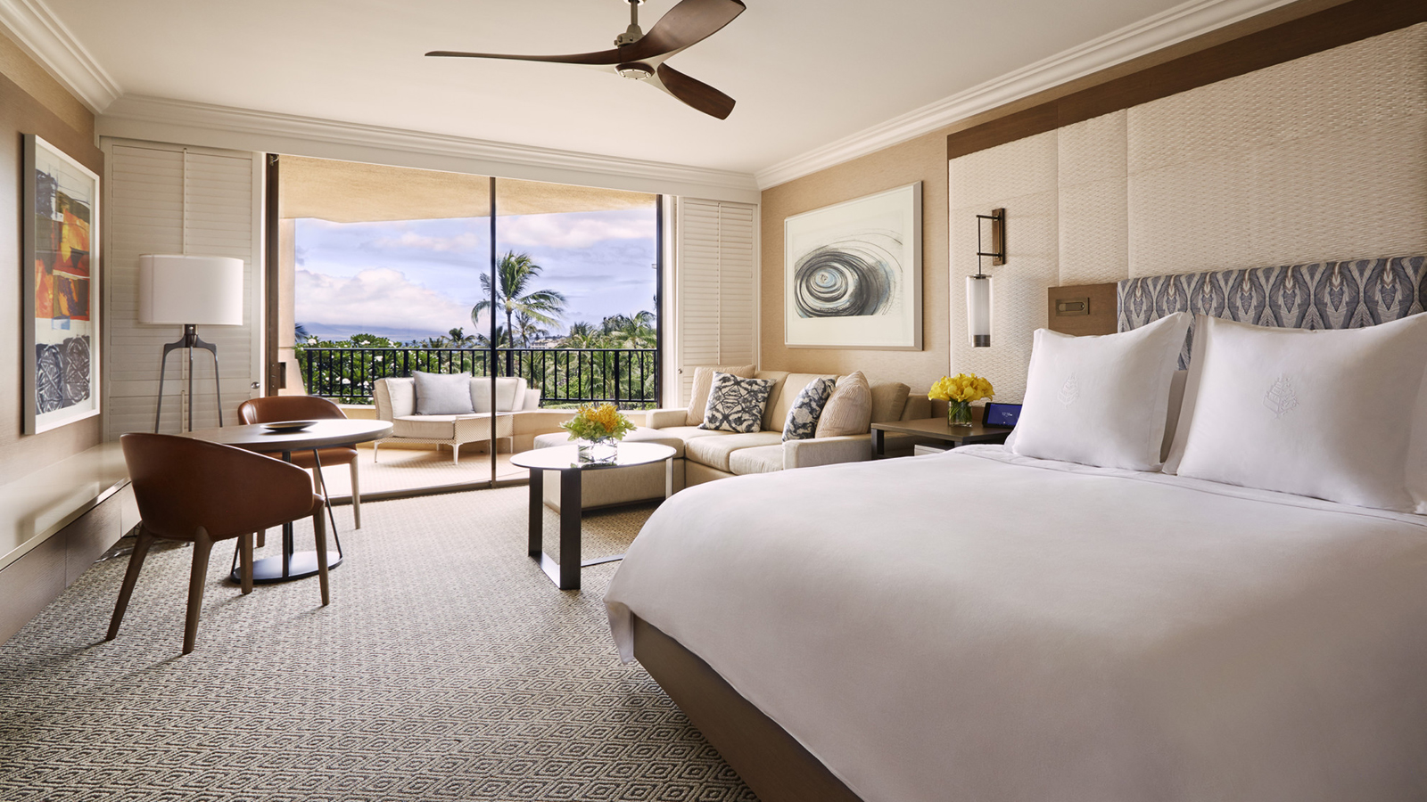 | November 28, 2016, Hawaii, Maui, U.S.A.  Maui Luxury Resort Undergoes Full Transformation - Four Seasons Resort Maui at Waileaa  http://publish.url/maui/hotel-news/2016/resort-transformation.html

PRESS CONTACTS

Charlotte Novom
President
Novom Marketing, 8502 East Chapman Avenue, Suite 648
Orange
U.S.A.
cnovom@novom.com

+1 (714) 941-9799

