FOUR SEASONS Macao, Cotai Strip
Tel: (853) 2881-8888 Email: press@fourseasons.com

OPENING DATE: August 2008
GENERAL MANAGER: Vikram Reddy

Physical Features
Total Number of Rooms: 649
- Guest Rooms: 276
- Suites: 84
- Grand Suites: 289
Number of Stories (Four Seasons Hotel Macao): 20
Number of Stories (The Grand Suites at Four Seasons): 40
Architect: Steelman Partners
Interior Designer(s):
- HBA/Hirsch Bedner Associates
- Deckelmann Wellness (Spa)
- Peter Silling Associates (The Grand Suites)
Location:
- Five minutes to Macau International Airport and Macau Taipa Ferry Terminal and 15 minutes to Maritime Ferry Terminal
- Steps from the Venetian Theatre, CotaiExpo

Spa
Number of Treatment Rooms: 14
Interior Designer: Deckelmann Wellness
Signature Treatment:
- Blissful Sensation (90 minutes)
Special Features:
- Sauna with intense heat
- Cool mist showers and ice fountains
- Indoor mosaic Vitality Pool
- Experience shower

Dining
Executive Sous Chef: Benjamin Lim
Examples of Locally Sourced Ingredients:
- Bacalhau (cod fish)
- Macanese sole
Restaurant: Zi Yat Heen
- Cuisine: Cantonese and dim sum

- Signature Dishes:
- Braised Indonesian whole lobster, bean curd, minced pork, chili sauce
- Baked whole abalone puff with diced chicken
- Zi Yat Heen deluxe appetisers
- Indoor Seating: 110
- Designer: HBA
- Chef: Ho Yam To, Anthony
Restaurant: Belcanção
- Cuisine: International

- Signature Dish:
- Bacalhau, or Macanese codfish
- Blood sausage and apple pizza
- Butter chicken
- Indoor Seating: 200
- Designer: HBA
Restaurant: Splash
- Indoor Seating: 80
- Designer: HBA
Restaurant: Xiao Ting
- Cuisine: Afternoon tea, Eastern and Western classics

- Signature Dishes:
- Chef Ben's Grandma pineapple tart
- Braised pork ribs glazed in coffee sauce
- Indoor Seating: 83
Restaurant: Ohte
- Cuisine: Ramen

- Signature Dish:

Recreation
Golf:

- Name of Course: Caesars Golf Macau
- Location: Off-site with special privileges
- Distance from Hotel: 5 minutes
- Date Open: 2007
- Par: 72
- Yardage: 7,068
- Number of Holes: 18

- Additional Services:
- Pro shop
- Golf instruction available
- Driving range
- Putting green
- Clubs rental
Off-site Activities:
- Beach
- Golf
- Helicopter tours
- Squash
- Tennis
- Exploring the city's rich heritage
Pools:
- Number of Pools: 5
Fitness Facilities:
- Size: 200 sq m / 2,152 sq ft
- Special Features: Kinesis wall

- Sample Fitness Activities:
- Pilates
- Yoga
- Kinesis wall training

For Younger Guests
Family-friendly, non-gaming hotel

Meeting Rooms
Total Size: 1,086 sq m/ 11,690 sq ft
Largest Function Area: 604 sq m/ 6,501 sq ft
Meet and Feed Capacity: 925
Banquet Capacity: 300
Breakout Spaces: 7

PRESS CONTACTS
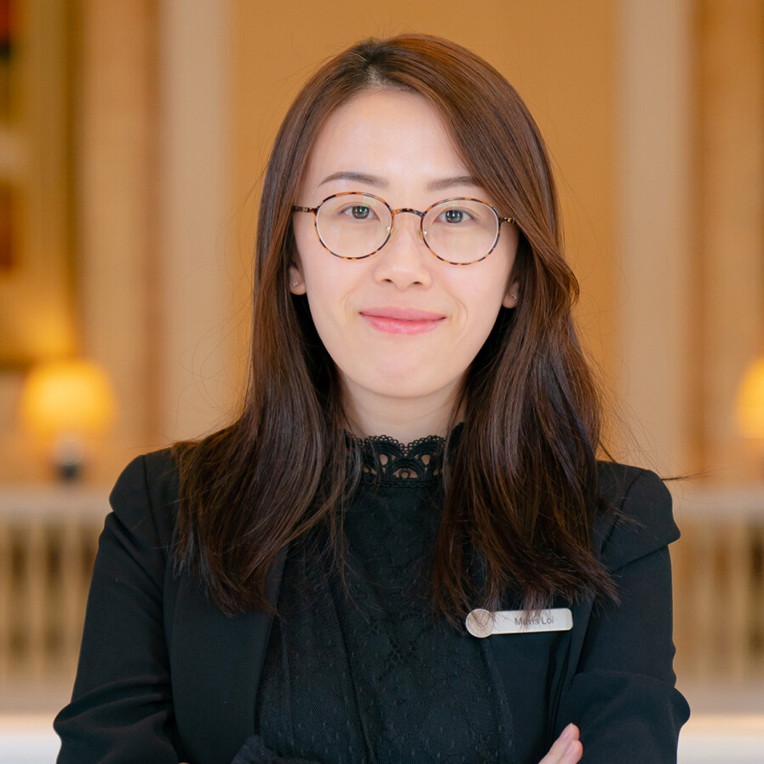 | Mavis Loi  Communications Manager  Estrada da Baía de N. Senhora da Esperança, S/N  Macau  China  mavis.loi@fourseasons.com  (853) 8112 8835
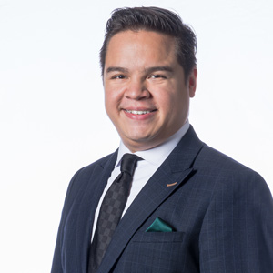 | Cristiano Nantes  Digital Marketing and Communications Manager, Public Relations  Estrada da Baía de N. Senhora da Esperança, S/N  Macau  China  cristiano.nantes@fourseasons.com  (853) 8112 8834

