Four Seasons Hotel Firenze Introduces a New Picnic Offer to Enjoy in the Beautiful Setting of its Historical Park

Michelin-starred picnic with a view at La Villa
June 29, 2017, Florence, Italy

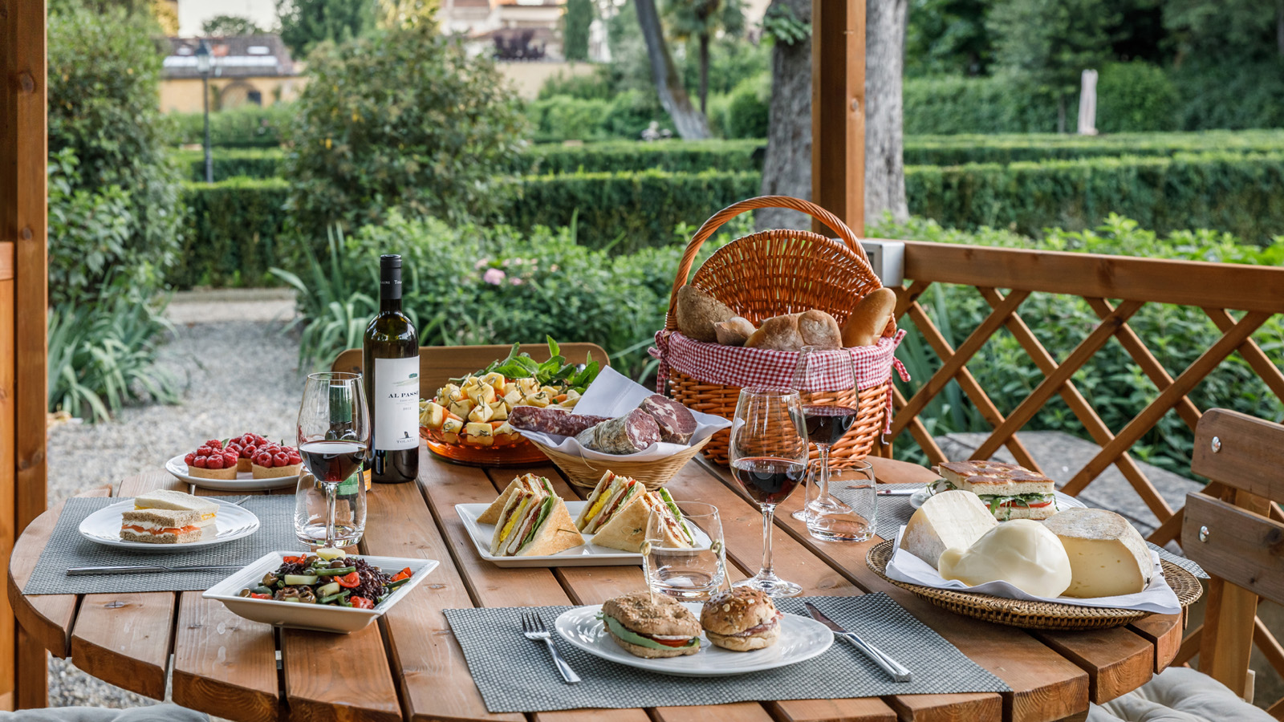
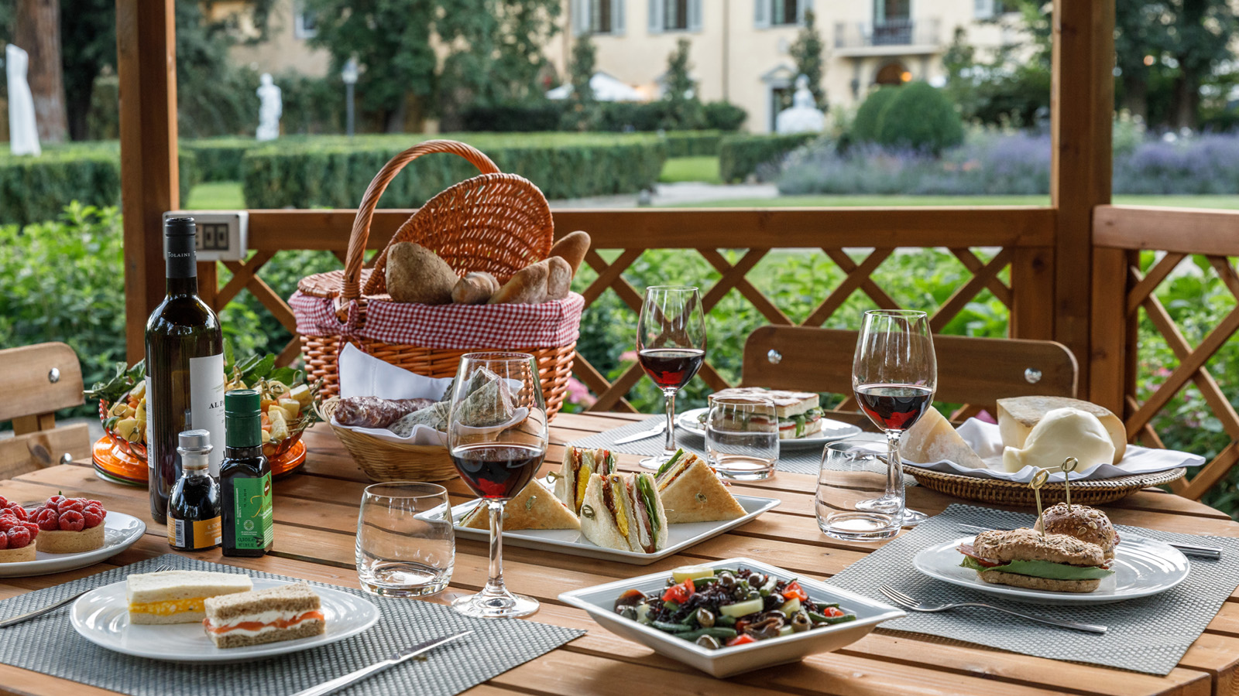 | 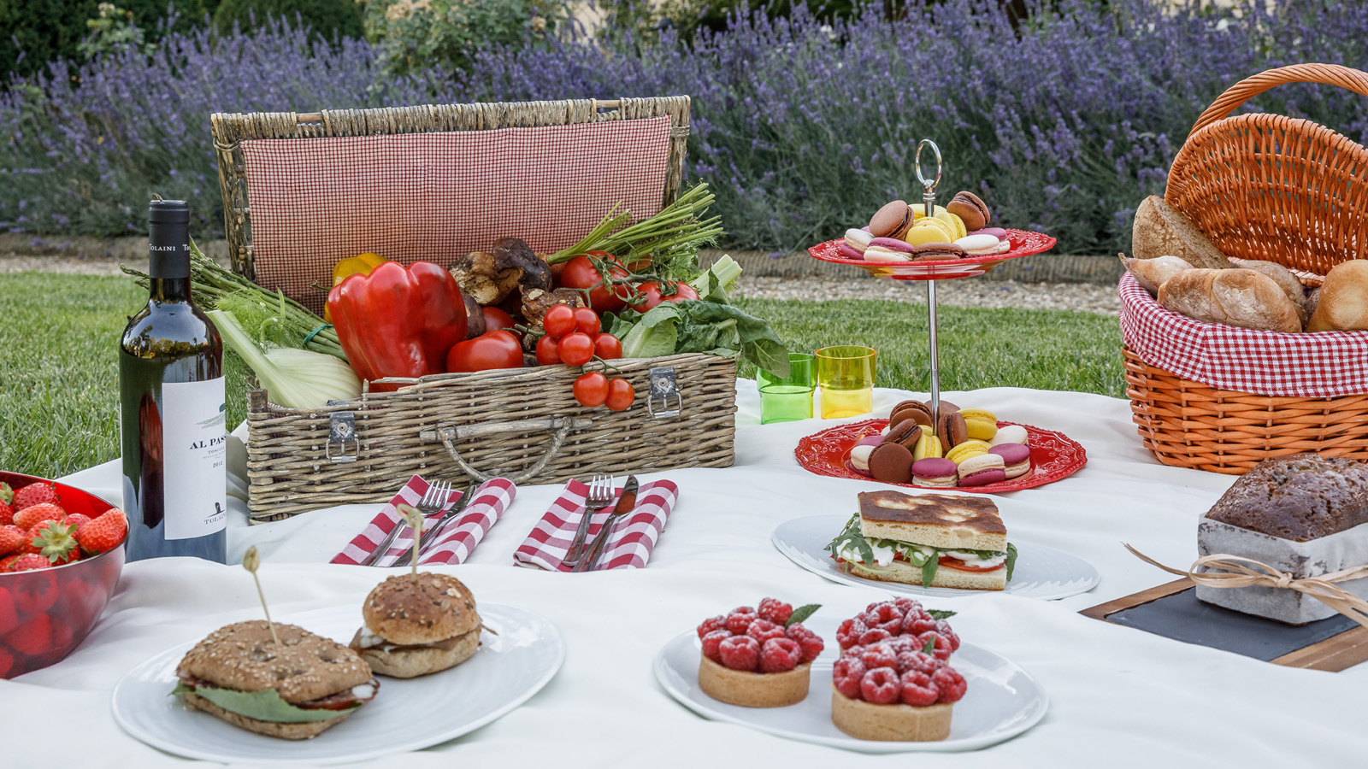 | 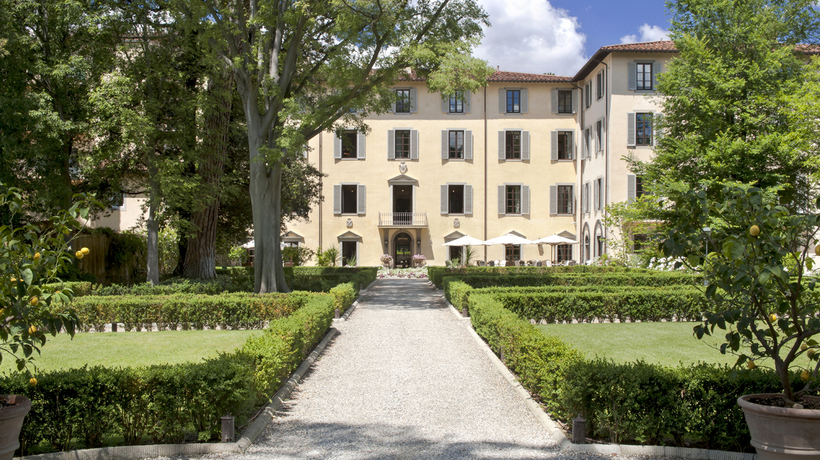
Summer has arrived, and there is nothing better than a refreshing picnic immersed in the greenery of a shaded park to enjoy the warm season. Guests of La Villa at
Four Seasons
Hotel Firenze can now experience a Michelin-starred picnic in the Hotel’s historical park, Giardino della Gherardesca, for lunch or dinner, perfect for a romantic escape or a family adventure, with 5-star comforts and delicious food.
The hamper is prepared by the Hotel’s Chef Vito Mollica and features quintessential Italian specialties, including the freshest seasonal products selected among the best local producers: a Tuscan spelt salad, Italian finger sandwiches, bresaola and of course, a variety of artisanal cheese, all paired with a bottle of Tuscan red wine produced in the nearby Chianti region.
The picnic can then be enjoyed in one of the four inspiring locations set in the green of the historic Giardino della Gherardesca, among the most suggestive areas of the park, based on the guests' preferences, from the refreshing shade of the secular trees to a memorable t&ecirc;te-&agrave;-t&ecirc;te facing the Cupola of the famous Duomo. Each area is equipped with Bluetooth so guests may listen to their favourite music.
Picnic Menu
- Selection of finger sandwiches
- Tuscan spelt salad with fresh vegetables
- Bresaola with parmesan shavings and rocket salad
- Selection of artisanal cheeses
- Fruit salad with berries
- Pear tartlet
- Traditional Tuscan biscuits
- Tolaini Al Passo 2012 red wine
- Still or sparkling water
The cost is EUR 60 per person, with 24 hour advance booking required through La Villa’s private butler. Locations include:
- La Collinetta: A secluded spot on the garden hilltop, shaded by giant trees
- Tempio Lawn: A green oasis by the Dome of the Seven Virtues
- Duomo View: A special enclave with views of the landmark Duomo cathedral
- Holm Oak Tree: A privileged corner under the foliage of this ancient tree
La Villa, a Unique Residential Atmosphere Within Four Seasons Hotel Firenze
With just 37 guest rooms and suites, La Villa offers a uniquely residential character, reminiscent of a historical mansion or an intimate apartment within
Four Seasons
Hotel Firenze. It features its own reception, concierge, butler service and breakfast room, as well as a ballroom in a former church. La Villa also includes its own private entrance on the western edge of the property, facing Via Gino Capponi, just a 10-minute walk to the Duomo and other historical attractions. This convenient setting is perfect for couples, families or any guest seeking privacy and discretion, with a personalised butler service, which is included in the stay. Barbara Amato, La Villa Manager, together with the Hotel’s highly trained and passionate team of butlers aims to anticipate every need. This includes unpacking and packing luggage to arranging laundry services and supplying a selection of bathroom amenities with distinctive fragrances, such as Il Giardino delle Rose by Dr. Vranjes Firenze, created especially for La Villa, and arranging private dinners with a selected menu by executive Chef Vito Mollica.

RELATED

June 29, 2017, Florence, Italy
Pic Nic stellato con vista a La Villa, Four Seasons Hotel Firenze
http://publish.url/it/florence/hotel-news/2017/picnic-in-the-garden-2.html

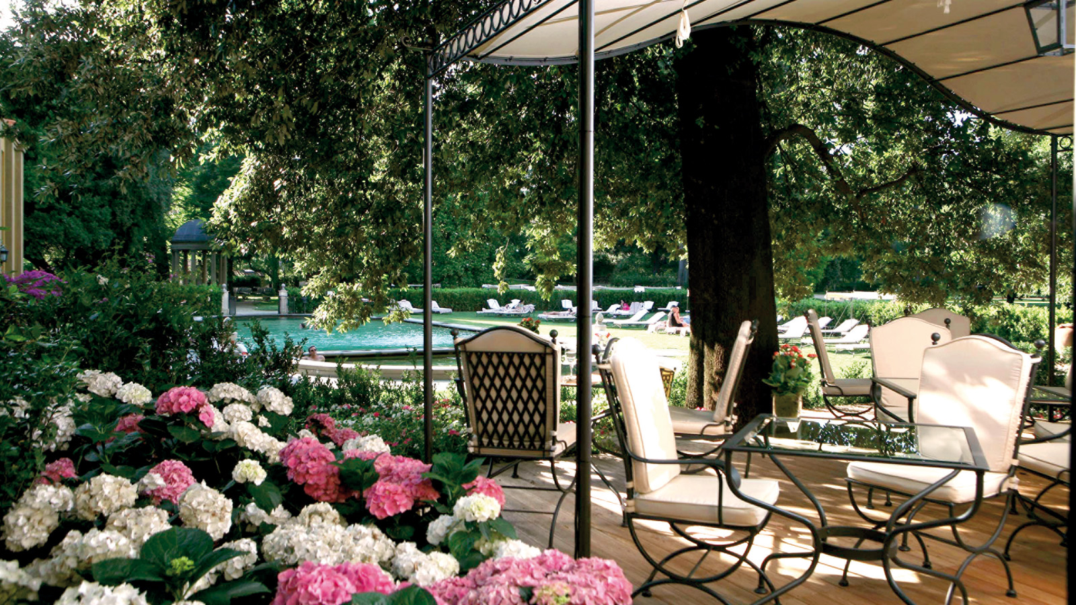 | May 29, 2017, Florence, Italy  Al Fresco Re-Opens for the Summer on June 1 at Four Seasons Hotel Firenze  http://publish.url/florence/hotel-news/2017/al-fresco-reopens.html

PRESS CONTACTS

Caroline Mennetrier
Director of PR and Marketing Communication
Borgo Pinti, 99
Firenze
Italy
caroline.mennetrier@fourseasons.com

+39 02 7708 1795

Martina Nesti
Public Relations and Marketing Communications Coordinator
Borgo Pinti, 99
Firenze
Italy
martina.nesti@fourseasons.com

+39 055 2626222

