Four Seasons Resort Costa Rica at Peninsula Papagayo Introduces “Sol and City with Miami” with Four Seasons Hotel Miami

A luxury layover package from the jungle paradise of Costa Rica to the urban jungle of Miami
March 16, 2017, Costa Rica

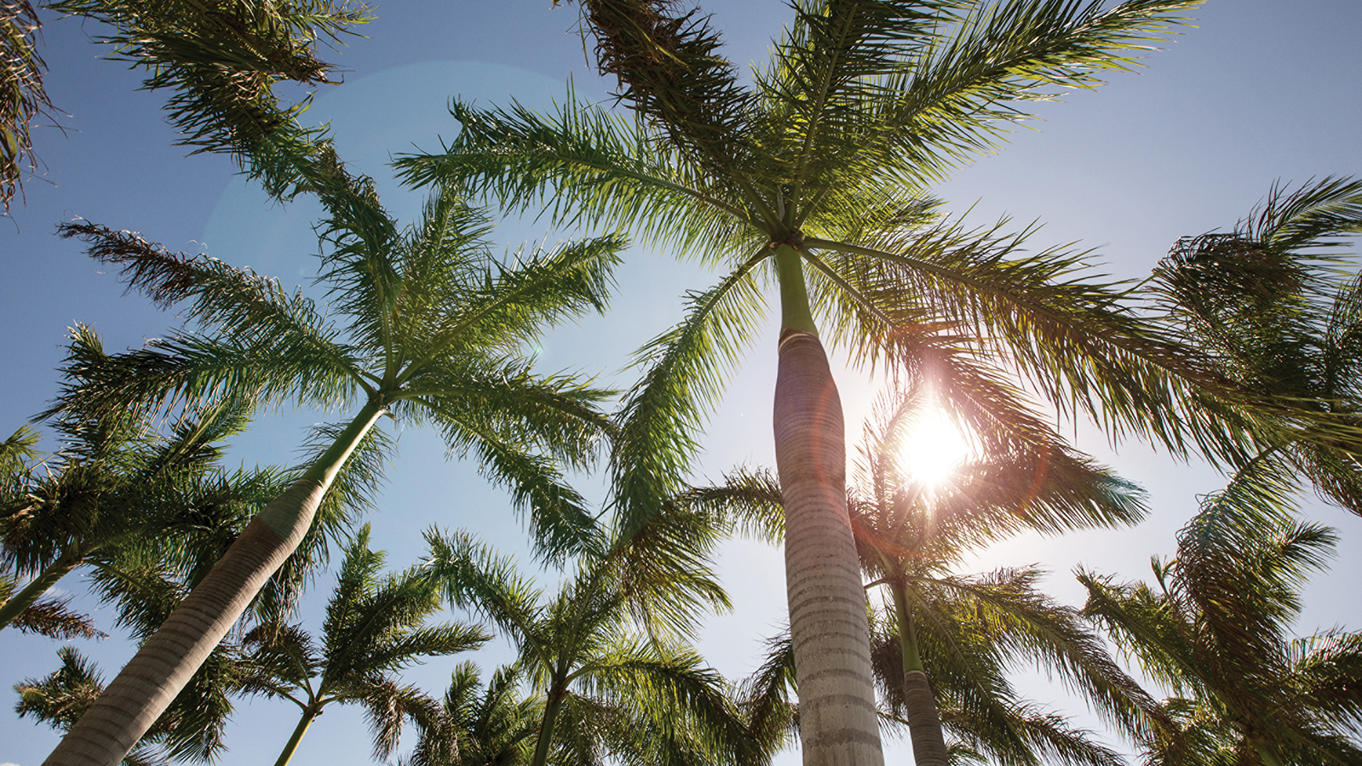
 | 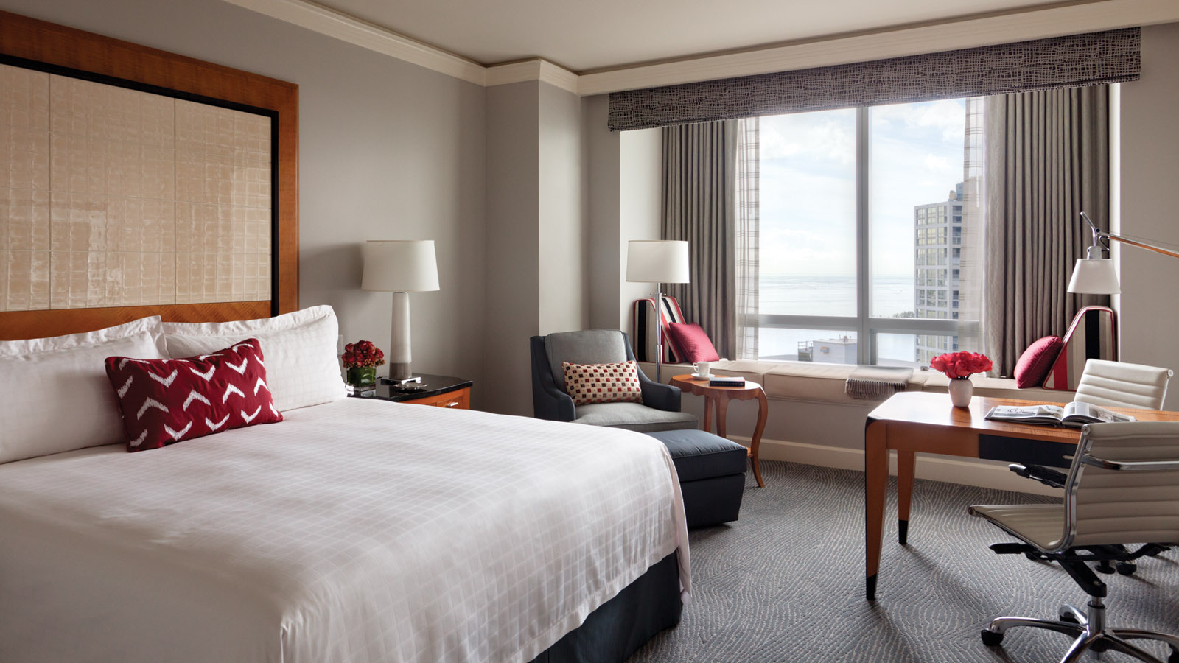 | 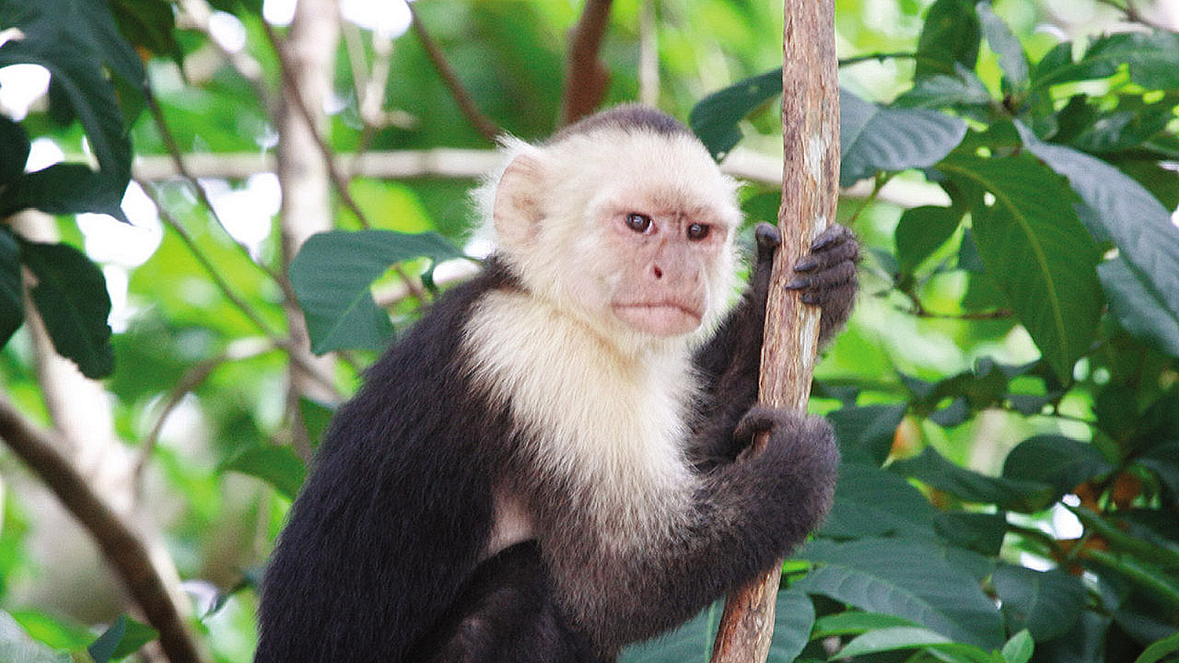
From one tropical destination to another,
Four Seasons
Resort Costa Rica at Peninsula Papagayo and
Four Seasons
Hotel Miami introduce the Sol and City with Miami package, offering two nights complimentary at the Brickell hotel when reserving four nights in Costa Rica. Travellers who take advantage of the special offer will enjoy a luxury playover in the Magic City pre and/or post their Costa Rican getaway. With Miami as the world’s gateway to Latin America and the Caribbean, this package is the best of both worlds, the vibrant energy of the city to the pristine beaches of a rainforest refuge.
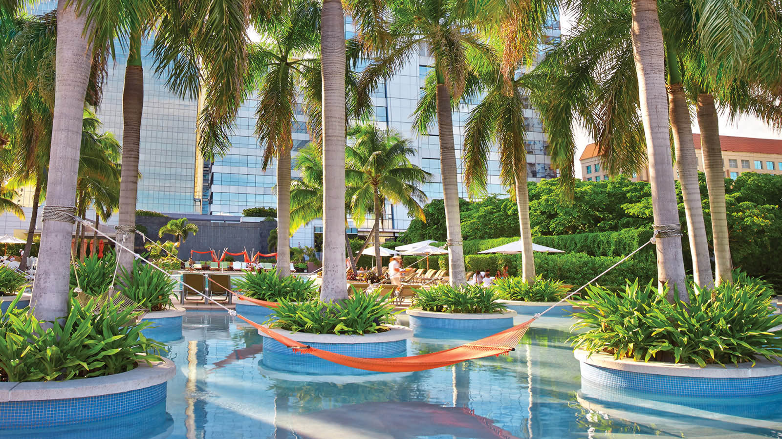 |  | 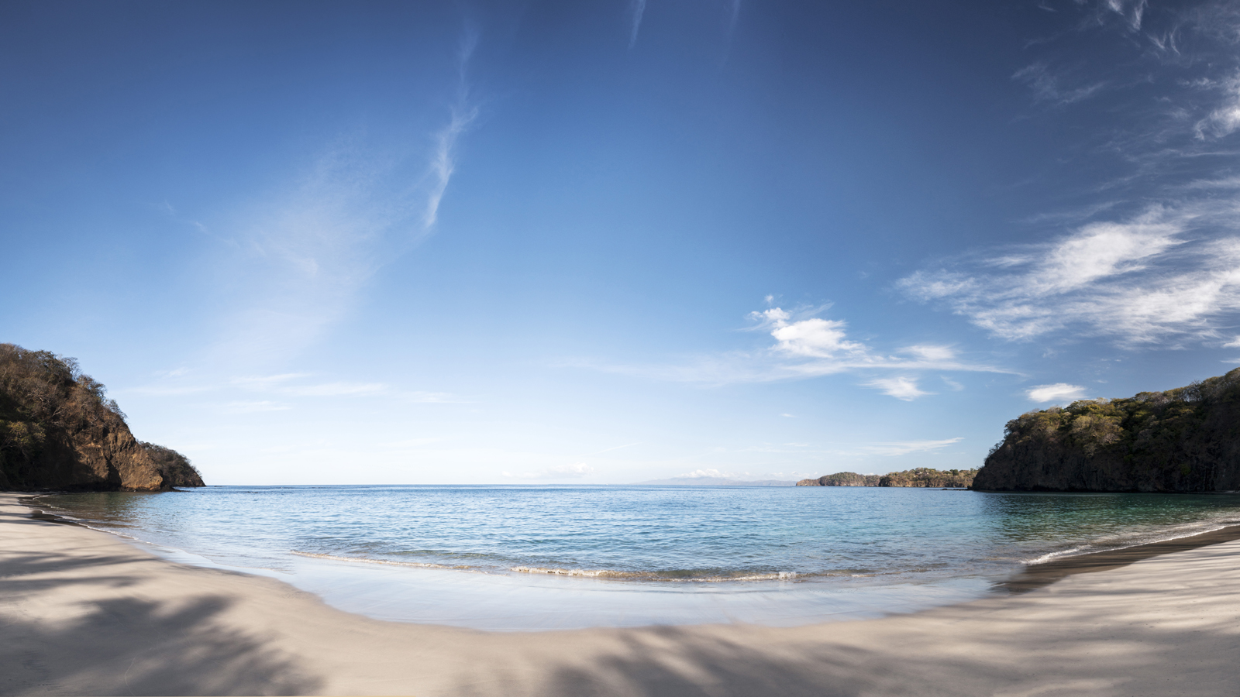
Four Seasons
Resort Costa Rica
Discover
Four Seasons
Resort Costa Rica, ideally located on the private and exclusive Peninsula Papagayo. Nestled between a six-mile (ten kilometre) stretch of two golden sand beaches, the Resort captures the spirit of pura vida, meaning "pure life," where the unforgettable awaits. Located in the world’s premier ecotourism destination, the Resort boasts a rare opportunity to discover nature’s playground – from active to artistic. By land or sea, adventure reigns whether soaring in the treetops like a bird, racing down a white-water river or riding an epic wave. The azure waters of the Pacific provide a dramatic contrast to the lush, green rainforests surrounding the Resort – creating an inspiring backdrop for adventure, wanderlust and rejuvenation.
Four Seasons
Resort Costa Rica is located less than 40 minutes from Daniel Oduber Quiros International Airport (Liberia/LIR), and easily accessible with quick, three hour, nonstop daily flights out of Miami. Along with the eco-activities, the Resort offers a Spa experience with indigenous treatments inspired by the healing traditions of Central America. Atop one of Peninsula Papagayo’s highest plateaus, guests can tee off on an Arnold Palmer signature championship golf course, overlooking the jeweled waters of Bahía de Culebra. Epicureans will delight in interactive culinary activities such as Costa Rican chocolate making classes and a Chef’s Table dining experience, served in the Resort’s organic garden under the stars. At once relaxing and rejuvenating, guests experience the magic of the destination, where nature and luxury meet on the sandy shores of Peninsula Papagayo.
Four Seasons
Hotel Miami
With the Sol and City with Miami package, the Costa Rica vacation begins or ends with a visit to
Four Seasons
Hotel Miami. The 70-story skyscraper features spacious guestrooms and suites from the 20th to 29th floors, offering views of Biscayne Bay and the city skyline. For the ultimate in relaxation, the two-acre 7th floor terrace boasts two resort-style pools, private cabanas, suspended hammocks and a newly designed Bahía restaurant and sunset lounge, making it a true tropical oasis amid the bustling Miami scene. The modern steakhouse and local gathering spot EDGE, Steak & Bar offers premium cuts of meat, local seafood and a new Whisk(e)y bar program. Adult guests also enjoy complimentary access to Equinox, the area’s premier 50,000-square-foot (4,600 square metre) fitness facility and spa situated on the fourth floor.
The Hotel is located in the burgeoning neighbourhood of Brickell, recently recognised as the “new heart of Miami” with its growing entertainment, shopping, culinary and nightlife scenes. The newly launched Brickell City Centre is only a few steps away and offers 500,000 square feet (46,000 square metre) of retail space, anchored by the area’s first Saks Fifth Avenue, a number of dining options, and a soon-to-debut luxury cinema experience. Guests can explore the local art and culinary scenes of the nearby neighbourhood of Wynwood, most notably known for the collection of street murals and public art galleries. The art-enthused may continue their Miami art journey with the multi-million-dollar collection housed within
Four Seasons
Hotel Miami, which is anchored by three unforgettable bronze statues by Colombian-born Fernando Botero. A luxury playover in Miami offers guests everything they need from a visit to the Magic City – sun, shopping, culture, dining and entertainment.
Sol and City Package Details
Reserve four nights in Costa Rica with the Sol and City with Miami package, and receive two complimentary nights at
Four Seasons
Hotel Miami, which can be redeemed pre and or post stay, or alternatively one night before and after the tropical retreat. Daily breakfast is also included for up to two guests at both locations, as well as access to all of the complimentary amenities at
Four Seasons
Resort Costa Rica, including non-motorised water sports, tennis and more.
Rates start from USD 525, per night, and may be reserved by contacting +(506) 2696 0098 or reservations.cos@fourseasons.com.
This offer requires a minimum stay of four nights at
Four Seasons
Resort Costa Rica and two nights at Four Seasons Hotel Miami and is available from April 1 to August 1, 2017. Blackout dates may apply. This offer cannot be reserved online.

RELATED

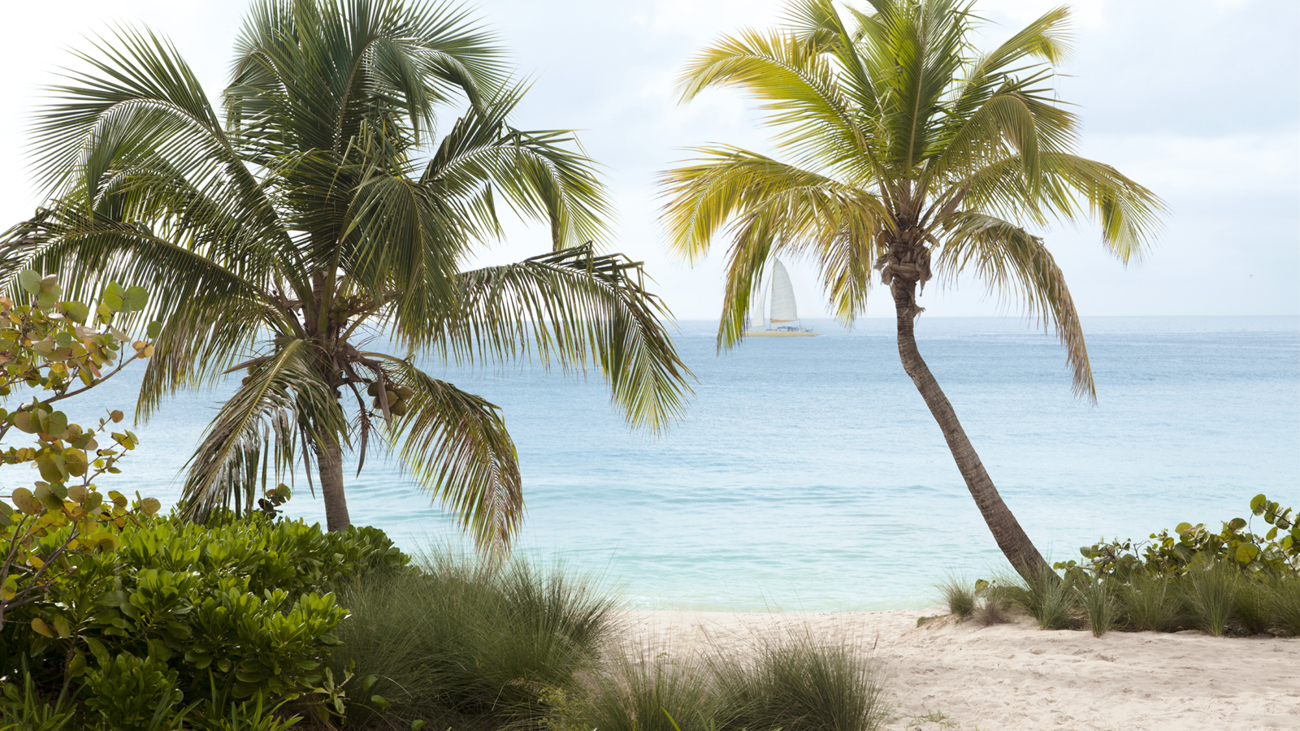 | April 17, 2017, Toronto, Canada  Four Seasons Resorts Anguilla, Costa Rica, Nevis and Punta Mita Announce "Book Once, Stay Twice" Three-Night Booking Bonus with Holiday Stays December 15, 2017 to January 7, 2018  http://publish.url/news-releases/2017/book-one-stay-twice-booking-bonus.html
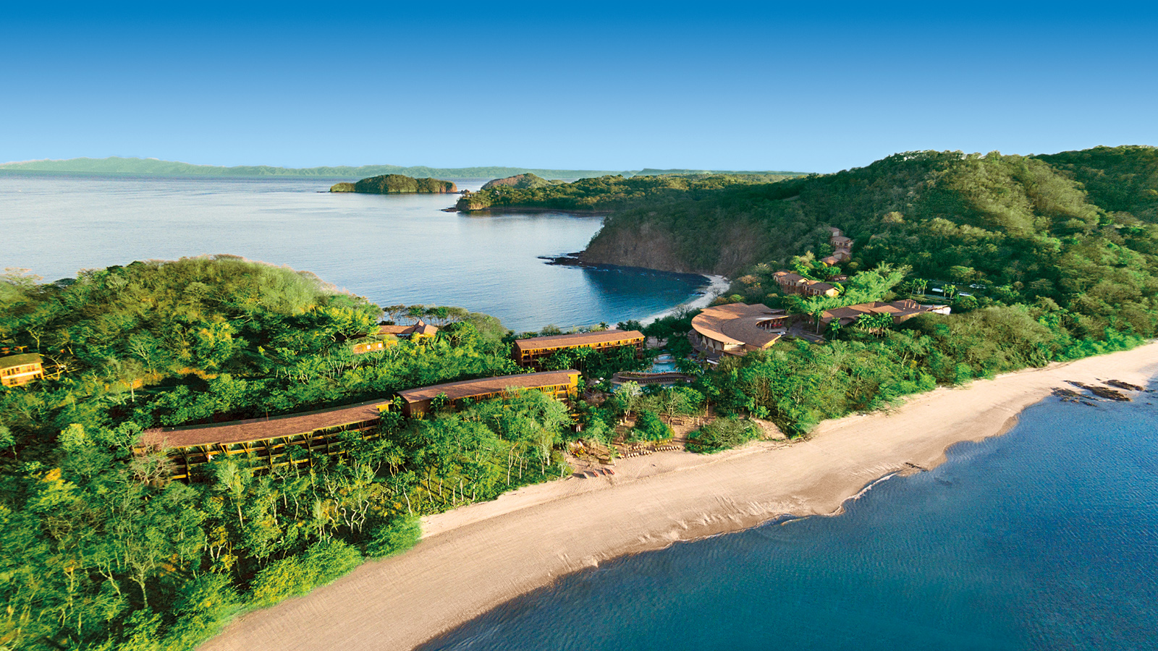 | February 22, 2017, Costa Rica  2017 Forbes Travel Guide Star Ratings: Four Seasons Resort Costa Rica Earns Five Stars, Reflecting Highest Level of Service Excellence  http://publish.url/costarica/hotel-news/2017/forbes-five-star-resort.html

PRESS CONTACTS

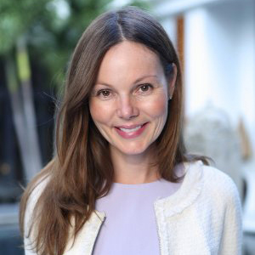 | Danielle Finnegan  Director of Public Relations  Peninsula Papagayo  Guanacaste  Costa Rica  danielle.finnegan@fourseasons.com  +1 (786) 655-9898
Carolina Insignares
Marketing Coordinator
Peninsula Papagayo
Guanacaste
Costa Rica
carolina.insignares@fourseasons.com

+1 (786) 655-8502

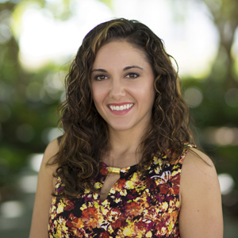 | Stephanie Cardelle  Director of Public Relations and Communications  1435 Brickell Avenue  Miami  U.S.A.  stephanie.cardelle@fourseasons.com  1 (305) 381-3037

