Four Seasons Resort Oahu at Ko Olina Launches Epic Earth, Wind & Fire Day Charter to Hawaii Island

Partnership with Paradise Helicopters Hawaii and Hawaiian Legacy Reforestation offers guests exclusive access to Hawaii Volcanoes National Park, natural landmarks
August 1, 2017, Hawaii, Oahu, U.S.A.

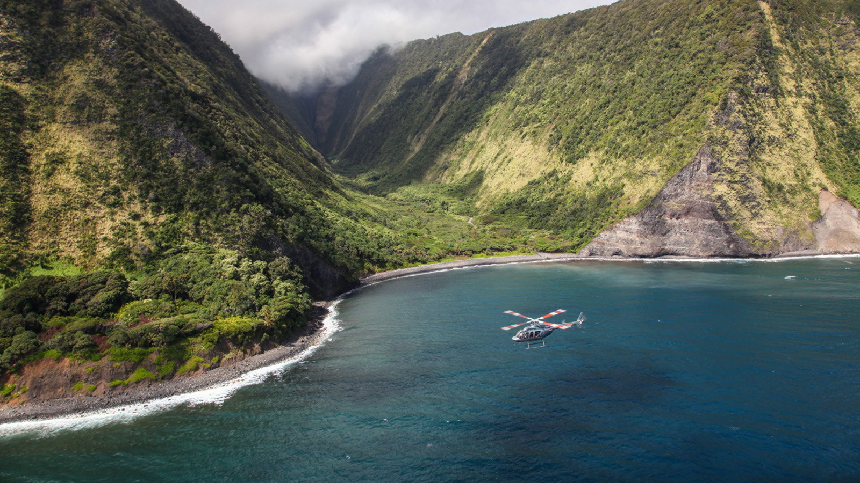
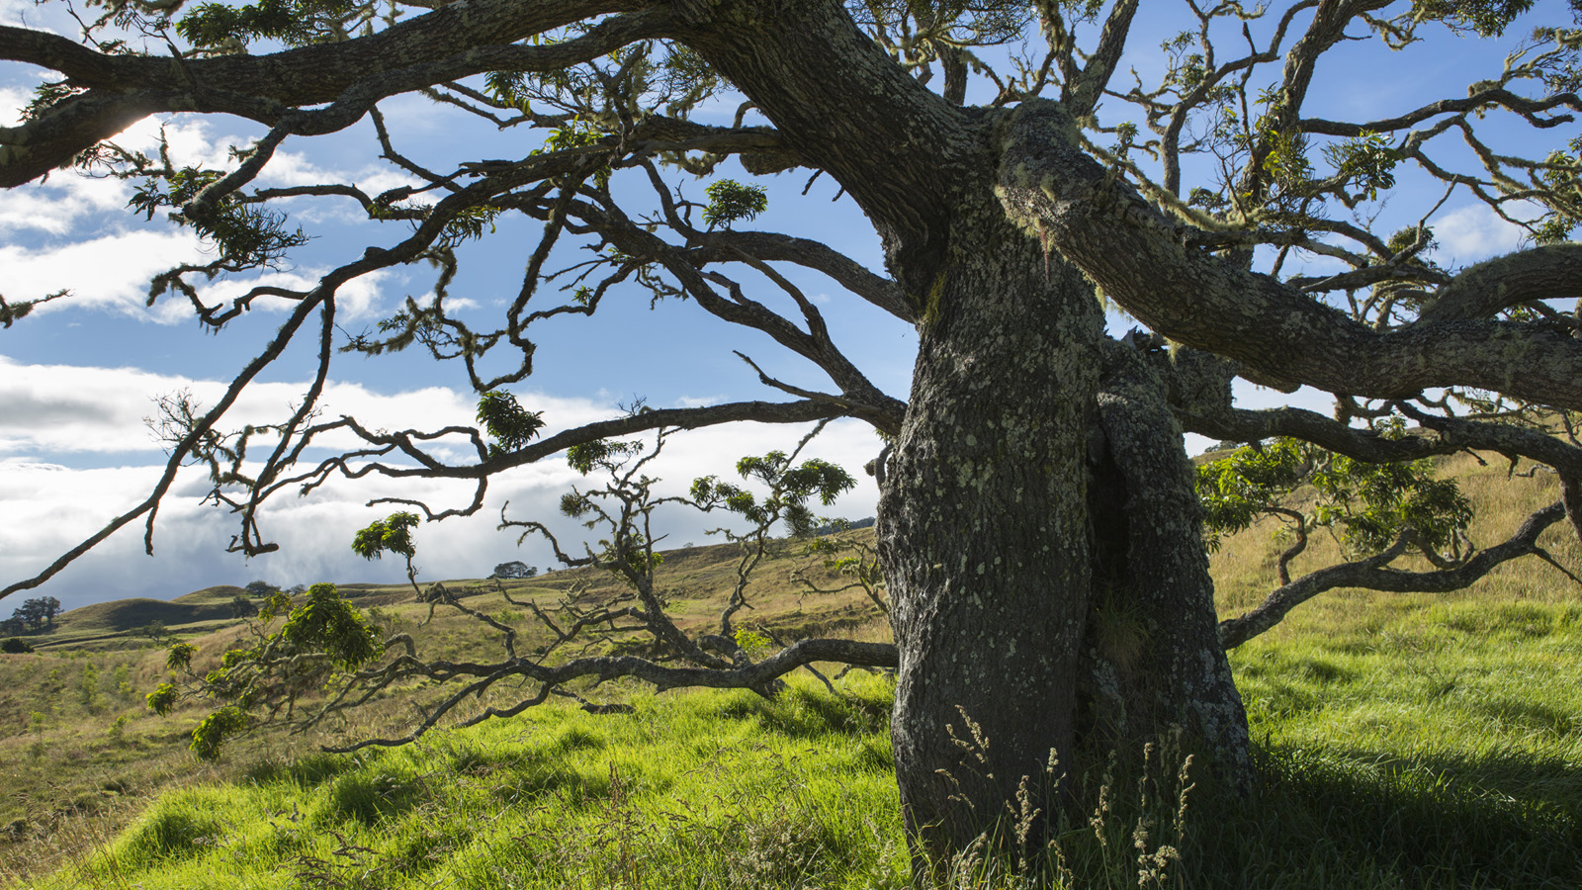 |  | 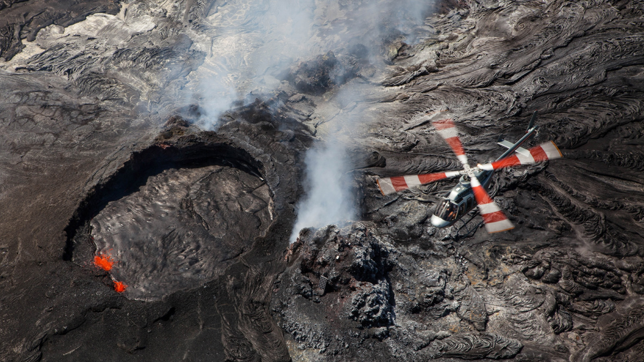
Four Seasons
Resort Oahu at Ko Olina and Paradise Helicopters Hawaii have partnered to offer an exclusive Earth, Wind & Fire day charter to the island of Hawaii – a once-in-a-lifetime experience for
Four Seasons
Resort Oahu guests to see one of the world’s most active volcanoes with exclusive access to the Hawaii Islands’ natural landmarks via a private helicopter day charter from nearby Kalealoa Airport.
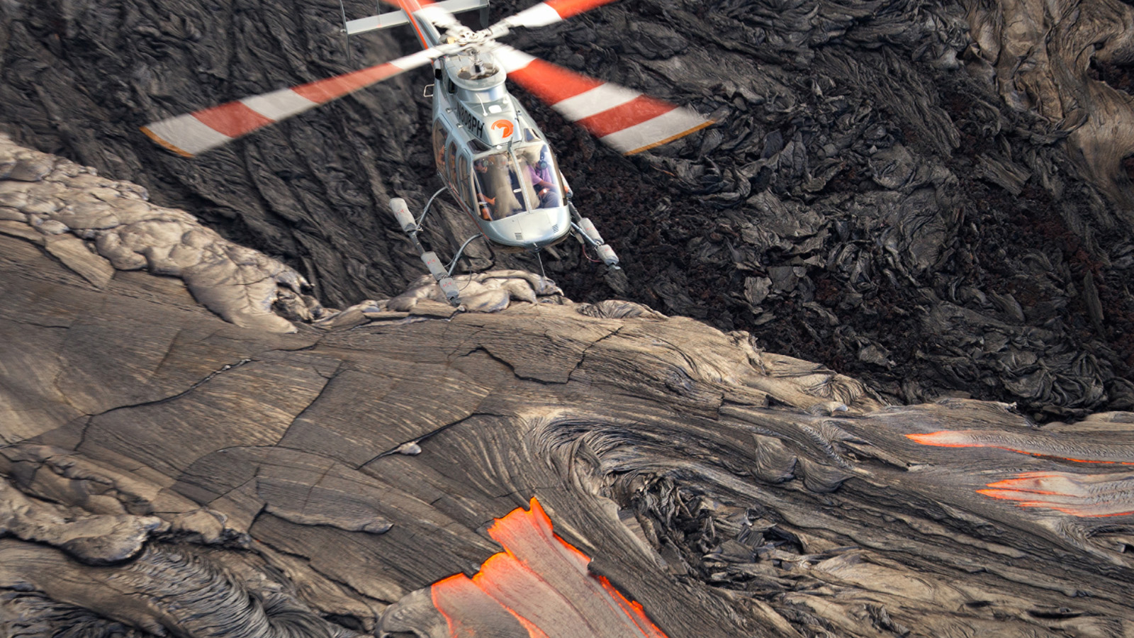 | 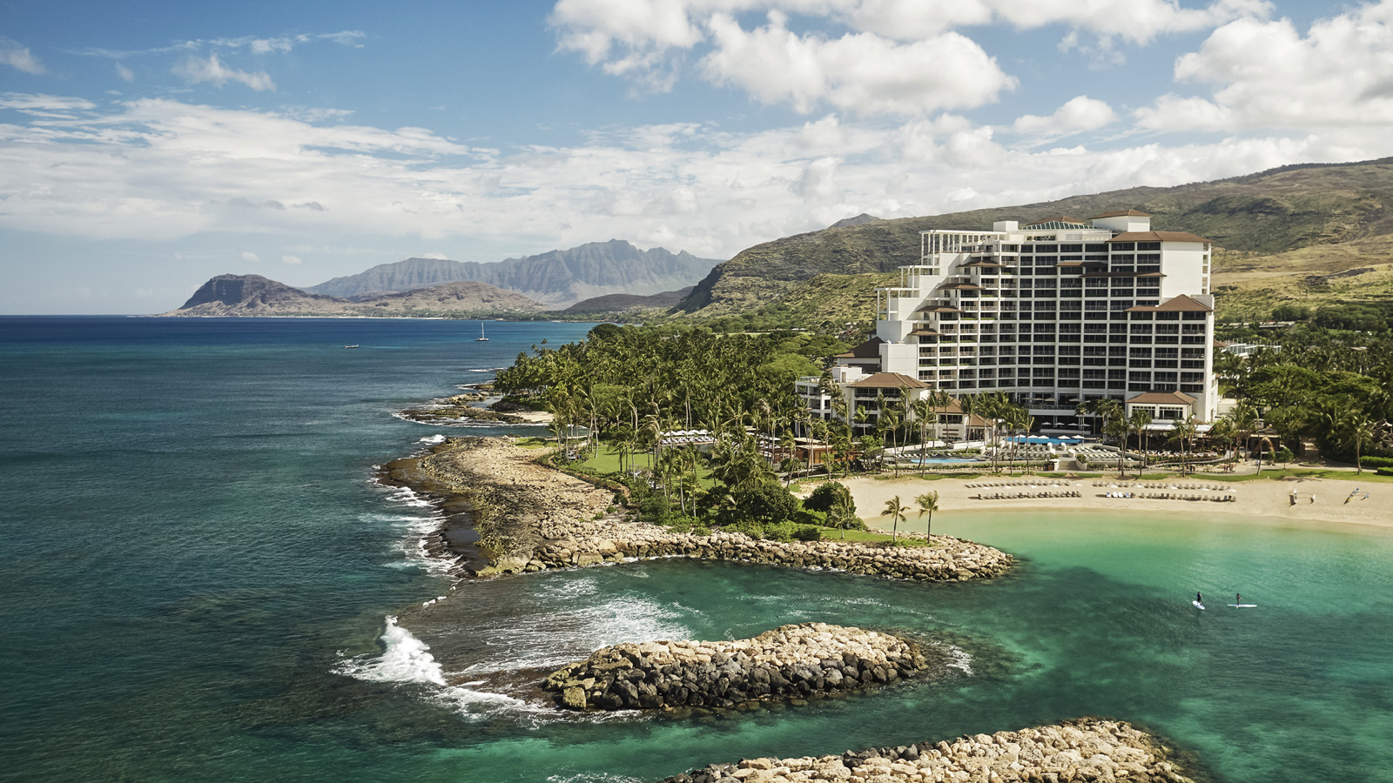 | 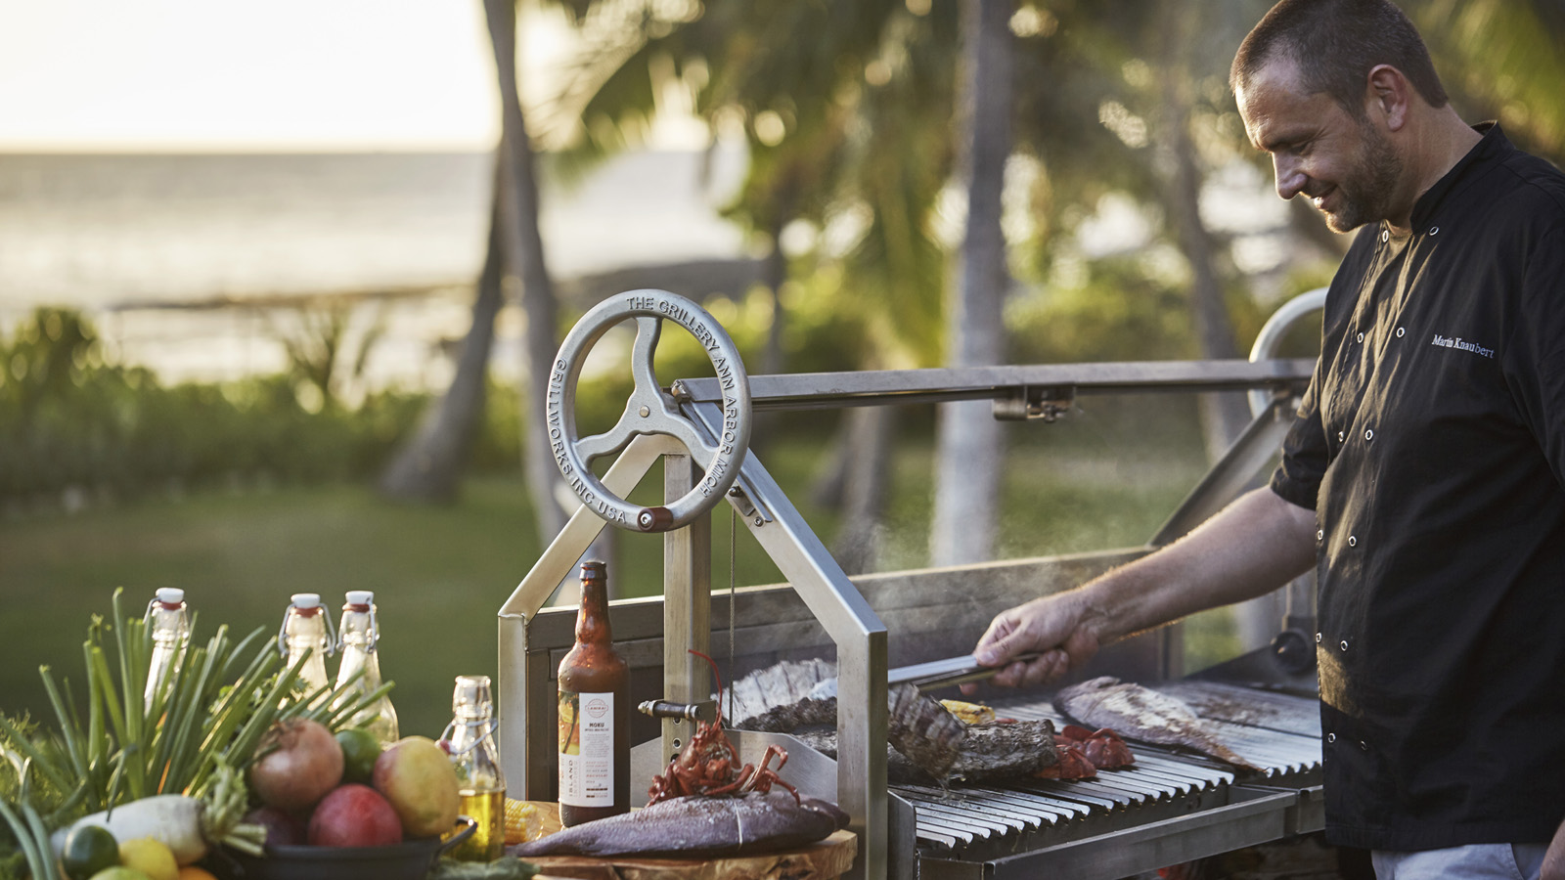
In an action packed one-day tour, guests will fly over scenic areas, including cliffs on the coast of Molokai, black sand beaches in Kona, waterfalls on the lush Hamakua Coast, Pu’uhonua O Honaunau National Historical Park, Papakolea green sand beach – the southernmost point in the US – and Kilauea's blistering lava flows.
After witnessing the primal sight of an erupting volcano, guests will land at Hawaiian Legacy Forest above the historic Umikoa Village to participate in a legacy tree planting experience accompanied by a gourmet five-course Chef’s Table with wine pairings.
Re-boarding a luxurious Bell 407 aircraft, guests will then explore several hard-to-reach, exclusive locations throughout the island and can opt to “Green Their Seat” with a carbon offset program that gives every guest the opportunity to compensate for greenhouse gases (GHGs) produced during the Oahu to Hawaii charter.
Paradise Helicopters is the first helicopter tour company to offer flights exclusively for the reforestation of endemic trees in Hawaii. Through the nonprofit Hawaiian Legacy Reforestation Initiative (HLRI), koa and sandalwood trees (endemic to Hawaii) are planted for permanent reforestation. Every tree is equipped with a proprietary RFID geo-tagging system, allowing the guest to track the growth of their tree from space using online applications such as Google Earth. The tree thus retains information about the guest and occasion, creating a living monument.
For the ultimate luxury experience, guests can book the Earth, Wind & Fire package at
Four Seasons
Resort Oahu to include Penthouse accommodations. Located on the 17th floor, the
Four Seasons
Resort Oahu Penthouse Suite offers stunning panoramic views and an expansive 800 square foot (74 square metre) terrace, perfect for morning yoga, evening cocktails or entertaining. Inside, the 3,200 square foot (297 square metre) suite designed by Philpotts & Associates provides comfortable yet luxurious Hawaiian interiors and includes two bedrooms, two and a half bathrooms, a living room, dining room and service kitchen.
Culminating this extraordinary day trip, Stars Above Hawaii, a #FSWayfinders experience, can be booked by request on the Penthouse lanai, highlighting Polynesian star navigation, Hawaii star lines, and the latest NASA discoveries throughout the universe for an awesome view of the night sky.
Available for a romantic getaway or small groups of up to six people, the Earth, Wind & Fire day charter starts at USD 16,800. Reservations can be made by calling 808 679 0079.
Four Seasons
Penthouse pricing available on request.
About Paradise Helicopters
Founded in 1997, Paradise Helicopters is a leading provider of unique air tours and bespoke charters in Hawai‘i. The award-winning company is widely recognised for its industry-leading safety practices and exclusive tours. Former Marine One presidential pilots keep guests safe with impeccable skills, experience and credentials and are well versed in Hawaiian geology, history and culture.

RELATED

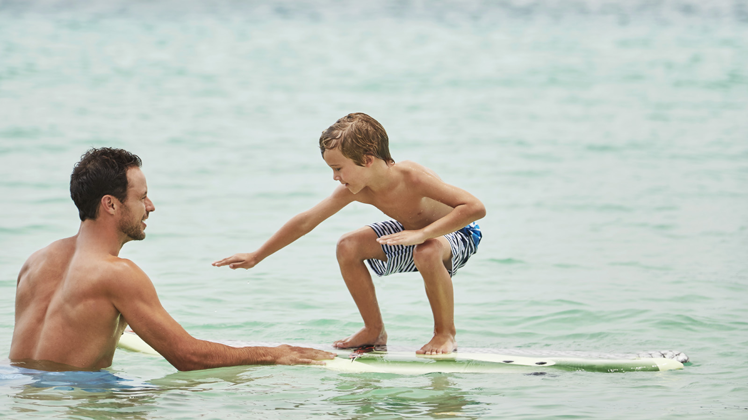 | July 20, 2017, Hawaii, Oahu, U.S.A.  Four Seasons Resort Oahu at Ko Olina Launches Luxury Camping Program for Keiki  http://publish.url/oahu/hotel-news/2017/glamping-program-for-children.html
June 14, 2017, Hawaii, Oahu, U.S.A.
Four Seasons Resort Oahu at Ko Olina Welcomes Summer with Moonlight Market and Art Walk Series
http://publish.url/oahu/hotel-news/2017/summer-moonlight-market-and-art-walk-series.html

PRESS CONTACTS

Yvonne Hunter
Director of Public Relations
92-1001 Olani Street
Kapolei
U.S.A.
yvonne.hunter@fourseasons.com

+1 (808) 729-0686

