Four Seasons Looks Ahead to 2017 and Beyond

Continues to grow global portfolio and strengthen position as partner of choice for luxury hotel and residential projects
January 24, 2017, Toronto, Canada

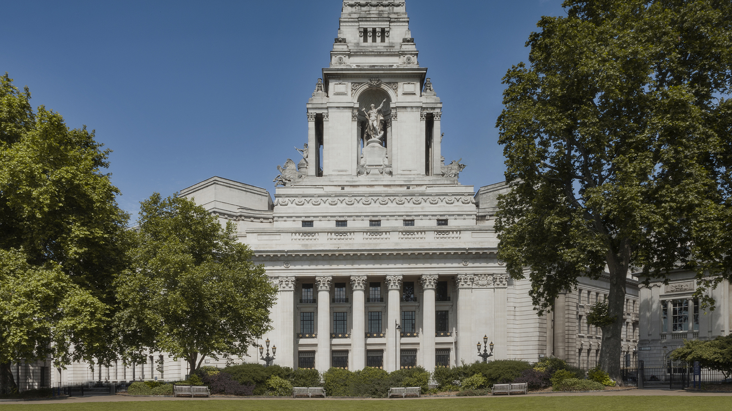 | 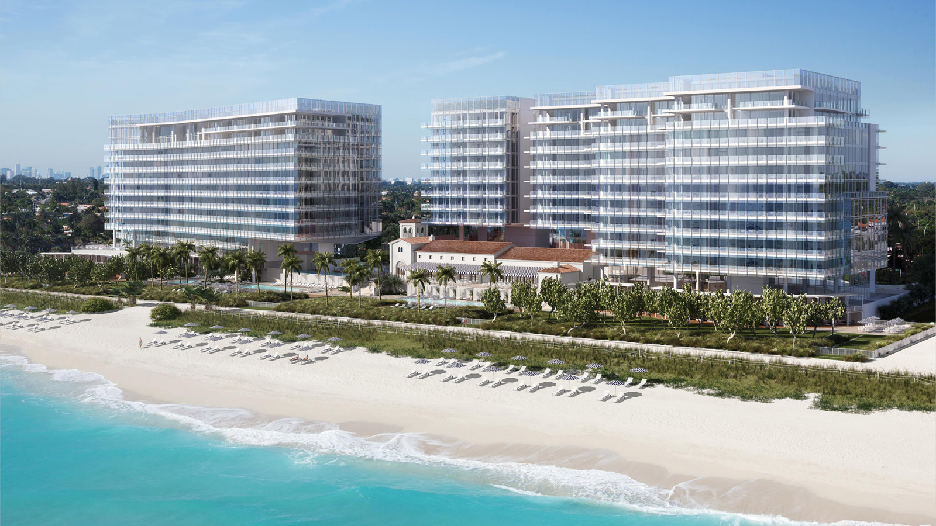 | 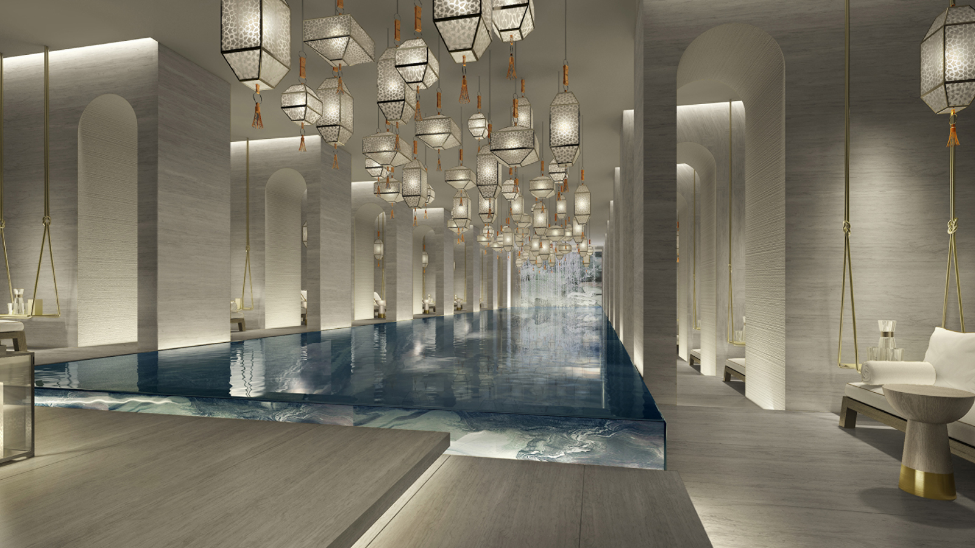
Four Seasons
Hotels and Resorts, the world’s leading luxury hospitality company, is strengthening its presence in the luxury hotel and residential space, and building on its position as the business partner of choice for luxury hotel, resort and residential projects.
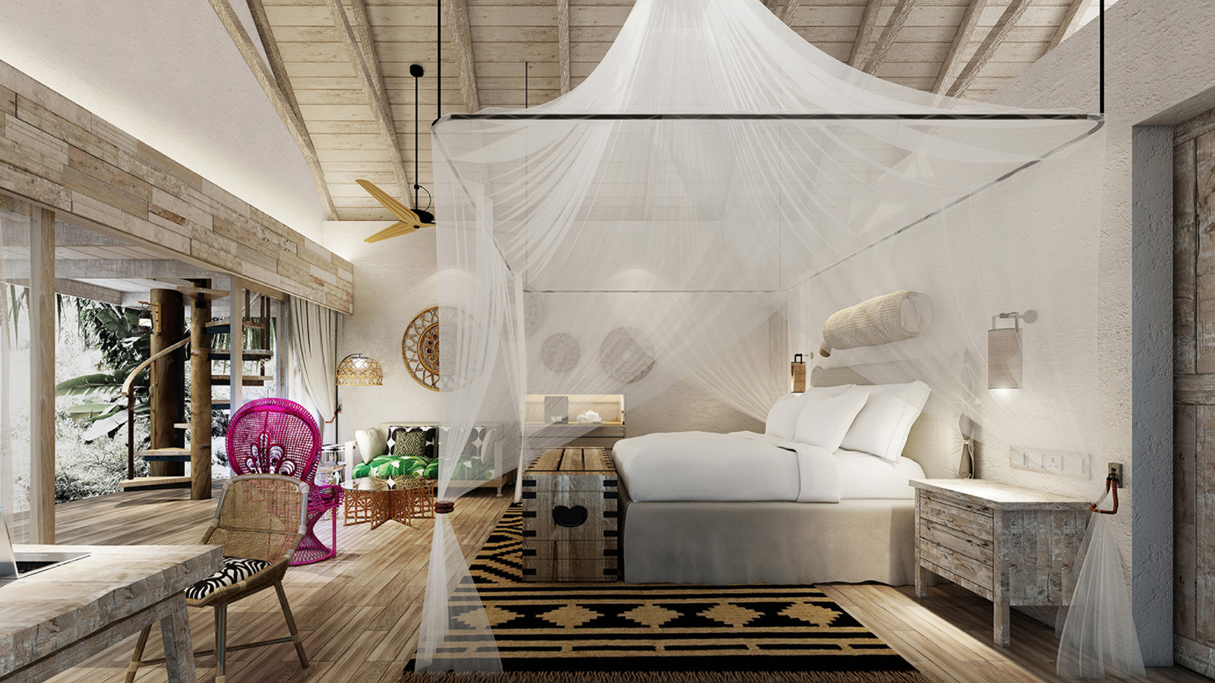 |  | 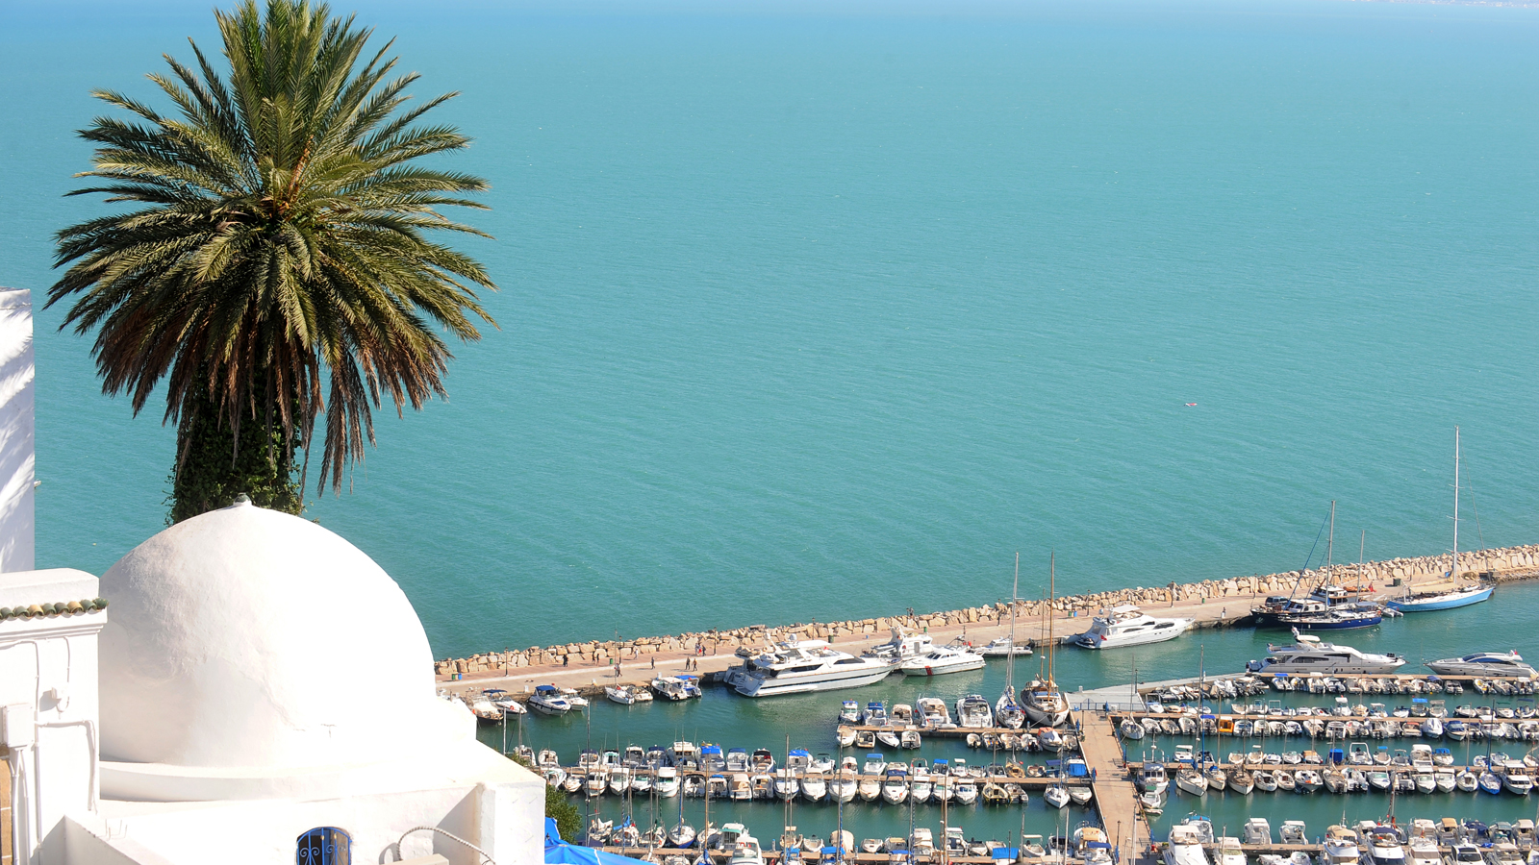
With a pipeline of more than 50 projects at various stages of planning and development, the company continues to extend its global portfolio in destinations of importance to luxury travellers.
“Our aspiration is not to be the biggest; it’s to be the best,” says J. Allen Smith, President and CEO,
Four Seasons
Hotels and Resorts. “We are singularly focused on serving the luxury consumer. Against the current backdrop of industry consolidation and commoditisation, there is tremendous opportunity to extend
Four Seasons
leadership in the pure luxury space.”
“But market dynamics alone do not guarantee success,” continues Smith. “Our ability to capitalise on these opportunities is directly related to the strength of our leadership team, and the ability of our people – the most passionate and talented in the industry – to deliver an unparalleled level of personalised service.”
This commitment to service excellence extends beyond the company’s service of its guests, continues Smith, “Extending the custom character of everything we do to help property owners realise the full value of their investment and relationship with
Four Seasons
is a top priority for us.”
Business Partner of Choice
One way the company is actioning this priority is through the appointment of Michael (Mike) Crawford to the newly created role of President, Portfolio Management and Owner Relations. Crawford, who joined
Four Seasons
in 2014 as President, Asia Pacific, moved into his new position in late 2016.
With global responsibility for design, construction and procurement, Crawford coordinates the intricate process of bringing development projects to fruition, including new builds, strategic conversions and adaptive reuses of historic buildings, working cross-functionally across the organisation and in collaboration with the company’s individual hotel owners. Crawford is also responsible for leveraging the company’s well-established leadership and expertise in branded residential – a key area of growth that includes more than 4,000 residential units in 17 countries around the world.
“Long-term partnerships with hotel owners are at the core of our business model, and just as each
Four Seasons
property is unique, so too is each individual hotel owner,” says Crawford. “Having a clear eye on the unique vision and objectives of each hotel owner and applying the same level of customisation to these relationships as we do with our guests continues to be a key competitive advantage for
Four Seasons
.”
Further articulating what it means to be a leader in this regard, Crawford says, “Building strong relationships with hotel owners is fundamentally grounded in trust, the same trust that our guests place in us to deliver the highest standards of product quality, design and service. I look forward to continuing to build on the strong relationships we have with our hotel owners, offering even greater attention and customisation, and putting dedicated resources in place to prioritise this effort.”
Targeted Growth: 2017 and beyond
Today
Four Seasons
opened its 9th hotel in China in Tianjin, and will extend its presence in several key markets in 2017 with the addition of second hotels in both London (Ten Trinity Square) and the Seychelles (Desroches Island), as well as adding a fourth property in Florida (Surfside). The company also plans to open hotels in new destinations including Kuwait, Megève, and Tunis later this year.
Four Seasons
has previously announced plans for hotels, resorts and residences in: Montreal, Los Cabos, Bangkok, Madrid, Philadelphia, São Paulo, Bengaluru, and Kuala Lumpur, as well as second properties in both Boston and Tokyo.
These developments build on 2016’s momentum, when
Four Seasons
added nine properties to its global portfolio:
Four Seasons
Hotel Dubai International Financial Centre,
Four Seasons
Hotel Bogotá,
Four Seasons
Hotel Abu Dhabi at Al Maryah Island,
Four Seasons
Resort O’ahu at Ko Olina,
Four Seasons
Hotel Jakarta,
Four Seasons
Hotel New York Downtown,
Four Seasons
Hotel Kyoto,
Four Seasons
Resort Anguilla, and
Four Seasons
Resort The Nam Hai, Hoi An, Vietnam.
Four Seasons
also introduced the first private island experience in the company’s portfolio -
Four Seasons
Private Island Maldives at Voavah, Baa Atoll - the world’s only exclusive-use UNESCO hideaway located in a World Biosphere Reserve.

RELATED

April 12, 2017, Toronto, Canada
Four Seasons Hotels and Resorts e Mabrouk Group, annunciano un grandioso progetto: il nuovo Four Seasons Hotel Tunis
http://publish.url/news-releases/2017/new-hotel-in-tunis-4.html

April 12, 2017, Toronto, Canada
Four Seasons anuncia primeiro hotel na Tunísia para o final de 2017
http://publish.url/news-releases/2017/new-hotel-in-tunis-5.html

PRESS CONTACTS

Sarah Tuite
Director, Corporate Communications and Public Relations
1165 Leslie Street
Toronto
Canada
prsm@fourseasons.com

+1 (416) 441-4440

