Shadi Suleman Named General Manager of Four Seasons Hotel Alexandria at San Stefano

Suleman journeys from the Arabian Gulf to the Mediterranean Sea to lead the team at
Four Seasons
Hotel Alexandria
February 16, 2017, Alexandria, Egypt

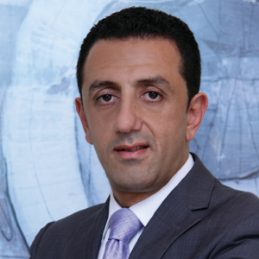
Four Seasons
Hotel Alexandria at San Stefano announces the appointment of Shadi Suleman as its new General Manager.
Suleman, a long-serving
Four Seasons
veteran, travels from the beautiful oasis of Doha to Alexandria, the Pearl of the Mediterranean, packing along a passion for the business, a creative mind, a charismatic devotion and extensive skills acquired over the span of his career.
Beyond his strive to perfection, Suleman’s exposure to numerous operations in the GCC and Middle East will contribute undoubtedly to the further success of
Four Seasons
Hotel Alexandria at San Stefano. During this new journey, Suleman will solidify the landmark’s position as a benchmark of impeccable hospitality, and will continue to set the bar high in the city.
Suleman first joined
Four Seasons
Hotels and Resorts in August 2002 at
Four Seasons
Hotel Riyadh at Kingdom Centre. In 2005, he returned home to Syria, to be part of the pre-opening team at
Four Seasons
Hotel Damascus. He then moved in 2007 to join another pre-opening mission with
Four Seasons
Hotel Istanbul at the Bosphorus. In 2008, he pursued his career by joining
Four Seasons
Hotel Doha as Director of Rooms and later became the Hotel Manager in 2013 until his recent promotion to General Manager in Alexandria.
“Suleman has the leadership, drive and the attitude that naturally inspires his team to give their best,” says Simon Casson, President, Hotel Operations - Europe, Middle East and Africa.
Aside from his gregarious nature, Suleman enjoys nothing more than exploring new destinations with his family. Full of enthusiasm, they are all excited to discover Alexandria with its charming coast and historical trait.

RELATED

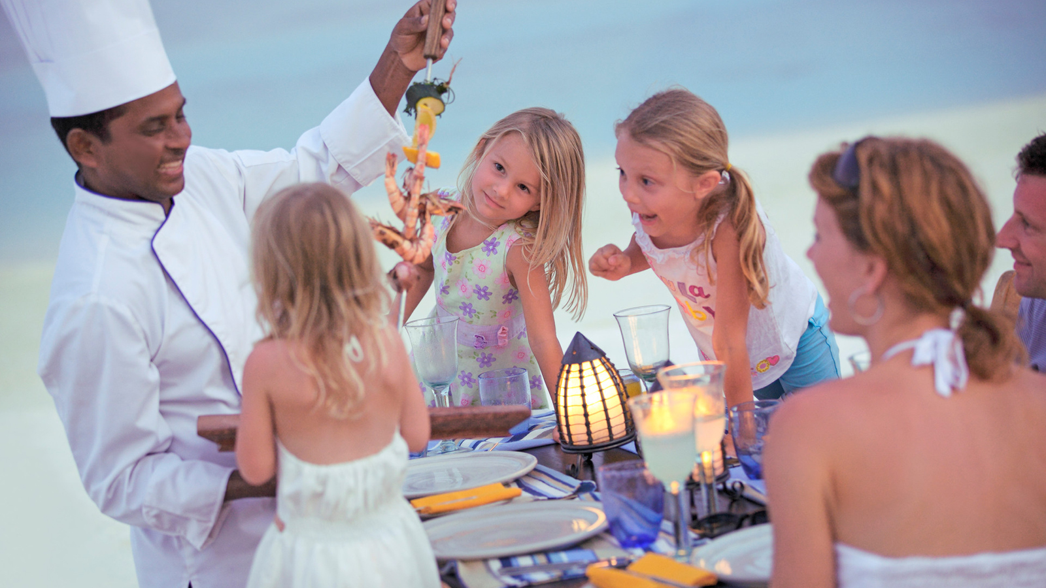 | March 28, 2017, Alexandria, Egypt  A Blooming Spring at Four Seasons Hotel Alexandria at San Stefano  http://publish.url/alexandria/hotel-news/2017/spring-offers.html
February 16, 2017, Alexandria, Egypt
شادي سليمان مدير عام فندق فورسيزونز الإسكندرية سان ستيفانو رحلة من الخليج العربى إلى البحر المتوسط
http://publish.url/ar/alexandria/hotel-news/2017/new-gm-shadi-suleman-2.html

PRESS CONTACTS

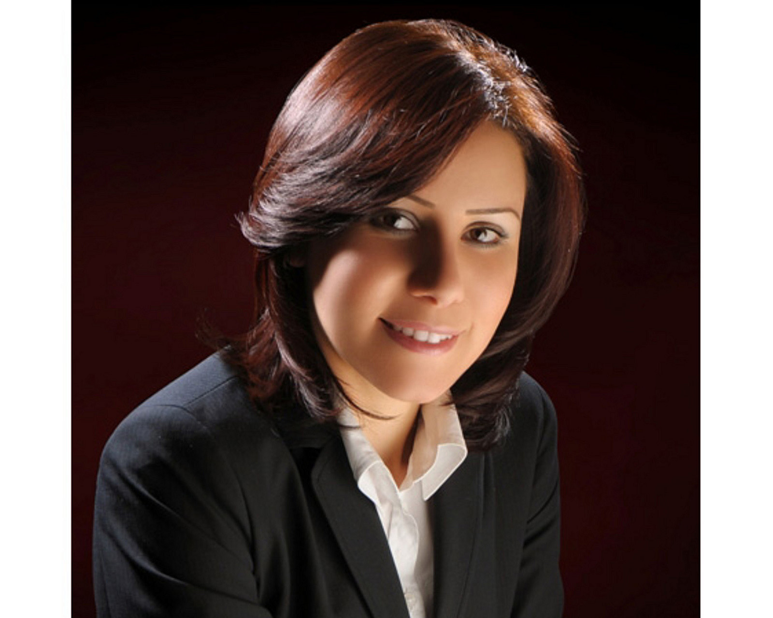 | Sarah Nabil  Director of Public Relations  399 El Geish Road  Alexandria  Egypt  sarah.nabil@fourseasons.com  20 3 581 8000

