Celebrate Valentine's Day with Four Seasons Resort Scottsdale at Troon North

Resort offers options for every type of love story
January 17, 2017, Scottsdale, U.S.A.

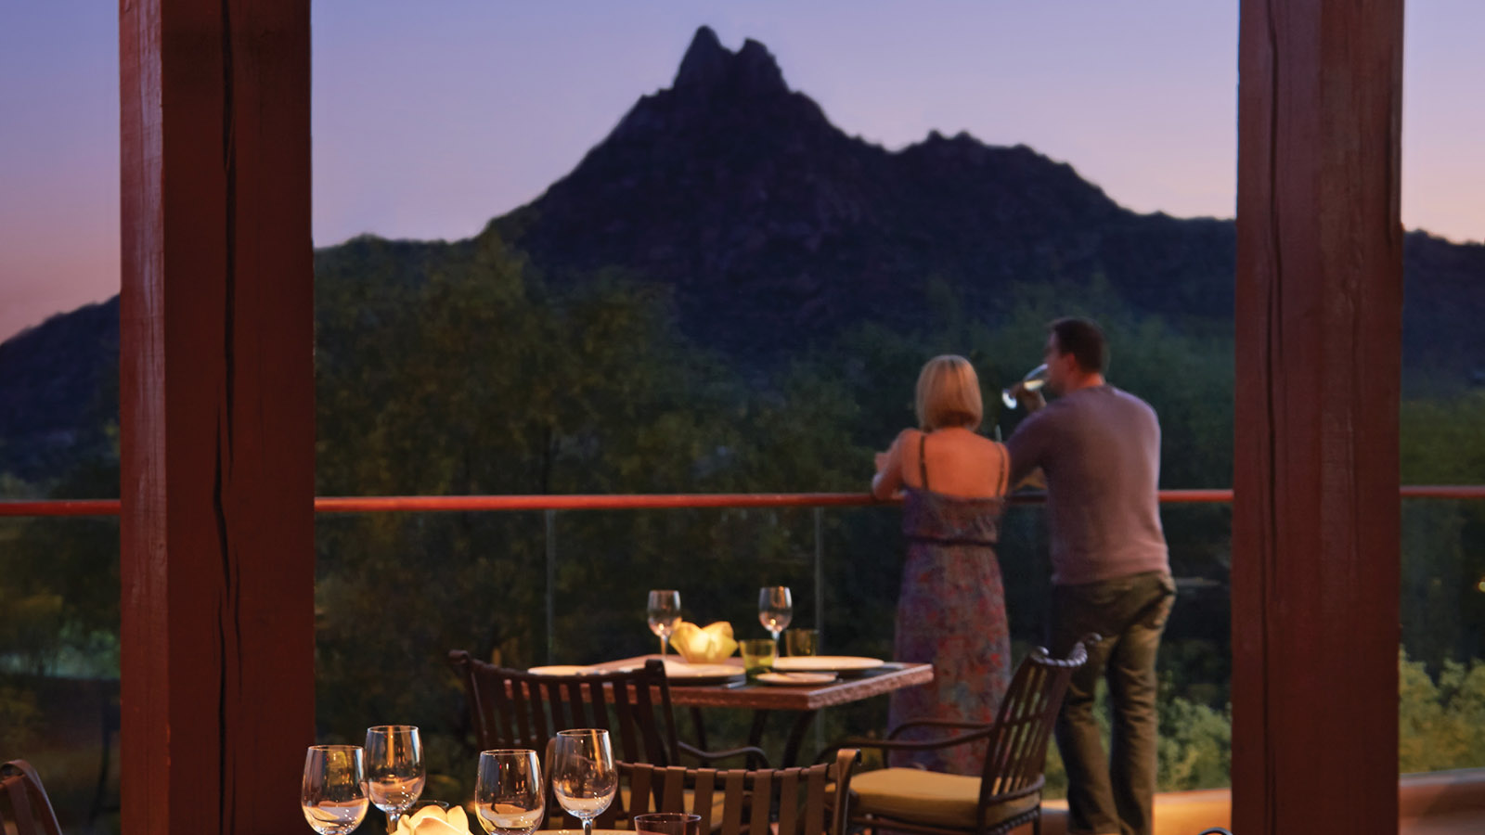
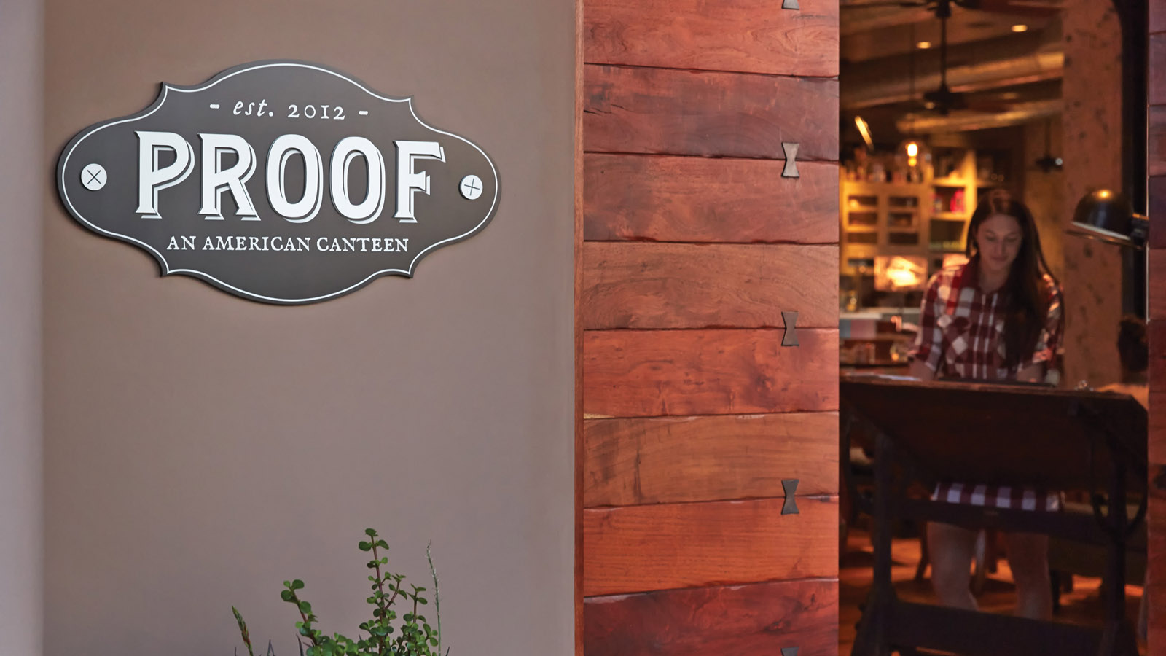
Enjoy a romantic evening in Talavera or a night of casual comfort and community at Proof, an American Canteen, this Valentine’s Day at
Four Seasons
Resort Scottsdale at Troon North.
“Talavera is your one-stop destination for romance, featuring panoramic Valley views and a menu tailored toward celebration,” says Director of Food & Beverage Bryan Feigenbaum. “Those seeking a break from tradition can head to Proof for laidback ambiance and a livelier atmosphere, perfect for couples, families and friends.”
Play up the romance with Talavera, offering a celebratory menu and premier views to match. Talavera will feature a five-course menu on February 10, 11, 12 and 14, 2017 beginning with salmon gravlax with fried oyster, caviar, crème frâiche, caperberries and horseradish. The next course highlights poached lobster salad with persimmon, sunchokes, watercress and saffron oil. The third course offers beet ravioli, fresh ricotta, pistachio brown butter, romanesco and blood orange. For the main course, enjoy a choice of slow braised short rib or banana leaf steamed bass. The meal concludes with chocolate passionfruit cake with raspberry macaron and almond milk sabayon. The cost per person is USD 125, and includes a glass of sparkling rosé with dessert. Also offered will be a limited à la carte menu featuring Talavera signature favourites.
Proof, an American Canteen, will offer laidback ambiance and the perfect gathering place for those seeking comfort and community. Shuffleboard, lively music and tables for large parties make this the ideal spot for a night with friends and family. Menu highlights on Tuesday, February 14, 2017 include pan-seared scallops with vanilla-parsnip pureé, baby beets, kale and rye. The entrée special features strip steak, with smoked moody blue fondue, confit baby red potatoes and charred cipollini onions. Lemon cheesecake with marinated strawberries and pistachios rounds out the special offerings. All items are available à la carte, or the three-course menu can be enjoyed for USD 58 per person.
Onyx Bar & Lounge will feature Valentine’s Day specials from February 10 to 14, 2017 including specialty Champagne cocktails, top-shelf Champagne by the glass and oyster appetisers. The restaurant will feature live music February 11 and 14.
Those looking to extend the romance can book the Experience More package to enjoy a USD 100 credit with every two paid consecutive nights. Experience a couple’s treatment in the full-service Spa, a romantic dinner in Talavera, or cocktails and light bites al fresco at Onyx Bar & Lounge. The property also features romantic Fire Pit Casita rooms, featuring outdoor fire pit and spacious, extended patios, ideal for evenings under the stars.

RELATED

April 12, 2017, Scottsdale, U.S.A.
Pop-Up Tiki Bar Launches at Proof, An American Canteen at Four Seasons Resort Scottsdale
http://publish.url/scottsdale/hotel-news/2017/pop-up-tiki-bar.html

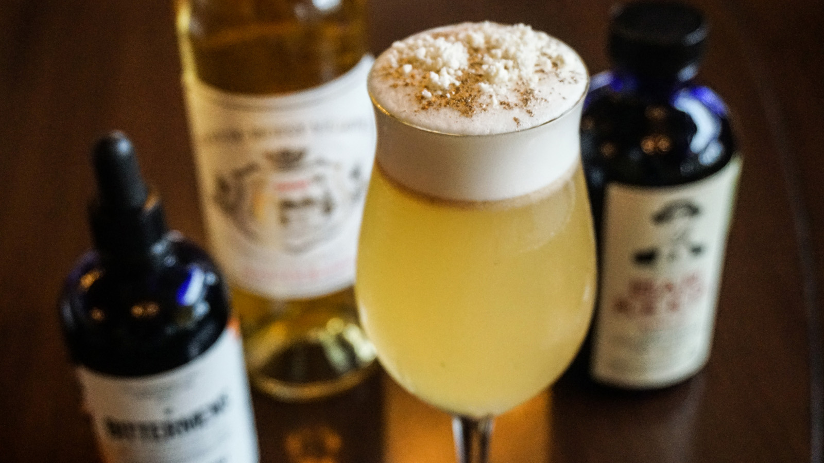 | April 6, 2017, Scottsdale, U.S.A.  Sip on the Golden Goose Cocktail at Four Seasons Resort Scottsdale at Troon North  http://publish.url/scottsdale/hotel-news/2017/golden-goose-cocktail.html

PRESS CONTACTS

Kim Cole
Director of Public Relations, (APR)
10600 East Crescent Moon Drive
Scottsdale
U.S.A.
kim.cole@fourseasons.com

1 (480) 513-5049

