Executive Chef of Four Seasons Resort Hualalai Thomas Bellec and Chef/Owner of Redbird Neal Fraser Host Intimate Dinner in Preview of Chef Fest 2017

Guests are invited to an advance taste of
Four Seasons
Resort Hualalai food and wine festival at Redbird on Wednesday, July 26, 2017
June 27, 2017, Hawaii, Hualalai, U.S.A.

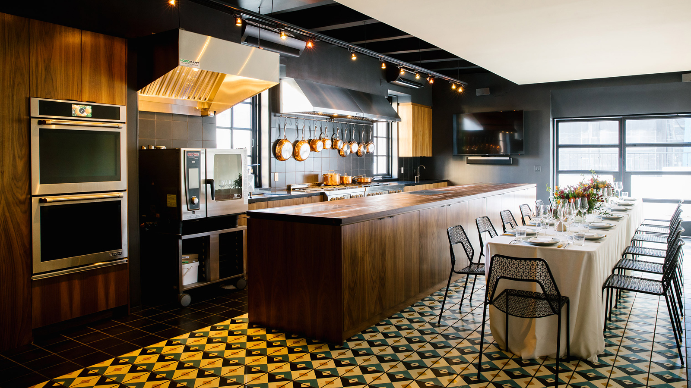
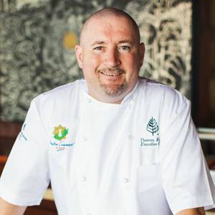 | 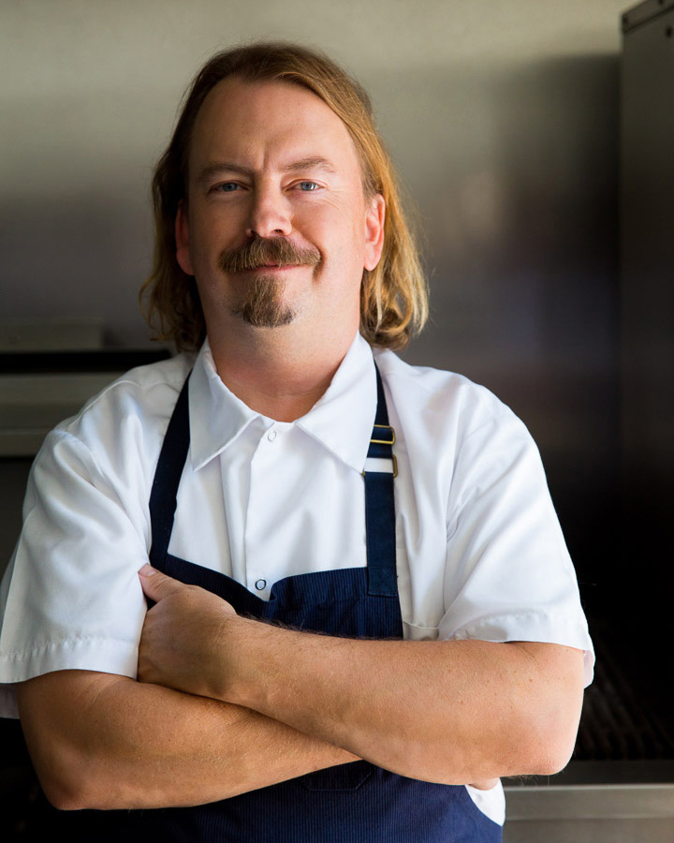 | 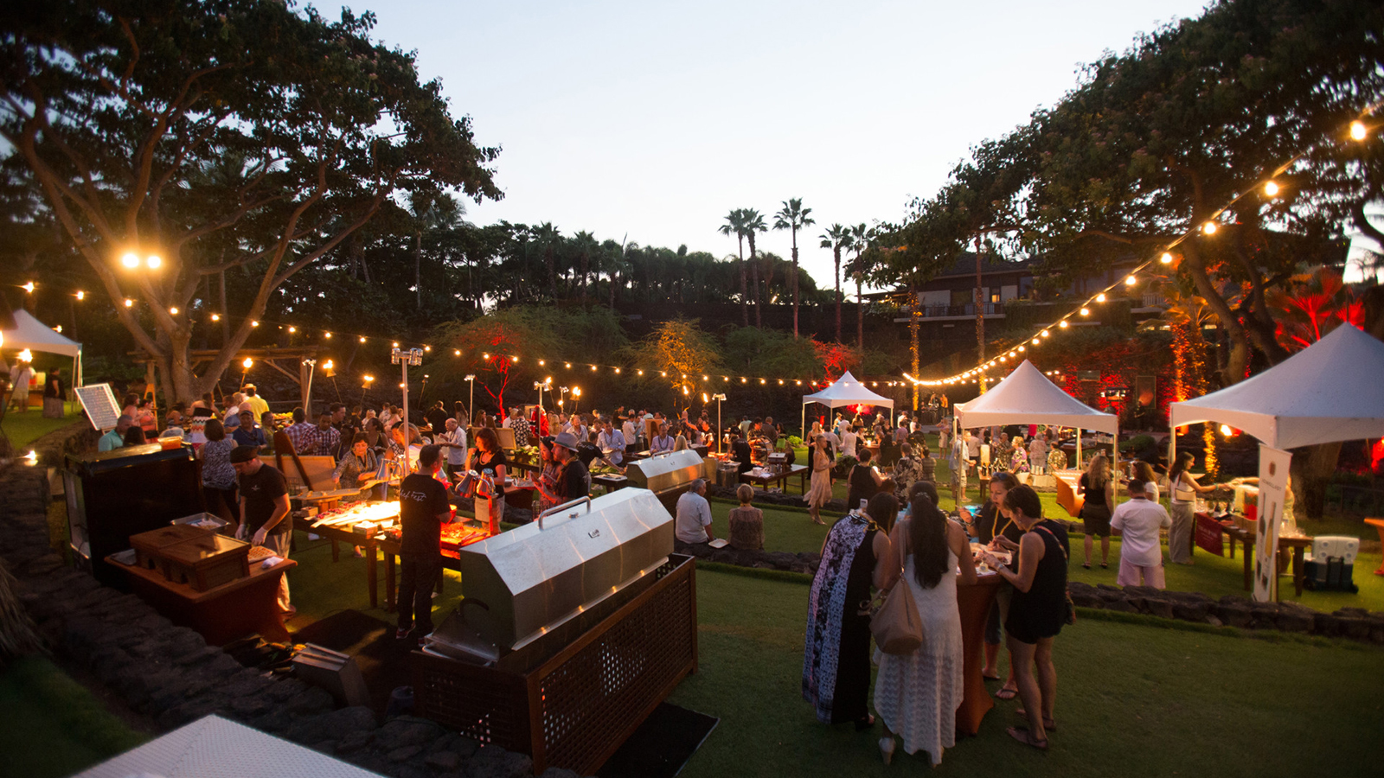
Chef Thomas Bellec and Chef Neal Fraser come together to prepare an intimate, seafood-centric dinner showcasing tastes of Hawaii and the exclusive experience guests will enjoy at
Four Seasons
Resort Hualalai food and wine festival Chef Fest.
Redbird, an award-winning restaurant in downtown Los Angeles, will host the dinner in a private dining room space featuring an open-concept kitchen and a patio with views of downtown LA. Guests will have the opportunity to interact with the chefs as they prepare the meal and throughout the evening.
The dinner experience will start with a signature Chef Fest craft cocktail served on the patio with close-up views of the historic Vibiana. The five-course dinner will showcase unique dishes from each chef featuring sustainable Hawaiian seafood and island-inspired ingredients. Each course is paired with carefully selected wine from throughout the world. Redbird Pastry Chef Kasra Adjari ends the meal with his take on a Hawaiian-inspired dessert.
The dinner is limited to 30 people and will take place on Wednesday, July 26, 2017. The Chef Fest specialty cocktail will be served on the patio at 7:00 pm, followed by the five-course dinner at 7:30 pm. The dinner includes wine pairings with each course and costs USD 135 per person inclusive of service charge and tax. Reservations may be made online.
About Chef Fest
Chef Fest takes place from October 4 to 7, 2017 at
Four Seasons
Resort Hualalai. The four-day culinary experience will feature a grand tasting, cooking academy presented by All-Clad, mixology showcases, and distinct dinners at various oceanfront locations. In addition to Chef Neal Fraser, additional guest chefs include Gabrielle Hamilton, Chef/Owner of Prune in New York City; Edward Lee, Chef/Owner of 610 Magnolia, The Wine Studio, MilkWood, and Whiskey Dry in Louisville; Ivan Orkin, Chef/Owner of Ivan Ramen in New York City; Andy Ricker, Chef/Owner of Pok Pok in Portland and New York City; Fabrizo Schenardi, Executive Chef of
Four Seasons
Resort Orlando; and Christof Syre, Executive Chef of
Four Seasons
Resort and Club Dallas at Las Colinas.

RELATED

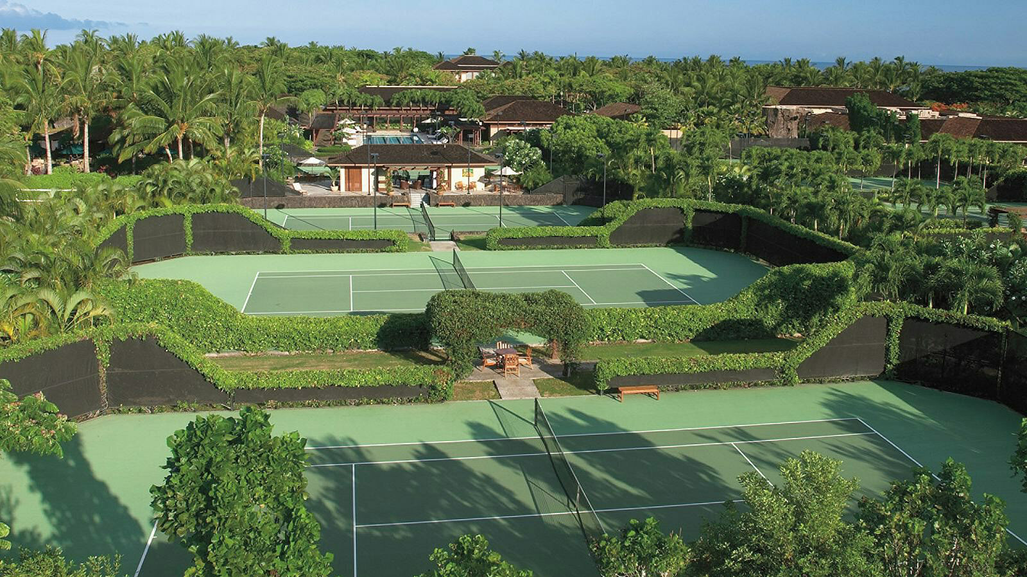 | June 1, 2017, Hawaii, Hualalai, U.S.A.  Four Seasons Resort Hualalai Introduces Tennis Pro Michael Chang’s Tennis Insider Camp  http://publish.url/hualalai/hotel-news/2017/michael-chang-tennis-camp.html
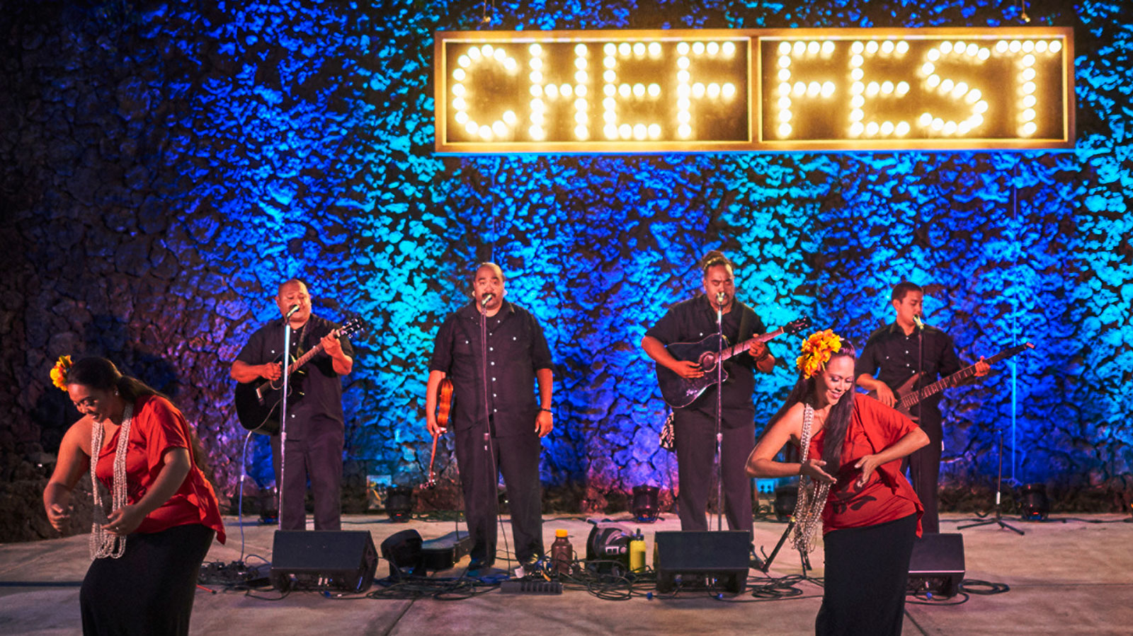 | May 25, 2017, Hawaii, Hualalai, U.S.A.  Four Seasons Resort Hualalai Presents Chef Fest 2017  http://publish.url/hualalai/hotel-news/2017/chef-fest-2017.html

PRESS CONTACTS

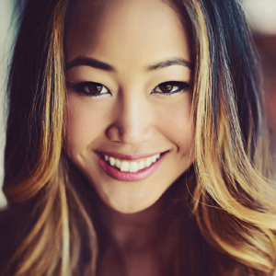 | Morgan Suzuki  Director of Public Relations and Communications  72-100 Ka'upulehu Drive  Kailua Kona  U.S.A.  morgan.suzuki@fourseasons.com  1 (808) 557-5909

