Holiday Dining and Events at Four Seasons Hotel Silicon Valley

November 4, 2016, Palo Alto, Silicon Valley, U.S.A.

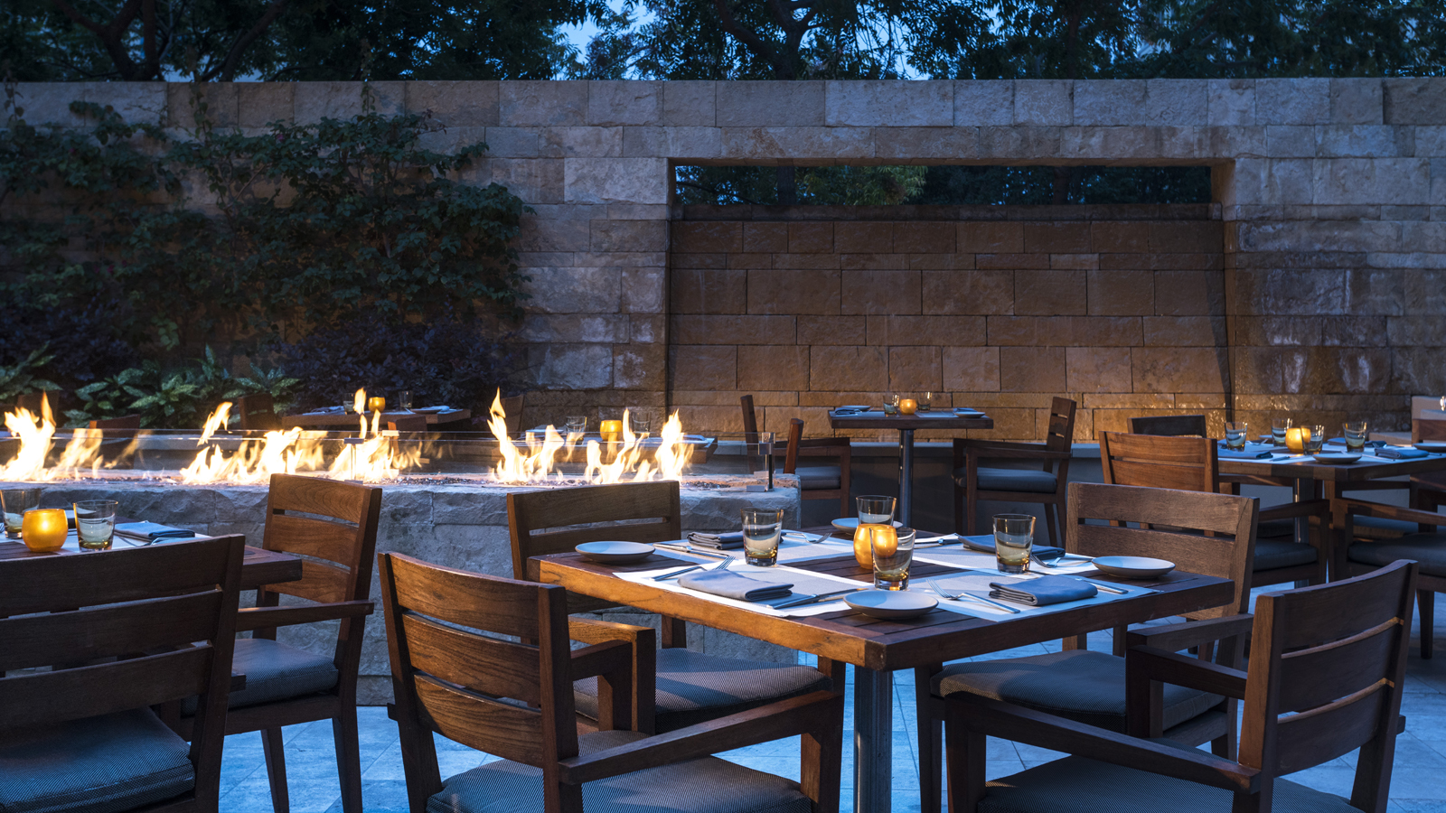
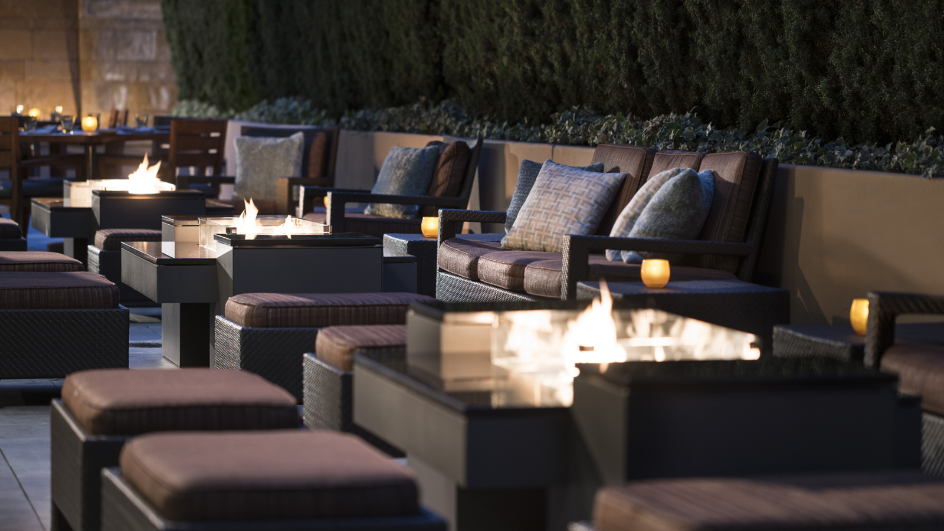 | 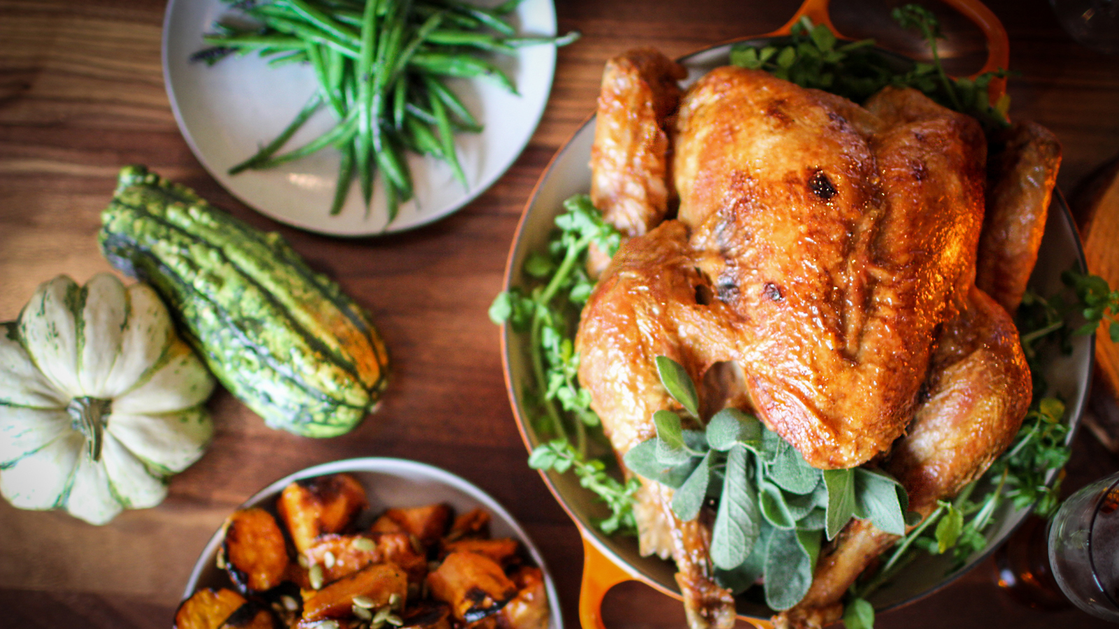 | 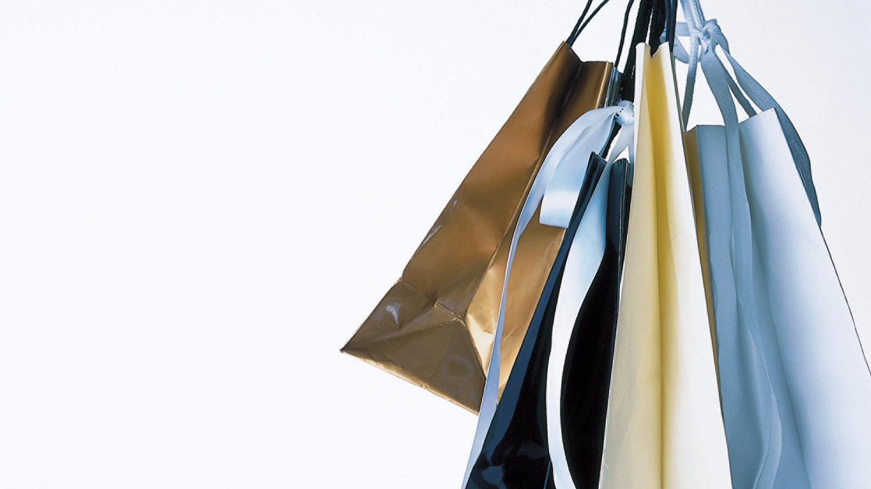
Make unforgettable holiday memories or start new traditions at
Four Seasons
Hotel Silicon Valley at East Palo Alto. The festive season shopping, dining and event options allow for numerous opportunities to bring friends and family together in collective celebration of the merriment of the season.
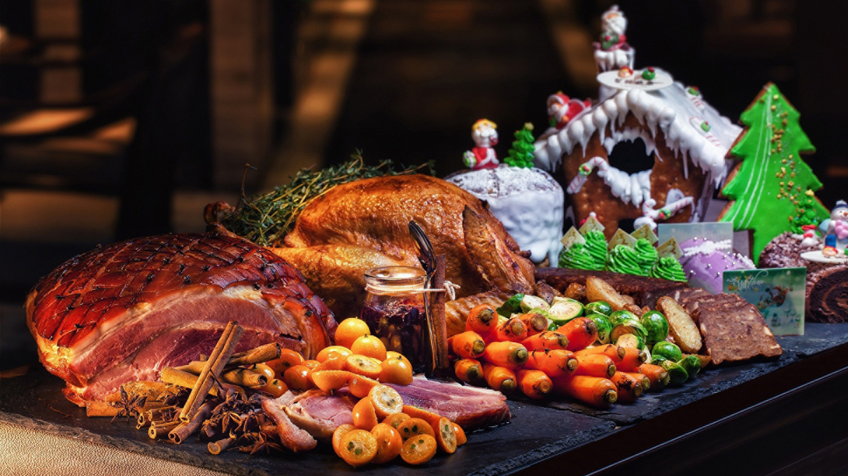 | 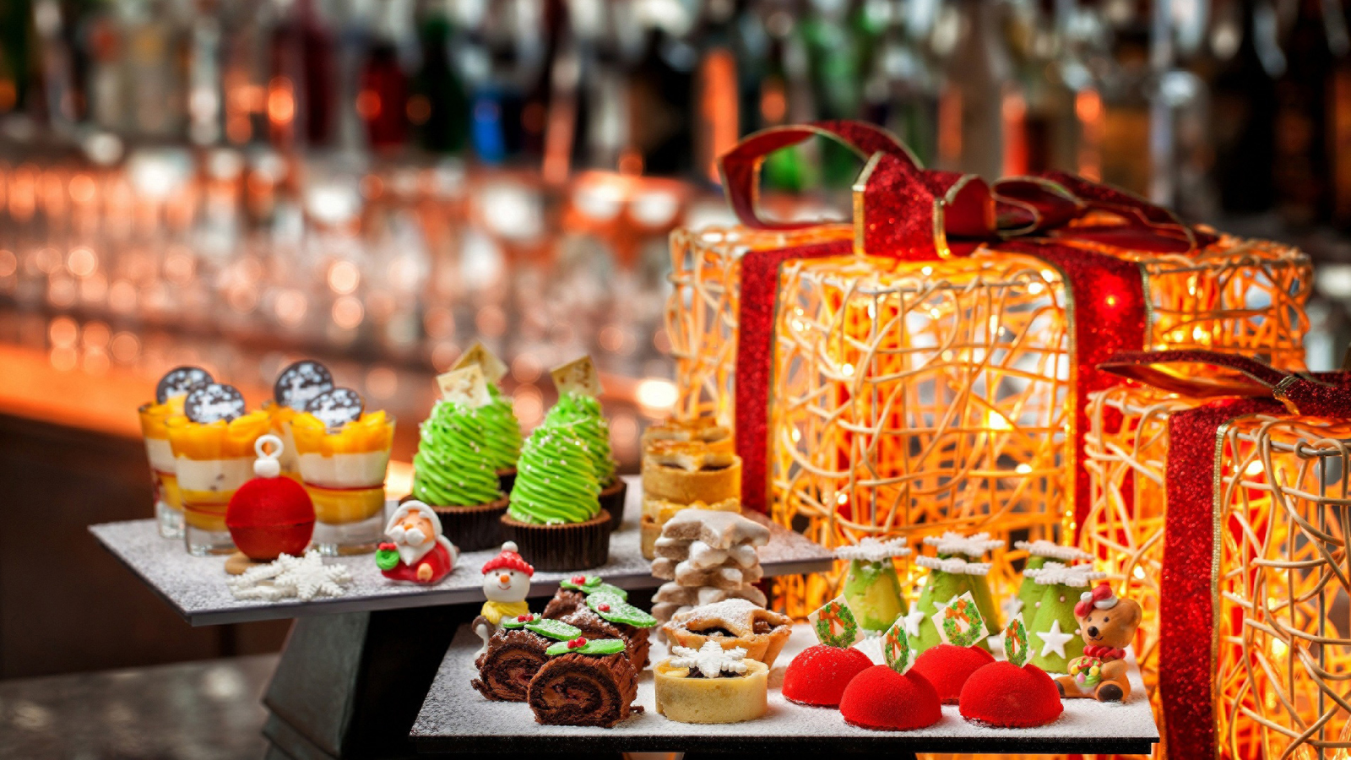
Spa-liday - Saturday, November 12, 2016, 1:00-5:00 pm
The Spa at
Four Seasons
Hotel Silicon Valley hosts the second annual shopping event Spa-liday to jumpstart the holiday shopping season. Discover a curated selection of luxury skin care lines, body products and home accessories. Featured product lines include: Natura Bissé, Skin Authority, Moroccanoil, Naked Princess, Back Label and Chuao Chocolatier alongside bespoke local menswear designs from Devan Vincent, and many more. Nationally recognised “Sleep Guru” Robert deStefano will be present to launch a brand new sleep massage designed in collaboration with The Spa and Longeva. Robert will also be providing an introductory workshop with tips for achieving a restful night’s sleep. The event will be held in the lobby of Four Seasons Hotel Silicon Valley and include:
- Mini-spa treatments
- Festive lite bites and drinks
- Gift with purchase
- Raffl­e drawings
- HydraFacial MD demonstrations
To RSVP and schedule to complimentary mini-spa treatment call 650 470 2865 or visit online.
Eat, Drink and Be Thankful - Thursday, November 24, 2016, 10:30 am - 8:30 pm
Gather friends and family in celebration this Thanksgiving at Quattro. The inspired three-course feast will feature a selection of seasonal entrées including succulent roast turkey with traditional accompaniments, pan-roasted Skuna Bay salmon and beef tenderloin. End things on a sweet note by sampling the legendary buffet crafted by Executive Pastry Chef Eric Keppler with modern twists on traditional fall favourites.
- USD 110 for adults
- USD 40 for children under 12
- USD 40 for dessert buffet only
- Quattro’s Thanksgiving Day hours: 10:30 am – 8:30 pm
Quattro's Perfect House - Sunday, December 4, 2016, 9:30-11:00 am and 12:00 noon - 3:00 pm
Celebrate the joyous spirit of the holiday season and gather the entire family to build the perfect gingerbread house. Executive Pastry Chef Eric Keppler will be on-hand to provide his industry expertise with professional tips and tricks. Both morning and afternoon sessions are available for families wanting to partake in Sunday Brunch before or after. The popular annual event sells out quickly and reservations are suggested well in advance to avoid any disappointment.
- USD 85 per family (up to 2 children and 2 adults)
- USD 10 additional for a glass of bubbles
Night Before Christmas - Saturday, December 24, 2016, 5:30-10:30 pm
Enjoy a silent night before Christmas in Quattro with a festive three-course meal featuring a selection entrées including Liberty Farms duck breast with black truffle rice croquettes, savoy spinach, sun choke puree and madera jus; or poached black cod in prosciutto brodo with mizuna-tatsoi salad, winter radish and pomegranate-ginger dressing. Sample the bite-sized desserts from the dessert buffet with surprising twists on classical holiday favourites.
- USD 95 for adults
- A la carte and children’s menu available
- Quattro’s Christmas Eve Hours: 10:30 am - 8:00 pm
Christmas Day Dinner - Sunday, December 25, 2016, 5:30-8:00 pm
Start a new tradition at Quattro for after all the presents are opened with a Sunday dinner to remember. The inspired four-course feast features a selection of seasonal entrées including Liberty Farms duck breast with black truffle arancini, savoy spinach, sun choke puree and madeira jus; pan-seared diver scallops with dashi brodo, mizuna-tatsoi salad, winter radish and a pomegranate-ginger dressing; or beef tenderloin and short rib duo with butternut squash puree, roasted brussels sprouts, butter poached wild mushrooms and cabernet jus. Enjoy a last taste of the holiday season and indulge at the imaginative dessert buffet, featuring contemporary interpretations of Christmas favourites.
- USD 125 for adults
- USD 40 for children under 12
- USD 40 for dessert buffet only
- Quattro’s Christmas Day Hours: 10:30 am - 8:00 pm
Felice Anno Nuovo! Saturday, December 31, 2016, 5:30-10:00 pm
Welcome the coming year in style at Quattro with an elegant four-course meal featuring a selection of seasonal entrées including a duo of lamb featuring lamb chop and lamb belly served with cauliflower, prunes and onion; or wagyu beef cheek with roasted mixed radishes and smoked potato purée. Finish the night with a bespoke dessert created by Executive Pastry Chef Eric Keppler.
- USD 115 for adults
- Children’s à la carte menu available
- Quattro’s New Year’s Eve Hours: 5:30-10:00 pm
Guests wishing to continue celebrations after dinner are welcome in The Bar, which is open until 1:00 am.
About Quattro
Quattro is an elegant yet innovative fine dining experience consisting of three distinct areas. The main dining room serves up Old World traditional Italian recipes transformed into modern culinary masterpieces with a rotating menu that changes with the seasons. Each new dish, envisioned by the talented culinary team, starts with premium locally-sourced produce at the peak of their seasonality. The extensive wine list of more than 300 bottles with 30 wines available by the glass, Quattro also features fine wines from around the globe highlighting California and Italy. During warmer months, dine al fresco on the outdoor terrace around a sleek central fire pit. Intermezzo provides an ideal place to stave off cravings in between meals with reimagined gastropub lite bites. The Bar features hand-crafted cocktails with a focus on incorporating craft-distilled spirits and local ingredients. Sample a selection of wines, dispensed from a cutting-edge enomatic preservation system, available in two, four, or six ounce glasses.
- To make a reservation at Quattro for the holiday season festivities, call 650 470 2889 or visit online.
About The Spa at
Four Seasons
Hotel Silicon Valley
The Spa at
Four Seasons
Hotel Silicon Valley features seven treatment rooms, a relaxation lounge, eucalyptus infused steam room, fitness centre, and locker rooms for men and women. Guests can enjoy the rooftop pool and whirlpool offering an oasis for relaxation. Offering an array of fully customisable, signature and seasonal treatments uniquely developed to hydrate skin, promote anti-ageing, and increase relaxation. The Spa also features aromatherapy and therapeutic treatments, advanced skin care for men and women, waxing services, and a nail salon.

RELATED

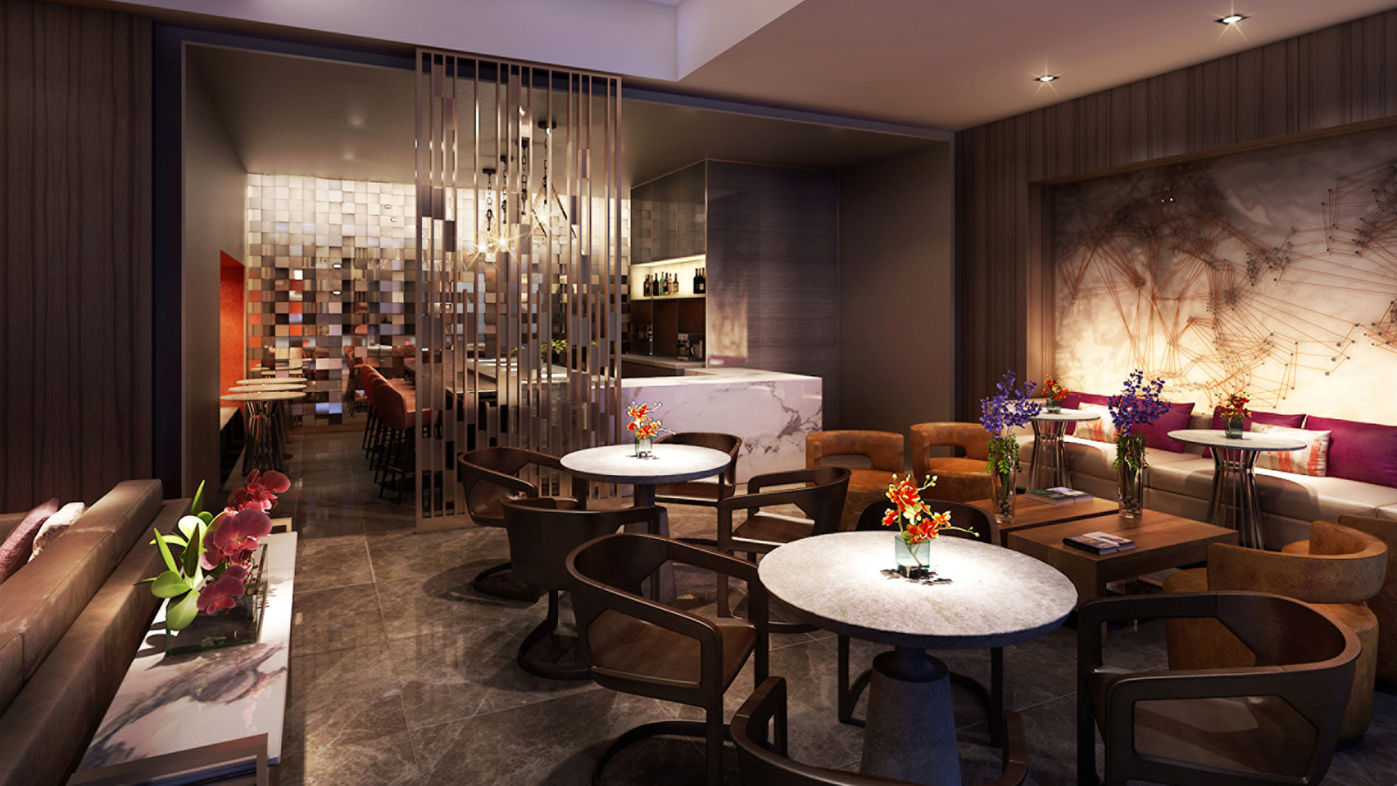 | March 31, 2017, Palo Alto, Silicon Valley, U.S.A.  Four Seasons Hotel Silicon Valley Launches [esc] - A Sleek Lounge-Style Lobby and Dining Destination in Palo Alto  http://publish.url/siliconvalley/hotel-news/2017/new-esc-lobby-and-dining.html
March 22, 2017, Palo Alto, Silicon Valley, U.S.A.
Four Seasons Hotel Silicon Valley at East Palo Alto Partners with Silicon Valley Innovation Center to Offer Exclusive Silicon Valley Tech Experiences for Groups
http://publish.url/siliconvalley/hotel-news/2017/silicon-valley-tech-experiences-for-groups.html

PRESS CONTACTS

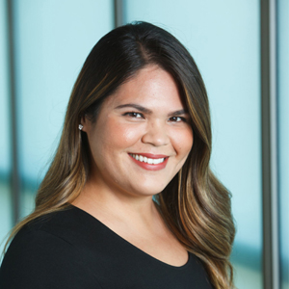 | Malia O'Connor  Public Relations and Communications Manager  2050 University Avenue  East Palo Alto  U.S.A.  malia.oconnor@fourseasons.com  +1 (650) 470-2810

