FOUR SEASONS Mauritius
Tel: + (230) 4023100 Email: press@fourseasons.com

OPENING DATE: October 2008
GENERAL MANAGER: Martin Dell

Physical Features
Total Number of Rooms: 136
- Villas: 90
- Royal Island Sanctuary: 1
- Private Retreats: 45
Design Aesthetic:
- Contemporary Mauritian style of open-air architecture that embraces natural surroundings
- Thatched roofs, wooden decks and stone walls amid palm trees and tropical gardens
- Every villa has its own plunge pool, private garden and outdoor shower

Spa
Number of Treatment Rooms: 12
Interior Designer: Macbeth Architects & Designers
Design Aesthetic: Contemporary Mauritian with open-air over-water pavilions, wood floors and decks

Dining
Examples of Locally Sourced Ingredients:
- Papaya
- Banana
- Chouchou (vegetable)
- Rouget, marlin and ombrine (local fish)
Restaurant: Acquapazza
- Cuisine: Contemporary Italian

- Signature Dishes:
- Crudo di Branzino - fine sashimi style slivers of the freshest seabass

Recreation
Tennis:
- Number of Tennis Courts: 2
- Tennis Lessons: Offered with a professional coach for a fee
- Equipment: Available to borrow from the Fitness Centre
Golf:

- Name of Course:
Four Seasons
Golf Club Mauritius at Anahita
- Designer: Ernie Els
- Par: 72
- Yardage: 7,440
- Number of Holes: 18
- Special Holes: 4th – ocean drive 9th - home to two giant aladabra tortoises 18th – sugar estate ruins

- Name of Course: Ile aux Cerfs Golf Club
- Designer: Bernhard Langer
- Par: 72
- Yardage: 7,115
- Number of holes: 18
- Special Holes: 11th – ocean drive, 18th – two playable greens

- Additional Services:
- Pro shop
- Golf instruction available
- Driving range
- Putting green
- Clubs rental

- Special Features:
- Golf green fees are available at a preferential rate to all guests of Four Seasons Resort Mauritius at Anahita on both golf courses
On-site Activities:
- Biking, boating, diving, kayaking, pedalo, stand up paddle boarding, sailing, snorkeling, wakeboarding, waterskiing, windsurfing, WiseOceans marine education and reef restoration program
Off-Site Activities:
- Biking, bird watching, boating, catamaran cruise, deep sea fishing, helicopter tours, hiking, horseback riding, jungle trekking, kite surfing, quad biking, local excursions, sailing, Segway safari, skydiving, surfing, underwater walk, ziplining
Pools:
- Number of Pools: 4
Fitness Facilities:

- Special Features:
- 25-metre (82-foot) lap pool
- Aerobics studio
- Steam rooms

- Sample Fitness Activities:
- Yoga and tai chi classes
- Guided jogging tours
- Water aerobics
- Complimentary use of bicycles to explore Resort grounds

For Younger Guests
- Kids for All Seasons: Supervised children's program at the Hobbit Village Kids' Club, a dedicated facility featuring paddling pool, playrooms, quiet room, amphitheatre and bakery
- Karokan, a young adults centre for children ages 10 and above, featuring DJ booth, computers, table tennis and pool
- Additional Kids for All Seasons activities include football on the beach, shell collecting, painting, golf, and movie nights

Meeting Rooms
Total Size: 209 sq m / 2,250 sq ft
Largest Ballroom: 144 sq m / 1,550 sq ft
Meet and Feed Capacity: 80
Banquet Capacity: 110
Outdoor Banquet Capacity: 150
Private Dining Room Capacity: 20
Unique Meeting and Event Facilities:
- Beautiful peninsula adjacent to one of the Resort's private beaches and surrounded by a turquoise lagoon and Bambou Mountain is the ideal wedding site
- Karokan Young Adults Centre with its own DJ booth can be booked for private parties

Sustainability
- Scholarship program giving youth one to three years of on-the-job training leading to full-time employment with Four Seasons
- Support for various local primary schools and the Eastern Welfare Association for Disabled

PRESS CONTACTS
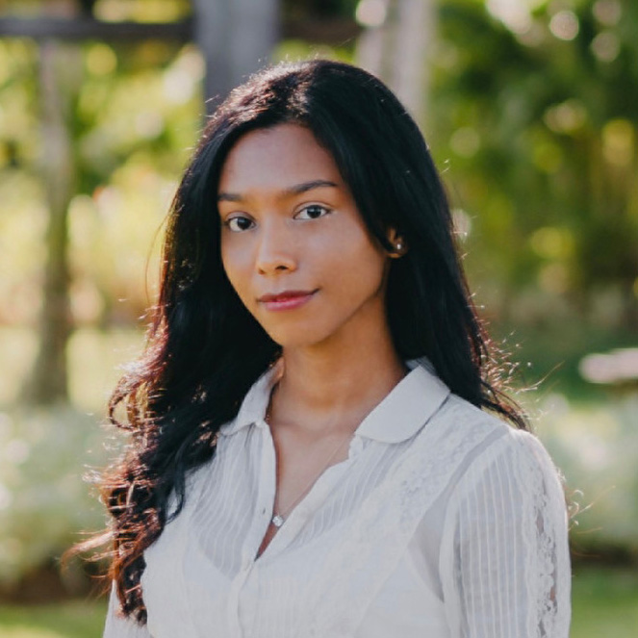 | Vidoushi Kooblall  Assistant Public Relations and Communications Manager  Beau Champ  Mauritius  vidoushi.kooblall@fourseasons.com  +230 4023100

