Jaleh Spa and Health Club at Four Seasons Hotel Baku Presents Arabian Oud Renewal Therapy from Sodashi

When the trees blossom and spring brings the first warmth of sunshine, skin is ready for renewal
March 14, 2017, Baku, Azerbaijan

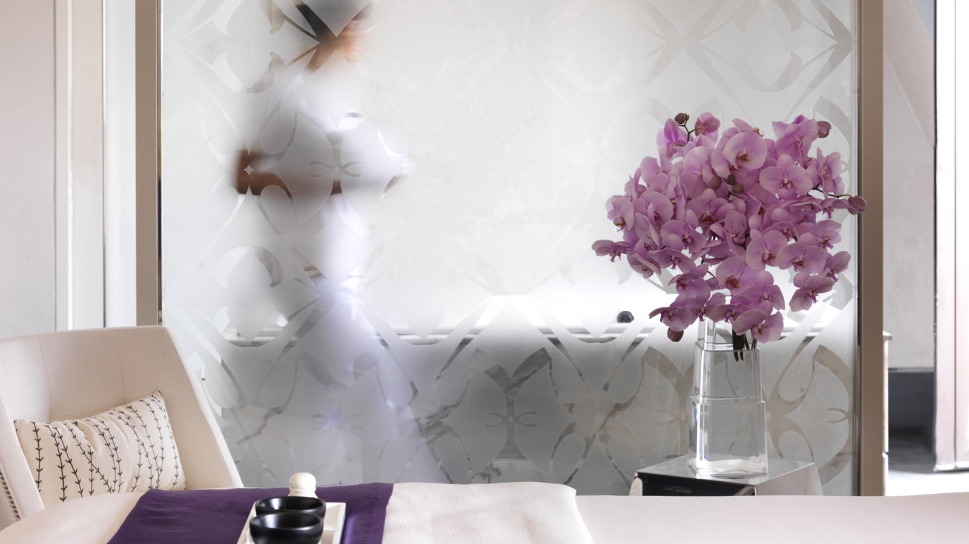
Jaleh Spa and Health Club at
Four Seasons
Hotel Baku presents the new special Arabian Oud Renewal Therapy from Sodashi.
This deluxe treatment works on both face and body to provide a complete head-to-toe experience, delivering incredible results in terms of released muscular tension, improved digestion, detoxification and skin radiance. The benefits of this exceptional holistic treatment however extend far beyond the physical. It has a profound ability to release stored emotions and alleviate negativity to improve emotional, energetic and spiritual well-being.
This fascinating treatment duration is 90 minutes and available with the price of AZN 180. Reservations can be done by telephone or e-mail: +99412 4042424; spa.bku@fourseasons.com.

RELATED

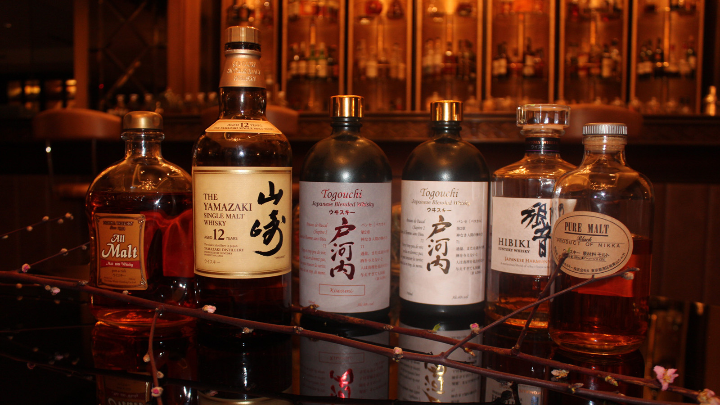 | April 20, 2017, Baku, Azerbaijan  A Celebration of Japanese Whisky at Bentley's Whisky Bar at Four Seasons Hotel Baku  http://publish.url/baku/hotel-news/2017/japanese-whisky-promotion.html
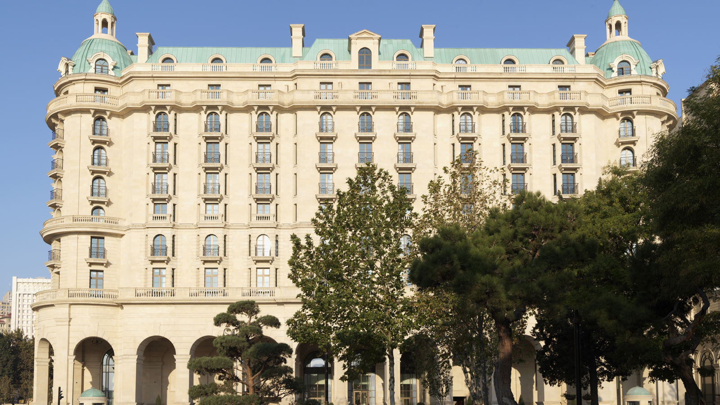 | April 20, 2017, Baku, Azerbaijan  “Волшебный Май“ с Four Seasons Hotel Baku: Оставайтесь с нами дольше – четвертая ночь бесплатна  http://publish.url/ru/baku/hotel-news/2017/may-package-promotion-2.html

PRESS CONTACTS

Aynur Mamedova
Director of Public Relations
1 Neftchilar Avenue
Baku
Azerbaijan
aynur.mamedova@fourseasons.com

+994 12 404 2424

