Begin Summer with Eid Celebrations at Four Seasons Hotel Cairo at Nile Plaza

June 19, 2017, Cairo at Nile Plaza, Egypt

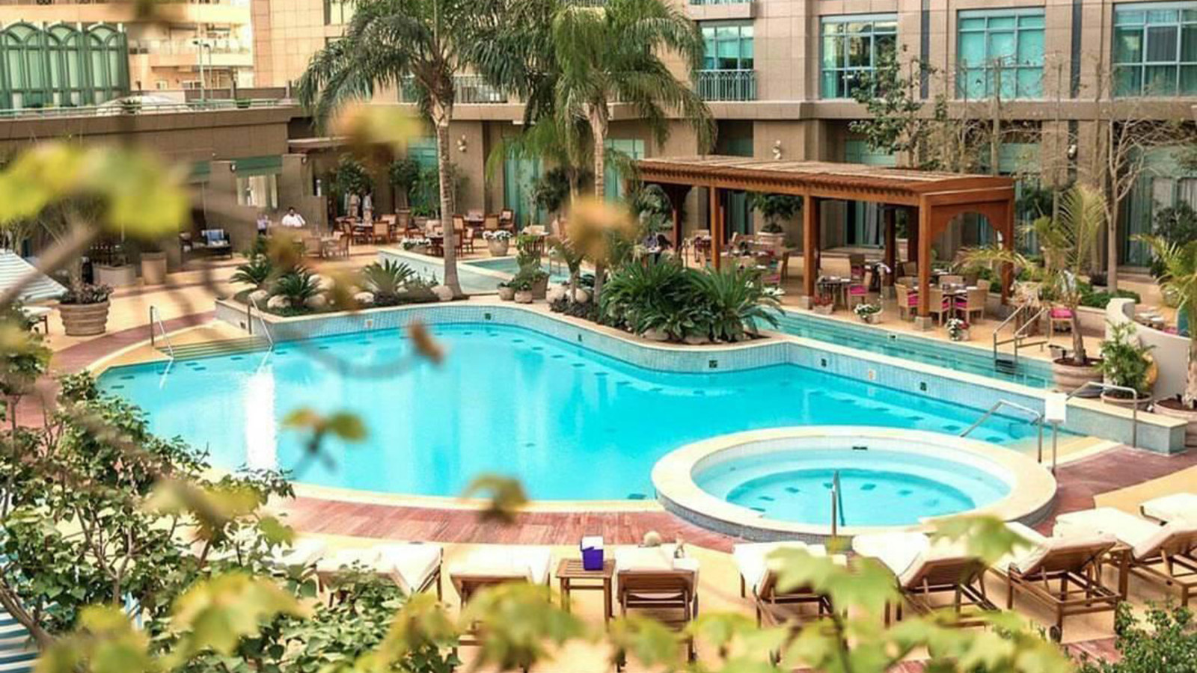
With a magnificent panorama of the world’s longest river and world-renowned impeccable hospitality,
Four Seasons
Hotel Cairo at Nile Plaza celebrates Eid El Fitr with exceptional packages and the most indulgent feasts with dishes created exclusively for the occasion. Celebrate among family and friends in the vibrant city of Cairo and experience the gracious elegance of Four Seasons with incredible room offers.
Zitouni restaurant takes guests on a trip around Egypt with a delicious all-day brunch buffet of authentic delicacies from every corner of the country for the duration of Eid. With its live cooking stations, freshly baked breads, extensive desserts buffet and widely sought-after chefs, Zitouni is the quintessential family Eid brunch.
For those looking to experience Cairo’s most fashionable destination, Upper Deck is the perfect location for a mid-day brunch or a late-night dinner, where the talented chefs create masterpieces on every plate.
As for those looking to celebrate in a true Chinese ambiance, 8 restaurant invites guests to indulge in an incredibly tempting dim sum brunch with a wide variety of authentic Chinese dishes, plus a Peking duck station.
What's a holiday without entertainment? Spend lazy afternoons by the Pool Grill while enjoying the live entertainment or add some spice to Eid celebrations with Graffiti Bar & Lounge's fun-filled nights of DJ beats, live percussion show, electric oud and special exhilarating performance of belly dancer Oxana.
For reservations, contact the Hotel on 02-2791-7000 or reservations.cai@fourseasons.com.

RELATED

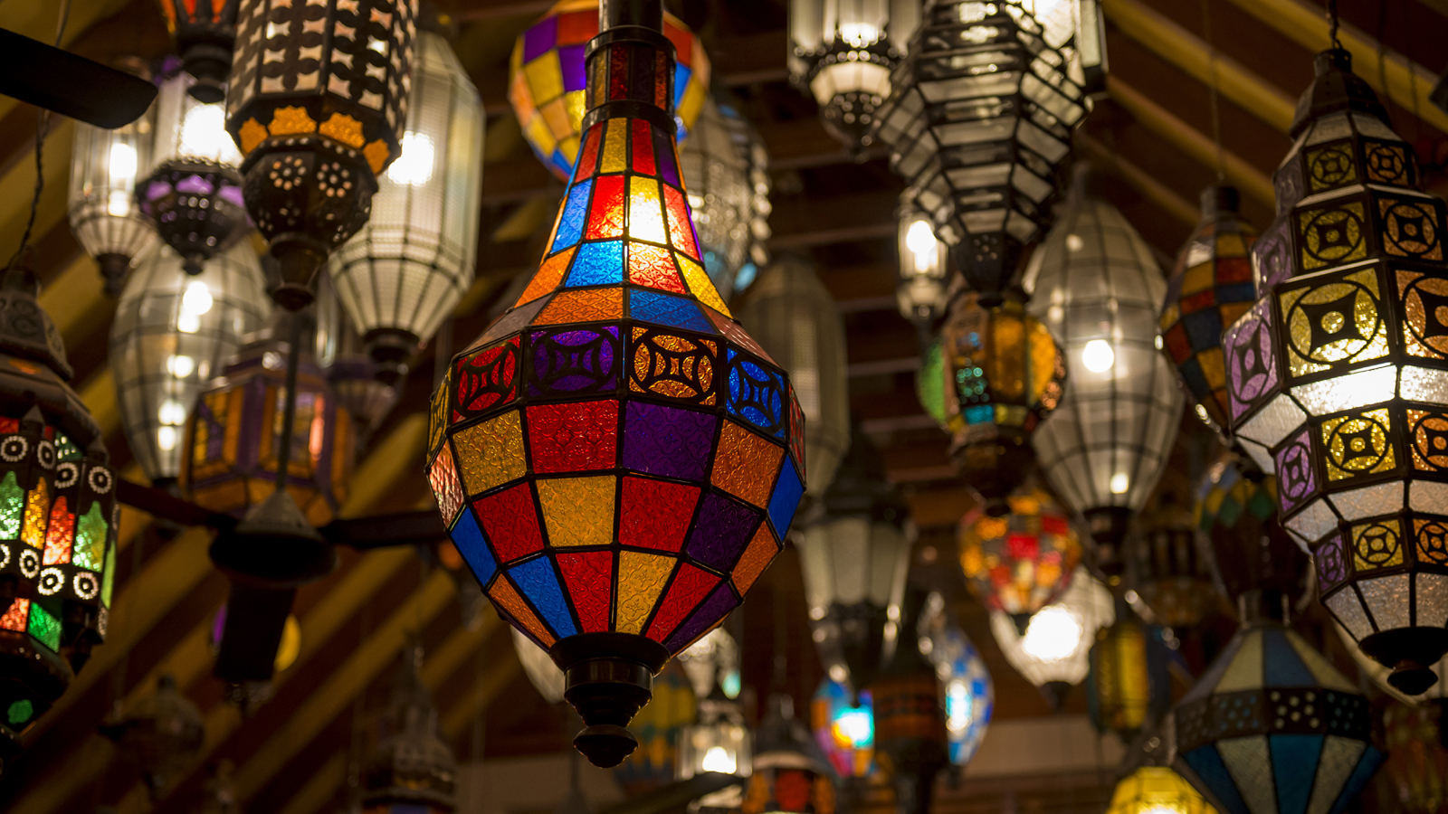 | May 4, 2017, Cairo at Nile Plaza, Egypt  A 1001 Ramadan Nights Celebration at Four Seasons Hotel Cairo at Nile Plaza  http://publish.url/caironp/hotel-news/2017/ramadan.html
May 4, 2017, Dubai, U.A.E.
Suite Summer Stays with Four Seasons Hotels and Resorts
http://publish.url/news-releases/2017/summer-suite-offers.html

PRESS CONTACTS

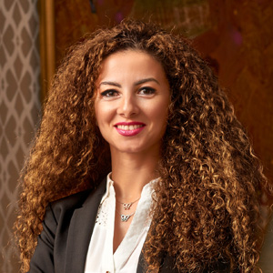 | Sherry Adel  Senior Director of Public Relations and Marketing Communications - Egypt  1089 Corniche El Nil, P.O. Box 63 Maglis El Shaab  Garden City 11519, Cairo  Egypt  sherry.adel@fourseasons.com  +20 (2) 2791 7000

