Four Seasons Hotel Miami Brings Australia Day to Brickell

Aussie specials and poolside barbie with Chef Aaron and his mates, January 23 to 29
January 4, 2017, Miami, U.S.A.

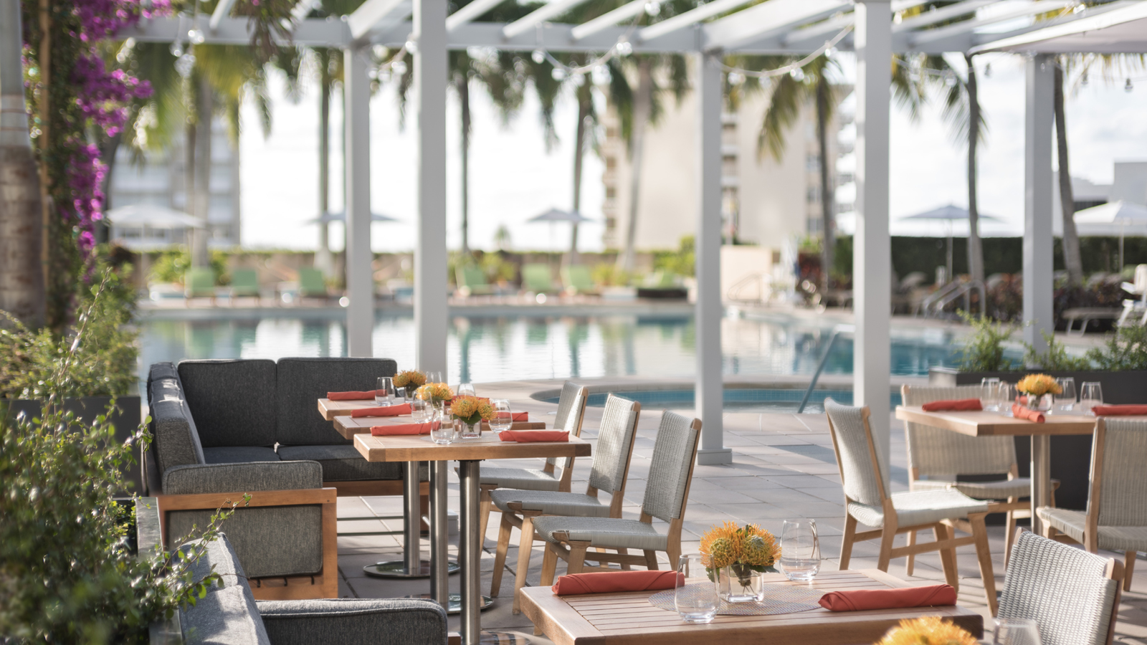
For the third consecutive year, Four Seasons Hotel Miami brings Australia Day to Brickell, with Aussie native and Executive Chef Aaron Brooks serving as the master of ceremonies. Named Miami’s “Lambassador” by Meat & Livestock Australia, Chef Aaron pays homage to the Land Down Under, and its January 26 national holiday with weeklong specials in EDGE, Steak & Bar and a special "barbie" with his "mates" on Sunday, January 29, 2017 from 1:00 to 4:00 pm at Bahía, the Hotel’s 7th floor poolside restaurant and lounge.
EDGE Steak & Bar Specials – January 23 to 29, 2017
The celebration begins on Monday, January 23 when Chef Aaron features his renditions of a few of his favourite dishes from back home on the EDGE menu. Diners can savour flavours from Australia on the USD 24, three-course Lunch Break menu, offered Monday through Saturday. Available all week, the Chef’s Tasting Menu will feature five surprise Australian-inspired courses for USD 55 per person.
- EDGE Reservations: Not required, but recommended, and can be made by contacting 305 381 3190 or edge@edgesteakandbar.com.
Bahía Barbie with Chef Aaron and his Mates – January 29, 2017
The week of festivities will conclude with a barbie in Bahía, the poolside restaurant and lounge, with Chef Aaron and his mates on Sunday, January 29 from 1:00 to 4:00 pm. Turning up the heat, Timon Balloo of SUGARCANE raw bar grill, Jimmy Lebron of 27 Restaurant & Bar, Bret Pelaggi of Threefold Cafe, Steve Santana of Taquiza, and Nicole Votano join Chef Aaron for an afternoon of grilling. Attendees will enjoy BBQ favourites, Aussie bites and wine, locally crafted beer from The Tank Brewing Co., and an exclusive, limited edition EDGE beer, brewed by J Wakefield Brewing and Chef Aaron himself. To add on to this great lineup, a couple of Aussies, Adrian Biggs and Chris Hopkins from Bacardi will be making some rum punches. Bring your "budgie smugglers," aka swimsuits, and enjoy complimentary access to the two resort-style pools, and celebrate winter in true Miami fashion – under the sun.
- Advance tickets are required and available at EDGEAustraliaDay.eventbrite.com for USD 75 per person, and include unlimited BBQ, Kangaroo Punch, select craft beer and wine, and complimentary pool access. Pool chairs are based upon availability. Eventbrite processing fee will be applied at time of purchase.
Reduced valet parking and self-parking (for up to three hours). Nearby street parking is also available.

RELATED

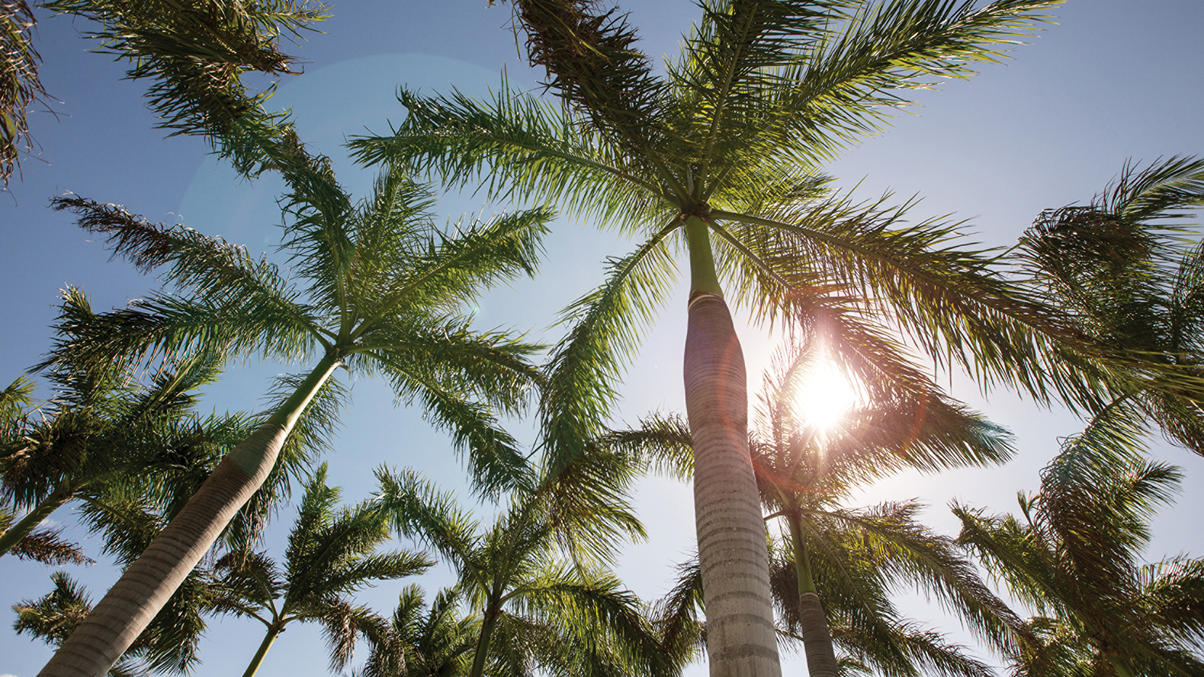 | March 16, 2017, Costa Rica  Four Seasons Resort Costa Rica at Peninsula Papagayo Introduces “Sol and City with Miami” with Four Seasons Hotel Miami  http://publish.url/costarica/hotel-news/2017/sol-and-city-package.html
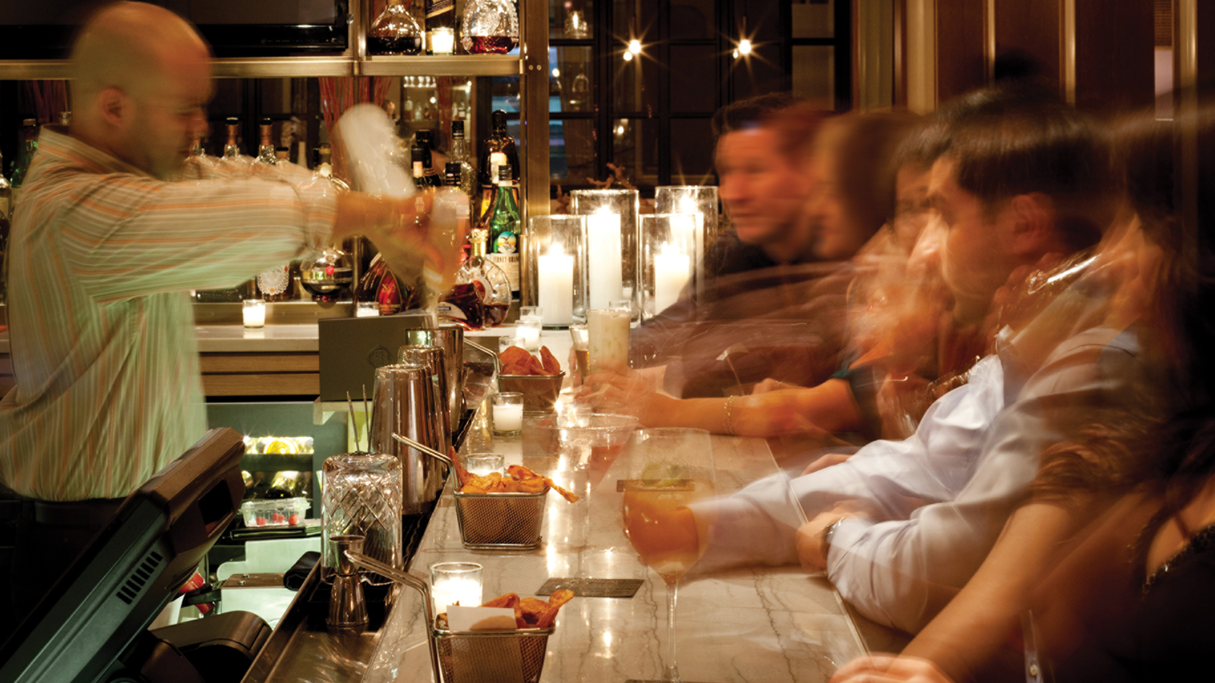 | December 5, 2016, Miami, U.S.A.  EDGE, Steak & Bar Five Year Anniversary Event at Four Seasons Hotel Miami  http://publish.url/miami/hotel-news/2016/edge-5th-anniversary.html

PRESS CONTACTS

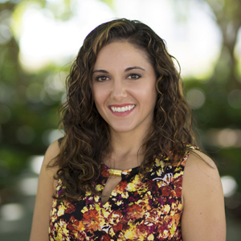 | Stephanie Cardelle  Director of Public Relations and Communications  1435 Brickell Avenue  Miami  U.S.A.  stephanie.cardelle@fourseasons.com  1 (305) 381-3037

