Four Seasons Hotel Los Angeles at Beverly Hills Announces Rooms Refresh with Homage to Old Hollywood

August 10, 2017, Los Angeles at Beverly Hills, U.S.A.

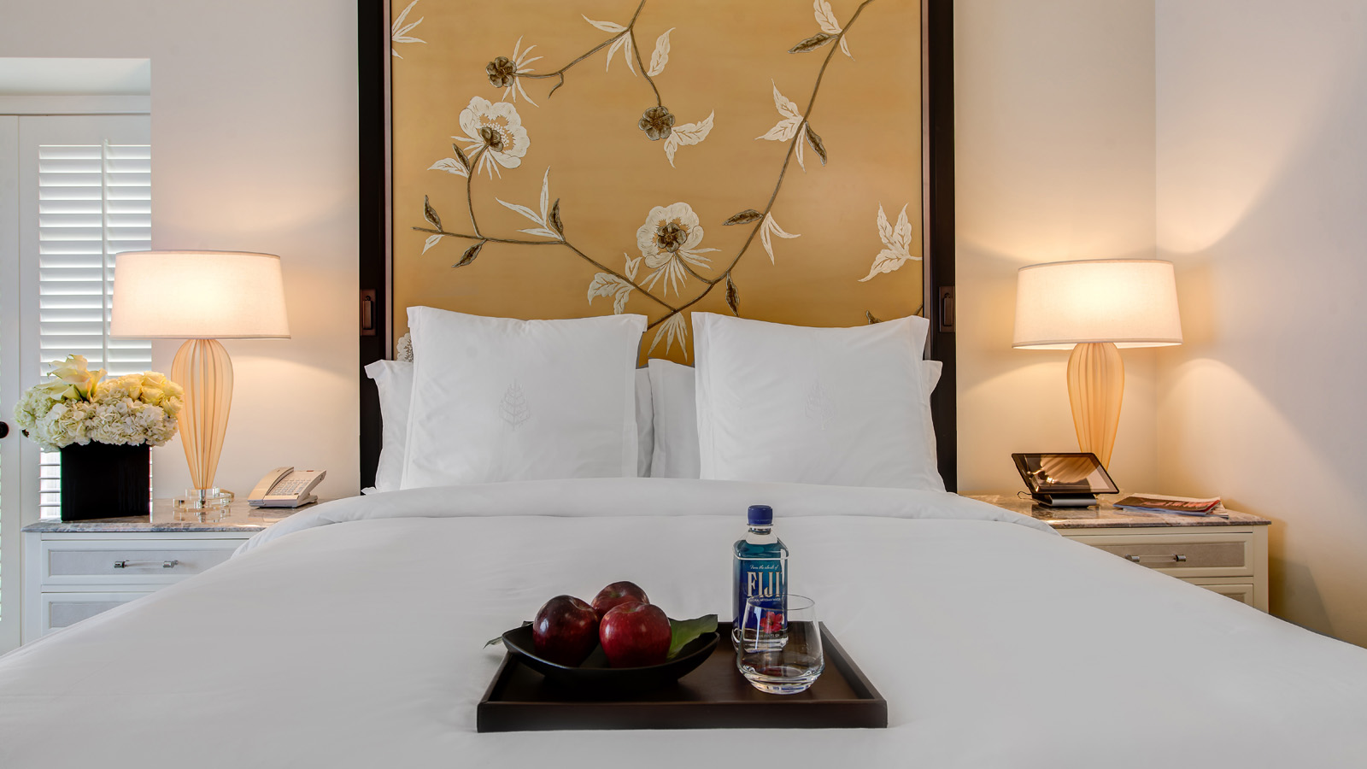
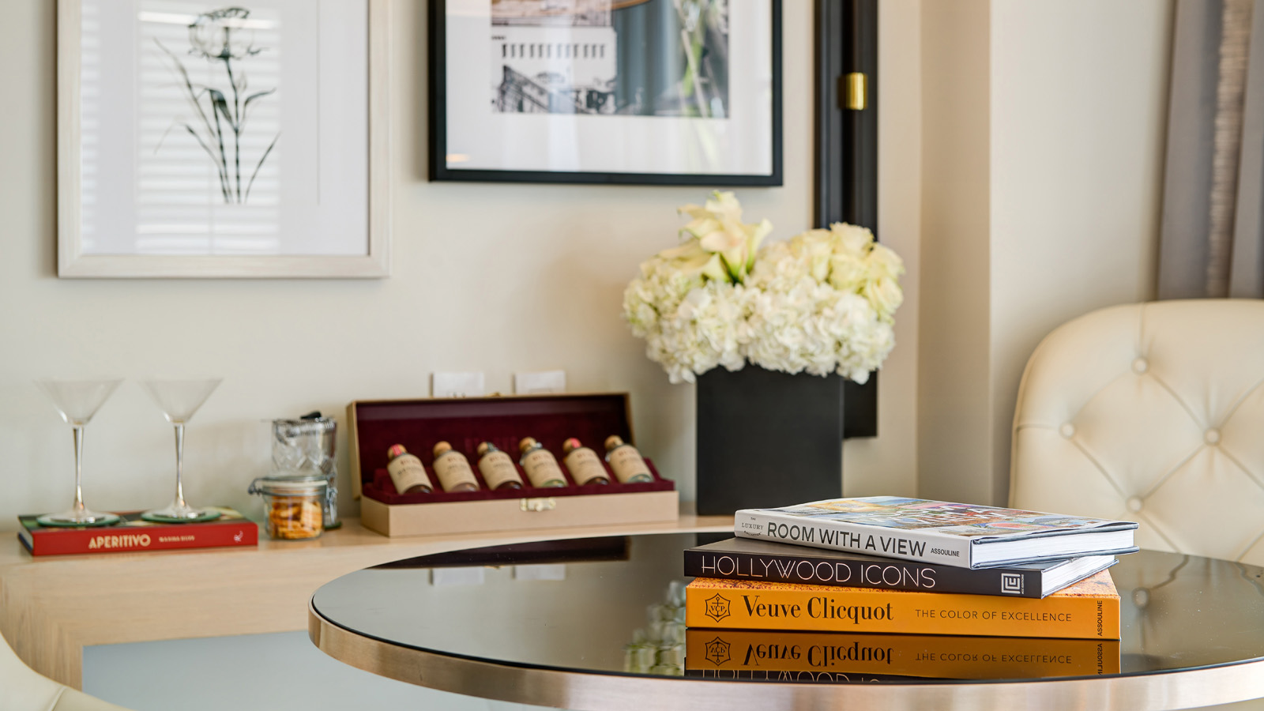 | 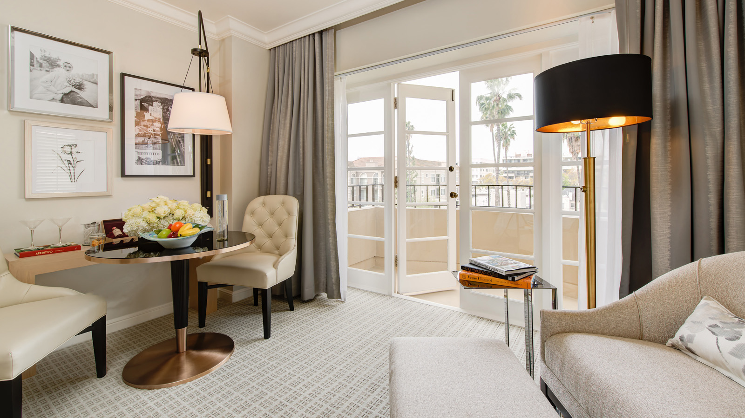 | 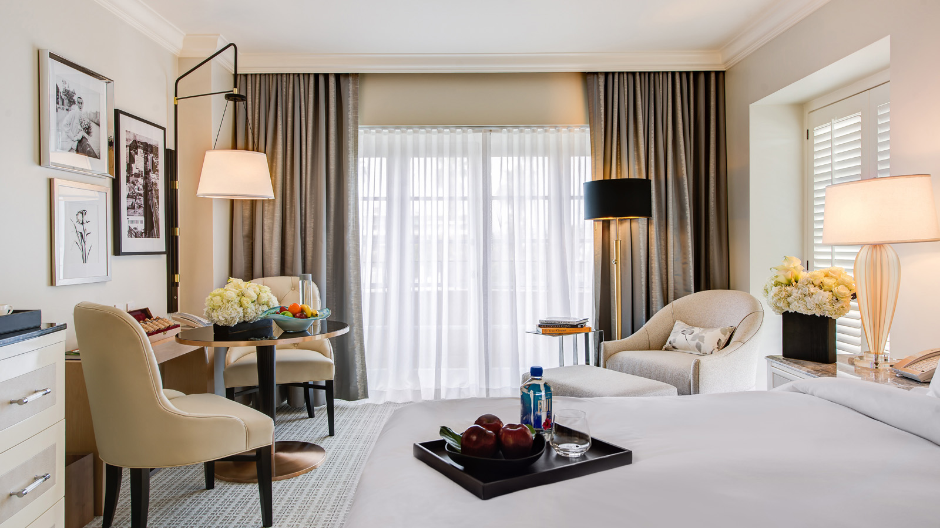
The iconic five-star
Four Seasons
Hotel Los Angeles at Beverly Hills is undergoing a complete interior redesign of all 285 guest rooms and suites, along with corridors and elevator lobbies. The project, led by Wimberly Interiors' Los Angeles office, is scheduled for completion by the end of 2017. The Hotel will remain fully operational during this process.
From the beginning, the Hotel has become a second home for celebrities and entertainment industry executives, and the importance of epic floral designs in public areas has always been a prominent theme throughout the years.
“It was extremely important in developing the design concept that we embraced the unique history of the Hotel,” says Jessica Houlemard, a senior designer at Wimberly Interiors. “We brought in a unique collection of neutrals with subtle textures to create a visual balance like that of a flower. It was an exciting challenge to use this inspiration to recreate the essence of Old Hollywood glamour in a fresh and timeless design.”
The overall aesthetic is modern and elegant. A soothing natural colour palette of beige, white and gray is juxtaposed with black accents and hints of Old Hollywood glamour. Framed black-and-white photography and art depicts historic scenes of Beverly Hills, silver screen stars and flowers. Corridors have been refreshed with sophisticated crystal chandeliers and fluted crystal glass wall sconces. Textured cream wall coverings and floral-patterned carpeting contrast with black guest room doors. The centerpiece of guest room interiors is a platform bed with a headboard upholstered in dramatic floral design to echo the floral arrangements throughout the Hotel.
Four Seasons
Hotel Los Angeles at Beverly Hills is especially fortunate to have artistic director Jeff Leatham, whose permanent studio is based at the Hotel, creating new floral displays on a weekly basis. The guest rooms also feature lizard-inspired detailing and crystal hardware. Floor-to-ceiling curtains dramatically frame the Hotel’s sweeping city views.

RELATED

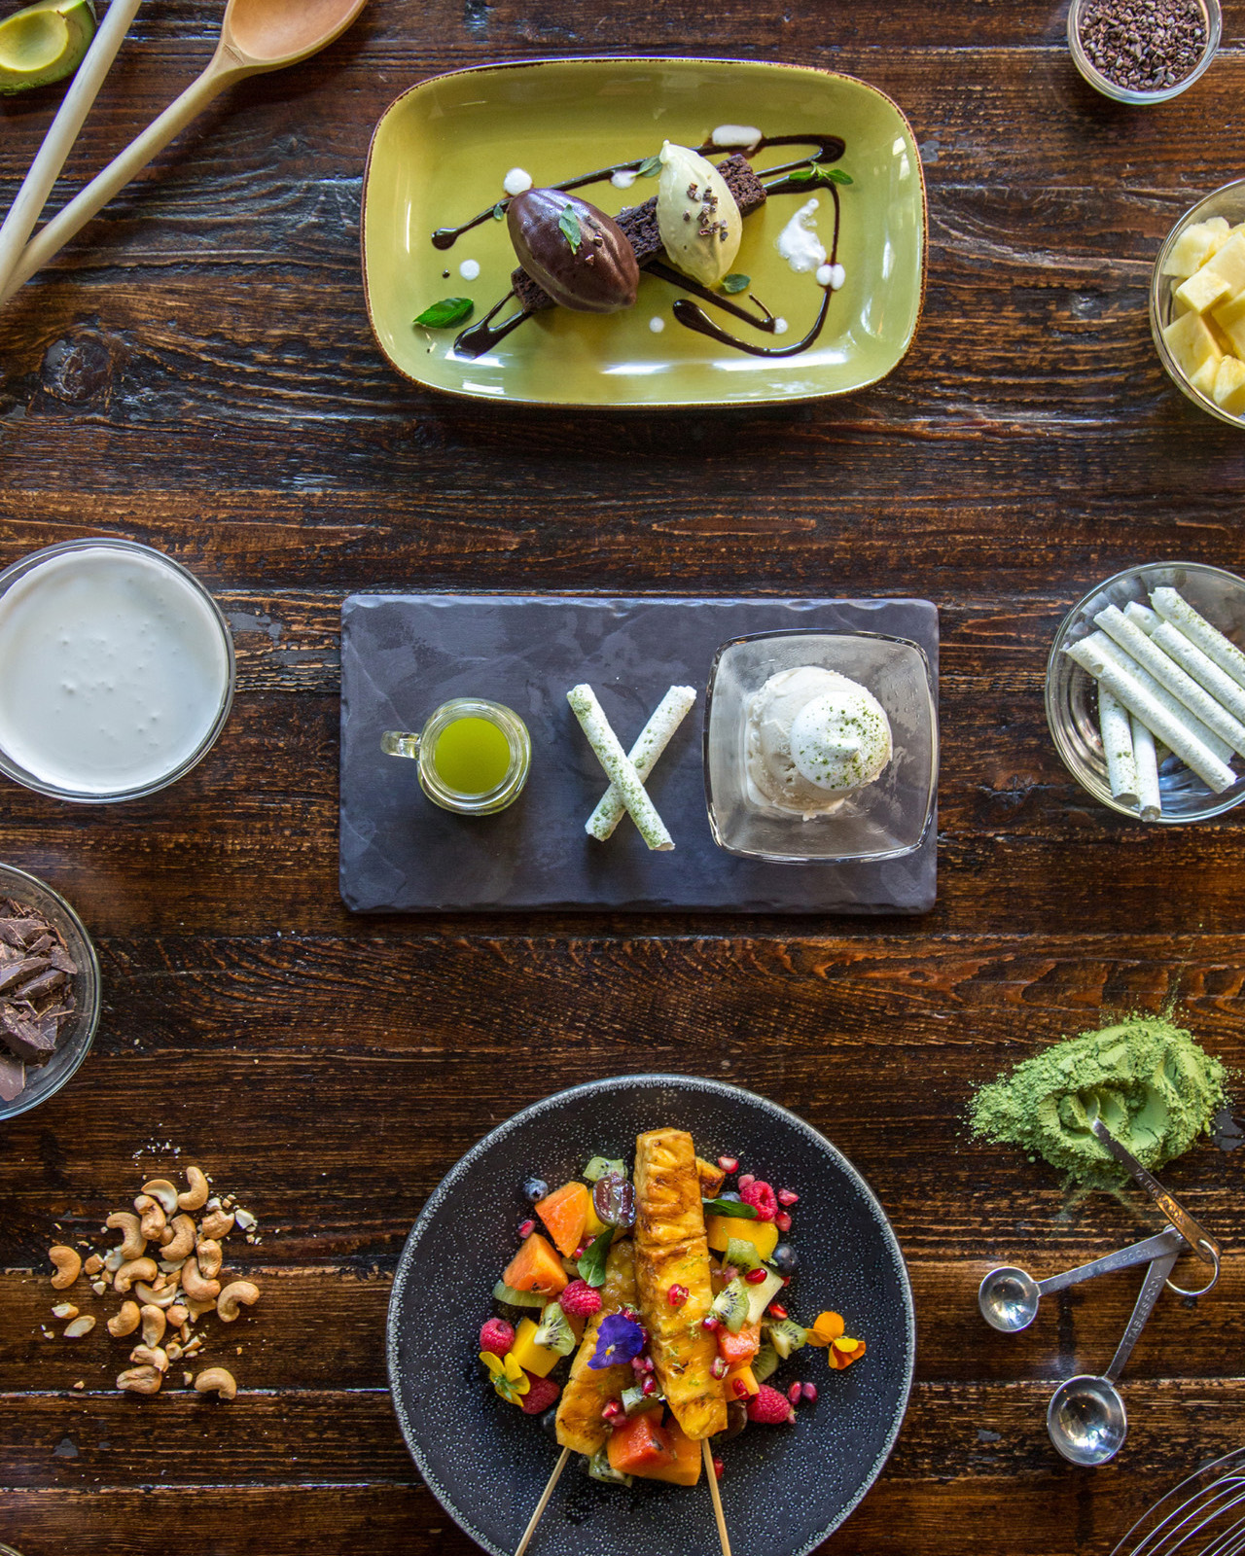 | May 26, 2017, Los Angeles at Beverly Hills, U.S.A.  Culina, Modern Italian at Four Seasons Hotel Los Angeles at Beverly Hills Debuts New Guilt-Free Dessert Menu  http://publish.url/losangeles/hotel-news/2017/new-healthy-desserts-at-culina.html
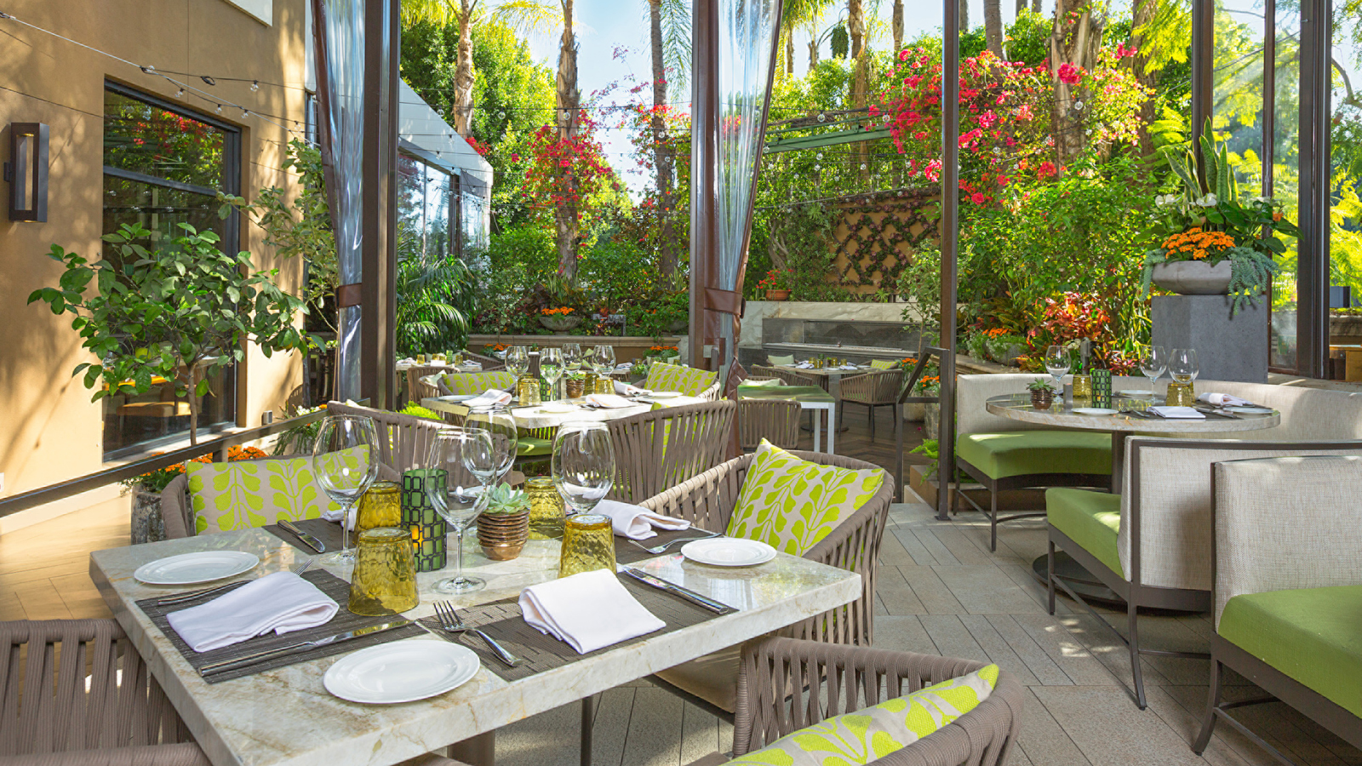 | May 10, 2017, Los Angeles at Beverly Hills, U.S.A.  Four Seasons Hotel Los Angeles at Beverly Hills Celebrates Global Wellness Day with Top Lifestyle and Wellness Experts  http://publish.url/losangeles/hotel-news/2017/wellness-la.html

PRESS CONTACTS

Melanee Shale
Digital Marketing Manager
300 South Doheny Drive
Los Angeles
U.S.A.
melanee.shale@fourseasons.com

+1 (310) 786-2217

Kim Kessler
Director of Public Relations
300 South Doheny Drive
Los Angeles
U.S.A
kim.kessler@fourseasons.com

1 (310) 786 2212

