Four Seasons Welcomes Back Edward Linsley as New General Manager of Four Seasons Resort Seychelles at Desroches Island

World traveller and veteran Four Seasons executive prepares island paradise for anticipated opening in early 2018
June 12, 2017, Seychelles, Desroches Island

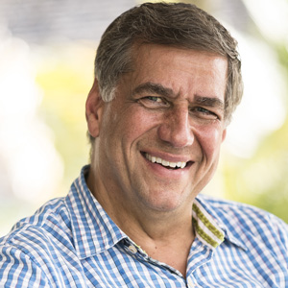
A keen sailor who is no stranger to life on secluded islands, Edward Linsley has circled the globe, touching down on all seven continents, including a recent trip to Antarctica. Now, as he prepares to open the new
Four Seasons
Resort Seychelles at Desroches Island, he’s focussing on getting to know this remote paradise, and looking forward to introducing guests to its unique charms.
“Ed is not only passionate about the hospitality industry, but also has the ability to inspire and takes a genuine interest in the communities where he works, connect with people and work towards common goals for the location and the business,” notes Simon Casson, President, Hotel Operations - Europe, Middle East and Africa. “We are delighted to welcome Ed back to the
Four Seasons
family.”
Ed originally joined
Four Seasons
in 1990, and quickly made his mark in progressive management positions in both urban hotels and island resorts over a period of 21 years – notably in Nevis, Hawaii and Bali. Time away from the company included general manager positions in Bali and The Nam Hai in Vietnam (which is now a
Four Seasons
resort), and most recently, he was managing director at Rosewood Little Dix Bay in the British Virgin Islands.
A lover of fine wines, Ed looks forward to adding local pieces to his art collection and exploring the islands and waters of his new home in Seychelles.
About
Four Seasons
Resort Seychelles at Desroches Island
Anticipated to open in early 2018,
Four Seasons
Resort Seychelles at Desroches Island will offer exclusive access to world-class adventure and rejuvenation in a secluded island paradise. Lush tropical forest surrounds white sand beaches and clear waters ideal for diving and fishing, while rustic luxury-style pool villas and residences offer relaxing respite with every modern convenience. An organic spa, an onsite tortoise sanctuary and abundant wildlife offer myriad opportunities to engage and reconnect.
The new resort joins sister property
Four Seasons
Resort Seychelles, as well as
Four Seasons
Indian Ocean island experiences in Mauritius and the Maldives.

RELATED

March 29, 2018, Seychelles
Four Seasons Appoints Edward Linsley as Senior General Manager of both Four Seasons Resorts in Seychelles
https://publish.url/seychelles/hotel-news/2018/new-senior-general-manager-edward-linsley.html

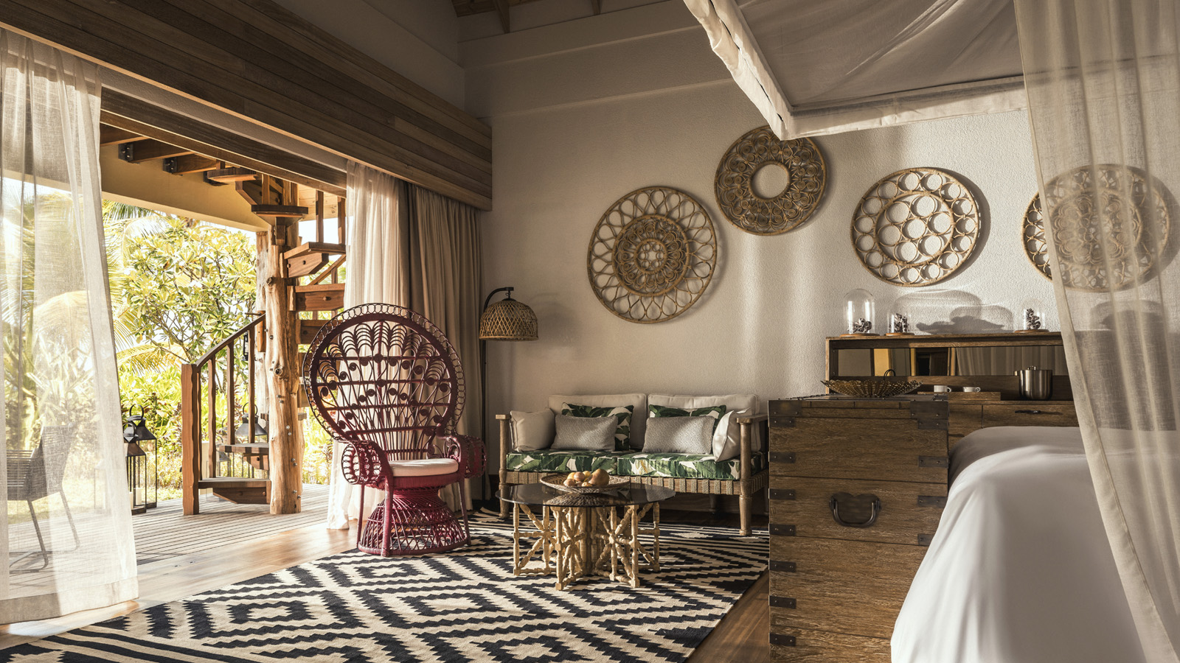 | March 1, 2018, Seychelles, Desroches Island  Four Seasons Hotels and Resorts Annuncia L'Apertura del Four Seasons Resort Seychelles at Desroches Island  https://publish.url/it/seychellesdesroches/hotel-news/2018/now-open-4.html

PRESS CONTACTS

Debbie Duval
Senior Director of Public Relations and Communications

Beau Champ
Mauritius
debbie.duval@fourseasons.com

(230) 402 3100

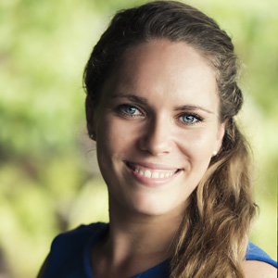 | Amy Sefton  Public Relations Manager  Petite Anse, Baie Lazare, P.O. Box 1397  Victoria, Mahe  Seychelles  amy.sefton@fourseasons.com  +248 439 3016

