Four Seasons Hotel Jakarta Celebrates First Anniversary

July 4, 2017, Jakarta, Indonesia

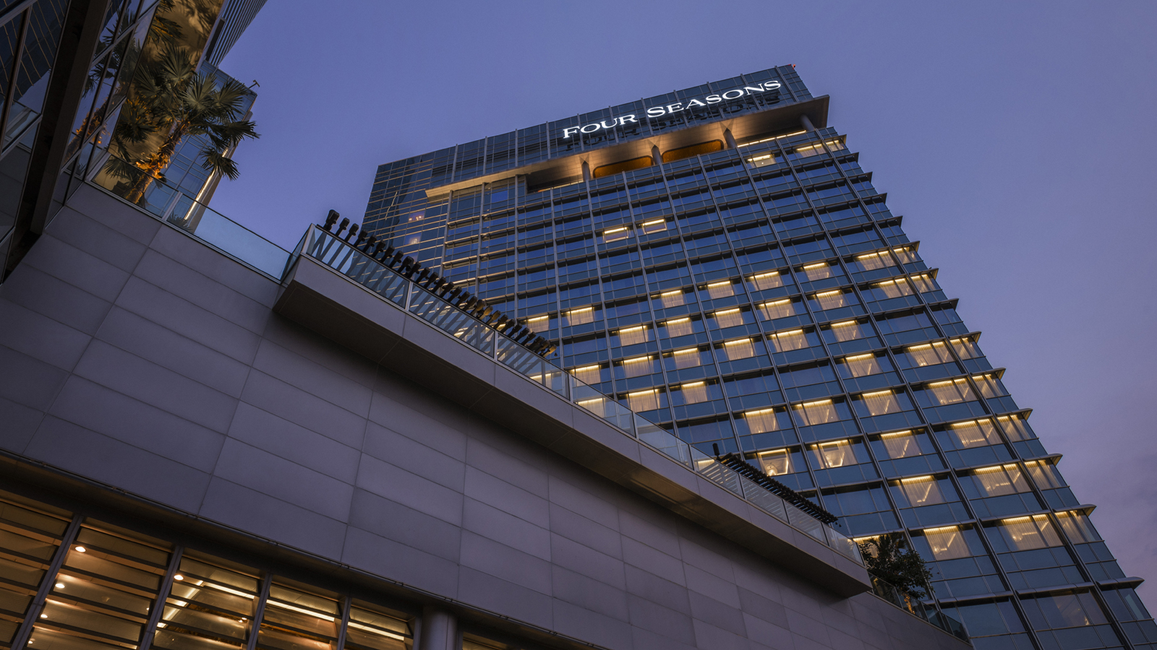
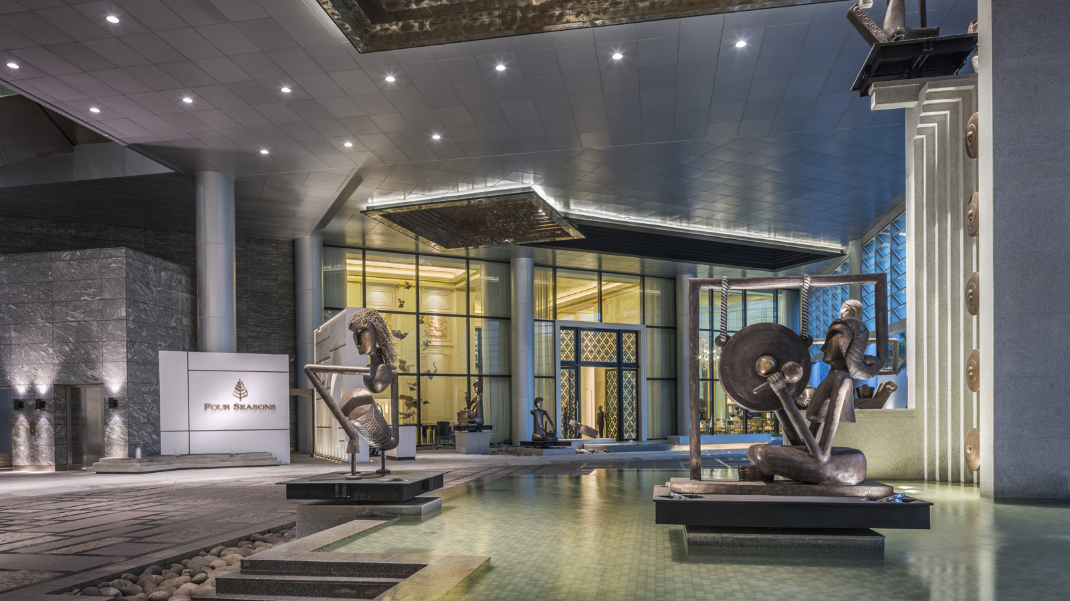 | 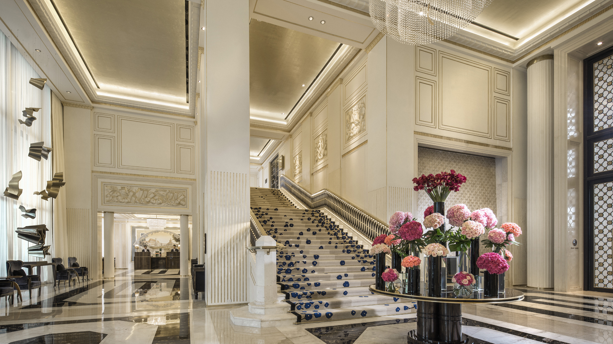 | 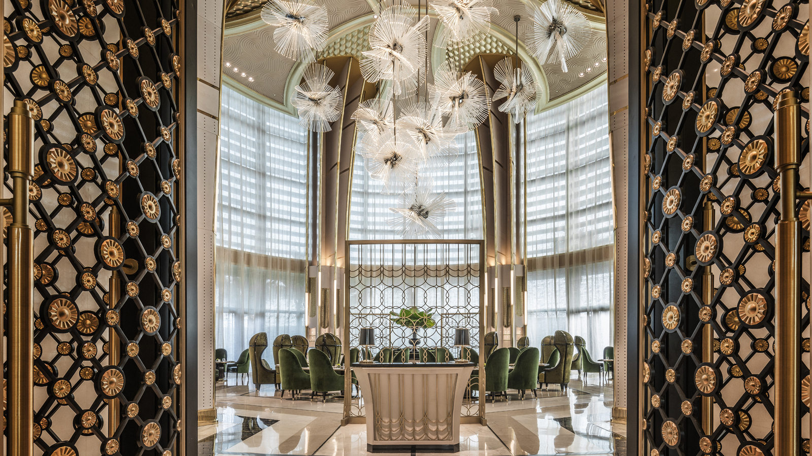
Four Seasons
Hotel Jakarta commemorates its 1st anniversary in July 2017 and the Hotel invites guests to celebrate together with family and friends.
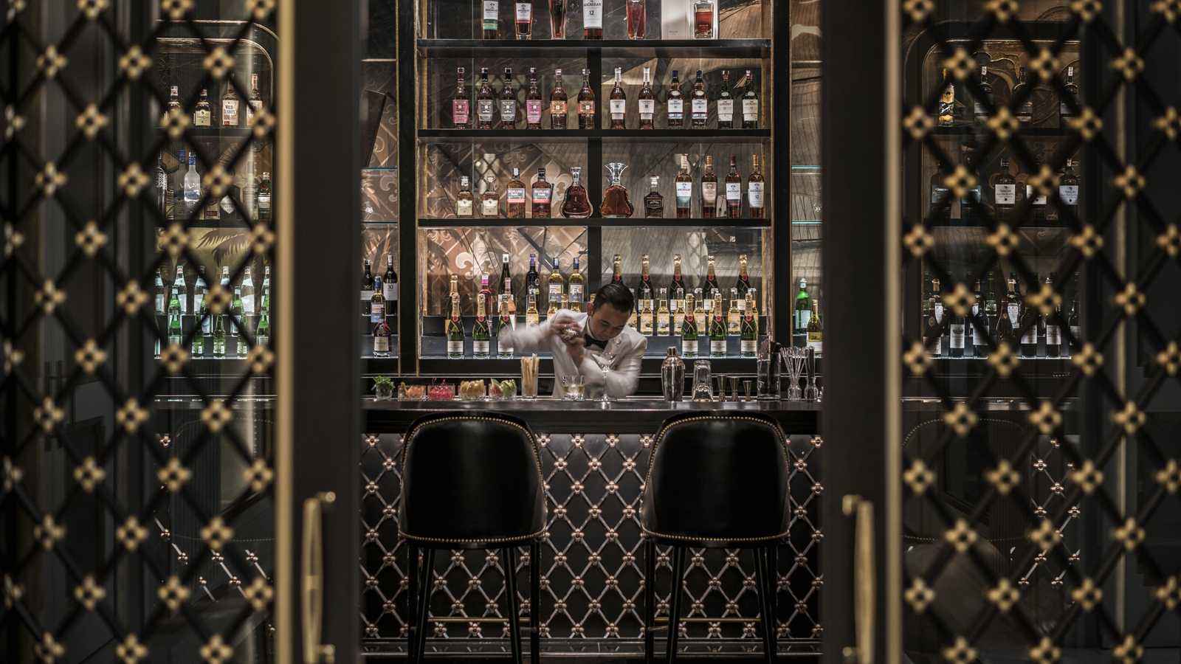 | 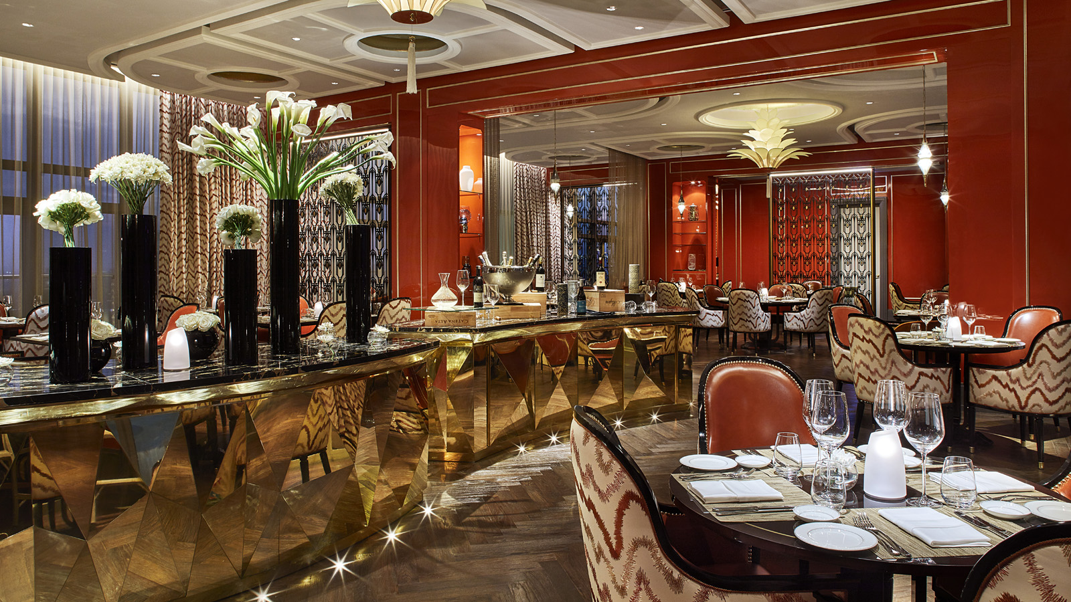
“In June of last year we opened our doors and received the first guests in our restaurants and the Hotel,” says Christian Poda, General Manager,
Four Seasons
Hotel Jakarta. “The last 12 months have been an exciting journey for us. To be honest, we have been so busy that we almost forgot about our first anniversary coming up soon!”
He continues, “It is a significant milestone for any hotel, and our first year has been overwhelmingly positive. This first anniversary would not be possible without our team, clients, partners, family and friends who have supported us from the beginning. In this special month, Four Seasons Hotel Jakarta would like to share an array of exciting options to show our appreciation for their continuous support.”
Alto Restaurant & Bar
A three-course truffle menu for lunch and dinner at Alto Restaurant & Bar, specially created by Executive Chef Marco Riva, is available at IDR 888,000.
Palm Court
Perfect for any occasion, Palm Court features a special three course East meets West anniversary menu, available at IDR 450,000 per person.
Nautilus Bar
Nautilus Bar rewinds the clock as it features special cocktails from its Take Over series. Special cocktails by three world-renowned bartenders are featured: Modest Mule by Jeremy Chua from 28 Hong Kong Street, Singapore; Thai Chili by Nico de Soto from Mace, New York; and Soft Ice by Philip Bischoff from Manhattan Bar; Singapore.
La Patisserie
La Patisserie features a special cake - gianduja passion tart. For a lovely afternoon, La Patisserie offers an afternoon tea that guests can enjoy at Palm Court or La Patisserie.
Two is Better than One
Guests can pamper with a rejuvenating escape at the city's ultimate urban sanctuary. Choose any treatment and receive a second treatment at half price at the Spa. This special package is valid on weekdays for the entire month of July 2017.
Share a Favourite Moment at Four Seasons Hotel Jakarta
The Hotel launches a social media contest on Instagram. Three winners will be chosen at the end of the month, with the chance to win amazing prizes.
The social media contest will be held from July 1 until 31, 2017. Everyone can participate in this contest. All entrants need to do is to submit a photo during July 2017, sharing a favorite moment with
Four Seasons
on their Instagram. To be eligible to win, entrants must follow @FSJakarta on Instagram, tag @FSJakarta in the Instagram photo and use the hashtag #FSJakarta #FSturning1 in the caption.
The Hote will pick three winners that may win a staycation for two nights, indulgent spa, and lunch at the Hotel's world class dining experience Alto Restaurant & Bar. Winners will be announced on Instagram @FSJakarta, and the team will contact each winner individually in the beginning of August 2017.

*Prices above are exclusive to 10 percent service charge and 11 percent government tax.

RELATED

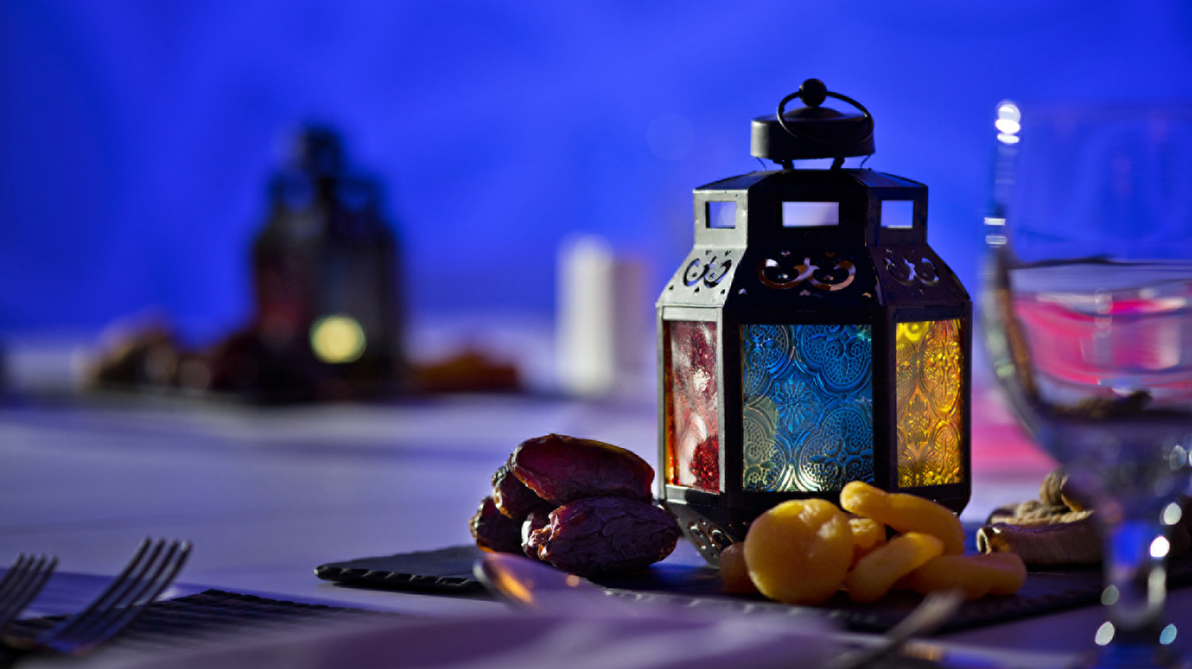 | May 17, 2017, Jakarta, Indonesia  The Holy Month of Ramadan at Four Seasons Hotel Jakarta  http://publish.url/jakarta/hotel-news/2017/ramadan.html
May 2, 2017, Jakarta, Indonesia
Treat Her Like a Queen on Mother's Day at Four Seasons Hotel Jakarta
http://publish.url/jakarta/hotel-news/2017/mothers-day.html

PRESS CONTACTS

Rumman Amanda
Public Relations Manager
Jalan Jenderal Gatot Subroto Kav. 18
Jakarta
Indonesia
rumman.amanda@fourseasons.com

+62 21 227 71888

