Four Seasons Appoints Michael Newcombe as Chair of Global Spa and Wellness Task Force

Promoting holistic approach to spa and wellness,
Four Seasons
spas combine traditional techniques and modern technologies in results-oriented treatments
March 8, 2017, Toronto, Canada

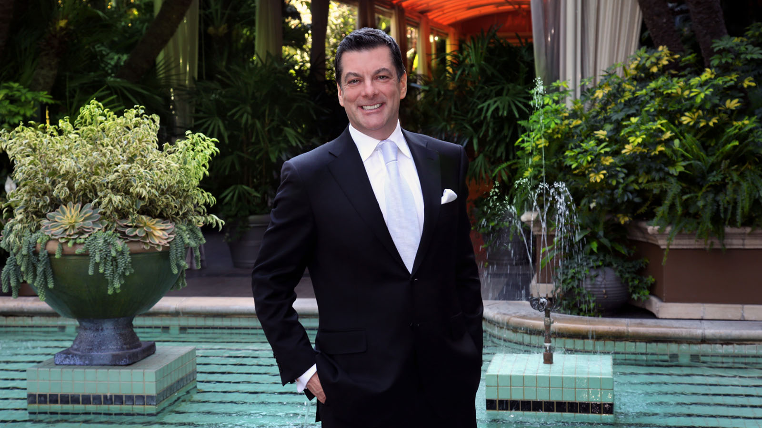
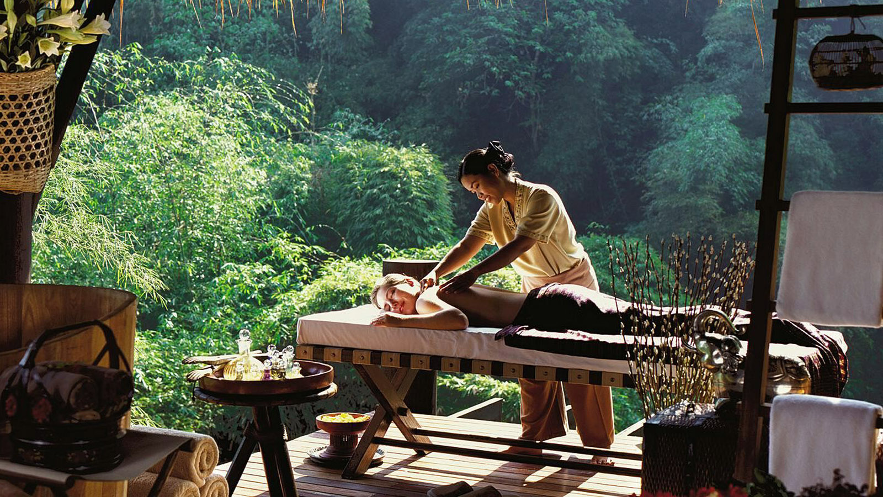 | 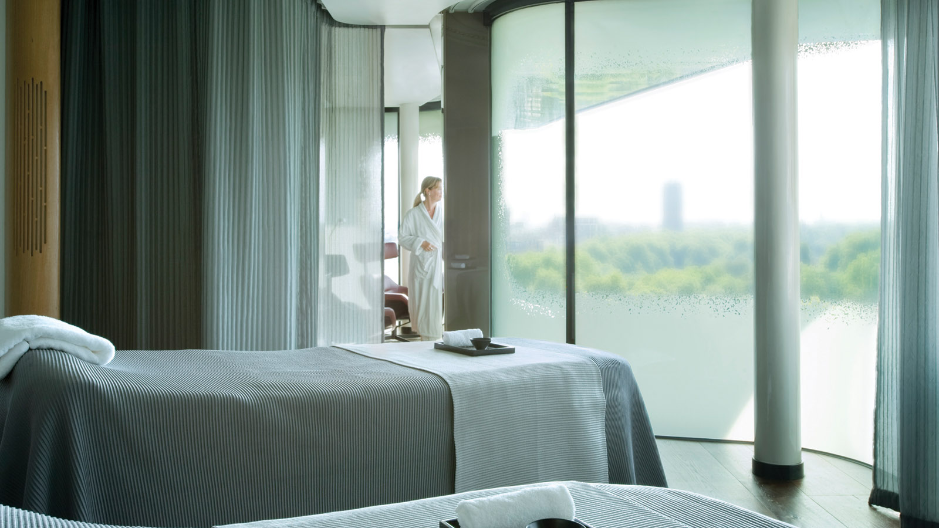 | 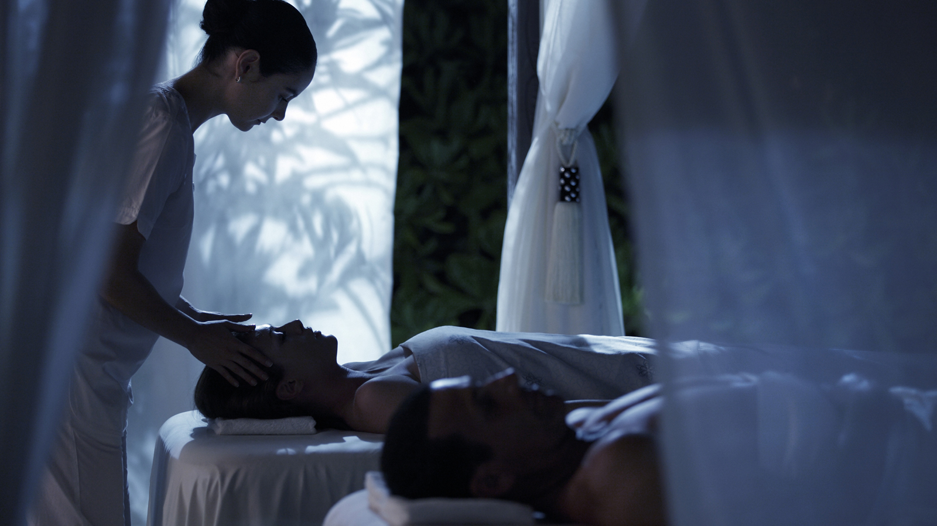
Four Seasons
Hotels and Resorts, the world’s leading luxury hospitality company and largest luxury spa operator, has appointed Michael Newcombe as Chair of the company’s Global Spa and Wellness Task Force. Comprised of passionate and visionary
Four Seasons
spa professionals from around the world, the Spa and Wellness Task Force guides
Four Seasons
global spa strategy, supporting the success and development of a growing portfolio of
Four Seasons
spas worldwide.
 | 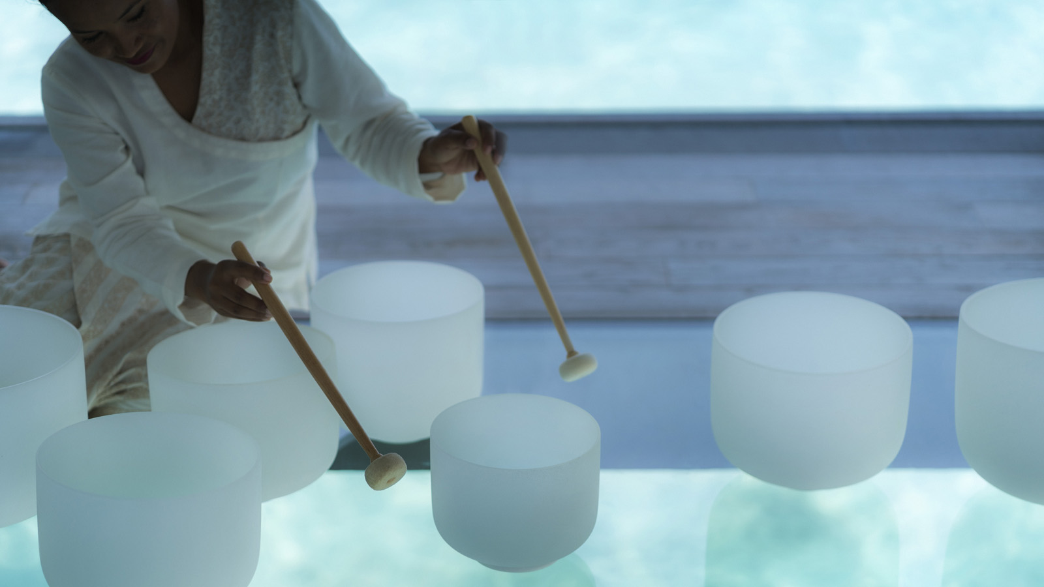 | 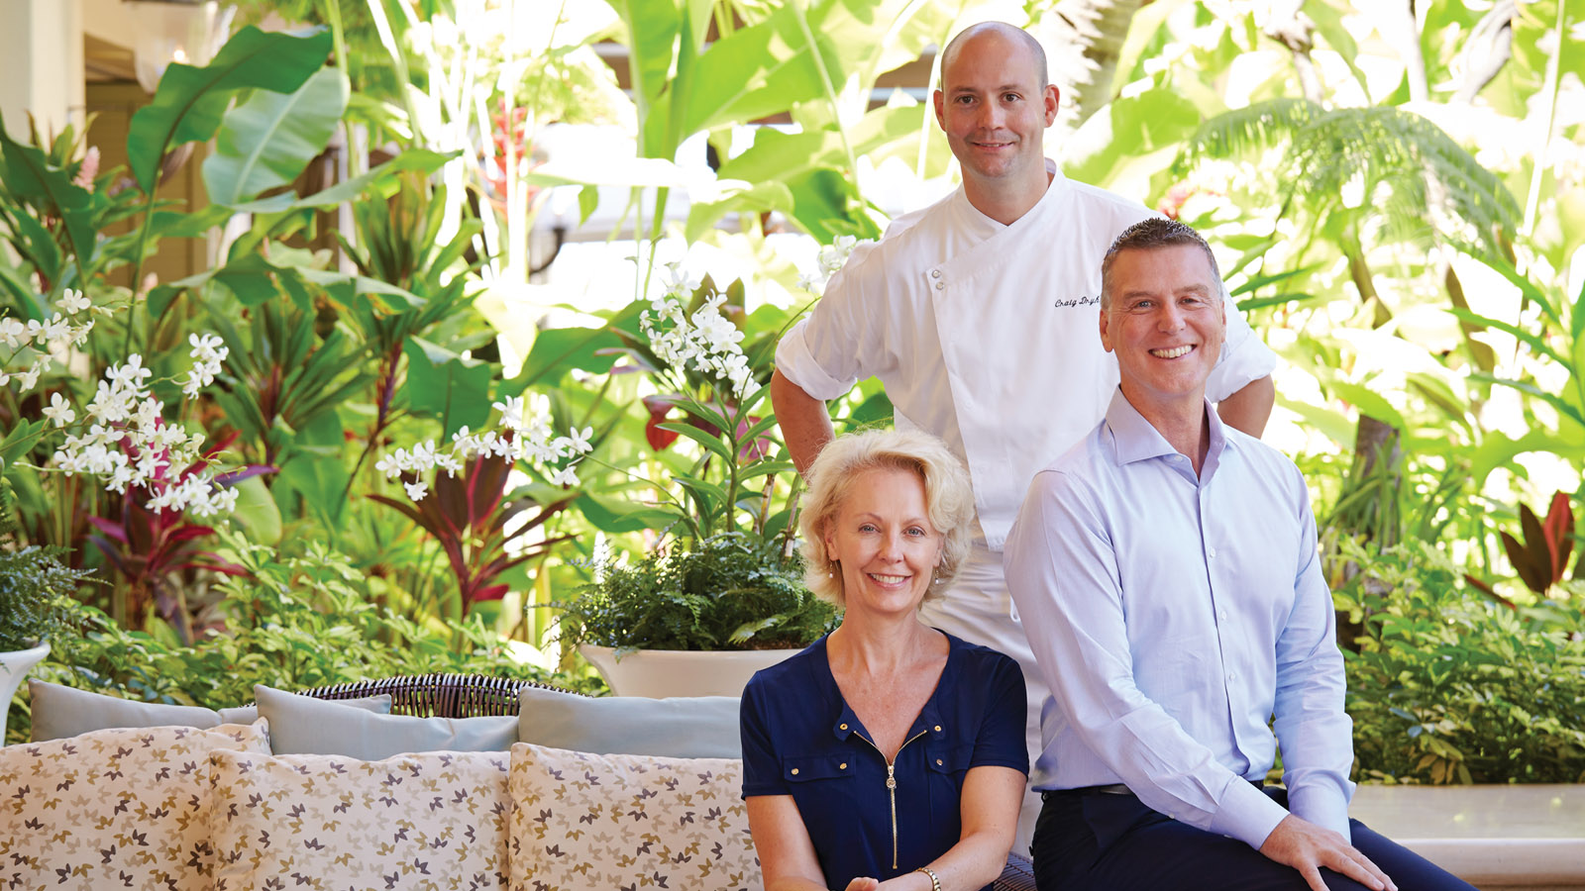
In his new role, Newcombe will place holistic wellness at the forefront of the Task Force’s mandate. As an avid cycler and lifelong advocate of health and wellness, Newcombe explains, “Wellness isn’t just about appearance or feeling good, it’s about restoring and maintaining balance, both physically and mentally. Whether it’s eating healthy and staying active while on a business trip or taking time to relax and recharge while on vacation, our goal is to create highly personalised, holistic spa experiences for each of our guests, helping them regain balance and find tranquility in their travels.”
As current General Manager of
Four Seasons
Hotel Los Angeles at Beverly Hills and the Americas Task Force Lead for the past four years, Newcombe has long been immersed in the world of spa and wellness. Since joining
Four Seasons
in 1991, Newcombe has overseen management of some of the company’s most renowned spas, including
Four Seasons
Resort and Club Dallas at Las Colinas - the first hotel in North America to offer a full-service spa;
Four Seasons
Hotel London; and the comprehensive spa and wellness program at
Four Seasons
Hotel Westlake Village, California. Having started his career in wellness at the single-room spa at the former
Four Seasons
Hotel Toronto in 1997, Newcombe has seen
Four Seasons
spa portfolio grow to the largest collection of luxury spas in the world, with 97 full-service spas of up to 28 treatment rooms. Combining a wealth of traditional knowledge alongside state-of-the-art technology,
Four Seasons
spas offer an extensive variety of services from hammams, laconium beds, underwater treatments and vitality pools to personalised weight loss programs, diamond-tip microdermabrasion treatments, advanced air massage facials, electroporation and LED light therapy among other offerings.
Globally Minded, Locally Grounded
Speaking to
Four Seasons
global spa strategy, Newcombe comments, “Authenticity and service have always been fundamental to
Four Seasons
spa experiences and the key to our global success. As our portfolio of spas has expanded, we’ve tapped into the unique wealth of local wellness knowledge that each destination holds while harnessing the world’s most advanced therapies. Helping our guests stay grounded is a vital part of any wellness experience, and a great sense of that grounding comes from genuine service and local authenticity.”
From the design of the treatment rooms to the locally-sourced, chemical-free ingredients on many spa menus, each
Four Seasons
spa is designed to be in harmony with its destination, incorporating local traditions and techniques as well as the latest scientific breakthroughs to achieve an authentic spa experience that is deeply connected to the destination.
More than a Massage:
Four Seasons
Holistic Approach to Spa and Wellness
Offering a variety of options that cater to every lifestyle, including best-in-class clean-eating options, in-house wellness consultants, meditation sessions and extensive fitness classes and facilities, Four Seasons spa offerings are designed to help guests achieve balance and overall wellness. Lifestyle spa and wellness offerings at select
Four Seasons
spas include innovations such as:
- Eight-Handed Massage at
Four Seasons
Resort Mauritius at Anahita: One of the only eight-handed massages in the world, the “Let it Go” treatment at
Four Seasons
Resort Mauritius at Anahita features a synchronised sensory treatment from four therapists, taking the ancient Ayurvedic techniques of four-handed massage to new heights of relaxation and rejuvenation. Combining fluid and harmonious motions from multiple therapists, the treatment helps guests achieve inner balance and mental relaxation.
- BioMeditation Therapy at
Four Seasons
Hotel Los Angeles at Beverly Hills: An innovative healing practice originating in Russia and perfected by
Four Seasons
spa therapist Jeannette von Johnsbach, Bioenergetic meditation is designed to remove energetic blockages and correct inputs at the energetic level, enabling the body to recognise imbalances and regenerate at the core. The therapy is known to naturally activate self-healing and strengthen the immune system, nervous system and metabolism, supporting guests in their journey to inner harmony and self-healing.
- Crystal Singing Bowl Sound Baths at
Four Seasons
Resort The Nam Hai, Hoi An, Vietnam: Inspired by Vietnamese Zen master Thich Nhat Hanh and perched above a tranquil lotus pond, the Resort’s The Heart of the Earth Spa is designed to help guests align with nature’s rhythms and improve harmony within themselves and between humanity. All treatments feature crystal singing bowls, tuned to the harmonic intonation of nature to join body and mind with the Earth’s heartbeat.
- Wellness Your Way at
Four Seasons
Resort Maui at Wailea: Recognising that there is no single journey to wellness, the Spa at
Four Seasons
Resort Maui offers fully customisable spa programs, individually designed for each guest’s unique wellness journey. Including everything from energy-focused spa treatments, health-conscious cuisine, an array of fitness classes and guided meditations to consultations and treatments with an on-site nutritionist, chiropractor and acupuncturist, the breadth and depth of each guest’s journey can be tailored to their individual wellness goals.

RELATED

March 8, 2017, Toronto, Canada
Four Seasons ernennt Michael Newcombe zum Chair of Global Spa and Wellness Task Force
http://publish.url/news-releases/2017/michael-newcombe-chair-global-spa-and-wellness-task-force-4.html

March 8, 2017, Toronto, Canada
フォーシーズンズ、グローバルスパ アンド ウェルネス タスクフォースのリーダーにマイケル・ニューカムを任命
http://publish.url/news-releases/2017/michael-newcombe-chair-global-spa-and-wellness-task-force-5.html

PRESS CONTACTS

Sarah Tuite
Director, Corporate Communications and Public Relations
1165 Leslie Street
Toronto
Canada
prsm@fourseasons.com

+1 (416) 441-4440

