Four Seasons and Venus Assets Announce Four Seasons Hotel in Kuala Lumpur, Located in Premier Golden Triangle Neighbourhood

Four Seasons strengthens presence in Southeast Asia with first urban property in Malaysia
December 14, 2016, Toronto, Canada

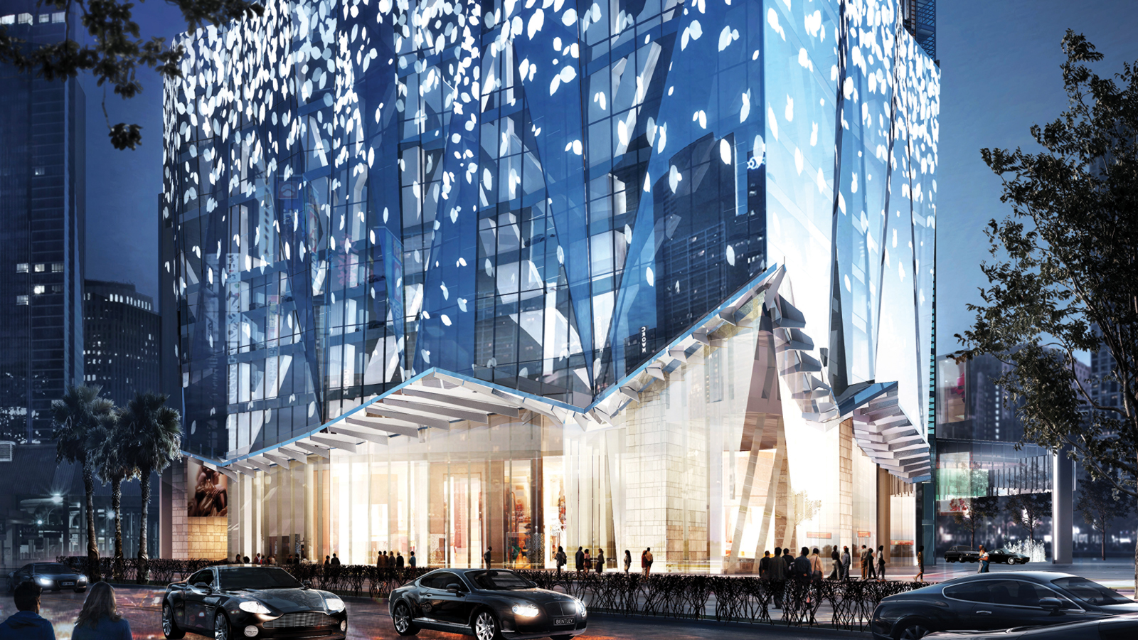
Four Seasons
Hotels and Resorts, the world’s leading luxury hospitality company, and Venus Assets Sdn Bhd (“Venus”), an internationally renowned property developer, today announced plans for
Four Seasons
Hotel Kuala Lumpur, set to open in early 2018. Located in the heart of the Golden Triangle neighbourhood, Kuala Lumpur’s thriving business and financial district, the Hotel is part of a 65-storey mixed-use tower that will include 242
Four Seasons
Private Residences, 27 serviced apartments, a 209-key Four Seasons hotel and a five-floor, 300,000 square foot (27,900 square metre) luxury retail podium, collectively known as
Four Seasons
Place Kuala Lumpur.
The latest addition to the city’s dramatic skyline and a vibrant hub for both business and leisure travellers,
Four Seasons
Hotel Kuala Lumpur will be conveniently located in close proximity to the city’s major attractions, including the Petronas Twin Towers and the Kuala Lumpur City Centre (KLCC).
Often referred to as a “city within a city,” the KLCC will offer guests of the Hotel designer shopping, fine dining, and the best of the city’s electric nightlife. The Hotel will also overlook the KLCC Park and be directly connected to the esplanade, allowing guests to take full advantage of the Park’s 50 acres (20 hectares) of green space, including lush gardens, fountains, waterfalls, a wading pool, and jogging track.
“
Four Seasons
Place is a multi-billion ringgit project with an iconic and majestic tower that elegantly combines a legendary name with a landmark address. With this new project, we are excited to continue our successful partnership with Four Seasons, a name synonymous with quality and service, to create the most exclusive hotel and private residences in Kuala Lumpur,” said Tan Sri Syed Mohd Yusof bin Tun Syed Nasir, Director and Shareholder, Venus Assets.
“One the most dynamic and fastest growing cities in the world, Kuala Lumpur is a key hub for both business and leisure travel, and an exciting destination for
Four Seasons
to establish a presence,” said J. Allen Smith, President and CEO,
Four Seasons
Hotels and Resorts.
Continued Smith, “We’re proud to work in partnership with Venus Assets to bring their vision for this remarkable property to life. We look forward to welcoming luxury travellers and private residence owners to experience
Four Seasons
legendary hospitality in the heart of Kuala Lumpur’s most vibrant neighbourhood, the Golden Triangle.”
An exciting addition to Kuala Lumpur’s culinary scene, the Hotel will introduce four unique dining outlets to the city, including a Cantonese restaurant, lobby and pool bars, and an all-day dining restaurant.
The Hotel will also offer an executive lounge for business travellers, a serene spa, wellness-focused fitness centre and pool. Lush landscaping around the pool and terrace will create an urban oasis, echoing the greenery of the KLCC Park below.
Four Seasons
Hotel Kuala Lumpur will offer both international and regional travellers an urban complement to the existing
Four Seasons
resort in Malaysia, the award-winning
Four Seasons
Resort Langkawi.
About Venus Assets Sdn Bhd
Venus Assets Sdn Bhd is a boutique real estate development firm based in Kuala Lumpur, Malaysia whose principals include, His Royal Highness Sultan Sharafuddin Idris Shah, The Sultan of Selangor, Tan Sri Syed Yusof bin Tun Syed Nasir, David Ban Song Long, as well as Ong Beng Seng, who has a long-standing relationship with
Four Seasons
Hotels and Resorts and owns a number of
Four Seasons
properties throughout the world.

RELATED

December 14, 2016, Toronto, Canada
Luxury Hotel in Kuala Lumpur Announced by Four Seasons and Venus Assets
http://publish.url/news-releases/2016/new-four-seasons-in-kuala-lumpur-6.html

December 14, 2016, Toronto, Canada
Luxury Hotel in Kuala Lumpur Announced by Four Seasons and Venus Assets
http://publish.url/news-releases/2016/new-four-seasons-in-kuala-lumpur-3.html

PRESS CONTACTS

Sarah Tuite
Director, Corporate Communications and Public Relations
1165 Leslie Street
Toronto
Canada
prsm@fourseasons.com

+1 (416) 441-4440

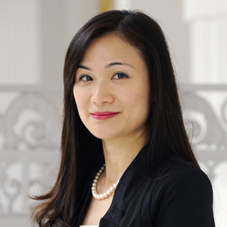 | Vivian Koh  Director, Public Relations and Content, Asia-Pacific  Tourism Court, 1 Orchard Spring Lane #04-01  Singapore  Singapore  vivian.koh@fourseasons.com  +65 6739 5806

