"Something Green" This Wedding Day at Four Seasons Resort Lanai

Couples can tie the knot on renowned Manele Golf Course at luxury Hawaiian resort
July 26, 2017, Hawaii, Lanai, U.S.A.

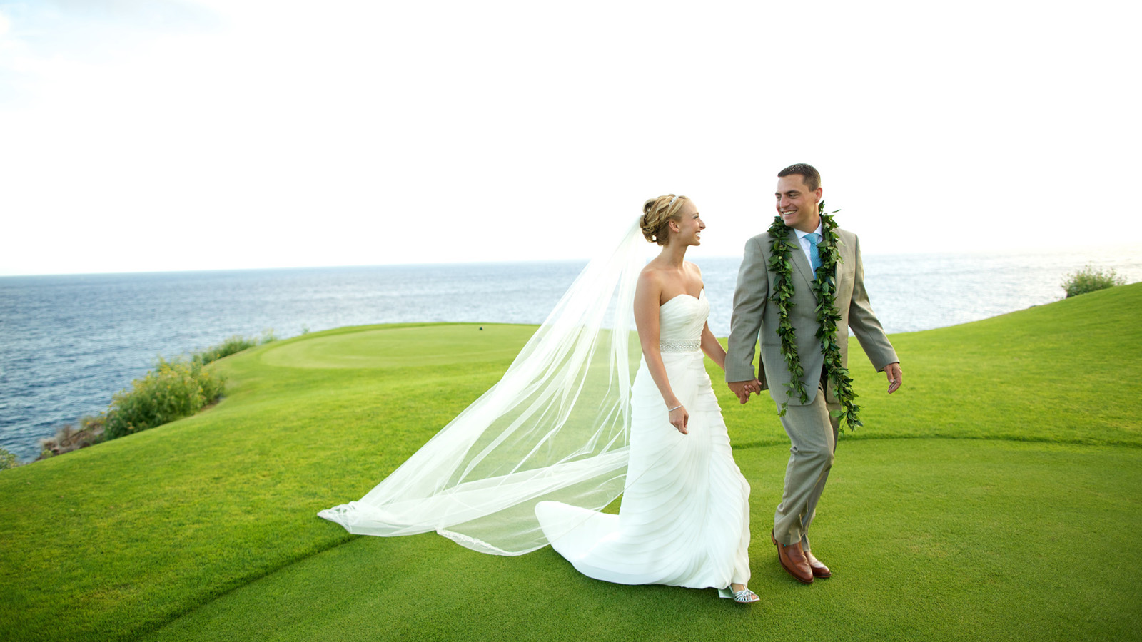
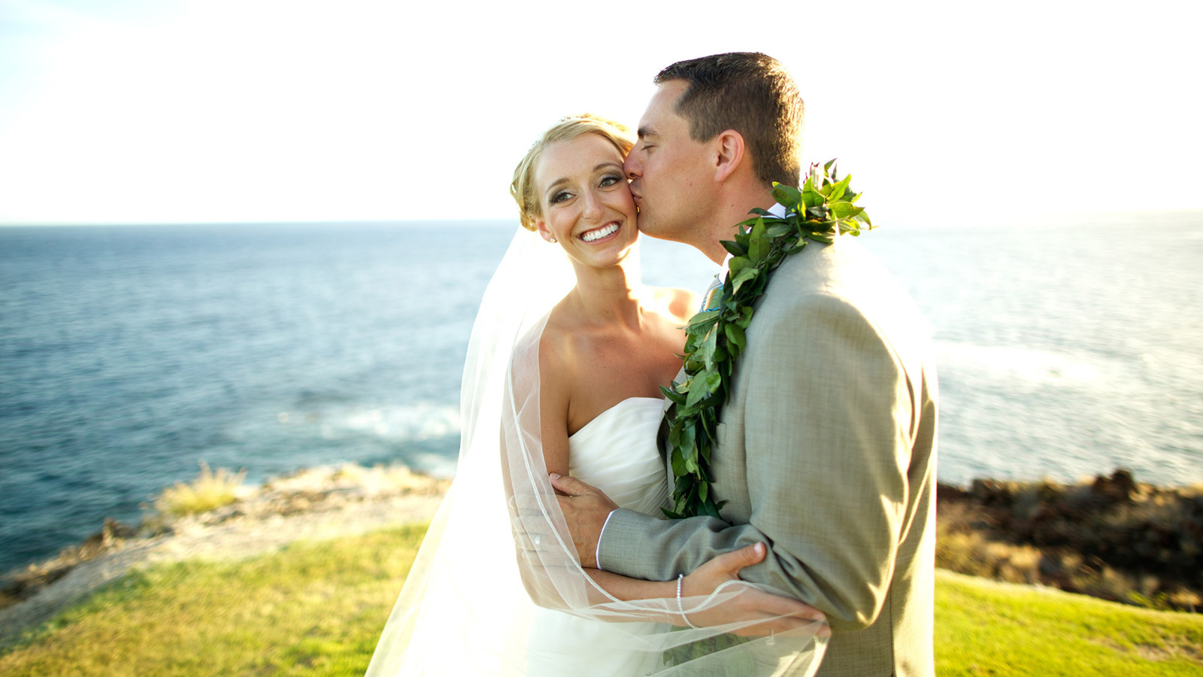 | 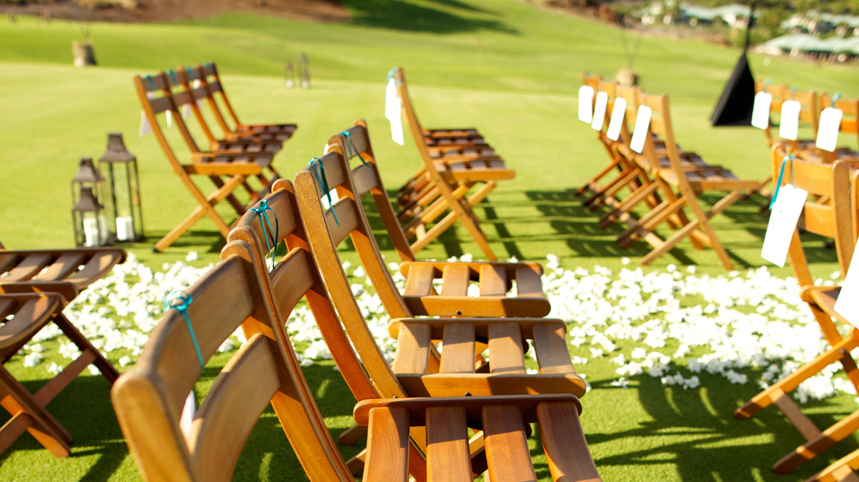 | 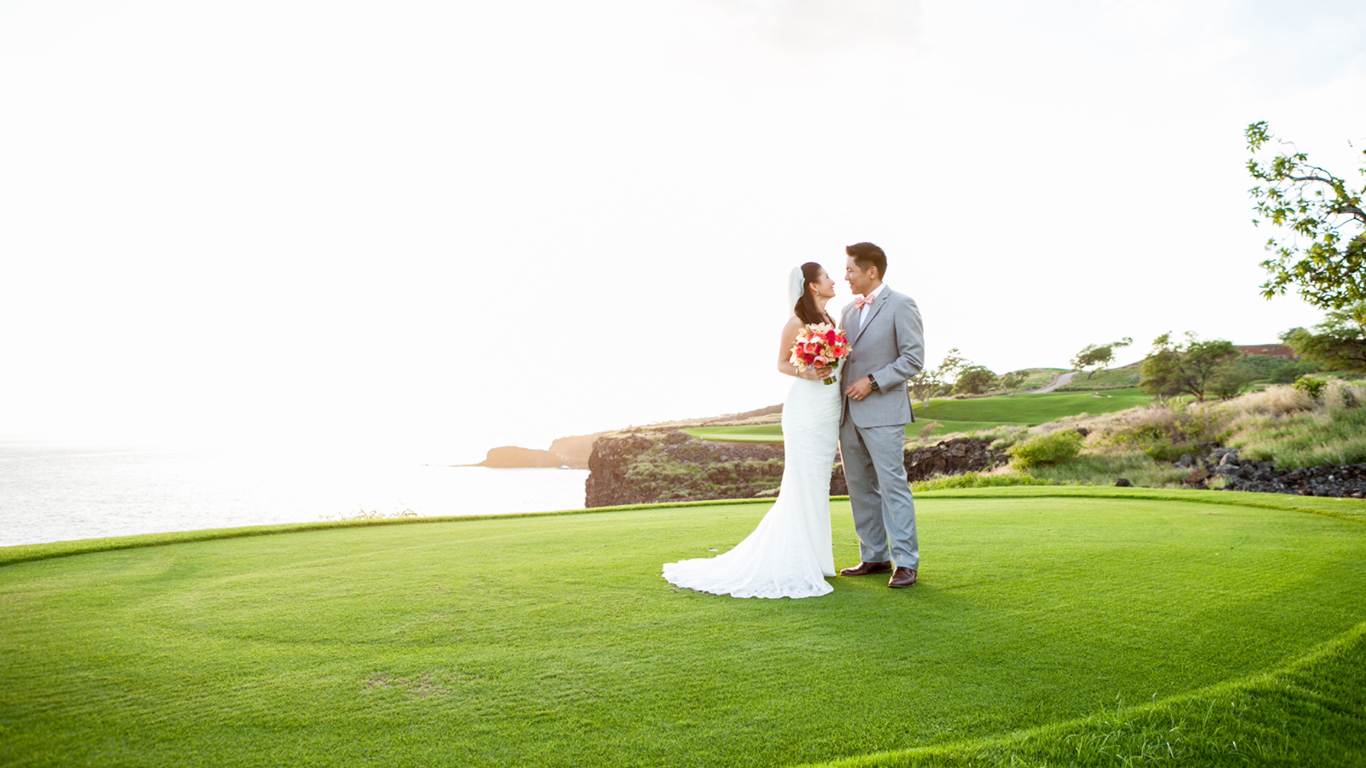
The secluded Hawaiian island of Lanai offers a paradise of possibilities for wedding celebrations – from the curve of white-sand beach to lush, tropical gardens and now to a brilliant green golf course, where the sweep of ocean and sky can serve as the bride's “something blue" backdrop to a perfect ceremony. The 90,000 acre (36,000 hectare) island offers couples a sophisticated setting at the AAA Five Diamond
Four Seasons
Resort Lanai, heartfelt aloha spirit and air, ocean and land activities galore - many managed by
Four Seasons
- for a truly unforgettable wedding and honeymoon.
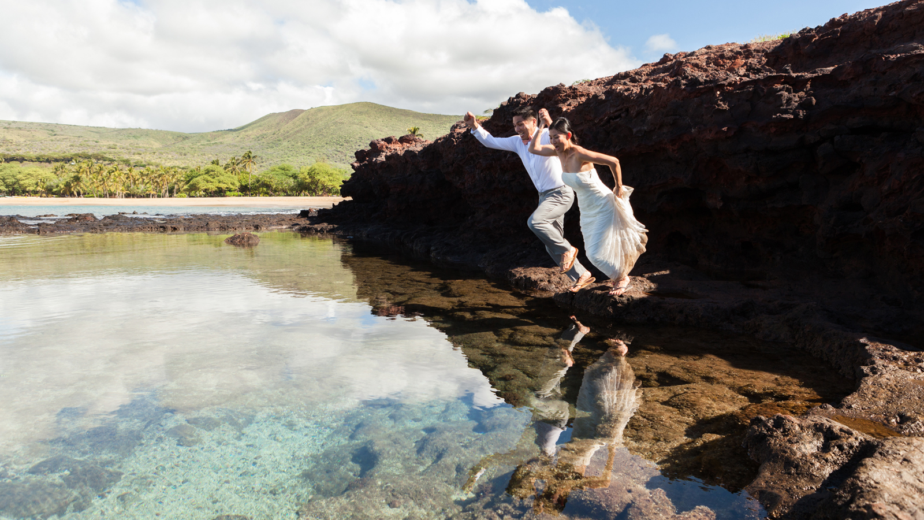 | 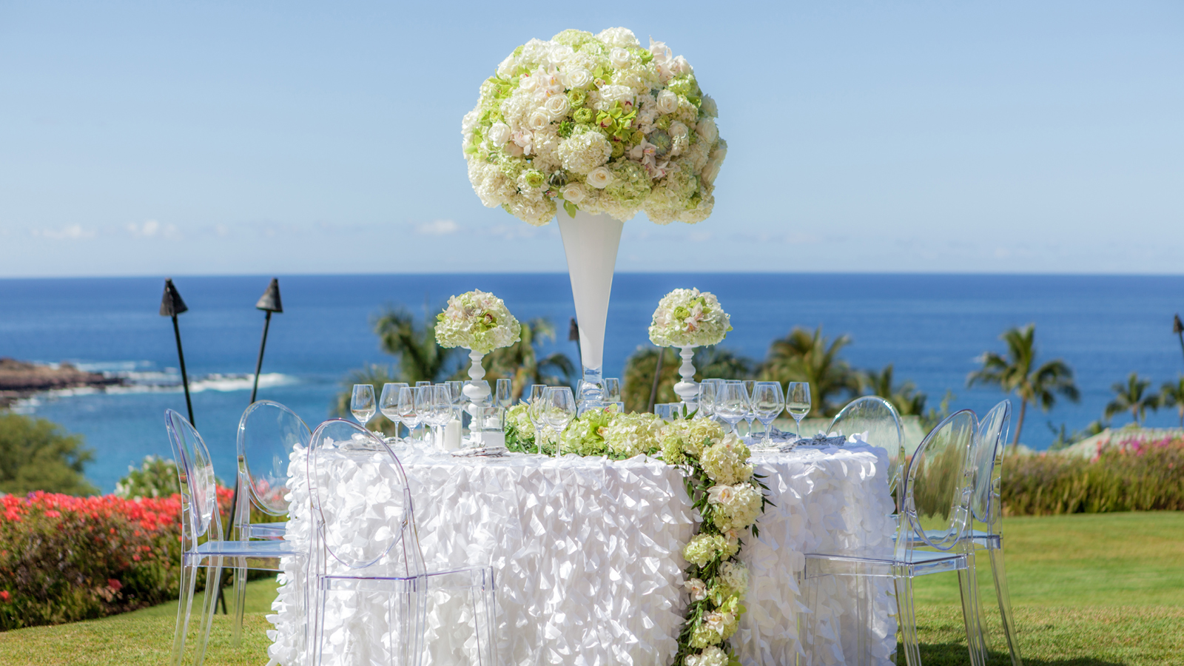 | 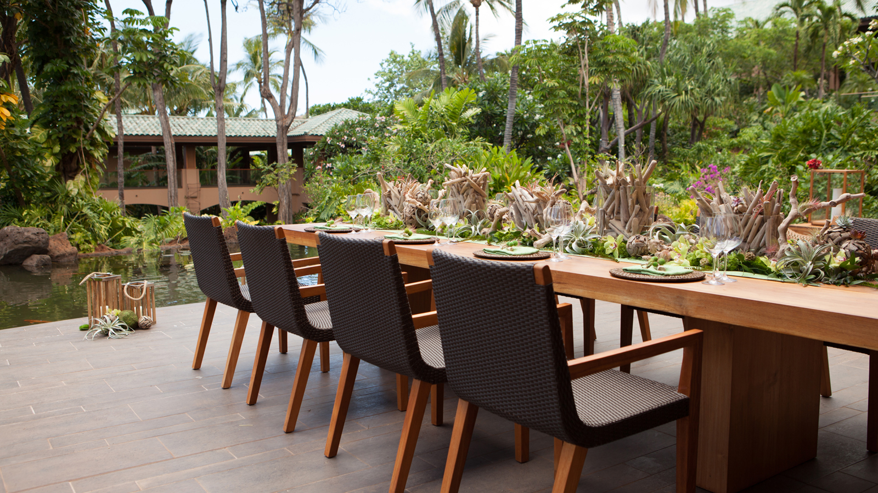
Choose from distinctive ceremony and reception locations including:
Manele Golf Course
On the edge of the cliffs, with panoramic views of the Pacific Ocean and the islands of Kahoolawe, Maui and Hawaii, the 9,600 square-foot (892 square metre) Manele Golf Tee Box is the perfect setting for newlyweds-to-be. Manele Golf Course – an award-winning, Jack Nicklaus-designed par-72 layout built on lava outcroppings and featuring three holes along rugged oceanside cliffs - is recognised for its superb playability as well its breathtaking scenery, challenging many golfers to keep their eye on the ball. The course's signature hole, number 12, is a unique alternative – Bill and Melinda Gates married here. This par 3 is notorious for the demanding carry it requires across 200 yards of ocean. Whether it’s the Pacific Ocean acting as water hazard that puts even the most experienced golfer’s skills to the test or the incredibly scenic views, the 12th hole’s Black Tee is a location to remember.
Imagine a conch shell blower heralding the beginning of the ceremony as the bride and groom take their places before a Hawaiian priest, white flower petals scattered at their feet. While the sun sets, vows are exchanged atop a 150-foot (46 metre) red lava cliff overlooking the Pacific, followed by a celebratory dinner under the stars. The course, which routinely features views of dolphins frolicking in the bay, creates a one-of-a-kind event location for small groups of any size or large groups up to 400 persons. For an unforgettable finale, a fireworks display over the ocean is available.
Luau Gardens
Overlooking the dazzling blue waters of Hulopoe Bay – just a few steps from the beach – the Luau Gardens include a perfectly manicured lawn surrounded by exotic tropical trees and flowers. Convenient to all the Resort’s facilities, the gardens are ideal for larger events of up to 300 people.
Ballroom and Terrace
Perched on a hill and surrounded by colourful bougainvillea, the Resort's ballrooms offers large windows with panoramic ocean views. Movable floor-to-ceiling glass wall panels allow for enclosed or open-air settings. Celebrations large and small can move outdoors onto the terrace, offering a high vantage point for amazing views, perfect for a cocktail reception with stunning views of Hulopoe Bay. Fireworks are available here and at the Luau Gardens as well.
Botanica and Cascades
Designed as outdoor living spaces, the venues are nestled amid ponds filled with koi, known as "living jewels," and lush gardens offering a secluded oasis under the stars – the perfect setting for an intimate ceremony and dinner. Additional lounge areas enhance the casual, comfortable atmosphere.

RELATED

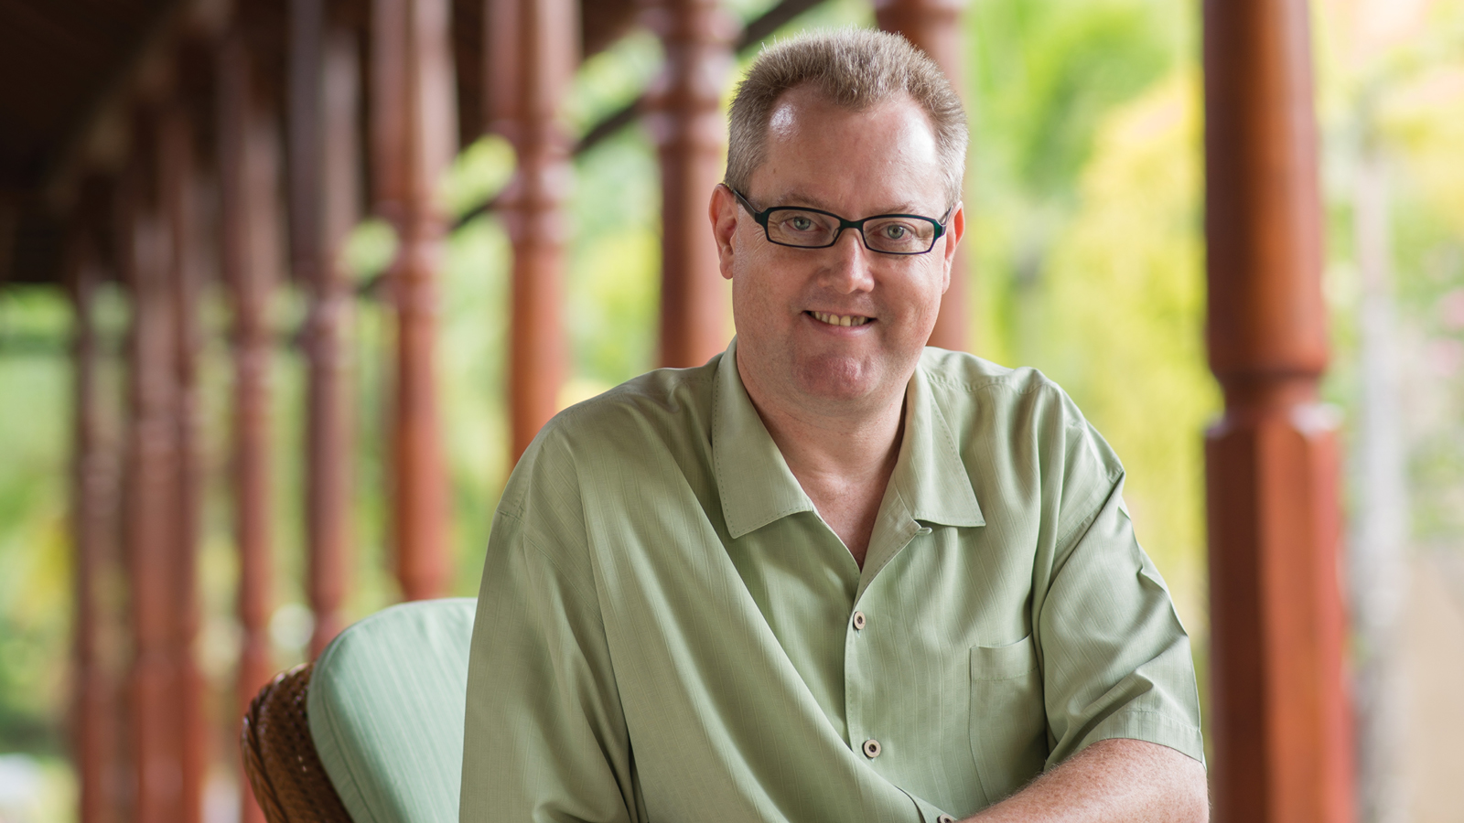 | June 19, 2017, Hawaii, Lanai, U.S.A.  Alastair McAlpine Appointed General Manager, Four Seasons Resorts Lanai  http://publish.url/lanai/hotel-news/2017/new-gm-alastair-mcalpine.html
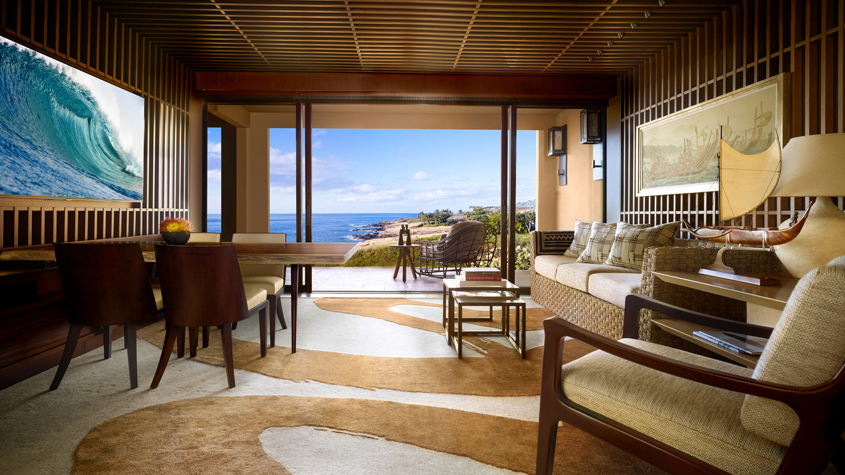 | April 19, 2017, Hawaii, Lanai, U.S.A.  Four Seasons Resort Lanai Recognised with Condé Nast Traveler's 2017 Hot List Award  http://publish.url/lanai/hotel-news/2017/hot-list-award.html

PRESS CONTACTS

Lori Holland
Director of Public Relations
6100 Center Drive, Suite 1250
Los Angeles
U.S.A.
lori.holland@fourseasons.com

1 (201) 294-7810

