Spend the Weekend with Wolfgang Puck at Four Seasons Hotel Bahrain Bay

Renowned chef’s upcoming visit kicks off a season of culinary experiences for the ultimate foodie weekend in Bahrain
April 11, 2017, Bahrain Bay, Bahrain

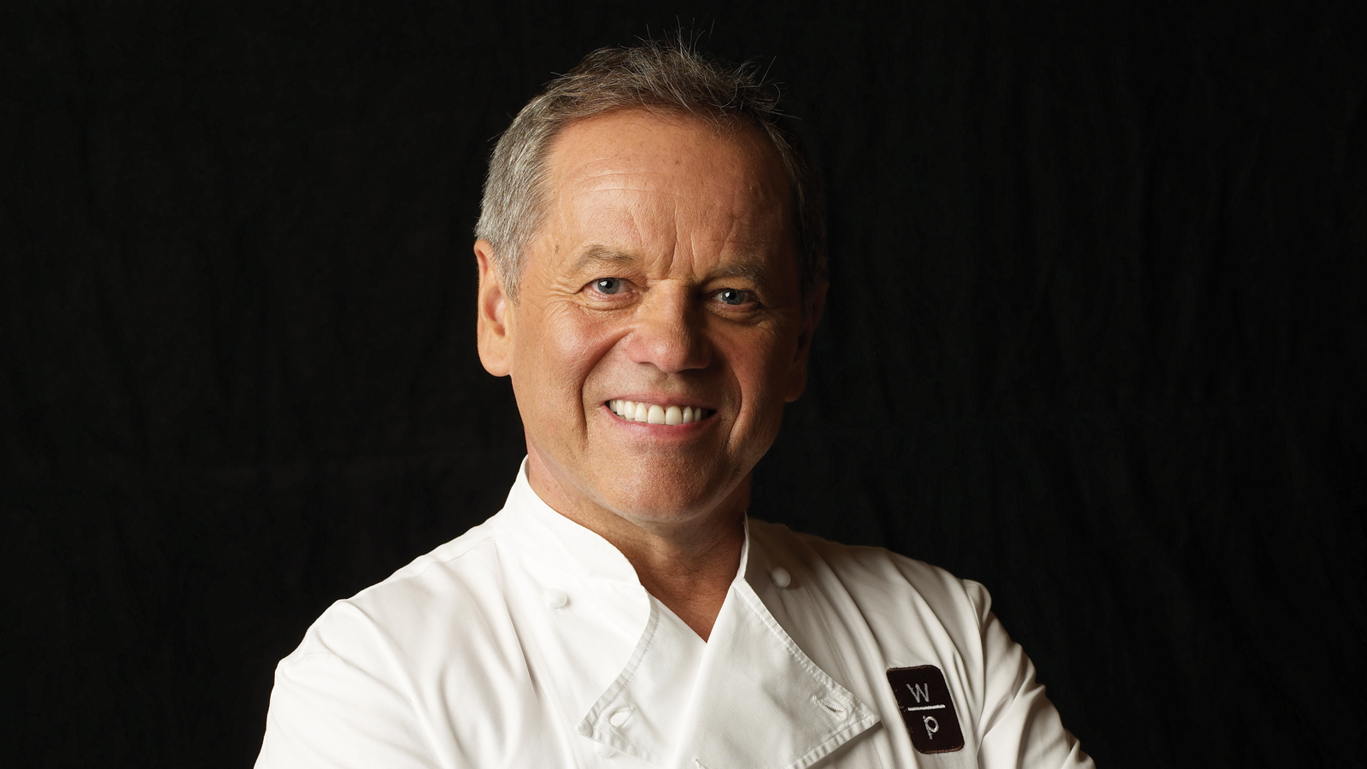
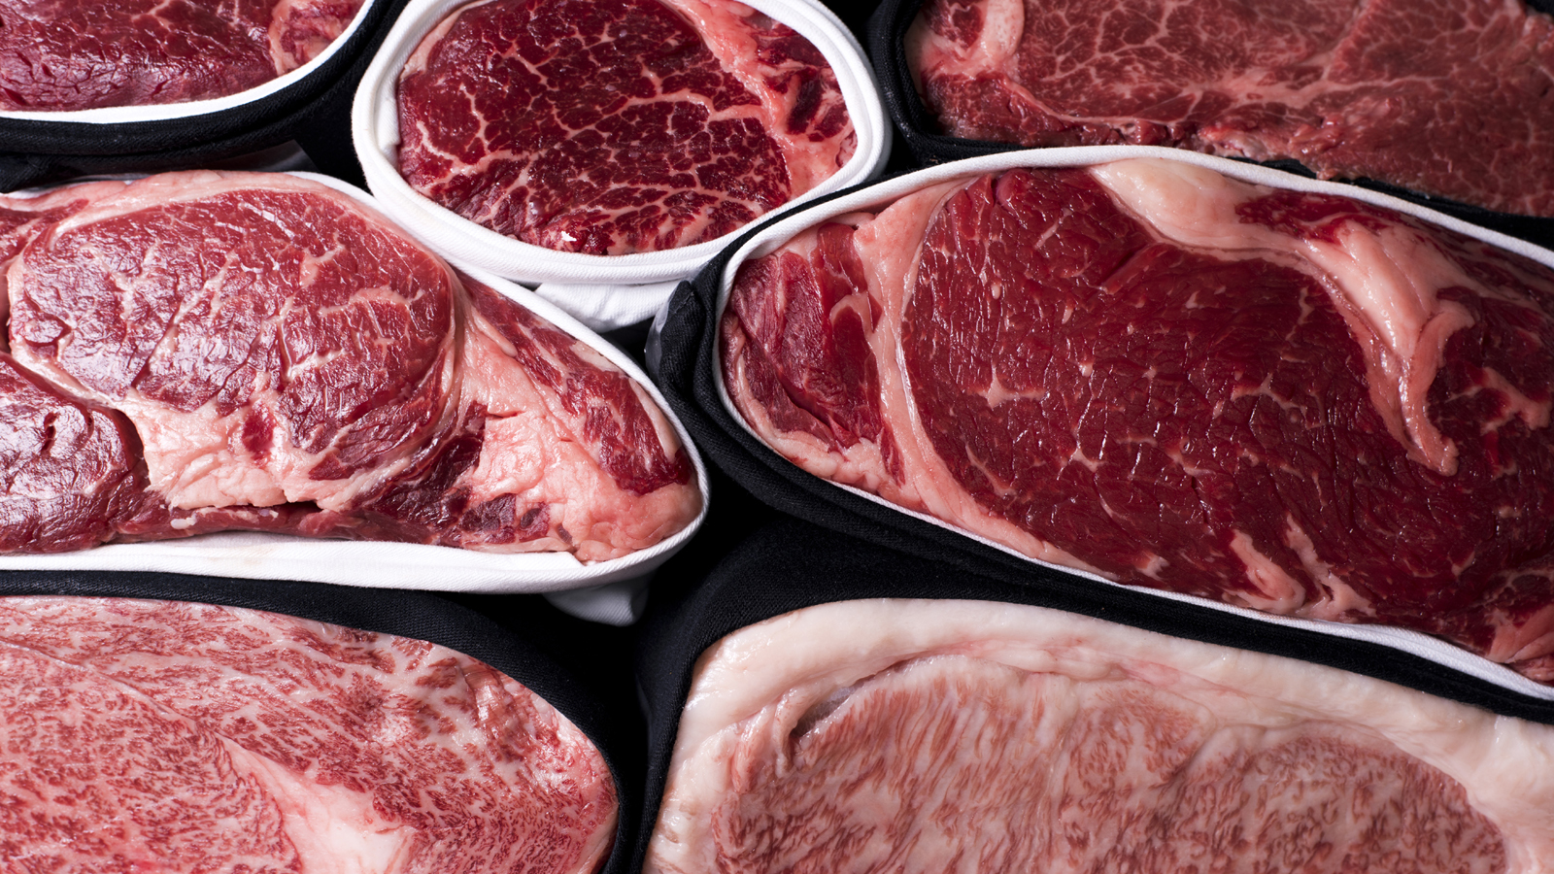 | 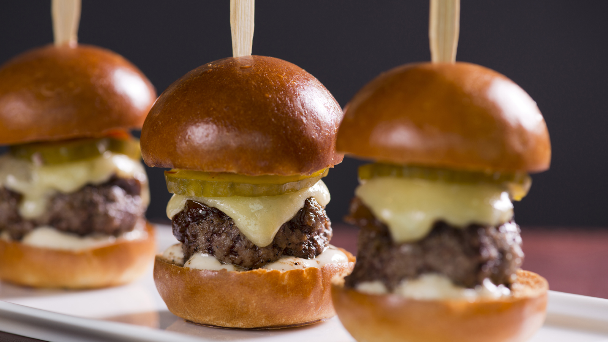 | 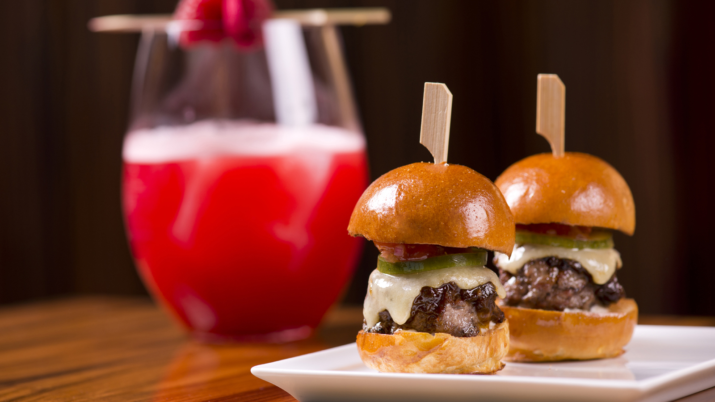
What better way to spend a well-earned weekend break with friends and family than indulging the taste buds? Foodies, cooks and bakers need look no further than the welcoming archipelago of Bahrain, where this April and May
Four Seasons
Hotel Bahrain Bay invites guests to explore the art and science of flavourful food at its outstanding collection of seven restaurants and lounges, including three venues by the internationally renowned celebrity chef Wolfgang Puck.
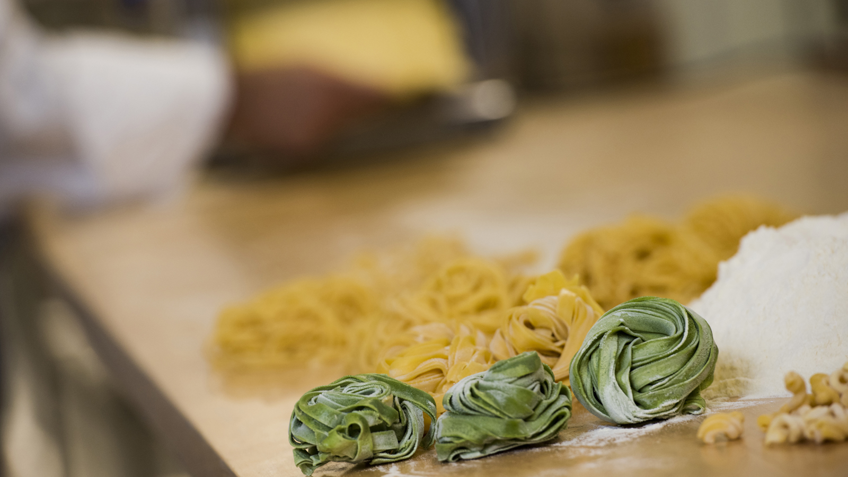 | 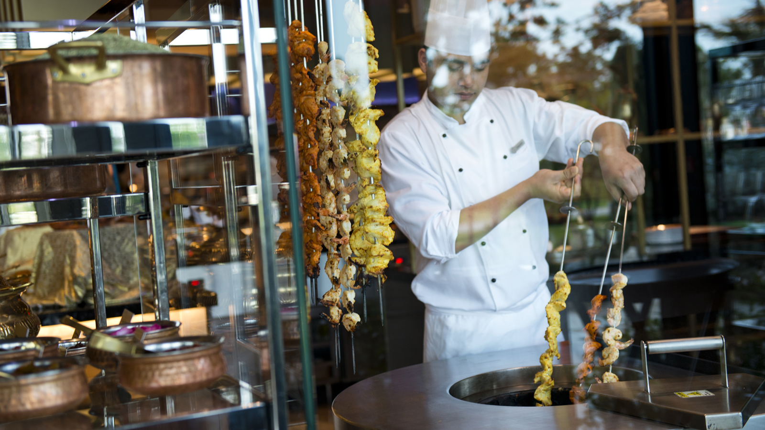 | 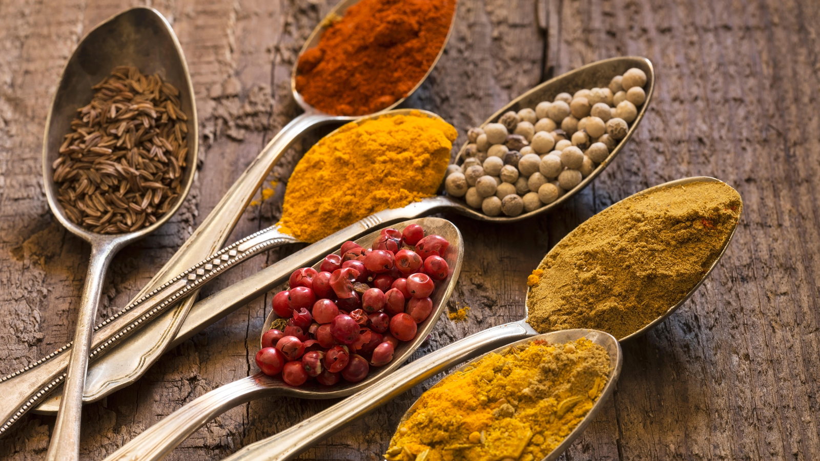
From an exclusive Formula 1 pre-race garden party with Wolfgang Puck himself to learning the tricks of the trade from the Hotel’s expert chefs at The League of Cuisines monthly classes, a range of exciting gastronomic experiences promise to take guests on an unforgettable journey of tastes, ingredients, aromas and textures.
A soaring architectural statement on its own exclusive island,
Four Seasons
Hotel Bahrain Bay is a breathtaking location for an urban resort holiday, offering luxurious relaxation and delectable cuisine for the ultimate foodie weekend away.
Meet the Celebrity Chef Over Brunch at CUT by Wolfgang Puck
During his April trip to Bahrain, Michelin-starred restaurateur and acclaimed Chef Wolfgang Puck is set to mesmerise guests over Friday Brunch at CUT by Wolfgang Puck with each dish prepared to feel like a warm delicious hug. At what promises to be the brunch of a lifetime, culinary aficionados can meet the legendary chef, take a picture with him, receive a personally signed autograph or simply watch him perform culinary magic.
- Friday Brunch will be hosted on April 14, 2017 from 12:30 to 3:30 pm at CUT by Wolfgang Puck. Guests can enjoy up to six brunch items at BHD 24 (including soft beverages and coffee) or BHD 34 (including an extended beverage package). To make a reservation, call +(973) 1711-5500.
To conclude the weekend in style, guests can head to the F1 pre-race party with Wolfgang Puck on the Hotel’s outdoor lawn grounds. Anticipate a showcase of the Chef’s most celebrated, internationally acclaimed signature dishes that indulge all the senses – from wagyu beef sliders with aged white cheddar and spicy tuna tartare in sesame miso cones to fuji apple salad with endive, candied Marcona almonds and Shropshire cheese or the roasted beet layer cake with peninsula farms goat cheese and toasted hazelnuts.
- The event will be hosted on April 15, 2017 from 8:00 pm. Tickets are priced at BHD 69 per person, inclusive of premium beverages. For reservations call +(973) 1711-5500.
Discover the Taste of Bahrain
Trace the history of Bahraini spices and ingredients as part of the Taste of Bahrain initiative by Four Seasons that gives foodies the opportunity to familiarise themselves with classic Bahraini dishes in a special cooking class at Bahrain Bay Kitchen. The truly authentic journey with
Four Seasons
chefs takes aspiring Bahraini cuisine experts on a journey of Arabian cuisine as they try their hands at preparing balaleet (sweet vermicelli with fried eggs on top), mahyawa (fresh fish sauce made of local catch from the Arabian Gulf drizzled on freshly baked Bahraini bread) or the forever-favorite lamb ouzi among other dishes.
- For bookings call +(973) 1711-5500.
Emerge as a Culinary Champion at The League of Cuisines Cooking Classes
Team up with
Four Seasons
Hotel Bahrain Bay specialty chefs to master the secrets of Indian and Italian dishes in Bahrain Bay Kitchen during The League of Cuisines. Go behind the scenes of culinary excellence with Executive Sous Chef Ravneet Manchanda and Chef Cristian Lisci with a dozen classmates to learn how to make chicken-wrapped kabsa rice, um ali, Malay-style turmeric coconut with shrimps, Indian-spiced chicken, spinach ricotta ravioli, tiramisu and more. Taste dishes after the class ends with the specialty chef himself and take back certificates from the Hotel as fond memories of the experience.
- The League of Cuisines classes run every second Sunday in April and May 2017 from 5:30 to 7:30 pm. The price is BHD 20 (BHD 15 for Spa members) plus 10 percent service charge and 10 percent government levy. Space is limited. To make a reservation, call +(973) 1711-5500.
Celebrate Mei Yue Nights at re/Asian Cuisine | Wolfgang Puck
Discover the street food culture of Asia every first Tuesday of each month. On May 2, 2017, the re/Asian Cuisine | Wolfgang Puck tables will be transformed into live cooking stations to bring a slice of Asia’s local delicacies to Bahrain, sprinkled with world-renowned restaurateur Wolfgang Puck’s modern twists during Mei Yue Nights. Mingle with the restaurant’s talented team of chefs as they whet the appetite for Asian food creations including traditional fried noodle mie goreng, the spicy chili pan mee, or the juicy Korean short rib and more.
- Mei Yue Nights take place every first Tuesday through May 2017 from 7:00 to 11:00 pm. Price is BHD 24 exclusive of beverages. To make a reservation, call +(973) 1711-5500.

RELATED

April 11, 2017, Bahrain Bay, Bahrain
هل ترغبون بقضاء عطلة نهاية أسبوع مميزة غنية بألذ المأكولات؟ فندق فورسيزونز خليج البحرين هو الوجهة الأفضل مع أطباق الشيف العالمي وولفغانغ باك
http://publish.url/ar/bahrain/hotel-news/2017/spring-dining-events-2.html

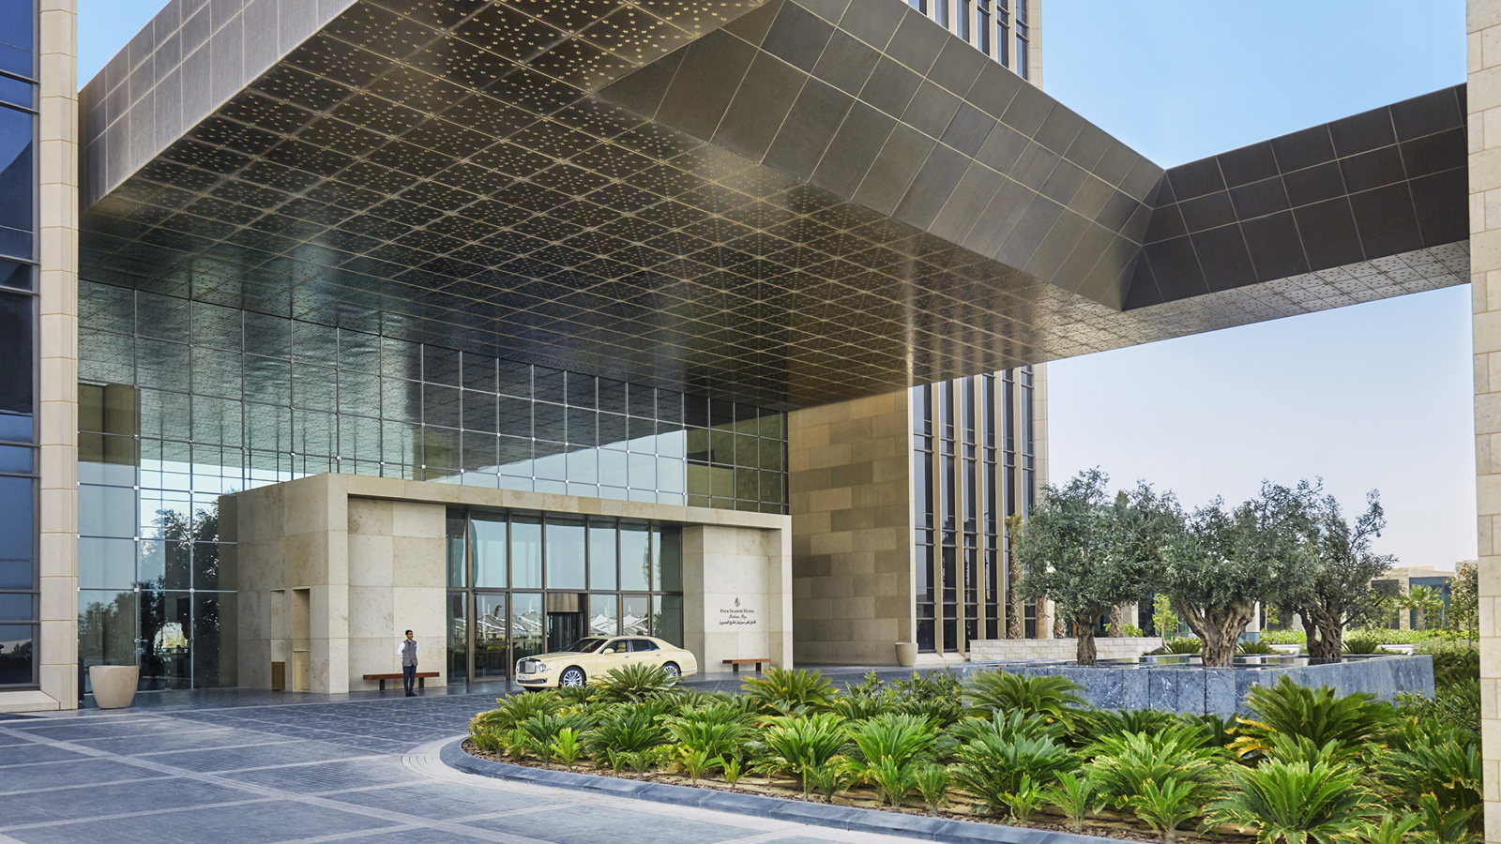 | March 6, 2017, Bahrain Bay, Bahrain  For the Second Consecutive Year, Four Seasons Hotel Bahrain Bay is Honoured with Four Esteemed Food and Travel Bahrain Awards  http://publish.url/bahrain/hotel-news/2017/food-and-travel-bahrain-awards.html

PRESS CONTACTS

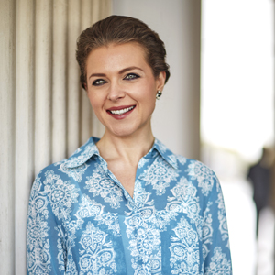 | Veronika Szabo  Director of Public Relations and Communications  Bahrain Bay, PO Box 1669  Manama  Kingdom of Bahrain  veronika.szabo@fourseasons.com  (973) 1711 5000

