Blackberry Season Marks the Arrival of Autumn at Four Seasons Hotel Hampshire

August 28, 2017, Hampshire, England

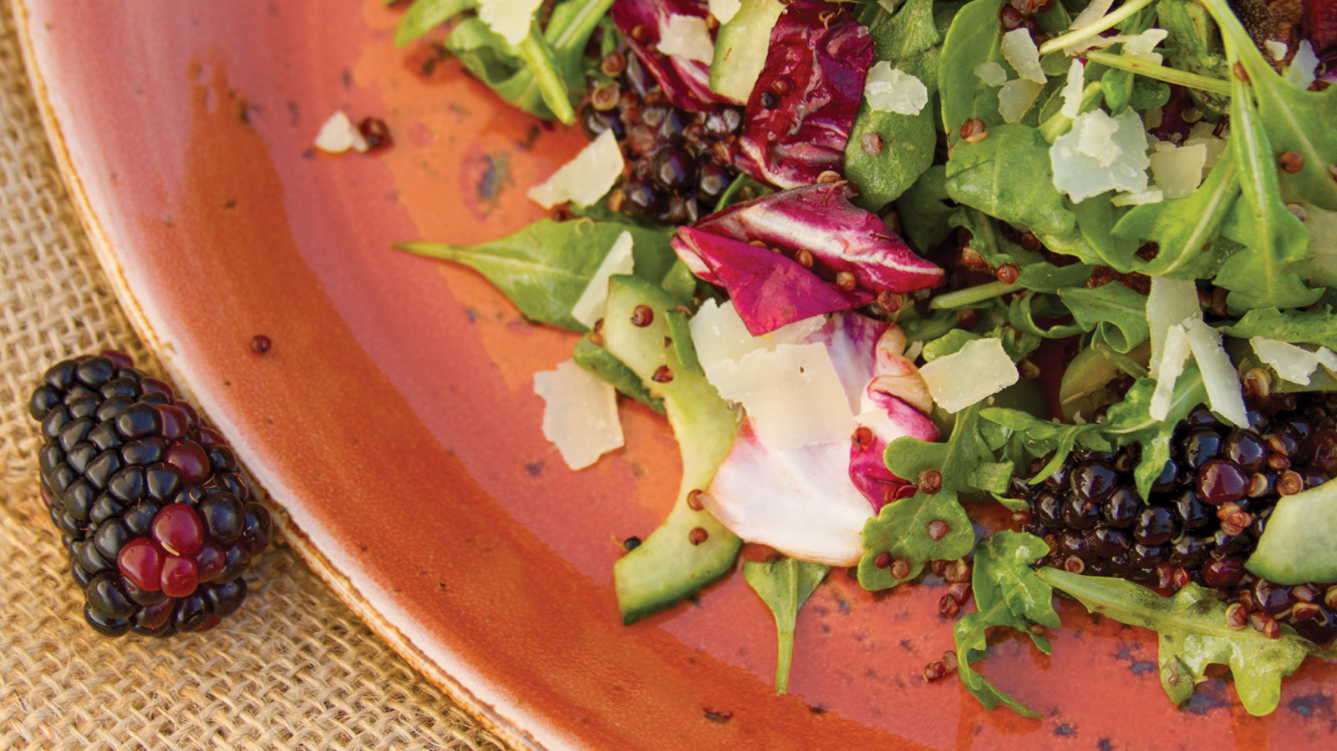
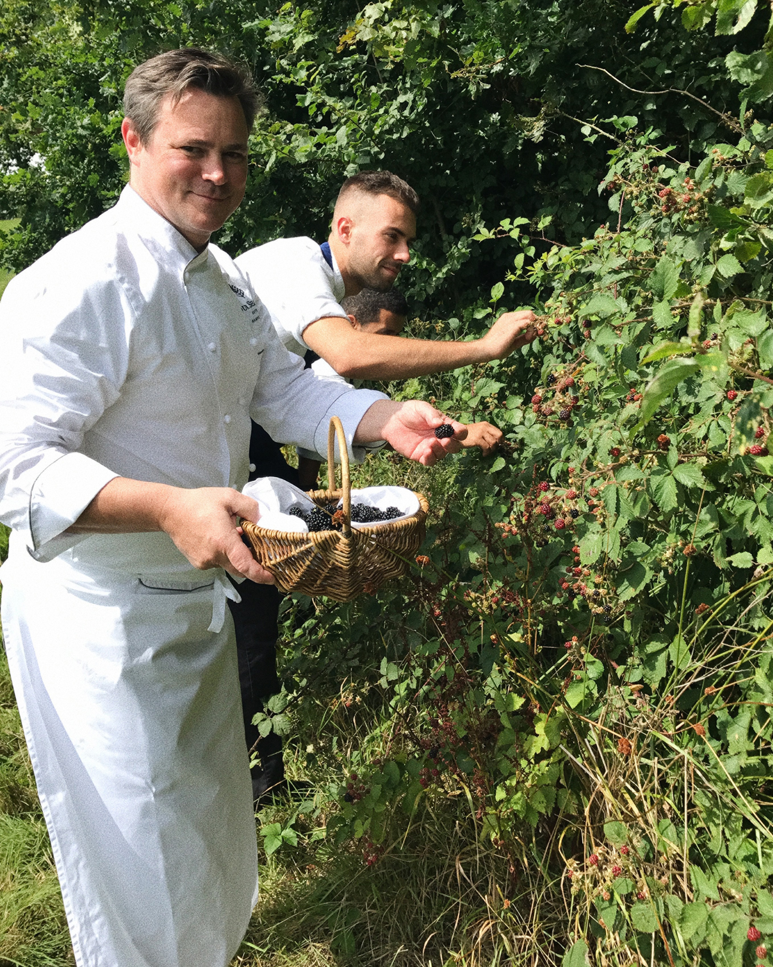 | 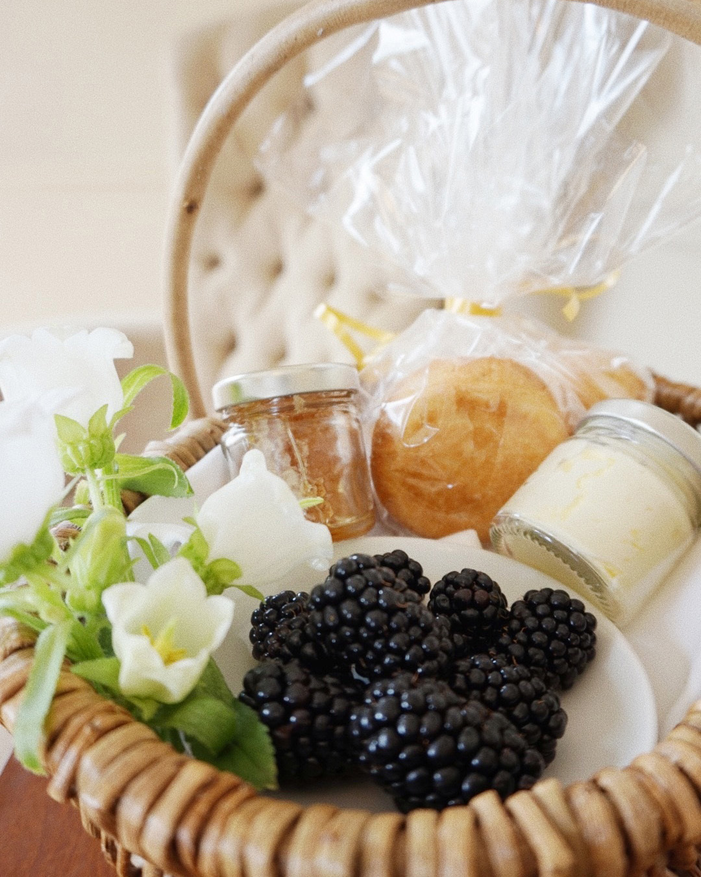 | 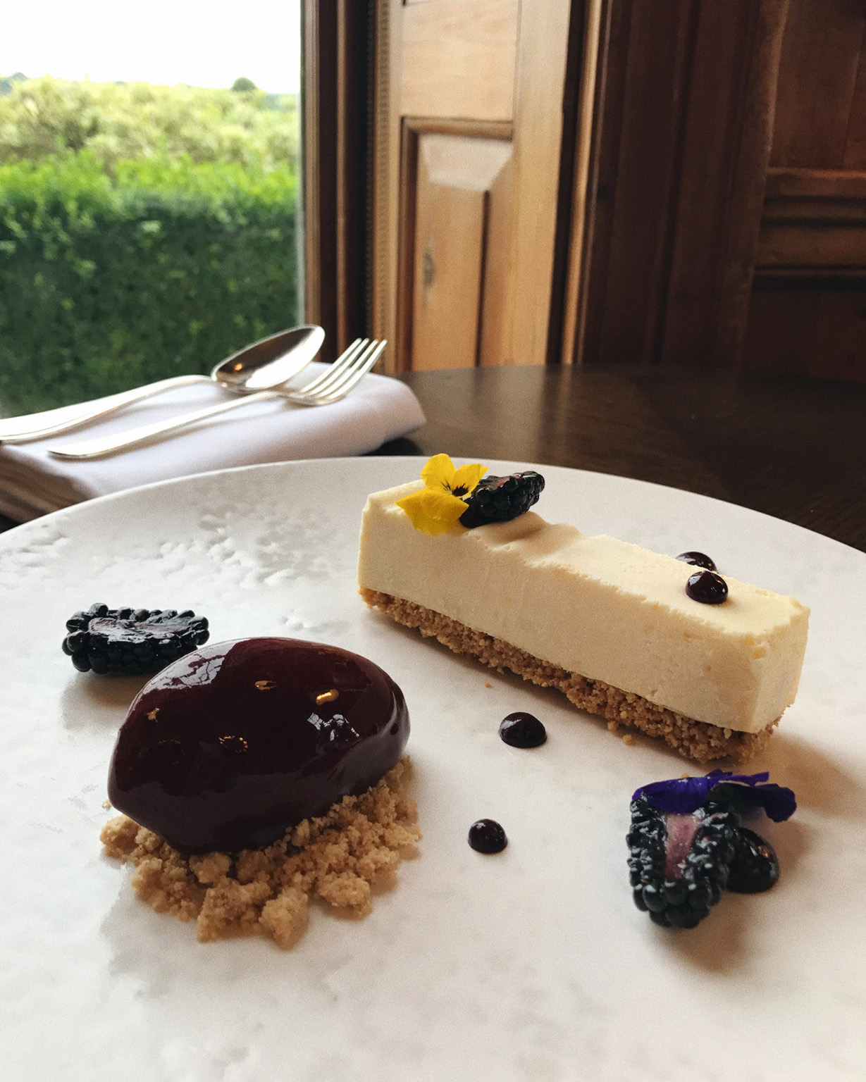
Throughout the English countryside, tangled prickly shrubs are beginning to fruit in woodlands, farmland, hedgegrows and gardens, their army of thorns providing shelter for plump, deliciously rich purple blackberries. In Britain, this is nature’s way of telling us that autumn is on its way.
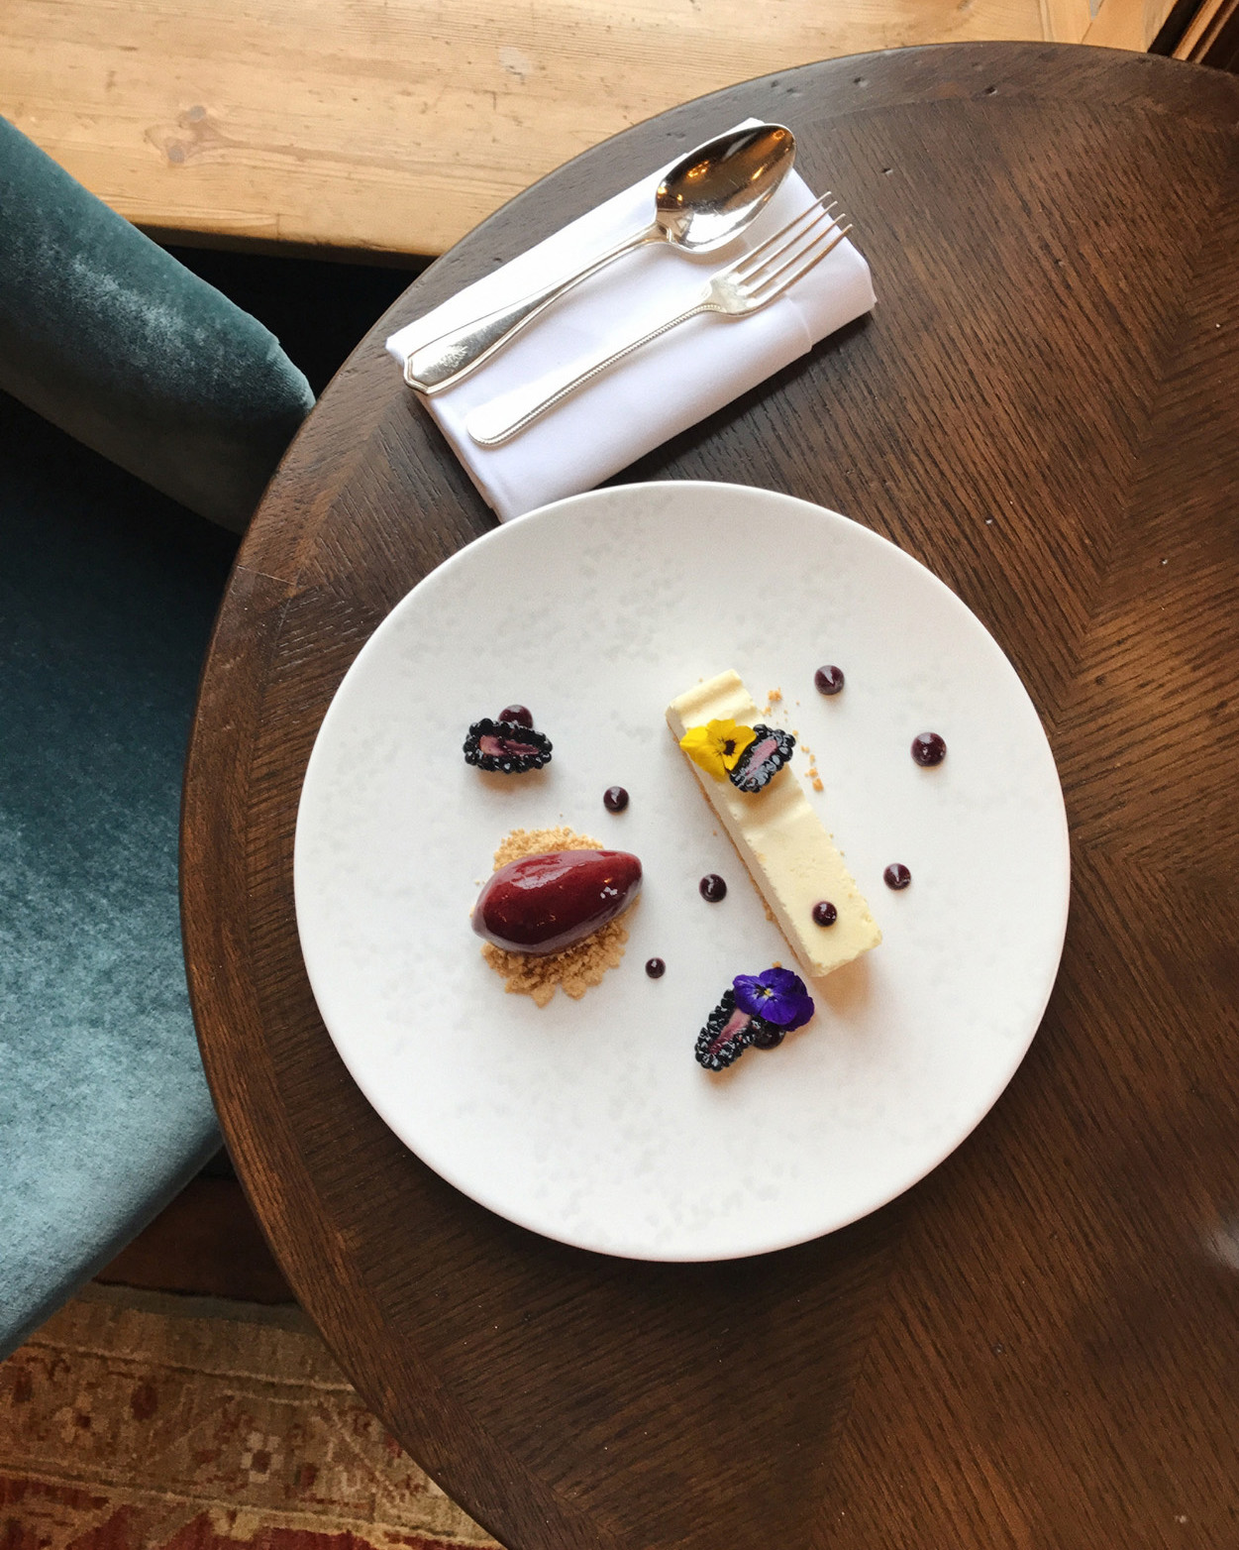 | 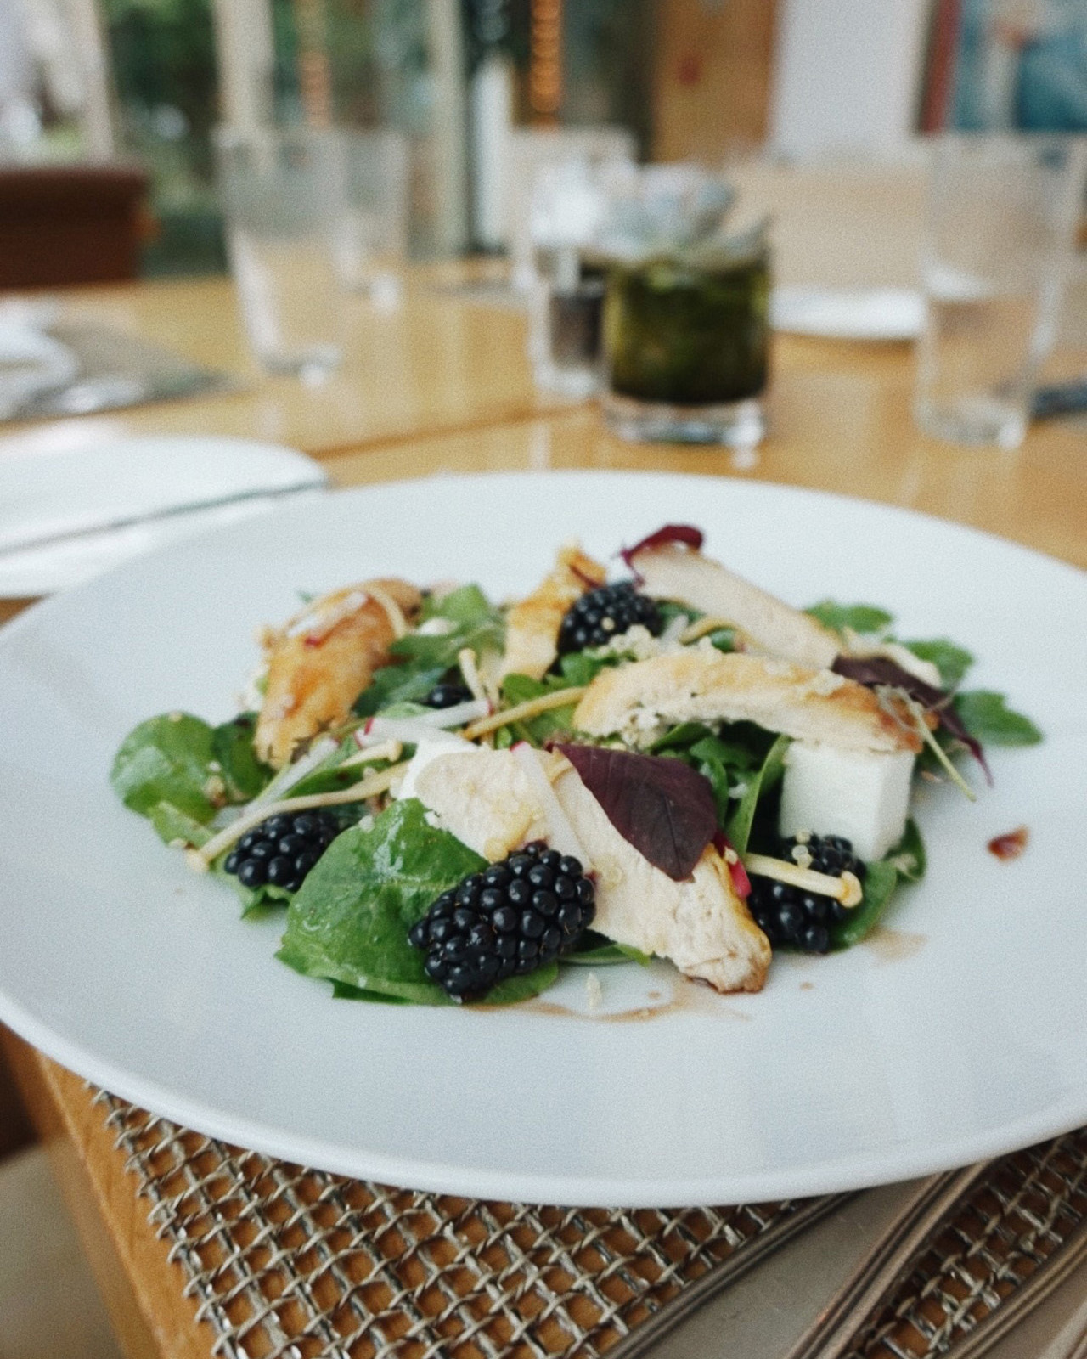
The British blackberry season peaks in the month of August, sweetness becoming more pronounced in the month of September, and harvesting continuing until the first frosts in November. In Britain, blackberries can be considered a staple fruit, and blackberry picking a very quintessential British pastime, as families traditionally spent autumn days foraging in search of the sweet berries, to turn into delicious jams and conserves, and to add to homemade pies, cakes, trifles and crumbles.
Blackberries have also played their designated part in British history. During the First World War, when food in England was scarce, many schools instructed their children to take part in blackberry picking during school hours, gathering as much of the fruit as possible to then be turned into jam to feed the soldiers. Some schools have recorded to have collected more than 180 pounds (81 kilograms) of blackberries each to be made into jam for the troops!
At
Four Seasons
Hotel Hampshire, Chef Dirk Gieselmann has found these nibbly berries growing in knotty bushes on the Estate’s south-facing fields, behind the tennis courts. Along with his culinary team, Chef Dirk has battled the brambles collecting all the fruit to create some delightful seasonal offerings for guests to enjoy until November comes around.
From a sumptuous vanilla and blackberry cheesecake to round up an evening meal – the sweetness of the vanilla blending lusciously with the slight tartness of the berry – to blackberry preserve, accompanied by crumbly scones to enjoy with afternoon tea.
For those seeking a healthy yet tasty lunch, in Café Santé guests can delight in chicken, Hampshire watercress and blackberry salad, with a rich blackberry balsamic dressing drizzled over quinoa, spinach and feta. Did you know that the blackberry is an anti-ageing fruit? Full of anti-oxidants, it helps the body to make collagen to maintain healthy skin!
Cocktail lovers can enjoy Barman James Edwards’ own take on the traditional Bramble, a delicious gin-based drink, as well as his blackberry cordial creation, to be enjoyed with soda or as a delicate touch in iced tea with lemon.
For those wishing to have a go and picking their own blackberries this season, it’s not yet too late! The Concierge team at Four Seasons Hotel Hampshire has put together a list of recommended farms offering blackberry picking within close distance of the Hotel:
- West Green Fruits, Hartley Wintney, Hook, Hampshire – 10 minute drive from
Four Seasons
Hotel Hampshire - family-run, set in 20 acres (8 hectares) of farmland, offering a variety of fruits including strawberries, raspberries, blackberries, gooseberries and ready picked summer vegetables; open Tuesdays and Fridays
- Durleighmarsh Farm, Petersfield, Hampshire – 40 minute drive from
Four Seasons
Hotel Hampshire - family-run farm shop and Pick Your Own, offering a variety of fruits and vegetables to pick, from strawberries, blackberries, blackcurrants and plums, to carrots, spinach and pumpkins; Pick Your Own is open every day from May until October, while the farm shop is open all year round
- Crockford Bridge Farm, Surrey – 40 minute drive from
Four Seasons
Hotel Hampshire - renowned for their Pick Your Own asparagus, rhubarb, strawberries, raspberries and blackberries; open until end of September
- Flower Farm, Godstone, Surrey – 50 minute drive from
Four Seasons
Hotel Hampshire - located in the picturesque North Downs, an area of outstanding natural beauty, offering Pick Your Own strawberries, raspberries, blackberries, rhubarb and sweet corn, among many more fruits and vegetables; open until September
For more information, contact the Concierge team on concierge.hampshire@fourseasons.com, or telephone 01252 853123.

RELATED

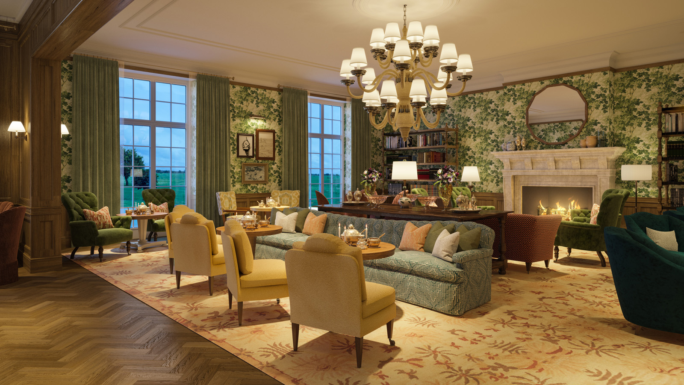 | September 6, 2017, Hampshire, England  Four Seasons Hotel Hampshire Unveils Wild Carrot Restaurant and Bar  http://publish.url/hampshire/hotel-news/2017/new-wild-carrot-restaurant-and-bar-test.html
September 6, 2017, Hampshire, England
Four Seasons Hotel Hampshire Unveils Wild Carrot Restaurant and Bar
http://publish.url/hampshire/hotel-news/2017/new-wild-carrot-restaurant-and-bar.html

PRESS CONTACTS

Ilse Van Steen
Director of Communications UK Collection
Hamilton Place, Park Lane
London
United Kingdom
ilse.vansteen@fourseasons.com

44 (20) 749 90 888

Alie Barbieri
Public Relations Coordinator
Dogmersfield Park, Chalky Lane, Dogmersfield
Hampshire
United Kingdom
alie.barbieri@fourseasons.com

+44 1252 583 008

