Two New Senior Appointments at Four Seasons Hotel Sydney

April 11, 2017, Sydney, Australia

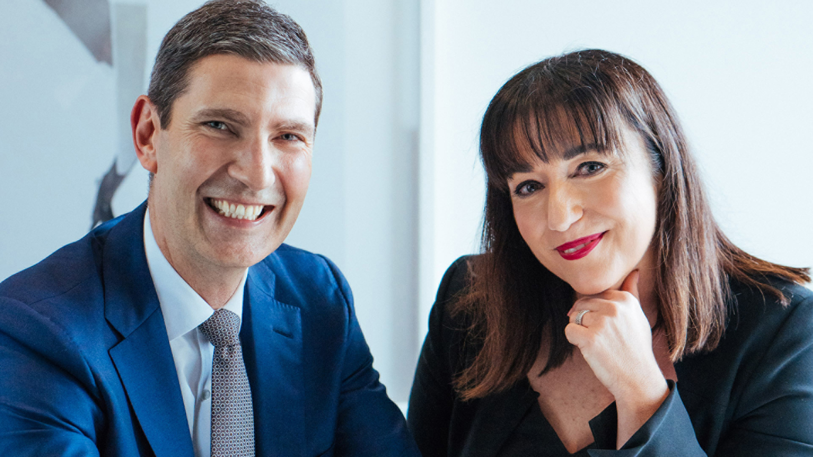
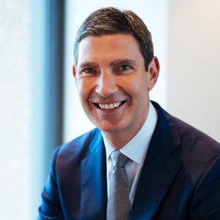 | 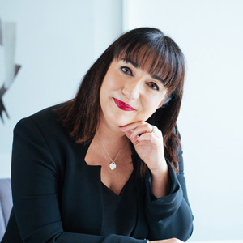
Sydney’s best located five-star hotel
Four Seasons
Hotel Sydney has strengthened its leadership team with the appointment of two highly regarded senior managers.
Respected Australian hospitality leader Simon Barnett has been appointed Hotel Manager, while renowned senior sales and marketing expert Helen Radic has joined the executive team as Director of Marketing.
A highly skilled and personable hotelier, Melbourne-born Barnett has taken the reigns from his previous role as Director of Marketing at
Four Seasons
Hotel Sydney, marking the third promotion in his six years at the property. He brings more than 25 years experience in hospitality to the role, working for top hotel groups in Australia and across the globe including Hilton Hotels and Jumeriah Hotels & Resorts in London and New York.
Fellow Victorian Radic has joined
Four Seasons
with an impressive career spanning more than 25 years in Australian hotels, including eight years in her most recent role as cluster director of sales and marketing at Sydney Harbour Marriott Hotel. With a passion for developing and mentoring future leaders in hospitality, she has successfully led sales and marketing teams at a number of luxury hotels across Australia, and acted as hotel manager at Sir Stamford Circular Quay in 2005.
General Manager of
Four Seasons
Hotel Sydney Rudolf van Dijk said he was delighted to bolster the leadership team with the new senior level appointments. “Mr Barnett and Ms Radic deliver an enviable combination of extensive operational experience and financial savviness, with collective experience of more than 50 years in delivering success in luxury hotels across the world.”
In collaboration with other members of the executive team at Four Seasons Hotel Sydney, Barnett and Radic will continue the success of the landmark hotel, spearheading major upcoming projects including the launch of a new modern Australian restaurant.

RELATED

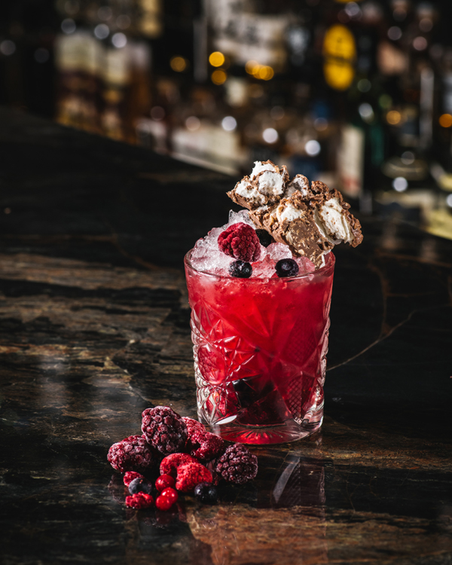 | April 7, 2017, Sydney, Australia  Chocolate Cocktails to Indulge in This Easter at Grain Bar at Four Seasons Hotel Sydney  http://publish.url/sydney/hotel-news/2017/easter-chocolate-cocktails.html
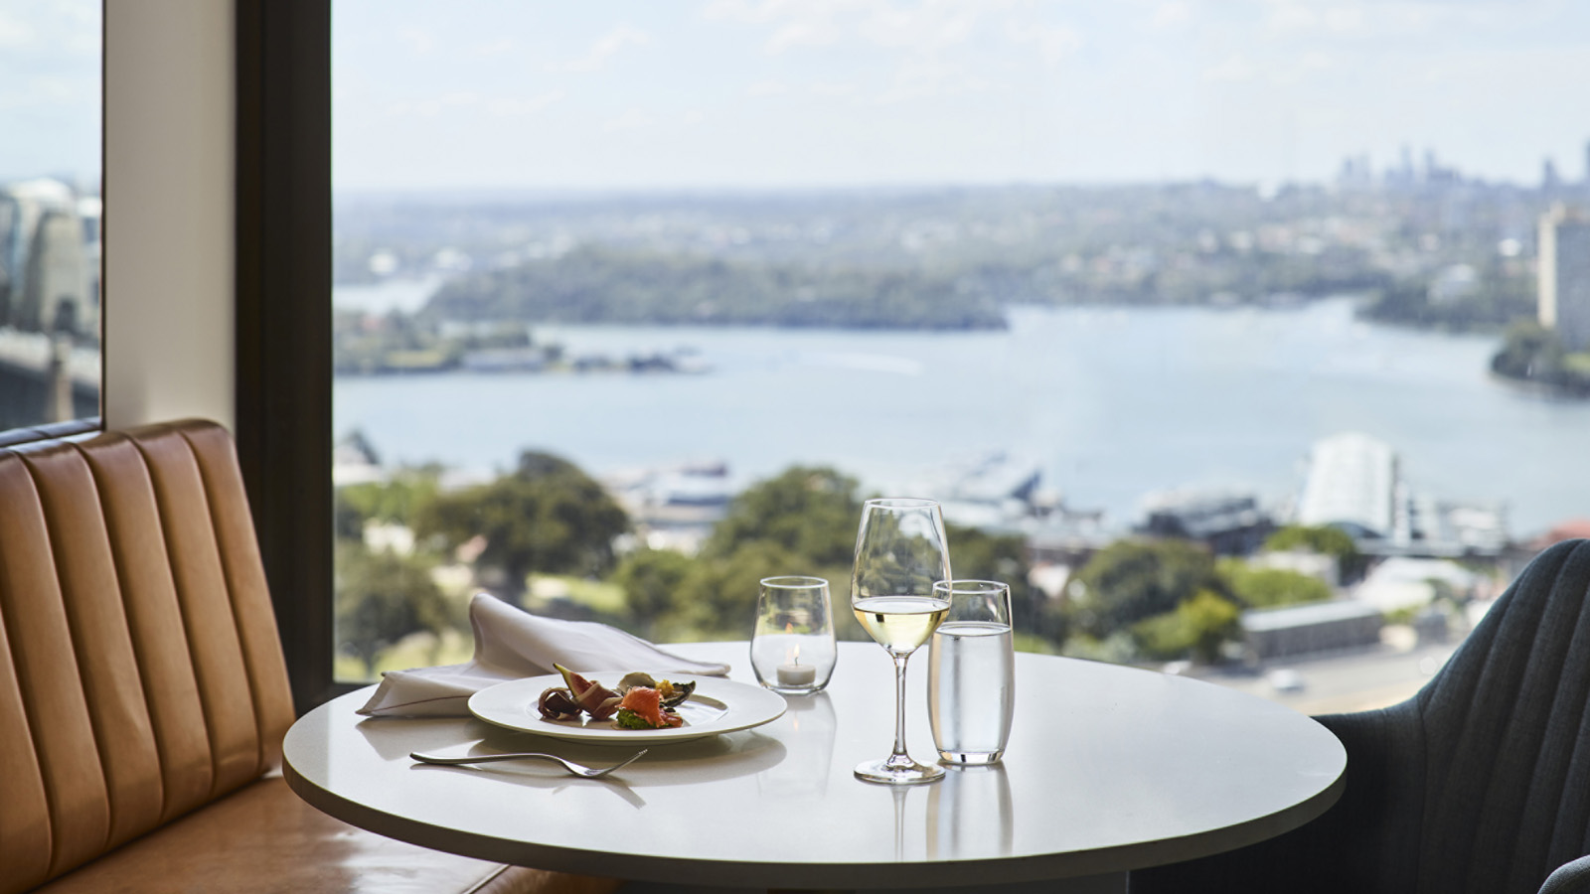 | January 18, 2017, Sydney, Australia  New Lounge 32 at Four Seasons Hotel Sydney Meets Guest Demand for Creature Comforts  http://publish.url/sydney/hotel-news/2017/new-executive-club-lounge.html

PRESS CONTACTS

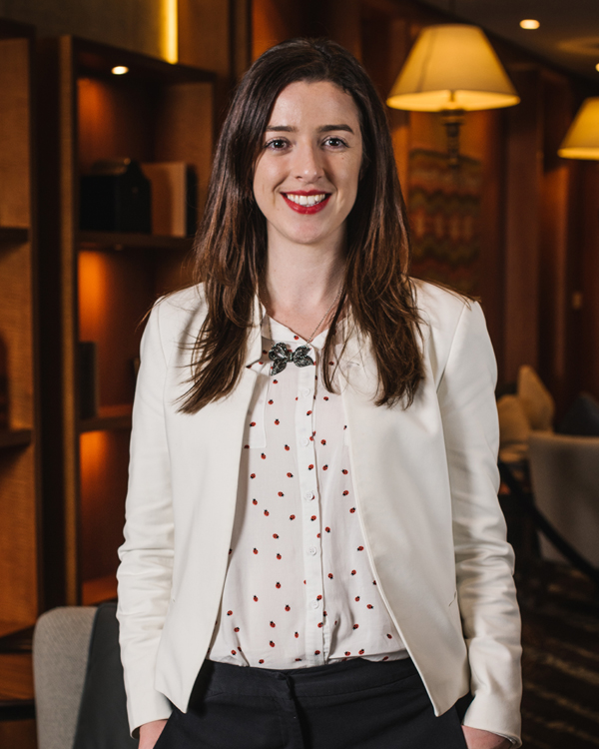 | Jasmine Cook  Director of Public Relations and Communications  199 George Street  Sydney  Australia  jasmine.cook@fourseasons.com  +61 2 9250 3315

