FOUR SEASONS Seoul
Tel: NOT_SETEmail: NOT_SET

OPENING DATE: 2015
GENERAL MANAGER: Michael Schmid

Physical Features
Total Accommodations: 317
- Guest Rooms: 285
- Suites: 32
Design Aesthetic:
- A modern reflection of Korean tradition, with light-filled spaces and every modern convenience at hand
- More than 160 contemporary artworks on display throughout
Architects: Heerim Architects & Planners
Designers:
- LTW Designworks (rooms, public spaces and lobby restaurant)
- André Fu/AFSO (Chinese and Japanese restaurants)
- AvroKO (Italian and market restaurants, and bar)
Location:
- In Gwanghwamun, steps from historic sites and neighbourhoods yet ideally located in the central business district

Spa and Fitness
Spa
Number of Treatment Rooms: 7
Product Lines: Biologique Recherche, Sodashi, EATH Library, Nail Art
Special Features:
- Nail Bar
- Barbershop
The Gym
Fitness Facilities: 765 sq. m. / 8,234 sq. ft.
Special Features:
- Class studios
- Authentic Korean saunas
Pools: Indoor pool plus adjacent plunge pool for children

Dining
Executive Chef: Jerome Deconinck
Restaurant: The Market Kitchen
- Cuisine: International buffet
- Indoor Seating: 241 plus 5 private dining rooms
- Designer: AvroKO
- Chef: David Cho
Restaurant: Boccalino
- Cuisine: Italian
- Indoor Seating: 166 plus 3 private dining rooms
- Designer: AvroKO
Restaurant: Yu Yuan
- Cuisine: Cantonese plus regional specialties
- Signature Dish: Peking duck
- Indoor Seating: 100 plus 8 private dining rooms include 2 deluxe VIP rooms
- Designer: André Fu/AFSO
Restaurant: Akira Back
- Cuisine: Japanese with a Korean essence
- Signature Dishes: Tuna pizza, AB hanwoo tacos, 48 hours short rib
- Indoor Seating: 106 plus 6 private dining rooms
- Designer: André Fu

Recreation
On-Site
- Golf experience
Off-Site
- Cultural sightseeing
- Shopping
- Ice skating
- Hiking
- Water sports

Meetings and Social Occasions
Total Event Space: 2,196 sq. m. / 23,638 sq. ft.
- Reception Capacity: 800
- Meet and Feed Capacity: 500
Largest Ballroom: 788 sq. m. / 8,482 sq. ft. (divisible, plus pre function space)
Junior Ballroom: 501 sq. m. / 5,393 sq. ft. (divisible, plus pre function space)
Additional Meeting Rooms:
- 1 divisible meeting room
- 2 additional function rooms
- 2 executive suites
- Numerous private dining rooms in the Hotel’s 7 restaurants and bars
Special Features:
- 15th floor Garden Terrace for up to 80 persons seated or 125 for a reception
- Traditional Korean pyebaek room for weddings
- On-site floral designer Nicolai Bergmann

Special Features
- Executive Club featuring 24/7 business and concierge service, light refreshments throughout the day, boardroom and more
- On-site floral designer Nicolai Bergmann

PRESS CONTACTS
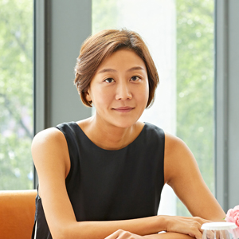 | Inyoung Moon  Director of Public Relations and Communications  97 Saemunan-ro, Jongno-gu  Seoul  Korea  inyoung.moon@fourseasons.com  82-6388-5041
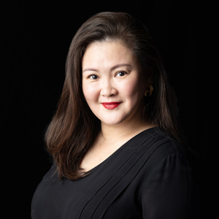 | Kelly Wong  Director of Marketing  97 Saemunan-ro, Jongno-gu  Seoul  Korea  kelly.wong@fourseasons.com  82 2 6388 5001

