Spa Your Way to a More Productive Day at Four Seasons Hotel Chicago

Hotel gives new meaning to a “working lunch” with its Break Away & Spa offer
March 10, 2017, Chicago, U.S.A.

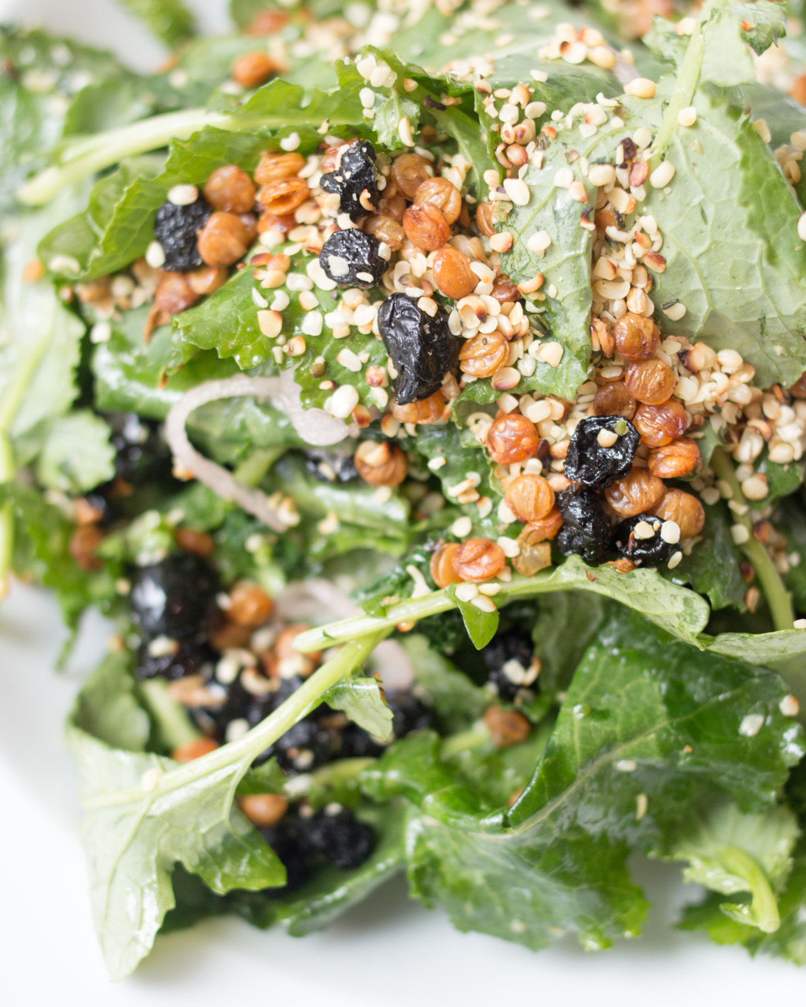
Lack of downtime throughout the day leads to decreased efficiency and reduced motivation.
Four Seasons
Hotel Chicago provides the ideal opportunity to step away from the office and recharge with its new Break Away & Spa offer. Beginning March 15, 2017, busy professionals can finally take some time for themselves during the day, and return to work with fresh ideas and renewed energy.
A simultaneous manicure and pedicure, combined with an antioxidant-packed lunch from the Hotel’s culinary team, will make the work day more productive, both personally and professionally.
The Break Away & Spa offer is available Monday through Friday, from 11:00 am to 3:00 pm. This experience includes Chef’s popular Antioxidant Salad featuring baby kale, blueberries, crispy lentils, hemp hearts, and an apple cider vinaigrette. Grilled chicken or shrimp can be added for additional protein. Lunch also features a fresh pressed seasonal juice.
To ensure an efficient break and seamless Four Seasons service, lunch orders will be requested at time of booking. Savour the meal overlooking the Hotel’s 50-foot indoor swimming pool, or back at the office.
The Break Away & Spa experience is USD 85. To schedule an appointment, call the Spa and Fitness Center at 312 649 2340.

RELATED

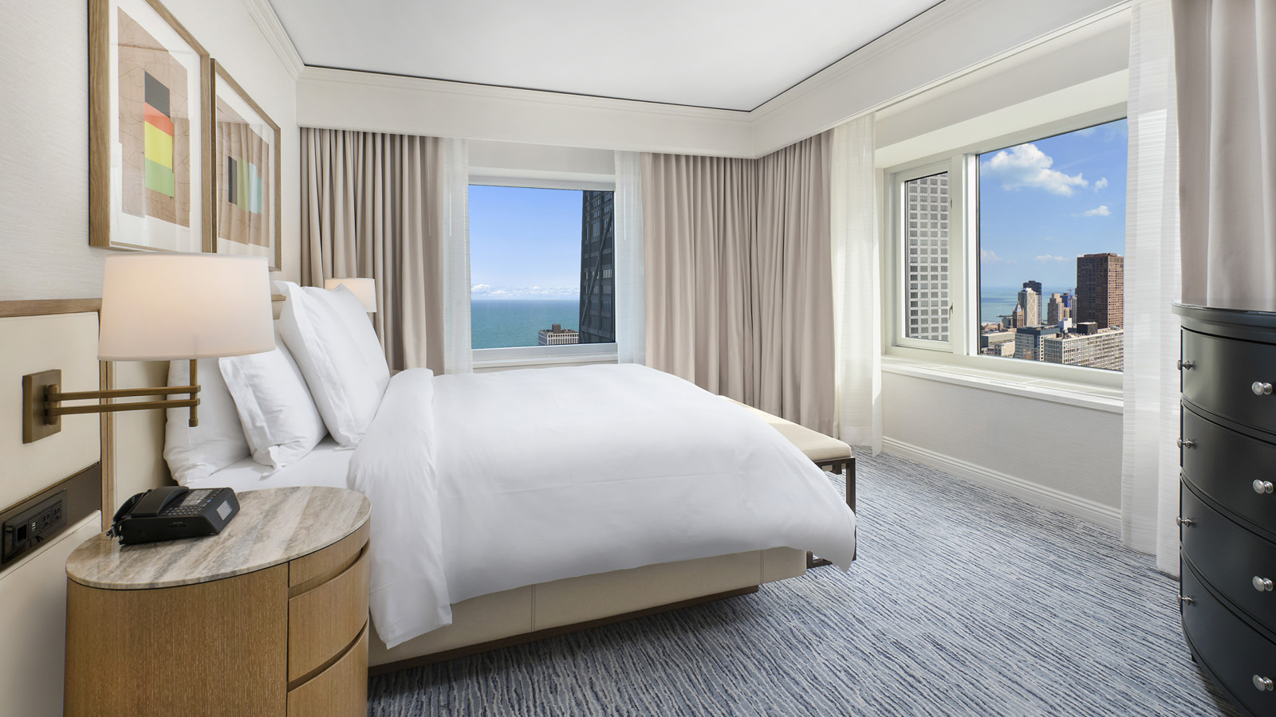 | April 10, 2017, Chicago, U.S.A.  Four Seasons Hotel Chicago to Complete Renovation in Summer 2017  http://publish.url/chicago/hotel-news/2017/guest-room-renovation.html
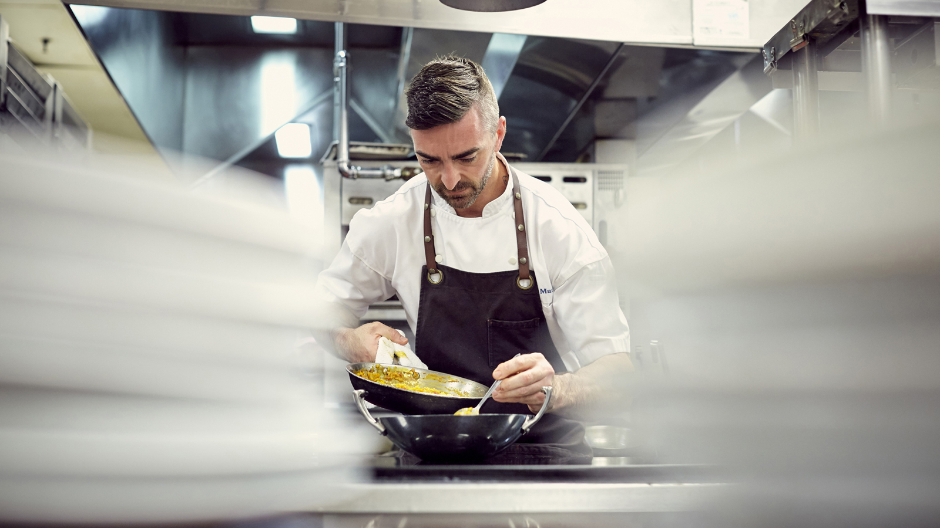 | February 3, 2017, Chicago, U.S.A.  Four Seasons Hotel Chicago Guest Chef Series Kicks Off with James Beard Foundation Celebrity Chef Tour Dinner at Allium  http://publish.url/chicago/hotel-news/2017/guest-chef-dinner-series.html

PRESS CONTACTS

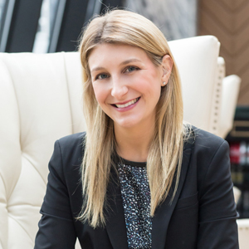 | Charlotte Berlin  Director of Public Relations  120 E. Delaware Street  Chicago  U.S.A.  charlotte.berlin@fourseasons.com  (312) 280-8800

