2017 Forbes Travel Guide Star Ratings: Four Seasons Resort Hualalai Earns Five Stars, Reflecting Highest Level of Service Excellence

Four Seasons makes Forbes Five-Star history, earning the highest number of Five-Star Ratings by a hotel brand in a single year since the Guide’s inception
February 22, 2017, Hawaii, Hualalai, U.S.A.

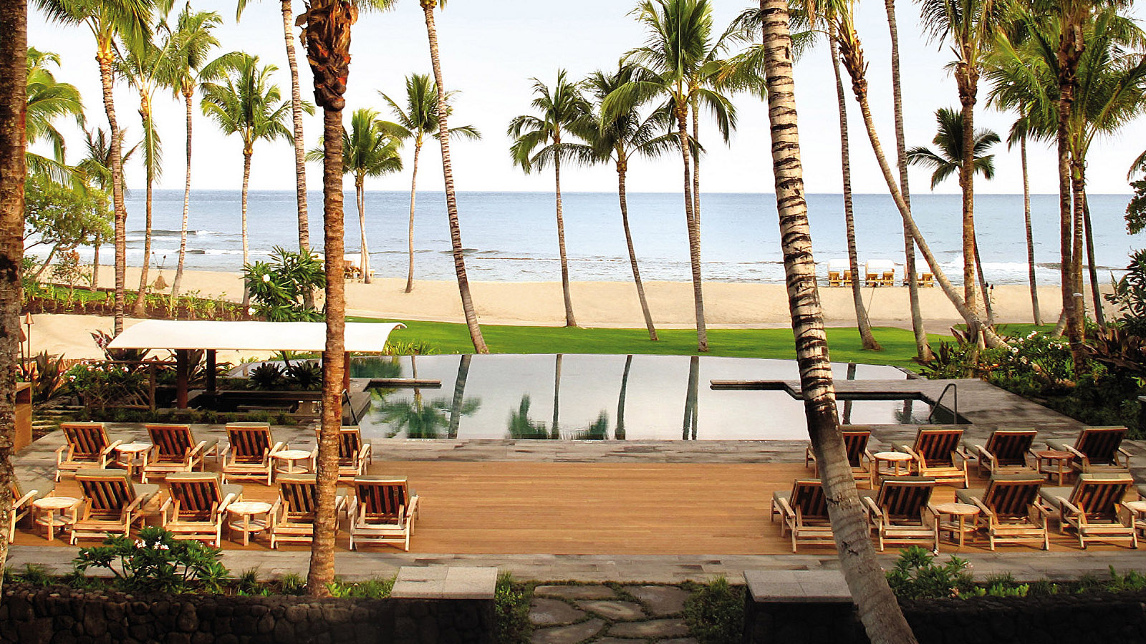
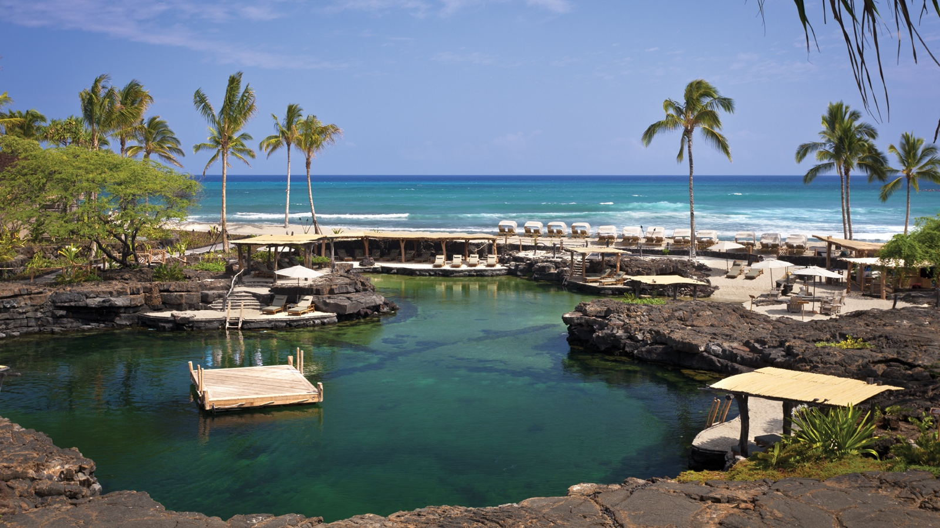 | 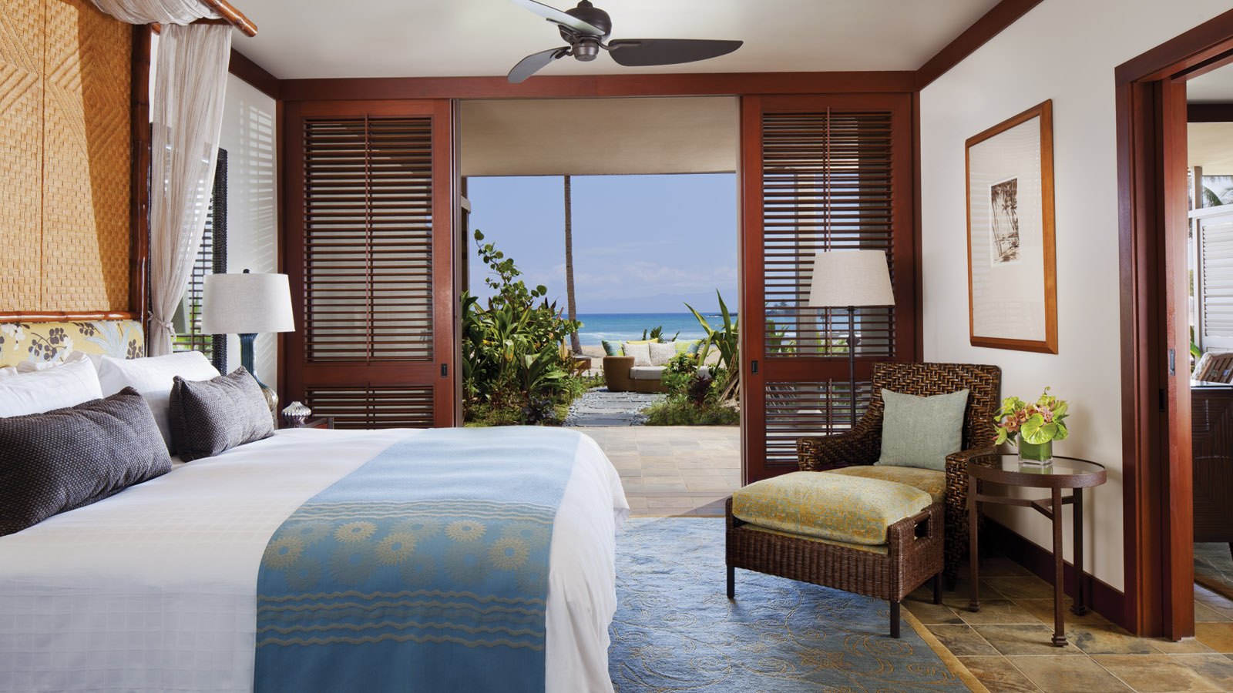 | 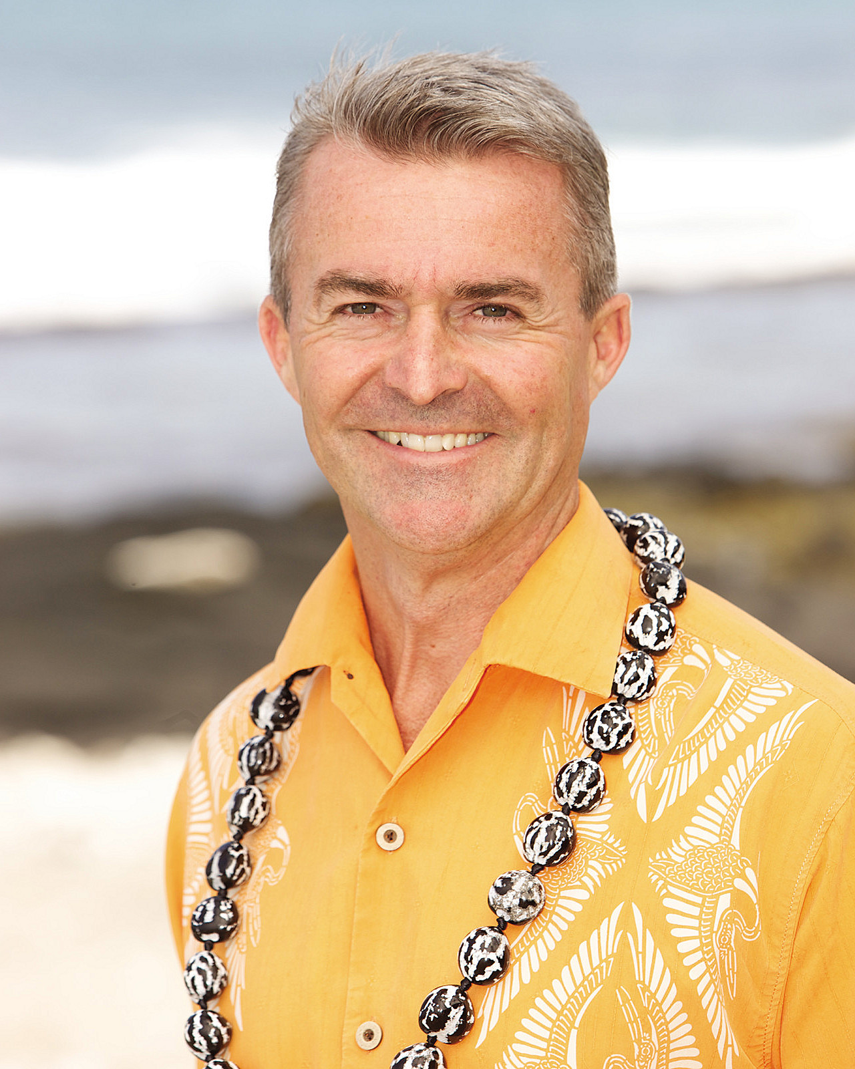
Four Seasons
Hotels and Resorts, the world’s leading luxury hospitality company, today announced that Forbes Travel Guide has awarded
Four Seasons
Resort Hualalai a Five-Star Rating, its highest honour. Worldwide, 30
Four Seasons
hotels and resorts earned the coveted Five-Star designation in 2017, setting the record for the highest number of Five-Star awards given to a single brand in the history of the Forbes Travel Guide Ratings.
With 243 guest rooms, award-winning golf course and seven pools,
Four Seasons
Resort Hualalai has received the Forbes Five-Star Rating for the past nine years. The Resort remains the only Five-Star rated property on Hawaii Island and the Resort's restaurant, 'ULU, is the only Forbes star-rated restaurant on the island.
“We are honoured to have once again received this accolade,” states Robert Whitfield, Regional Vice President and General Manager of
Four Seasons
Resort Hualalai. “The team here makes every effort to provide individualised and authentic service to each guest who stays with us, keeping every detail of their travel experience in mind.”
Star Ratings are awarded by a team of anonymous professional inspectors. In the words of Forbes Travel Guide, its inspectors “travel the world to assess hotels, restaurants and spas against up to 800 objective standards.” Star Ratings ultimately emphasise quality of service. Five-Star properties are defined as “outstanding, often iconic properties with virtually flawless service and amazing facilities.”
Forbes Travel Guide rates properties in 42 countries throughout the Americas, Europe and the Asia-Pacific region, with plans to add the Middle East and Africa for 2018.
The 30
Four Seasons
properties that have earned Five Stars in 2017 are:
- Four Seasons Hotel Atlanta
- Four Seasons Resort Bali at Jimbaran Bay
- Four Seasons Resort Bali at Sayan
- Four Seasons Hotel Boston
- Four Seasons Hotel Chicago
- Four Seasons Resort Costa Rica at Peninsula Papagayo
- Four Seasons Hotel des Bergues Geneva
- Four Seasons Hotel Firenze
- Four Seasons Hotel George V, Paris
- Four Seasons Hotel Gresham Palace Budapest
- Four Seasons Hotel Guangzhou
- Four Seasons Hotel Hangzhou at West Lake
- Four Seasons Hotel Hong Kong
- Four Seasons Resort Hualalai
- Four Seasons Resort and Residences Jackson Hole
- Four Seasons Hotel Los Angeles at Beverly Hills
- Four Seasons Hotel London at Park Lane
- Four Seasons Hotel Macao, Cotai Strip
- Four Seasons Resort Maui at Wailea
- Four Seasons Hotel New York
- Four Seasons Resort Palm Beach
- Four Seasons Hotel Pudong, Shanghai
- Four Seasons Resort Punta Mita, Mexico
- Four Seasons Hotel San Francisco
- Four Seasons Hotel Seattle
- Four Seasons Hotel Toronto
- Four Seasons Hotel Vancouver
- Four Seasons Hotel Washington, DC
- Four Seasons Resort and Residences Whistler
- Grand-Hôtel du Cap-Ferrat, A Four Seasons Hotel
Forbes Travel Guide plans to formally bestow the ratings at a Five-Star Awards Ceremony and Banquet in New York City on March 1, 2017.

About Forbes Travel Guide
Forbes Travel Guide is the originator of the prestigious Five-Star Rating system, and has provided the travel industry’s most comprehensive ratings and reviews of hotels, restaurants and spas since 1958. Forbes Travel Guide has a team of expert inspectors who anonymously evaluate properties against up to 800 rigorous and objective standards, providing consumers the insight to make better-informed travel and leisure decisions. Forbes Travel Guide is the most prestigious standard for luxury hospitality worldwide.

RELATED

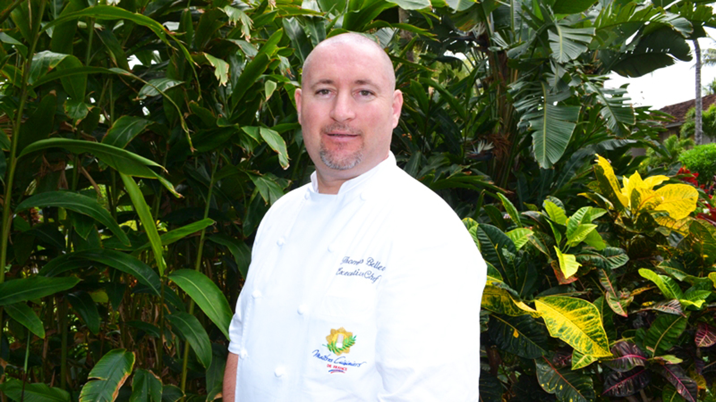 | April 6, 2017, Hawaii, Hualalai, U.S.A.  Four Seasons Resort Hualalai Welcomes Executive Chef Thomas Bellec  http://publish.url/hualalai/hotel-news/2017/new-executive-chef-thomas-bellec.html
March 20, 2017, Hawaii, Hualalai, U.S.A.
Colin Clark Appointed General Manager of Four Seasons Resort Hualalai
http://publish.url/hualalai/hotel-news/2017/new-gm-colin-clark.html

PRESS CONTACTS

Morgan Suzuki
Director of Public Relations and Communications
72-100 Ka'upulehu Drive
Kailua Kona
U.S.A.
morgan.suzuki@fourseasons.com

1 (808) 557-5909

