Four Seasons Resort and Residences Whistler Celebrates Canada 150 with a Delicious Hunt, Gather, Fish Three-Course Menu and Some Very Canadian Promotions

May 30, 2017, Whistler, Canada

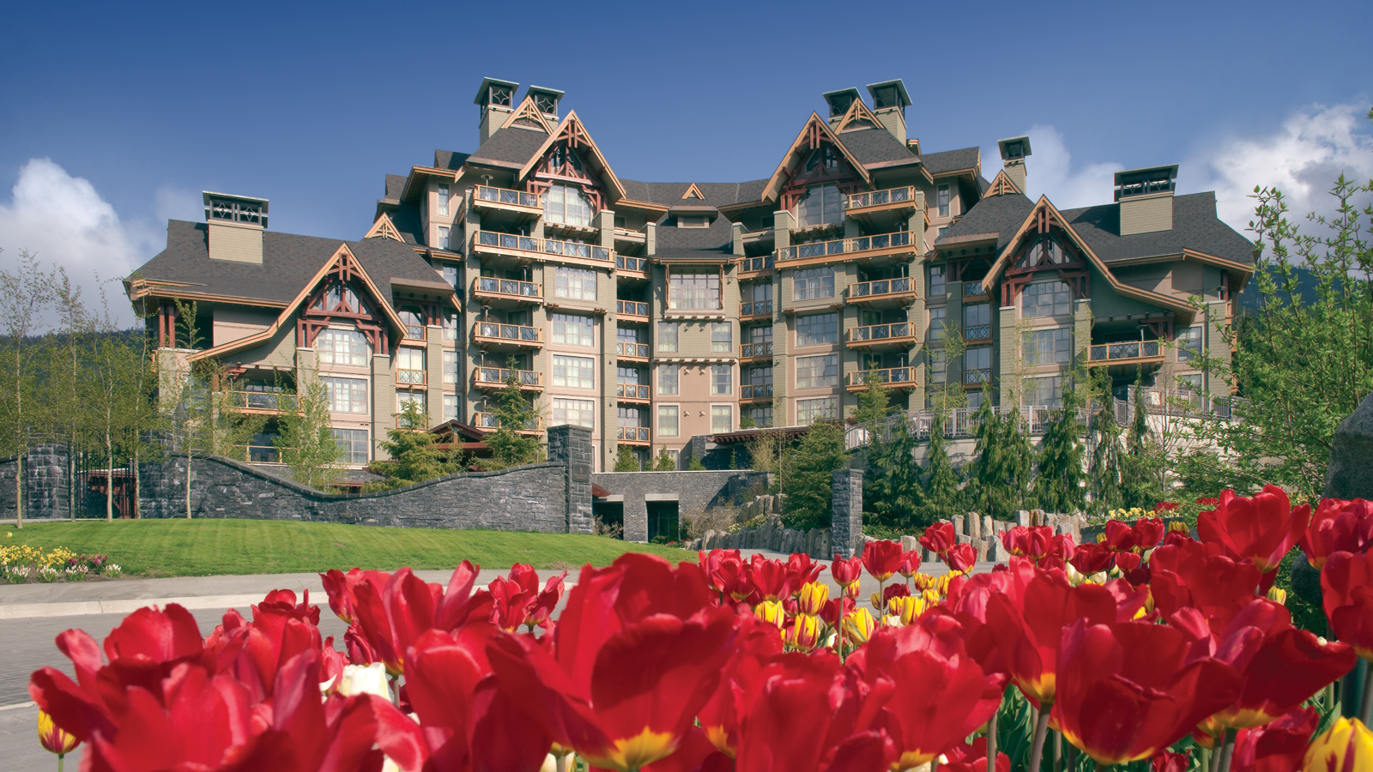
Spring is on in Whistler - longer days, warmer weather and a spirit of celebration inspires the village vibe. While Canada generously provides year-round discovery and adventure for all types of travellers, this year’s July 1 Canada Day birthday marks 150 years since the country joined together in confederation. There are so many reasons that make this part of Canada so special, so exhilarating, so welcoming, and so delicious. Here are a few not to miss.
Eat with Purpose: Hunt, Gather, Fish at SIDECUT Modern Steak
SIDECUT's’s thoughtful Canada 150: Hunt Gather Fish CAD 39 menu is a nod to the original foragers of the local area who celebrated the spirituality of indigenous ingredients. SIDECUT strives to weave storytelling of First Nations tribes into its culinary offerings. This three-course menu is also available with wine pairings from the Similkameen’s Orofino Vineyards.
Stay the Night and Celebrate: Canada 150 Perks
For Canada's sesquicentennial,
Four Seasons
Resort and Residences Whistler jubilates coast to coast with its sister properties
Four Seasons
Hotel Vancouver and
Four Seasons
Hotel Toronto with a special Canada Turns 150 package that provides a “guests’ choice” CAD 150 credit that can be used for coursed epicurean dinners, a maple sugar scrub spa treatment or an outdoor adventure in the majestic and vast terrain of Whistler. In addition, a special Canadian-inspired amenity will be delivered to the suite upon arrival, and the package is available until December 28, 2017.
Get to Know Us: In 50 Hours
Four Seasons
Canada Collection is also inviting guests to take advantage of the favourable exchange rate and spend 150, equally divided hours in Canada to celebrate this momentous occasion. With unique and memorable activities from East Coast to West, guests can sample activities that make each visit truly remarkable in Vancouver, Whistler and Toronto.
- 50 Hours in Whistler
- 50 Hours in Vancouver
- 50 Hours in Toronto
To plan a #Canada150 vacation at
Four Seasons
Resort and Residences Whistler, contact the Reservations Department at +1 604 984 3500 or online.

RELATED

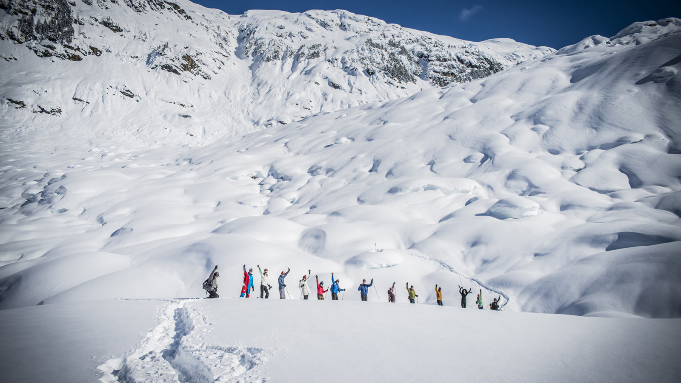 | May 4, 2017, Whistler, Canada  Ski Now and Ski Later with Great Value Offers at Four Seasons Resort and Residences Whistler  http://publish.url/whistler/hotel-news/2017/early-bird-ski-package.html
May 4, 2017, Whistler, Canada
Pamper Mom with a Relaxing, Rejuvenating and Delicious Weekend at Four Seasons Resort and Residences Whistler, The Spa and SIDECUT Modern Steak May 12 to 14
http://publish.url/whistler/hotel-news/2017/mothers-day.html

PRESS CONTACTS

Christine Kim
Public Relations and Communications Manager
4591 Blackcomb Way
Whistler
Canada
christine.kim@fourseasons.com

+1 (604) 966-2666

Kate Colley
Director of Public Relations and Communications
4591 Blackcomb Way
Whistler
Canada
kate.colley@fourseasons.com

+1 (604) 844-6769

