FOUR SEASONS Seychelles
Tel: (248) 439 3000 Email: press@fourseasons.com

OPENING DATE: February 2009
GENERAL MANAGER: Renan Astolpho

Physical Features
Total Number of Rooms: 67
- Guest Rooms: 62
- Villas: 5
Number of Residential Units: 27
Design Aesthetic:
- Local Creole style with extensive use of wood and stone in a series of indoor and outdoor pavilions
- Nestled into a lush hillside leading down to a white-sand beach
- Every villa has its own infinity pool, deck, outdoor shower and open-air reading pavilion with daybed
- Features colourful art by the country's foremost artist
Architect: Area
Interior Designer(s): Hirsch Bedner Associates
Location: Secluded private bay on the country's main island of Mahe, 30 minutes by land from the airport

Le Syel Spa
Number of Treatment Rooms: 8
Product Range: MyBlend, Belliche, Temple Spa
Signature Treatments:
- Le Syel Signature: Beginning with a nurturing foot ritual, signature Opening Sequence using Breath Of Life inhalation and cooling balm application, moving up the body where cells are restored during singing bowl vibration to melt stress and tension away. Concluding with a facial and scalp massage.
- The Miracle of Coco De Mer: A rare native palm tree with the largest seed in the plant kingdom. This five step ritual includes a body scrub and mask, body butter massage, bath overlooking the bay and application of body lotion.
Interior Designer: Hirsch Bedner Associates
Design Aesthetic:
- Located at the uppermost point of the Resort, far above Petite Anse bay, with sweeping Indian Ocean views
- Contemporary island décor and furnishings, with natural harmonious colour palette of warm browns, white, gold, greens and greys
Special Features:
- Every double treatment room is equipped with changing facilities, restroom, indoor massage beds, outdoor bathtub and rain shower
Interior Designer: Hirsch Bedner Associates

Dining
Examples of Locally Sourced Ingredients:
- Herbs and spices including cinnamon and lemongrass
- Fruits including mangoes, jackfruit, pineappple, papaya, coconut and passion fruit
- Local fish brought ashore by fishermen including mahi mahi, tuna, red snapper, job fish and octopus
- Vanilla
Restaurant: Koi
- Cuisine: Japanese

Recreation
Pools:
- Number of Pools: 1
Fitness Facilities:
- Size: 128 sq m / 1,380 sq ft
- Latest cardio machines, free weights area, strength-training equipment, complimentary coffee, fruit and granola bars and exercise wear
- Classes and personal training
- Walking and jogging trail
- Bespoke surf and yoga retreats
On-site Activities:
- Beach
- Birdwatching
- Boating
- Fishing
- Hiking
- In-room spa services
- Jogging
- Kayaking
- Library
- Sailing
- Scuba diving
- Snorkeling
- Marine education
Off-site Activities:
- All-terrain vehicle excursions
- Biking
- Boating
- Canoeing
- Deep sea fishing
- Golf
- Helicopter tours
- Hiking
- Horseback riding
- Jet skiing
- Jungle trekking
- Kayaking
- Local excursions

For Younger Guests
- Kids for All Seasons: Supervised children's program in a dedicated facility
- Marine education
- Surf lessons
- Junior spa
- Upon arrival, children each receive special amenities

Meeting Rooms
Unique Meeting and Event Facilities:
- Indoor and outdoor spaces
- Private dining
- Weddings
Breakout Spaces: 2
Private Dining Room Capacity: 4
Unique Meeting and Event Facilities:
- Old beach house available for private weddings or intimate meals

Corporate Social Responsibility
- Member of the Green Globe program for sustainable travel and tourism
- Resort-specific Sustainability Management Plan in place
- Vegan and vegetarian menu items available
- Certified “Seychelles Sustainable Tourism Label Hotel” by the Ministry of Tourism
- Elimination of single-use plastic water bottles
- Employees participate in an annual charity event, Run for Hope, to raise awareness and funds for cancer research
- Locally sourced fruits and seafood
- Biodiversity support program to support Petite Anse Reef Restoration Project to protect the reef
- Local artists featured throughout the Resort

PRESS CONTACTS
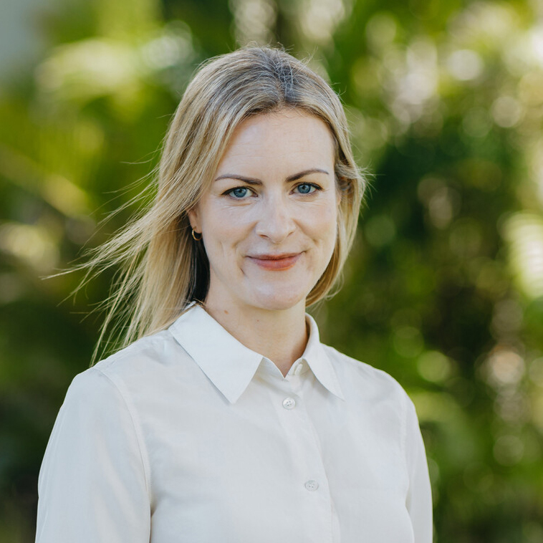 | Ellen Donington-Smith  Senior Director of Public Relations and Communications  Beau Champ  Mauritius  ellen.donington-smith@fourseasons.com  +230 402 3100
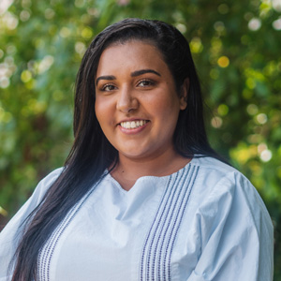 | Ilu Bhatia  Assistant Marketing Communications Manager  Petite Anse  Victoria  Seychelles  vaninthorn.bhatia@fourseasons.com  (248) 252 6932

