A Vibrant Culinary Journey from Istanbul at Four Seasons Hotel Jakarta

Celebrated chefs from
Four Seasons
Hotel Istanbul at the Bosphorus will present an array of Turkish delights at the Hotel’s all day dining restaurant
September 12, 2017, Jakarta, Indonesia

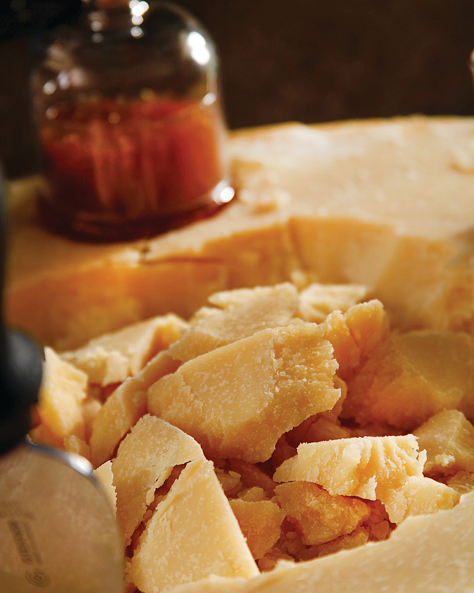
Palm Court at
Four Seasons
Hotel Jakarta invites gourmands to a flavourful journey to Turkey and its culinary roots hosted by guest chefs from the celebrated
Four Seasons
Hotel Istanbul at the Bosphorus. In conjunction with the Turkish National Day, this event aims to add excitement and diversity to Jakarta’s dining scene by bringing in exciting global culinary talents.
Venturing to the vibrant food city of Turkey, Palm Court will showcase tasty and authentic regional cuisines of Turkey, a culinary-oriented exploration of this ancient land bridge between Europe and Asia. The special menu offers a rich variety of items from different regions inspired by Central Anatolia, and the Aegean and Mediterranean Seas.
During the three-day food festival, Chef Fatih Kalem and team will flare up the kitchen of Palm Court, as they prepare signature dishes including hunkar begendi (braised beef with eggplant puree), levrek bugulama (steamed sea bass with onion, lemon, tomato), kuzu tandir (roasted lamb) and also variety of kebabs. Special desserts are available for those who have a sweet tooth. Indulge with desserts selections such as baklava, sütlaç (rice pudding), şekerpare (semolina and almond dessert) and Turkish bread pudding with pistachio.
Experience a Turkish culinary feast at Palm Court Restaurant,
Four Seasons
Hotel Jakarta October 27-29, 2017.
For reservations, call +62 21 2277 1888.

RELATED

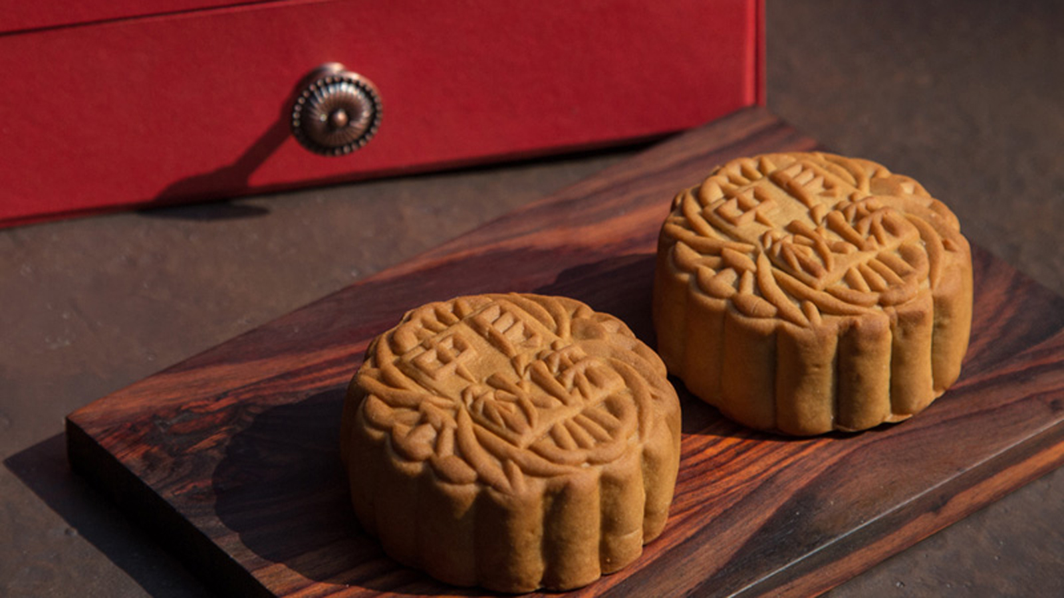 | September 8, 2017, Jakarta, Indonesia  Four Seasons Hotel Jakarta Celebrates the Mid-Autumn Festival with Premium Crafted Mooncakes  http://publish.url/jakarta/hotel-news/2017/mooncakes.html
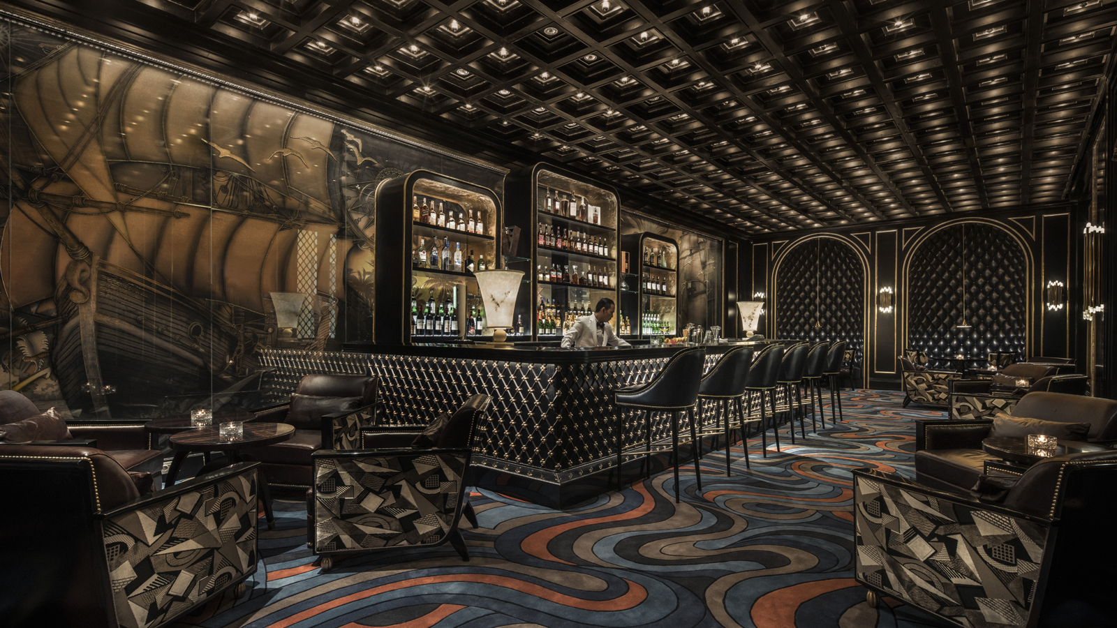 | September 7, 2017, Jakarta, Indonesia  Nautilus Bar Takeover at Four Seasons Hotel Jakarta with Keli Rivers  http://publish.url/jakarta/hotel-news/2017/keli-rivers-nautilus-takeover.html

PRESS CONTACTS

Rumman Amanda
Public Relations Manager
Jalan Jenderal Gatot Subroto Kav. 18
Jakarta
Indonesia
rumman.amanda@fourseasons.com

+62 21 227 71888

