Four Seasons Hotel Sydney Lights Up for Vivid Sydney with Pop-Up Champagne Bar and Special Offers

May 19, 2017, Sydney, Australia

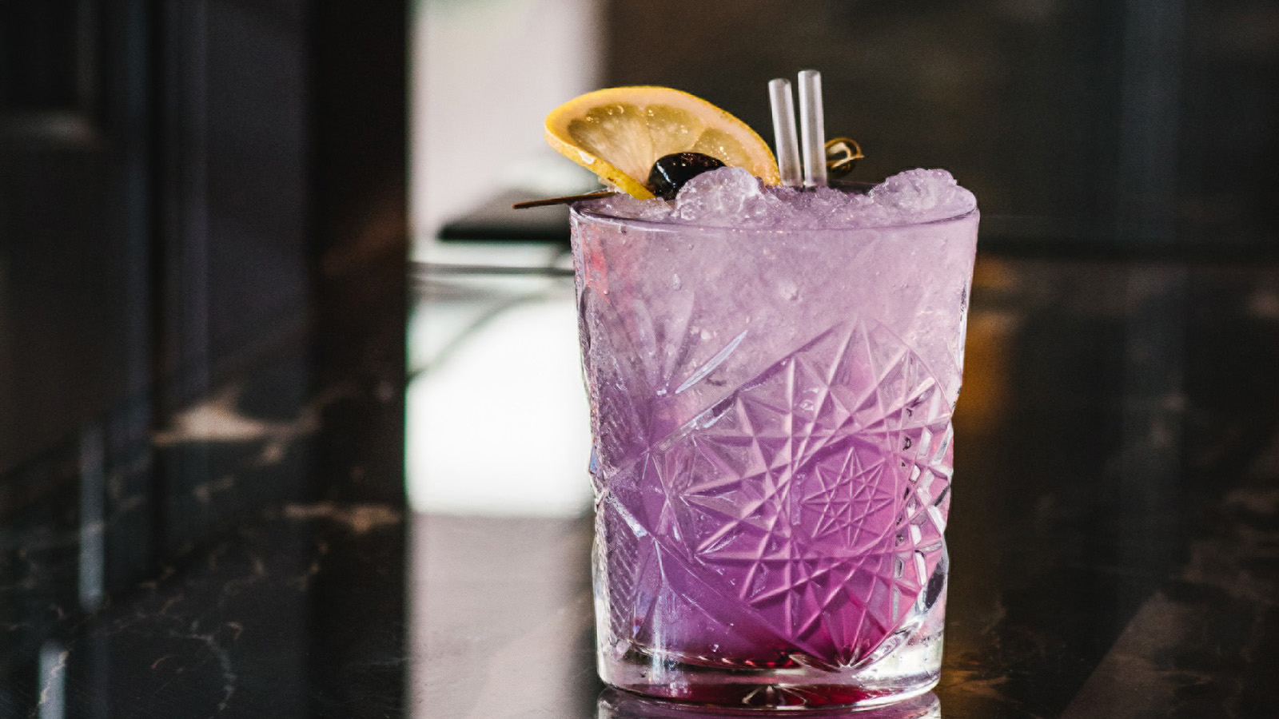
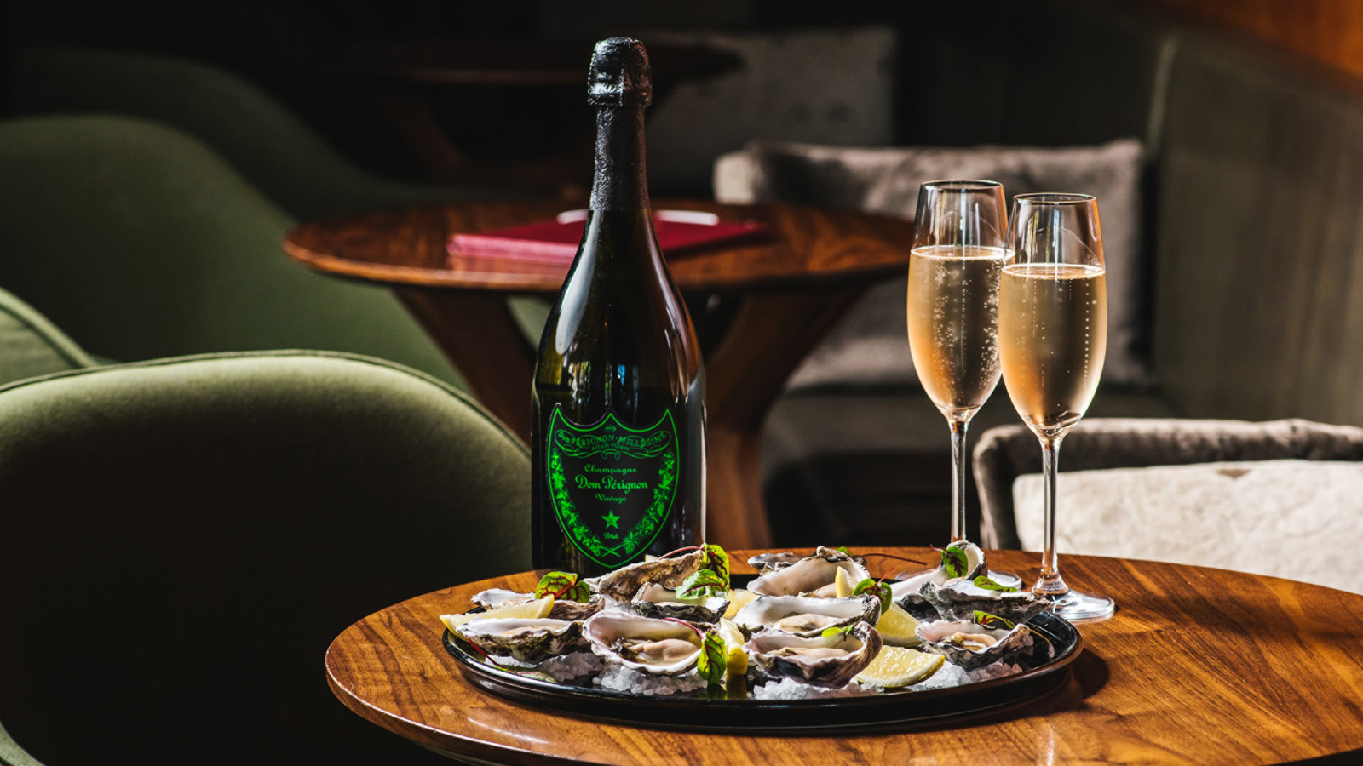
Spectacular harbour views, glowing cocktails and illuminated Dom Pérignon Champagne are just the beginning of the Vivid Sydney experience at
Four Seasons
Hotel Sydney this year, May 26 to June 17, 2017.
Sydney’s best located luxury hotel will join the celebrations starting with the return of its popular Dom Pérignon Luminous Champagne pop-up in Grain Bar.
Grain will glow green each night of the festival with an exclusive pop-up Champagne bar serving Dom Pérignon by the glass for AUD 60, and Dom Pérignon Luminous by the bottle paired with a complimentary dozen freshly-shucked oysters for AUD 375.
The streetfront bar will also offer gourmet treats designed to match with Champagne, such as lobster corn dogs with citrus aioli and duck fat fries, along with a Vivid-inspired signature cocktail, Viva Violetta (AUD 18) mixed with purple-coloured locally-made Ink Gin.
Festival goers can make a night of it and enjoy uninterrupted panoramic views of Vivid’s colourful projections across the Harbour Bridge and Opera House from a harbour view room or suite at
Four Seasons
Hotel Sydney.
To celebrate the festival,
Four Seasons
Hotel Sydney has created a special Vivid Sydney Package, including overnight accommodation, buffet breakfast for two and a complimentary Viva Violetta signature cocktail in Grain bar, starting from AUD 380 per night.*
Located at 199 George Street,
Four Seasons
Hotel Sydney is just a minute’s stroll from Vivid Sydney’s harbourside highlights including the Light Walk around The Rocks and Circular Quay.
For bookings: +61 9250 3100, res.sydney@fourseasons.com, or reserve online.
\
*Terms and conditions apply. Subject to availability. Accommodation rate is per room, per night. Prices are quoted in AUD.

RELATED

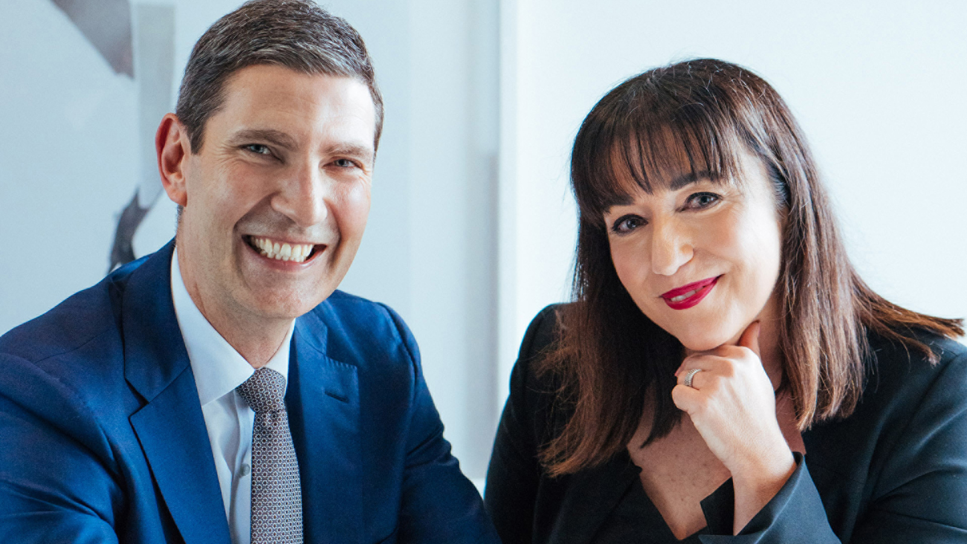 | April 11, 2017, Sydney, Australia  Two New Senior Appointments at Four Seasons Hotel Sydney  http://publish.url/sydney/hotel-news/2017/new-hotel-manager-and-director-of-marketing.html
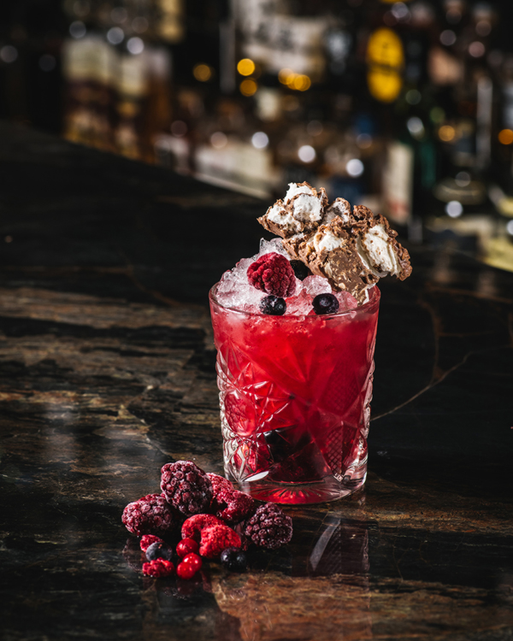 | April 7, 2017, Sydney, Australia  Chocolate Cocktails to Indulge in This Easter at Grain Bar at Four Seasons Hotel Sydney  http://publish.url/sydney/hotel-news/2017/easter-chocolate-cocktails.html

PRESS CONTACTS

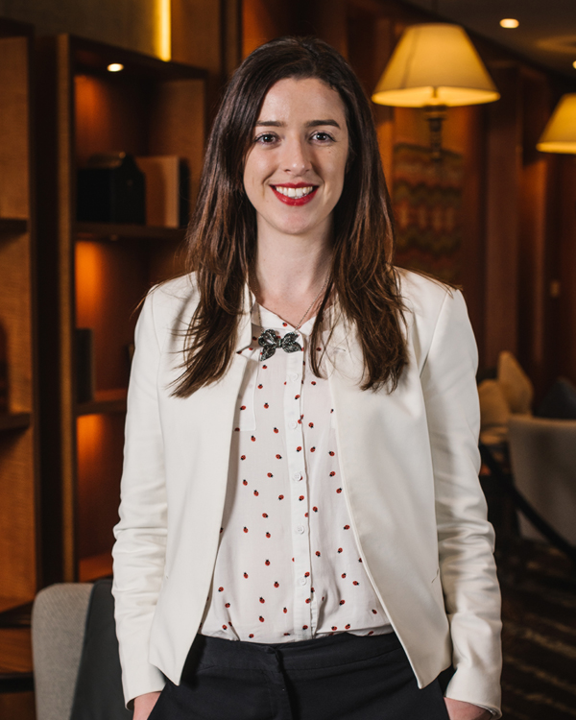 | Jasmine Cook  Director of Public Relations and Communications  199 George Street  Sydney  Australia  jasmine.cook@fourseasons.com  +61 2 9250 3315

