FOUR SEASONS Bahrain
Tel: (8000) 4115 Email: press@fourseasons.com

OPENING DATE: March 2015
GENERAL MANAGER: Jason Rodgers

Physical Features
Total Number of Rooms: 273
Architects:
- Skidmore, Owings & Merrill
Interior Designer:
- Pierre-Yves Rochon
- Waldo Fernandez (selected restaurants)
Location:
- Towering above a lushly landscaped private island, easily accessible via causeway to the Manama's business, commercial and shopping as well as historic and cultural sites and numerous recreational opportunities
- Just 15 minutes from Bahrain International Airport

Spa
Size: 3,485 sq. m. (37,512 sq. ft.)
Designer: Pierre-Yves Rochon
Number of Treatment Rooms: 17
Product Lines:

Dining
Restaurant: CUT by Wolfgang Puck
- Cuisine: Steakhouse

Recreation
On-site Activities
Beach and Pools:
- White Sand Beach (outdoor): 160-metre (525-foot)

For Younger Guests
- Fully supervised children's program
- Kids' Pool

Meetings and Events
Total Size: 35,222 sq. ft. / 3,272 sq. m.
Largest Ballroom (Al Bahrain): 9,935 sq. ft. / 923 sq. m.
Second Ballroom(Al Manama): 4,650 sq. ft. / 432 sq. m.
Reception Capacity: 750
Banquet Capacity: 550
Meet and Feed Capacity: 250
Additional Meeting Rooms: 4 additional meeting rooms plus 2 boardrooms
Special Facilities:
- Enclosed music studio to pipe live music into the ballrooms
- Bridal suite including private entrance, photography room, pantry and separate living room and companion suite
- Business centre

PRESS CONTACTS
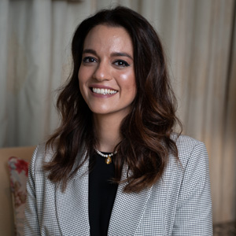 | Tugce Goksel  Director of Public Relations and Communications  P.O.Box 1669, Bahrain Bay  Manama  Bahrain  tugce.goksel@fourseasons.com  +973 1711 5000

