Four Seasons Resort Marrakech Hosts an exhibition of Talented Painter Noureddine Daifallah

Resort’s guests can discover the artworks of Noureddine, in exclusive collaboration with Four Seasons for few months
August 10, 2017, Marrakech, Morocco

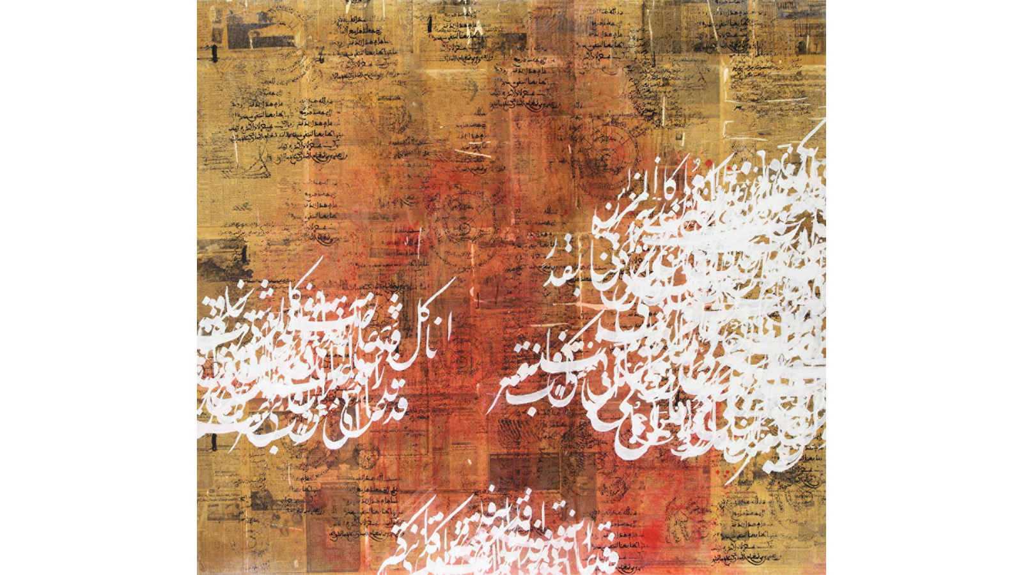
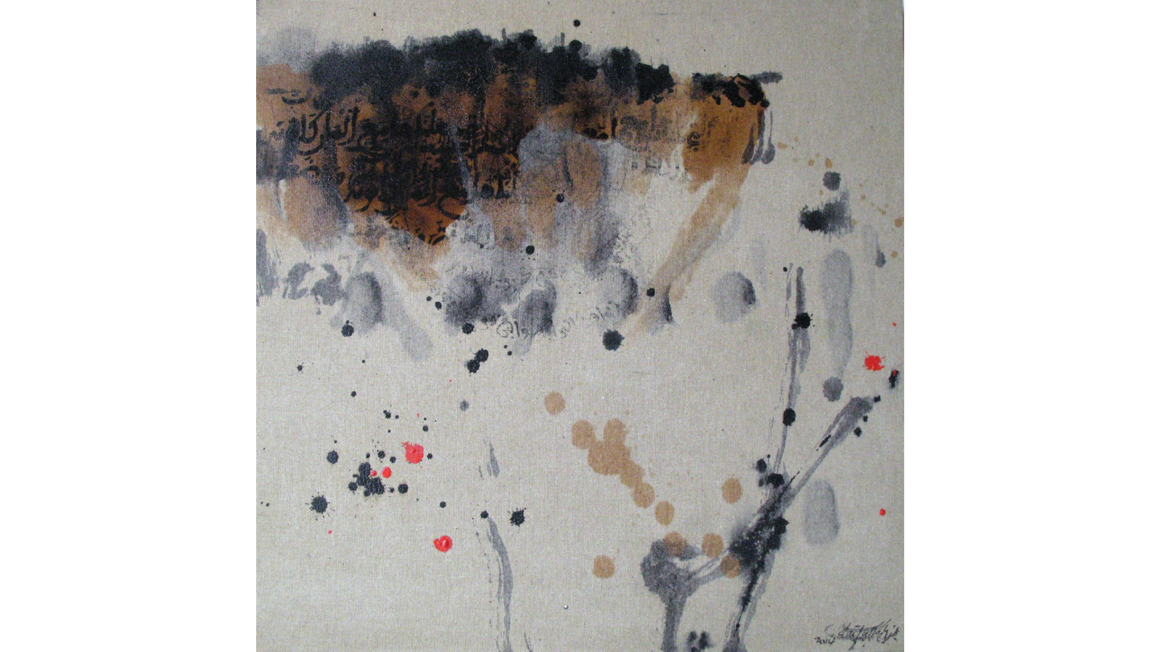
Arabic calligraphy is being honoured at Four Seasons Resort Marrakech. The exhibition features numerous paintings inspired by Muslim calligraphy, in which writing merges with painting. However, in this case, the paintbrush replaces the kalam, traditional instrument of the calligraphers. Guests can admire beautiful artworks made mainly with dark colours and earth tones, painted with a unique approach by Noureddine Daifallah. According to the artist, these shades were chosen to preserve the authenticity of this traditional art while presenting an innovative and conscientious work. The text appearing on the paintings is actually derived from the famous work Al-Maârifia Al-Arabia of the writer Abdelkbir Khatabi. The challenge to decode the text and the fact that his paintings are untitled allows the guests’ imagination a complete free range among the lines and colours.
The Marrakechi painter is also a plastic arts professor. Since his first exhibition at age 17, his creations have been recognised in many countries, particularly in Europe, in the Arab world and in New York. He participated in numerous exhibitions such as the Istanbul Biennale, the Sharjah International Biennale, and periodically at the Matisse Art Gallery in Casablanca and Marrakech, and the Guggenheim Museum in New York.
This unique exhibition is an opportunity for local and international guests to observe a fresh art interpretation differing from the aesthetics of paintings generally found. It's the perfect chance for art lovers to discover another side of Moroccan creativity.

RELATED

August 10, 2017, Marrakech, Morocco
Four Seasons Resort Marrakech accueille l’exposition du talentueux artiste peintre Noureddine Daifallah
http://publish.url/fr/marrakech/hotel-news/2017/noureddine-daifallah-art-exhibition-2.html

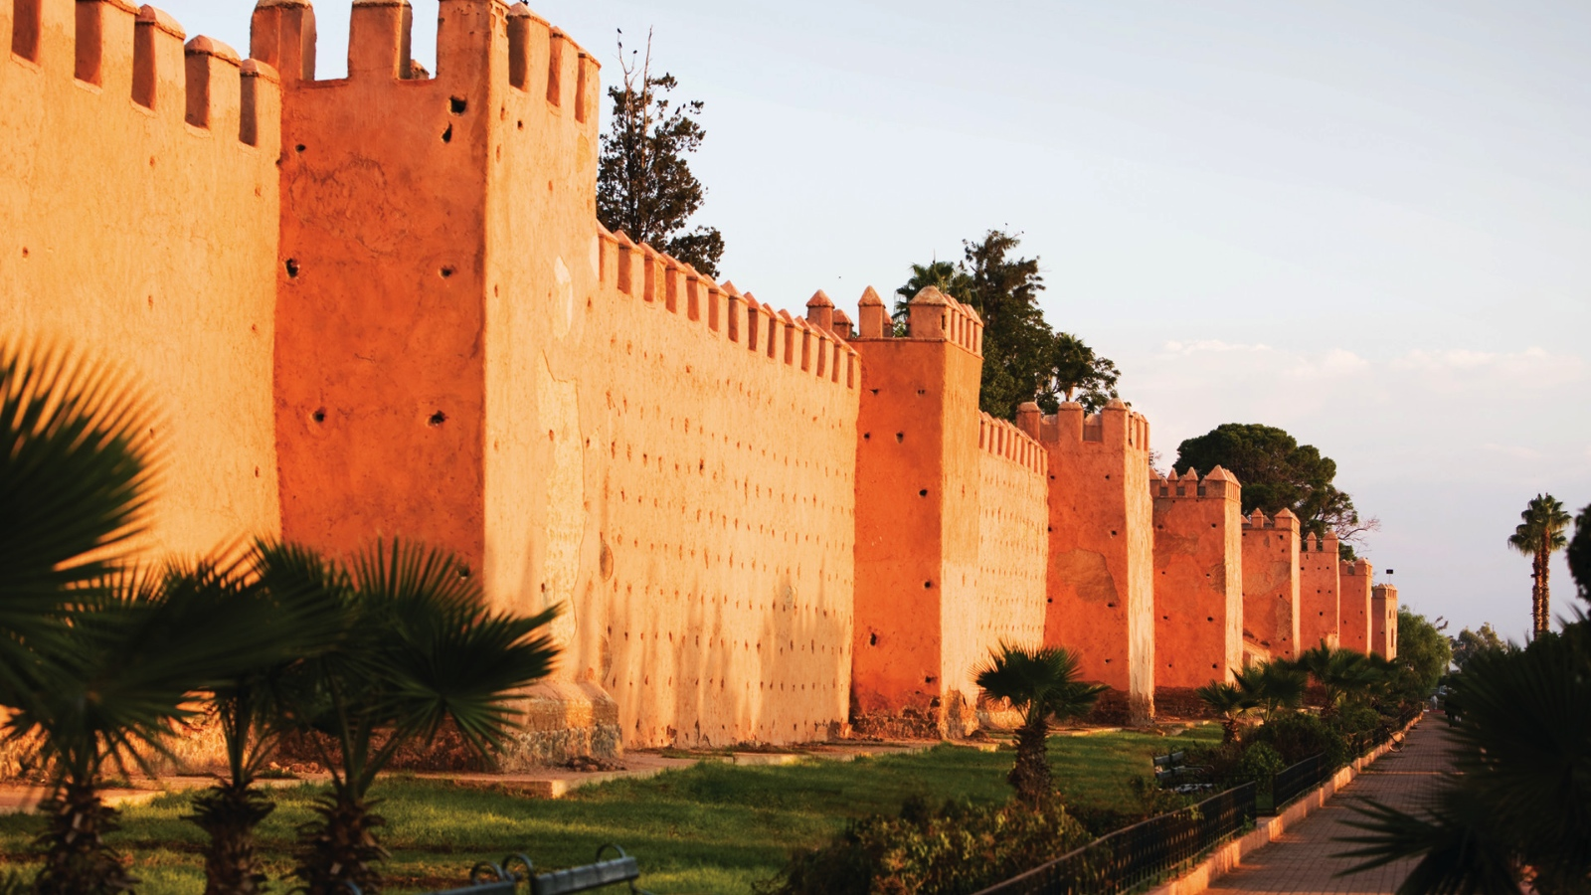 | July 25, 2017, Marrakech, Morocco  New 2018 World of Adventures Private Jet Experience to Include Four Seasons Resort Marrakech  http://publish.url/marrakech/hotel-news/2017/world-of-adventures-private-jet-tour.html

PRESS CONTACTS

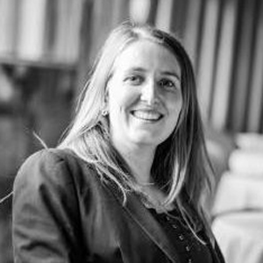 | Virginie Vaillant  Public Relations Manager  1 Boulevard de la Menara  Marrakech  Morocco  virginie.vaillant@fourseasons.com  +212 524 359 200

