Now Open: Four Seasons Resort Lanai Welcomes Guests to a New Vision of a Hawaiian Luxury Resort

February 2, 2016, Hawaii, Lanai

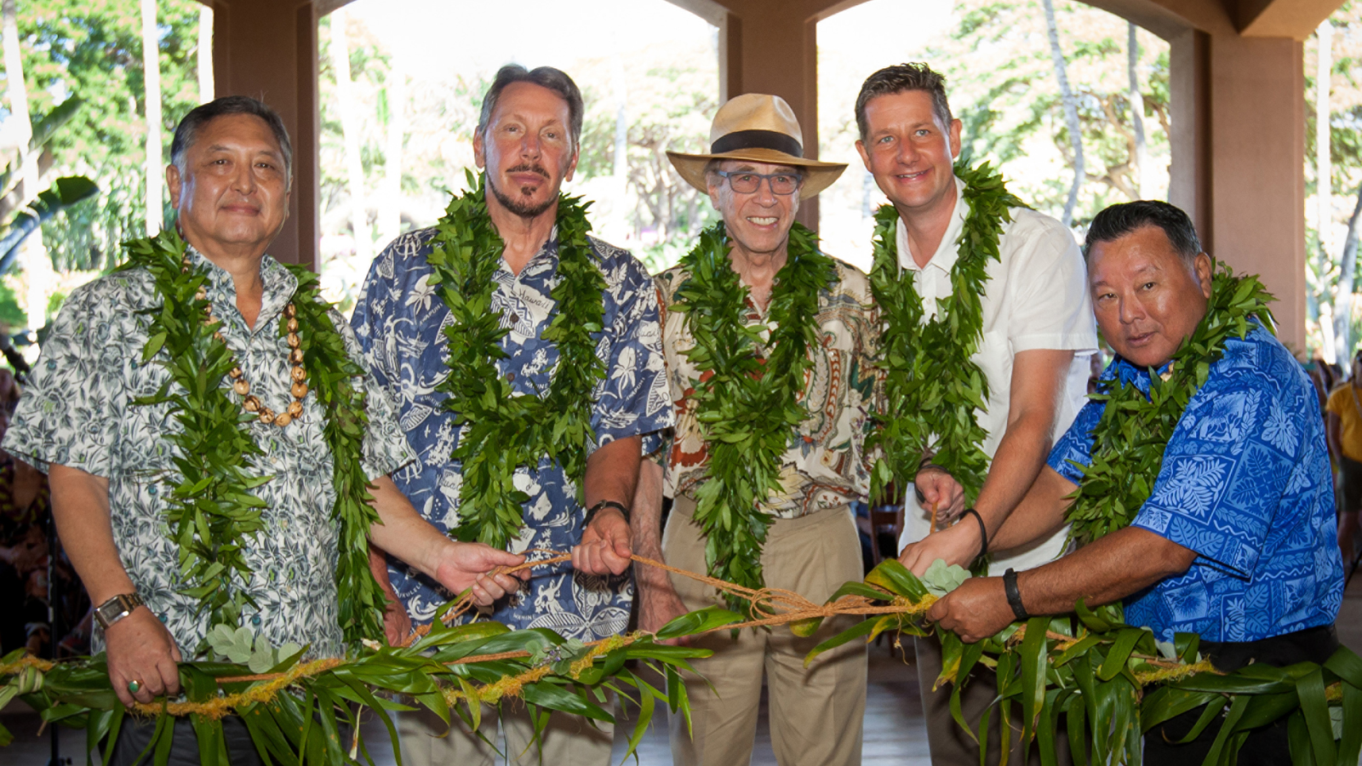
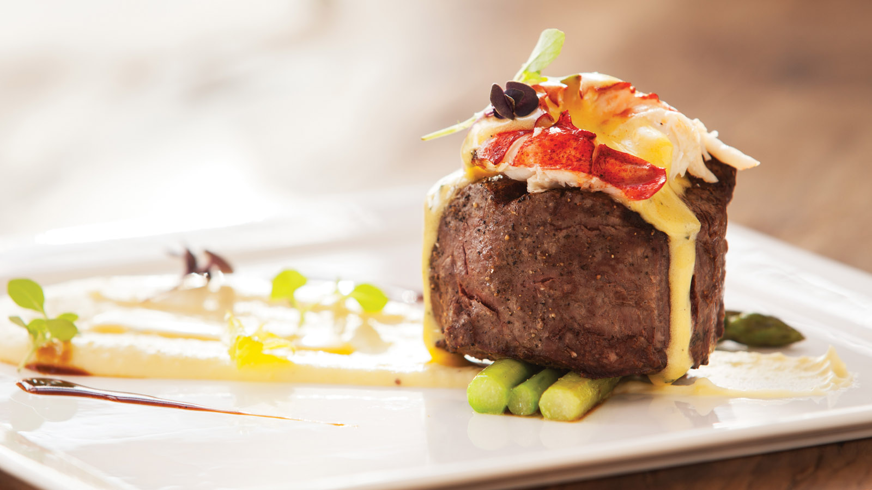 | 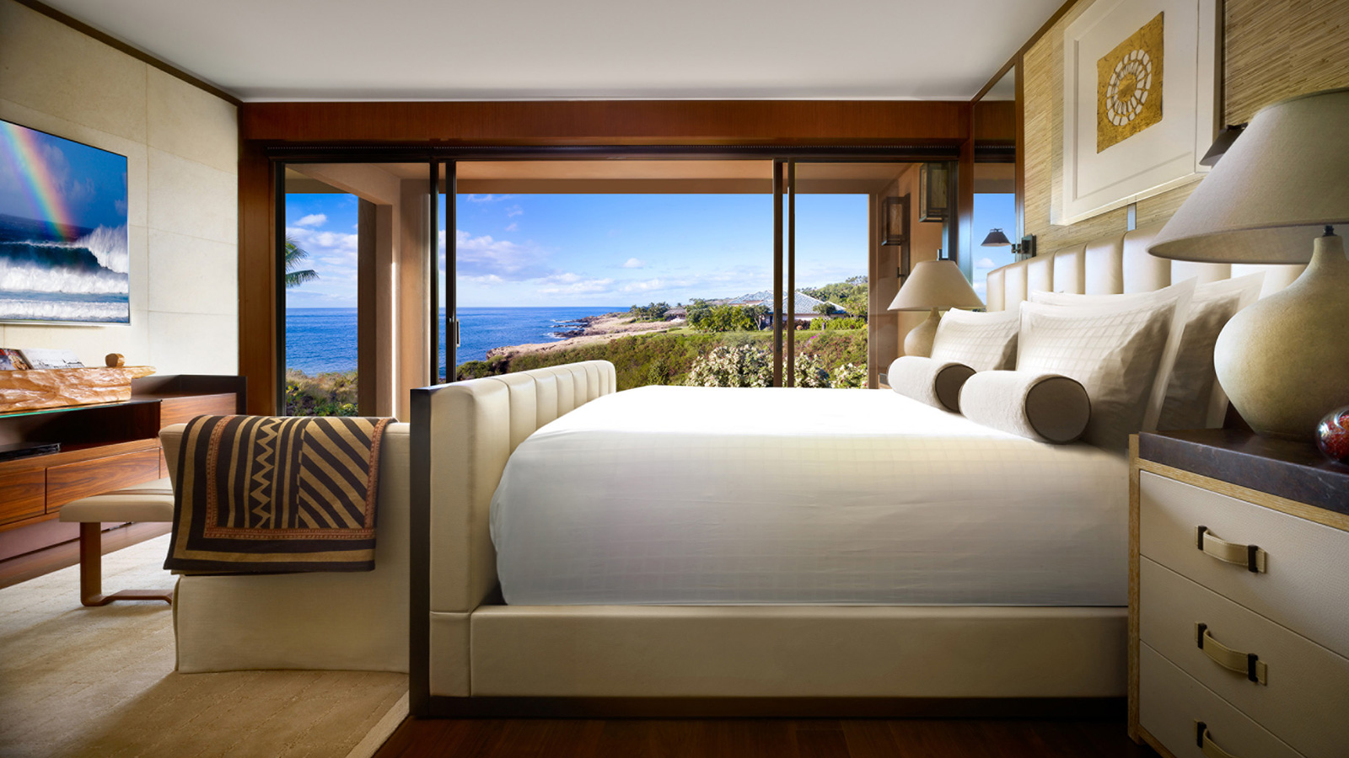 | 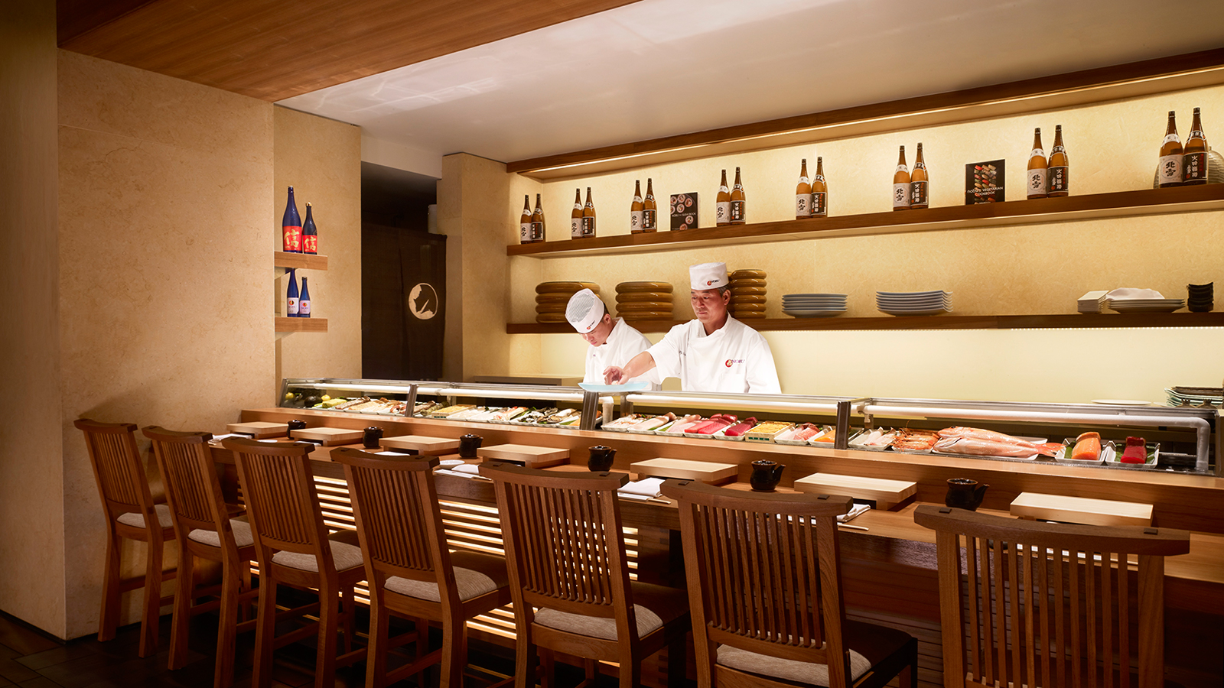
Four Seasons Resort Lanai, on a 90,000 acre (36,000 hectare) secluded island just nine miles (14.5 kilometres) from Maui, is now celebrating its grand opening.
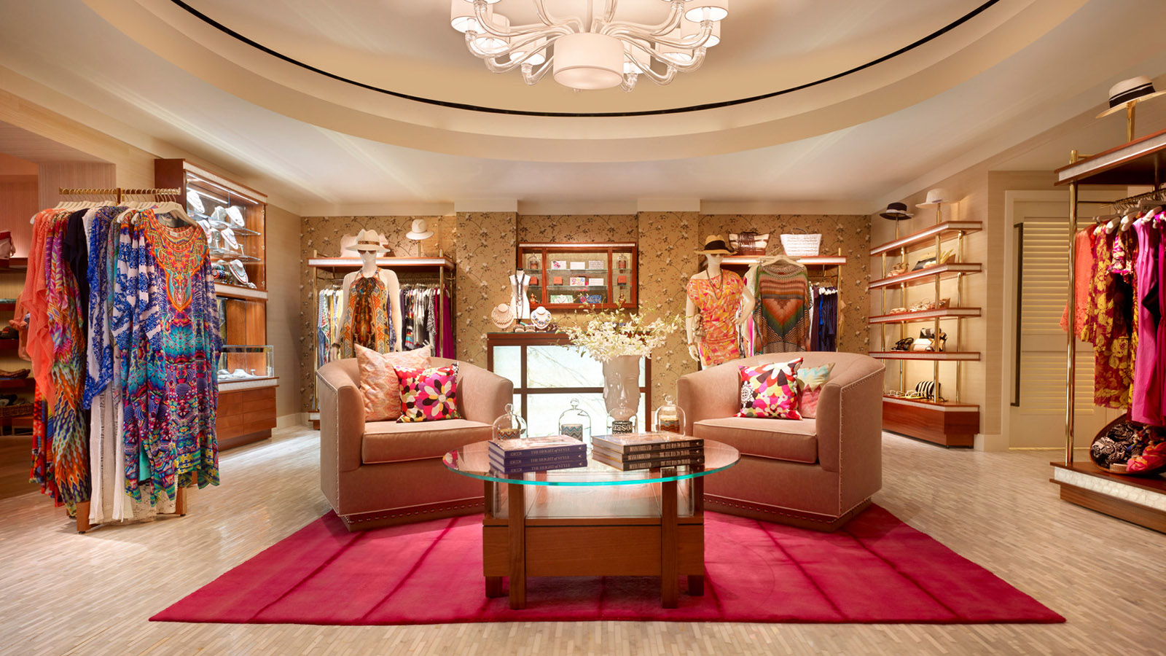 | 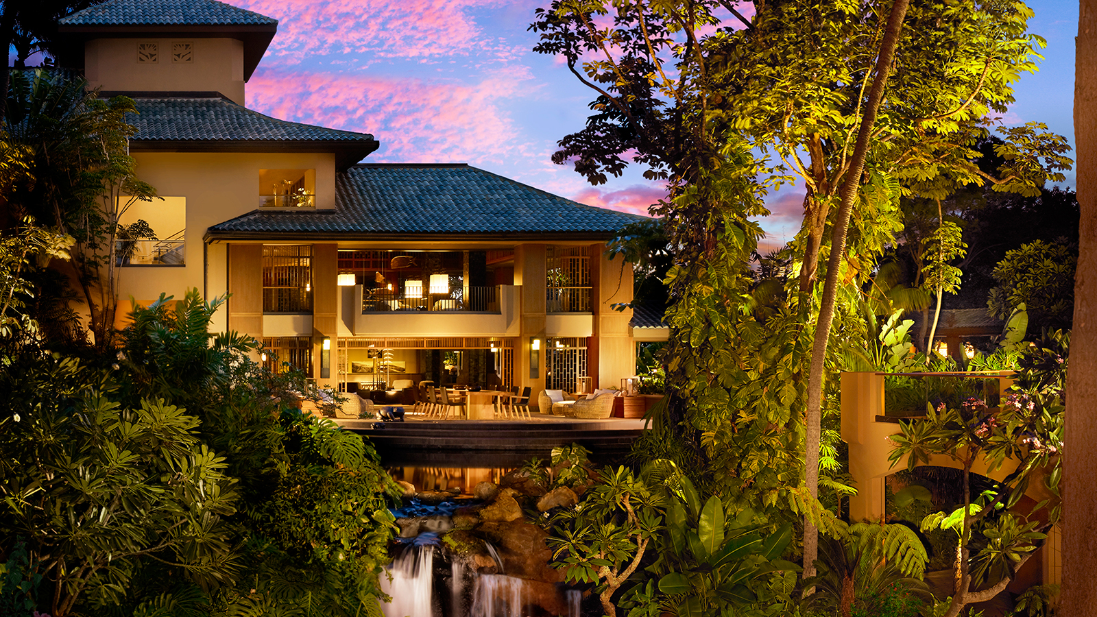
In a Hawaiian blessing ceremony, Lawrence J. Ellison, owner, Four Seasons Resorts Lanai, and Isadore Sharp, Founder and Chairman of Four Seasons Hotels and Resorts, were joined by Maui Mayor Alan Arakawa, local dignitaries, community members and employees to untie the sacred, mana-filled lei and officially open the Resort.
The new Resort features 217 guestrooms including 51 suites, lobbies and seating areas for contemplation; multiple dining experiences such as the signature ONE FORTY, NOBU LANAI, VIEWS at Manele Golf and Sports Bar; an immersive spa and wellness program; luxury retail boutiques featuring Missoni, Jimmy Choo and the Lanai Collection; and the 18-hole ocean-view Jack Nicklaus Signature Manele Golf Course.
Sophisticated Design Meets Beachside Innovation
Inspired by Hawaii's diverse and storied influences, the interiors showcase walls of teak and zebra wood edging artisan-produced Nepalese lokta paper and floors of mahogany laid with wool hand-woven area rugs. Fully integrated and intuitive lighting, temperature, service and privacy controls offer a highly responsive in-room technology experience featuring a 75 inch platinum bezel LED television panel, wearable key wristbands to allow maximum flexibility during activities on island, in-room iPad Airs and more.
Lush Hawaiian Landscaping Showcases New Pool Experiences
Verdant botanical gardens and waterways reveal both intimate enclaves as well as spectacular vistas to the Pacific Ocean and serve as a beautiful backdrop for commissioned works of outdoor art and sculpture. A lagoon-style, free-form central pool features a cascading waterfall and two spas. Set apart is the adults-only Retreat, whose waterfalls and lava rock grottos echo Lanai’s dramatic cliffs and offer stunning views of Hulopoe Bay, where resident dolphins are a frequent sight. Delve further into the garden to find sublime sanctuaries, perfect for relaxing on a collection of secluded lounge chairs and daybeds.
“We are delighted to share a unique destination experience with rich culture, diverse landscapes and limitless options for relaxation and adventure here on Lanai,” says Tom Roelens, General Manager, Four Seasons Resorts Lanai. “As a first, we offer guests the opportunity to experience Lanai by Four Seasons through a number of activities curated by the Resort, in true Four Seasons style."
Lanai’s diverse topography creates an island of unique contrasts, with myriad activities for all. Guests can choose from hiking and horseback riding in the green upcountry lands or go off-roading in a Polaris UTV across red dirt roads, coloured from volcanic rock. Play championship golf. Snorkel in a marine sanctuary teeming with colourful fish, set sail to see whales and dolphins or charter a luxury sailing yacht for the ultimate ocean experience. Explore the Hawaiian Islands from above or take control and learn to fly with exciting helicopter adventures. Immerse in Hawaiian culture through activities with Lanai's kupuna (elders) or simply relax on a deserted beach accessible only by a 4x4 vehicle.
Experience Lanai by Four Seasons: In celebration, the Resort is offering a Stay Longer – Fourth Night Free package to discover how Hawaii was meant to be enjoyed.
Celebrate at Four Seasons: Unforgettable Special Events
With flexible indoor and outdoor space accommodating parties up to 500, including a newly refurbished Conference Center, the private-island feel of Lanai is an exciting backdrop for spectacular conferences, incentives and social occasions such as weddings and birthday parties. Take gardens and beautiful ocean vistas, add whimsical sparklers, fireworks, private yachts, helicopters and bubbles along with the mastery of Four Seasons staff for a truly unforgettable event.
Four Seasons
Resort Lanai is located on a pristine island just west of Maui reflecting a simpler pace of life and Hawaii as it was intended to be. Guests can enjoy an exclusive island getaway offering unique cultural adventures, myriad water and land activities and world-class tennis and golf. To make a reservation, contact
Four Seasons
at 1 800 321 4666, visit your travel professional, or book online. Join the Resort's online communities at Facebook @FourSeasonsResortsLanai, Twitter @FSLanai and Instagram @FSLanai.

RELATED

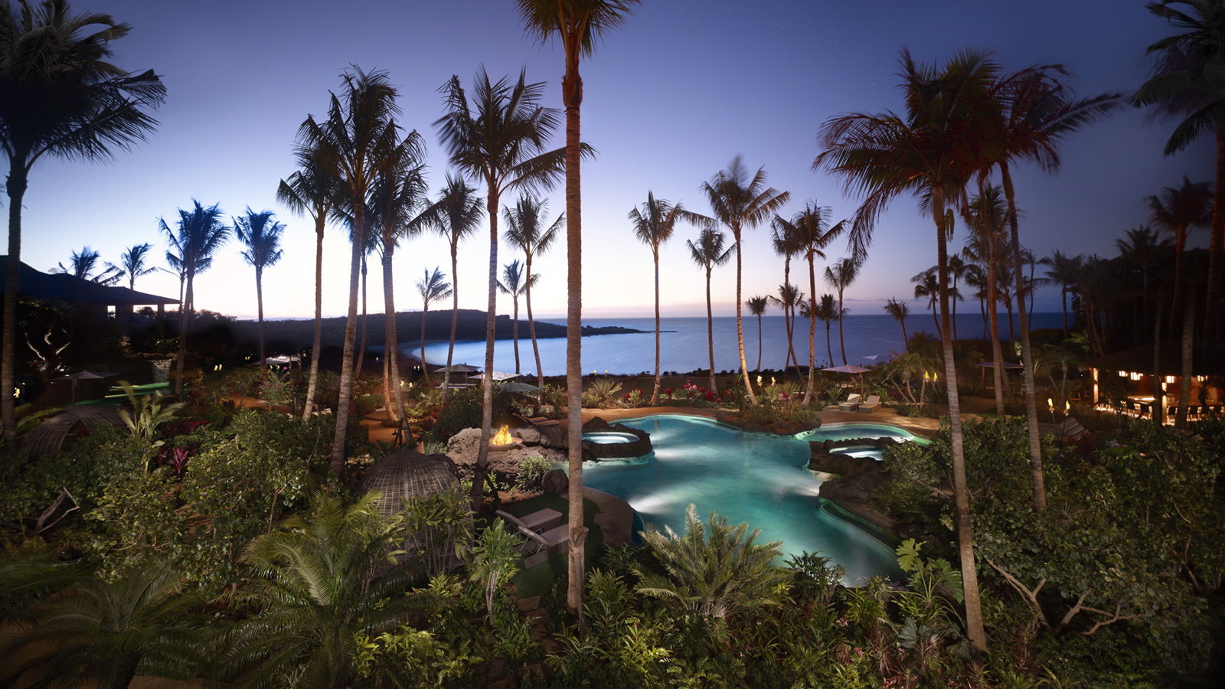 | April 11, 2017, Hawaii, Lanai, U.S.A.  Treat Mom at Twilight This Mother's Day at Four Seasons Resort Lanai  http://publish.url/lanai/hotel-news/2017/mothers-day.html
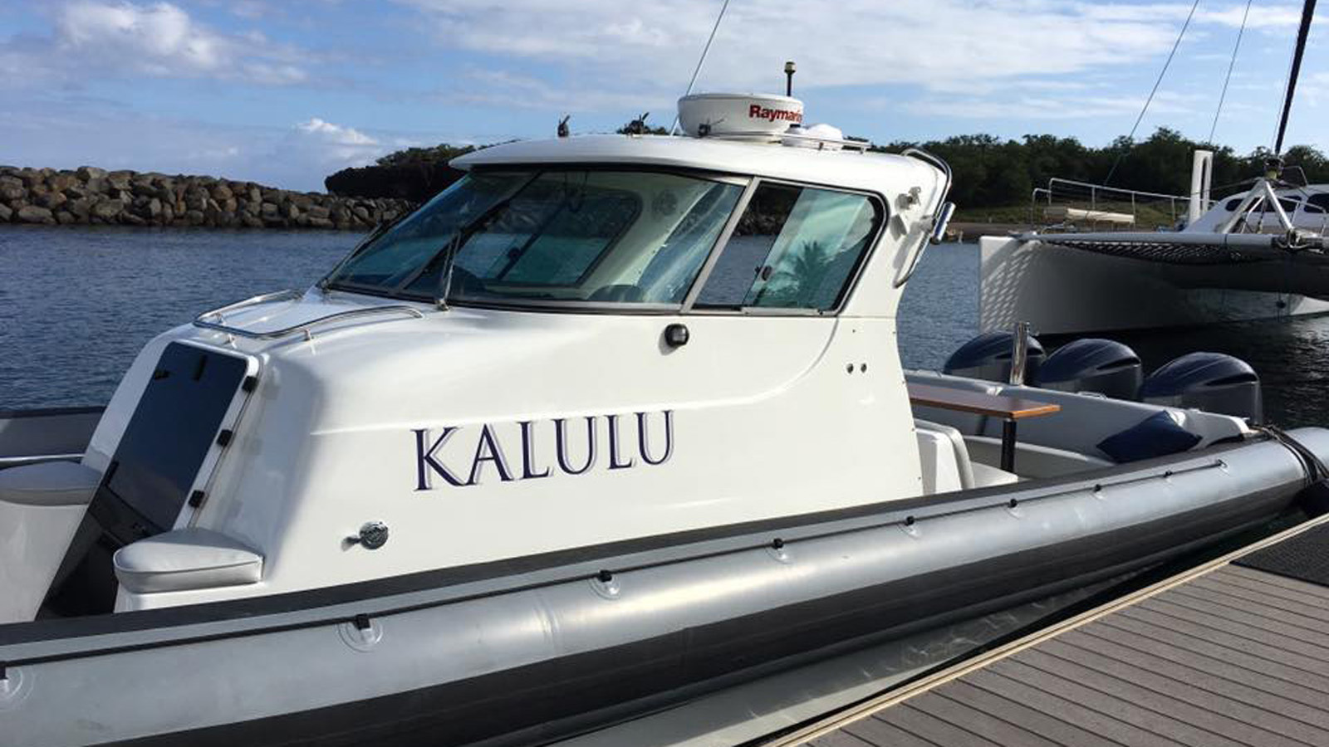 | March 29, 2017, Hawaii, Lanai, U.S.A.  Set Sail with New Ocean Adventures at Four Seasons Resort Lanai  http://publish.url/lanai/hotel-news/2017/new-ocean-adventures.html

PRESS CONTACTS

Lori Holland
Director of Public Relations
6100 Center Drive, Suite 1250
Los Angeles
U.S.A.
lori.holland@fourseasons.com

1 (201) 294-7810

