Four Seasons Resort Hualalai Presents Chef Fest 2017

Signature annual event showcases celebrity chefs and top mixologists from throughout the country from October 4 to 8, 2017 for a culinary celebration with one-of-a-kind dinners, cooking classes, and mixology events
May 25, 2017, Hawaii, Hualalai, U.S.A.

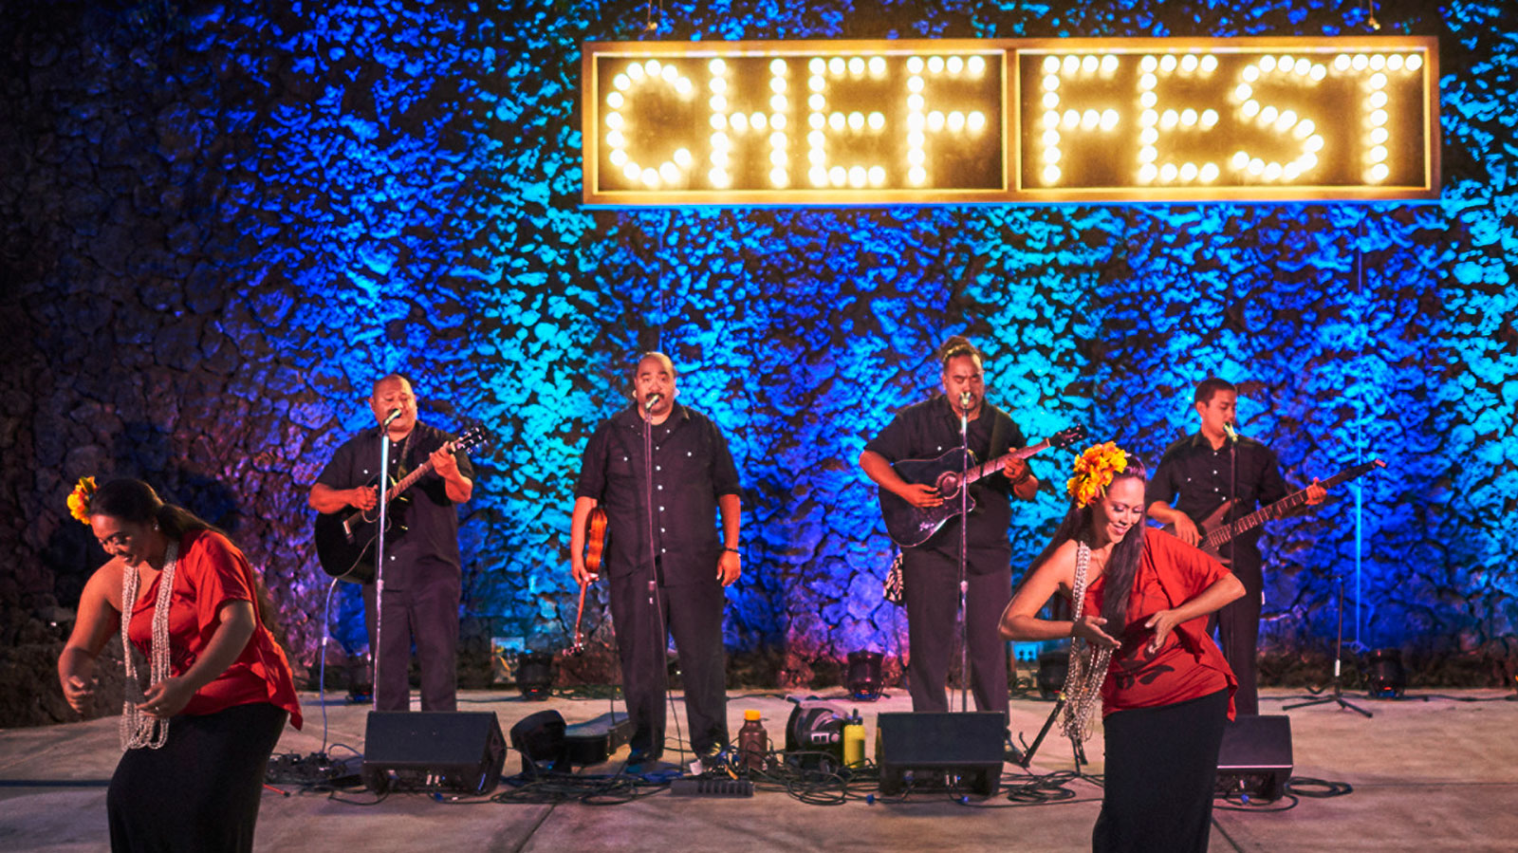
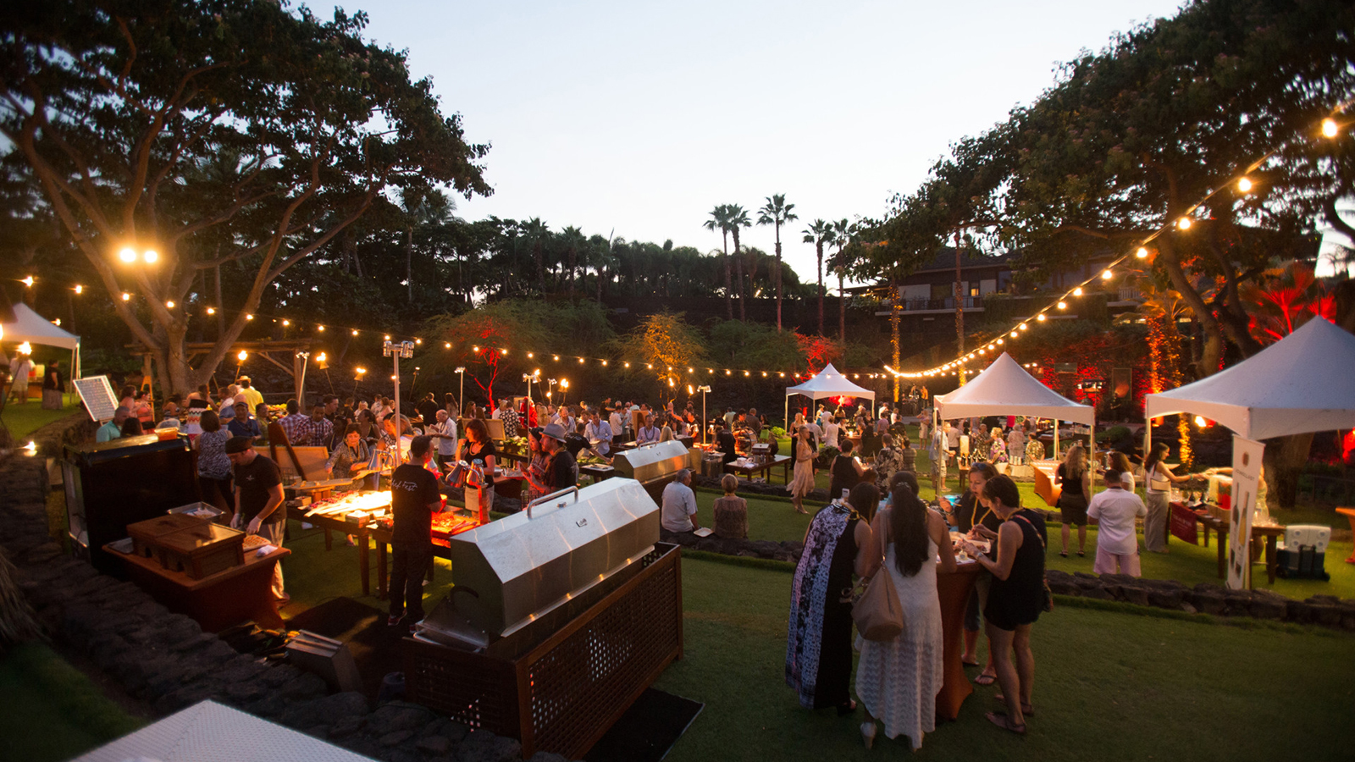 | 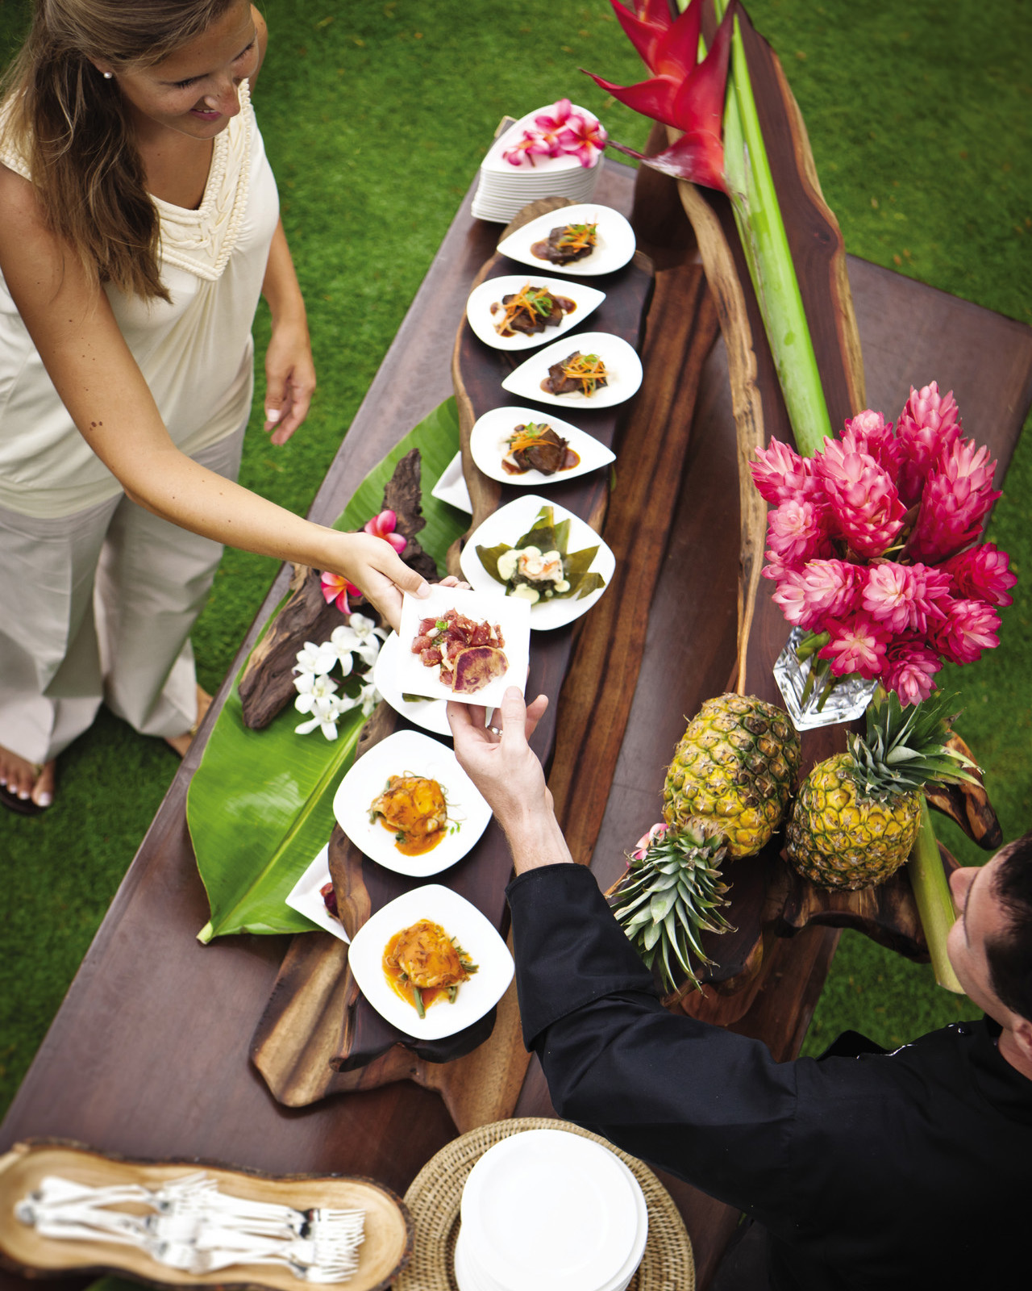
Four Seasons
Resort Hualalai, the only AAA Five Diamond and Forbes Five Star hotel on Hawaii Island, announces Chef Fest 2017. From October 4 to 8, 2017, the Resort will host a multi-day food and wine event featuring high-profile dinners, interactive cooking classes and culinary experiences. The series of events showcases some of the country’s best culinary and mixology talent in an intimate beachfront setting.
New additions for Chef Fest 2017 include a pop-up All-Clad Cooking Academy in the Resort’s Herb Garden. The outdoor kitchen will be home to the six cooking classes led by the guest chefs throughout the weekend. Also new for 2017 is a line-up of four award-winning, well-known mixologists who will each host a special cocktail showcase at the Patrón Lounge at the Resort’s adults-only Palm Grove Pool. The experience features a DJ and a unique cocktail created by the highlighted mixologist using local ingredients and spirits.
Executive Chef of
Four Seasons
Resort Hualalai Thomas Bellec, 18-year
Four Seasons
veteran, welcomes an impressive lineup of award-winning celebrity guest chefs, including:
- Neal Fraser (Chef/Owner of Redbird, Fritzi Coop - Los Angeles); Los Angeles Times Gold List, Los Angeles Magazine Best New Restaurant, Top Chef Masters participant, Iron Chef winner
- Gabrielle Hamilton (Chef/Owner of Prune - New York City); three time James Beard Award winner, Iron Chef winner, Daytime Emmy Award winner for Mind of a Chef, author of New York Times bestseller Blood, Bones & Butter: The Inadvertent Education of a Reluctant Chef
- Edward Lee (Chef/Owner of 610 Magnolia, The Wine Studio, MilkWood, and Whiskey Dry - Louisville); James Beard Award finalist, Daytime Emmy Award nominee for Outstanding Host of Mind of a Chef, author of bestselling cookbook Smoke & Pickles
- Ivan Orkin (Chef/ Owner of Ivan Ramen - New York City); Conde Nast Traveler Best Restaurants in New York City, featured on Chef’s Table, Food & Wine "Ramen Genius," author of bestselling cookbook Ivan Ramen
- Andy Ricker (Chef/Owner of Pok Pok - New York City and Portland); two time James Beard Award winner, Michelin Star recipient, author of bestselling cookbook Pok Pok: Food and Stories from the Streets, Homes, and Roadside Restaurants of Thailand
- Fabrizio Schenardi (Executive Chef of
Four Seasons
Resort Orlando at Walt Disney World); Wine Enthusiast 100 Best Wine Restaurants, Orlando Magazine Best Restaurant and Best Steak, James Beard House invitee
- Christof Syre (Executive Chef of
Four Seasons
Resort and Club Dallas at Las Colinas); 17 year
Four Seasons
veteran, who previously worked for Anton Mosimann at the Dorchester Hotel in London
- Jonathan Waxman (Chef/Owner of Barbuto, Jams - New York City; Adele’s, Bajo Sexto - Nashville; Brezza Cucina - Atlanta; Waxman’s - San Francisco); Top Chef Masters participant, judge on Recipe for Deception, author of bestselling cookbooks A Great American Cook and Italian, My Way
The notable mixologists featured at Chef Fest 2017 include:
- Chandra Lucariello (Director of Mixology and Spirits Education of Southern Glazers Wine & Spirits of Hawaii); founding member of United States Bartenders Guild - Hawaii Chapter
- Julie Reiner (Co-owner and Beverage Director of Flatiron Lounge, Pegu Club, Clover Club, Leyenda - New York City); Tales of a Cocktail Best New Cocktail Lounge in the World and Best Bar Mentor, Drinks International 50 Best Bars in the World
- Kyle Reutner (Brand Manager of KōHana Hawaiian Agricole Rum - Oahu); President of Hawaii United States Bartenders Guild, Beverage Media 10 Mixologist to Watch
- Pamela Wiznitzer (Creative Director of Seamstress - New York City); National Restaurant Association Star of the Bar winner, Tales of a Cocktail American Bartender of the Year nominee, Food & Wine Top 10 Rising Star Mixologists, Wine Enthusiast 40 under 40
“Chef Fest is such a special week here at the Resort, where our guests are able to experience the flavours, talents and personalities of some very special guest chefs, wine and spirits experts,” says Colin Clark, General Manager of
Four Seasons
Resort Hualalai. “The energy and excitement is in the air, and these events are truly some of the most fun, intimate and indulgent experiences available anywhere – only matched by the setting and aloha of Hualalai.”
The Chef Fest 2017 schedule of events (subject to change) is listed below.
Wednesday, October 4
- 8:00-10:00 am: Paddle with Chefs (stand-up and outrigger), Alaka’i Nalu, USD 50
- 2:00-5:00 pm: Mixologist Showcase with Kyle Reutner, Patron Lounge at Palm Grove Pool
- 6:00-8:00 pm: Chef Fest Grand Tasting, Hoku Amphitheater, USD 85
- 8:00-10:00 pm: VIP After Hours with Chandra Lucariello, Waiolu Garden in The Spa, USD 40
Thursday, October 5
- 11:00 am - 1:00 pm: Interactive Cooking Class with Jonathan Waxman, All-Clad Cooking Academy, USD 95
- 1:00-4:00 pm: Mixologist Showcase with Julie Reiner, Patron Lounge at Palm Grove Pool
- 2:00-4:00 pm: Interactive Cooking Class with Edward Lee, All-Clad Cooking Academy, USD 95
- 4:00-6:00 pm: Rare Wine Tasting of Don Weaver of Harlan Estate, Hualalai Grille, USD 150
- 6:00-9:00 pm: Chef Fest Reception & Dinner (Chefs Neal Fraser, Gabrielle Hamilton, Ivan Orkin, Fabrizio Schenardi and Thomas Bellec; Mixologists Pamela Wiznitzer and Chandra Lucariello), progressive dinner at Beach Tree, USD 175 with wine
Friday, October 6
- 11:00 am - 1:00 pm: Interactive Cooking Class with Gabrielle Hamilton, All-Clad Cooking Academy, USD 95
- 2:00-4:00 pm: Interactive Cooking Class with Ivan Orkin, All-Clad Cooking Academy, USD 95
- 2:00-5:00 pm: Mixologist Showcase with Pamela Wiznitzer, Patron Lounge at Palm Grove Pool
- 4:00-6:00 pm: Mixology Class with Julie Reiner, Moana Terrace at ‘ULU, USD 45
- 6:00-9:00 pm: Chef Fest Reception & Beach Cookout (Chefs Edward Lee, Andy Ricker, Jonathan Waxman, Christof Syre and Thomas Bellec; Mixologist Kyle Reutner), Kumukea Beach, USD 175 with wine and cocktails
Saturday, October 7
- 11:00 am - 1:00 pm: Interactive Cooking Class with Andy Ricker, All-Clad Cooking Academy, USD 95
- 2:00-4:00 pm: Interactive Cooking Class with Neal Fraser, All-Clad Cooking Academy, USD 95
- 2:00-5:00 pm: Mixologist Showcase with Chandra Lucariello, Patron Lounge at Palm Grove Pool
- 6:00-10:00 pm: Chef Fest Reception, Gala Dinner and After-Party featuring all chefs and guest winemaker, ‘ULU, USD 250 with wine
Guests are invited to book the Taste of Chef Fest package including four nights of luxurious accommodations (Ocean View and Ocean Front accommodations available) and a Resort Credit of USD 150 per night that guests may apply towards any Chef Fest event(s). The Taste of Chef Fest package is available between October 2 and 10, 2017.
This year’s sponsors include Southern Glazers Wine & Spirits, Patrón, HILuxury, United Airlines, Stolichnaya, Olu Kai, and All-Clad.
For reservations or tickets, call 808 325 8000.

RELATED

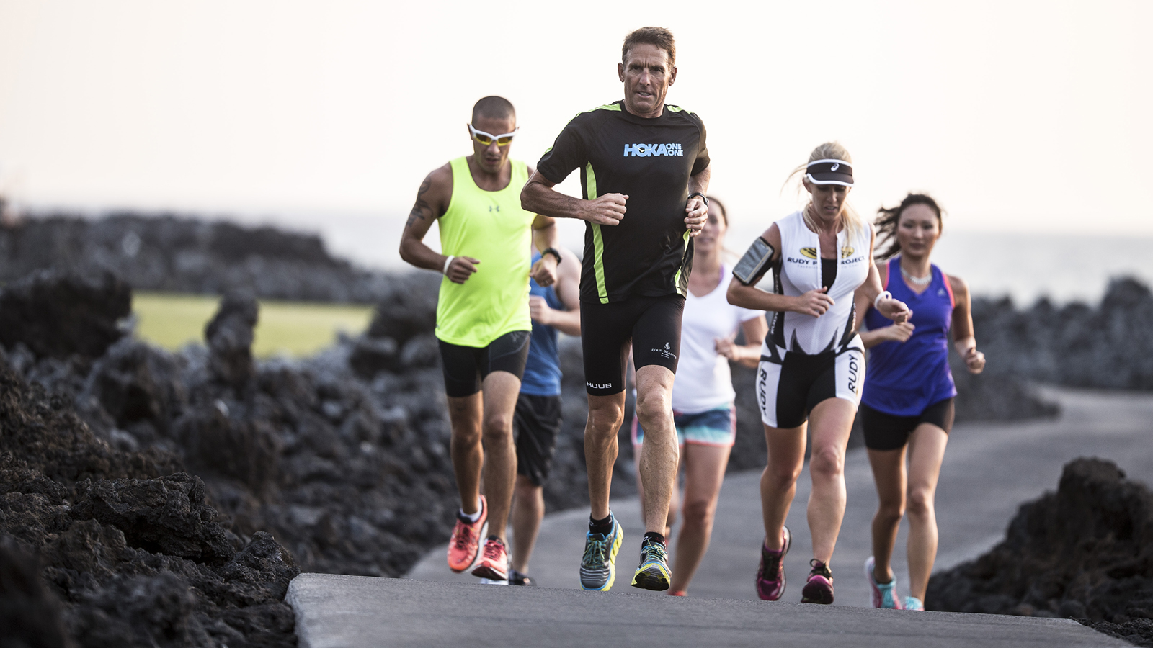 | September 20, 2017, Hawaii, Hualalai, U.S.A.  Four Seasons Resort Hualalai Hosts Exclusive IRONMAN World Championship Weekend Experience with Legendary IRONMAN Champion Dave Scott  http://publish.url/hualalai/hotel-news/2017/weekend-with-ironman-dave-scott.html
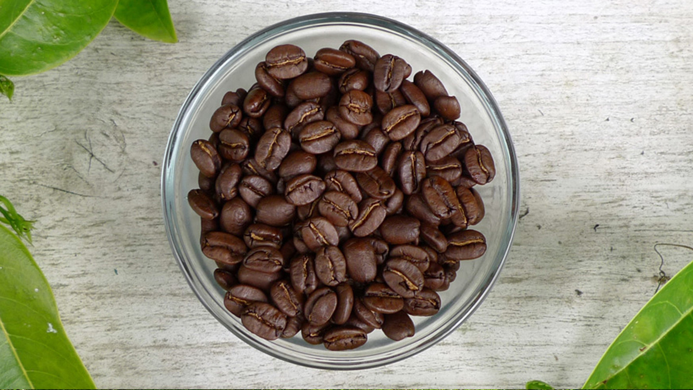 | August 24, 2017, Hawaii, Hualalai, U.S.A.  Four Seasons Resort Hualalai Introduces Exclusive Hawaii Island Coffee Farm Tour and Tasting  http://publish.url/hualalai/hotel-news/2017/coffee-farm-tour-and-tasting.html

PRESS CONTACTS

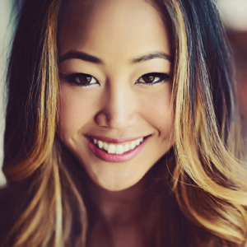 | Morgan Suzuki  Director of Public Relations and Communications  72-100 Ka'upulehu Drive  Kailua Kona  U.S.A.  morgan.suzuki@fourseasons.com  1 (808) 557-5909

