Four Seasons Hotel Westlake Village Introduces New Virtual Fitness Training Program, "Fit Four All Seasons"

March 31, 2017, Los Angeles, Westlake Village, U.S.A.

Four Seasons
Hotel Westlake Village and on-site wellness centre, California Health & Longevity Institute (CHLI), have partnered to launch an exclusive virtual fitness training program that can travel alongside the guest, whether on the road or at home. Fit Four All Seasons delivers customised fitness training straight to the guest’s mobile device. This concept combines legendary
Four Seasons
five-star service and expert advice from trusted exercise physiologists at CHLI, allowing guests to sustain their workout regime and healthy habits from anywhere in the world.
Fit Four All Seasons is designed to give accessible guidance and one-on-one training to clients based on their schedule and preferences. The comprehensive program is perfect for frequent travellers, extreme athletes, and locals who want the flexibility of working out anytime, anywhere, at their own pace. This specialised approach to wellbeing provides a customised routine focused on the personal fitness needs and weight loss goals of the user.
Fit Four All Seasons uses state-of-the-art software adaptable to all ages and fitness levels with seamless integration to mobile devices and fitness wearables. The software allows the exercise physiologists to tailor workouts, and adapt these recommendations as fitness needs change to maximise the client’s success. Analytics are measured and monitored by CHLI’s expert team and include components such as heart rate variability, exercise duration, distance, intensity factor, blood pressure, body composition, training test score, number of steps, and dietary habits. This allows for real time adjustments and accountability, increasing the success rate of the user.
Fit Four All Seasons is USD 250 per month and requires a four month minimum commitment. To book a complimentary fitness consultation call 818 575 1114.

RELATED

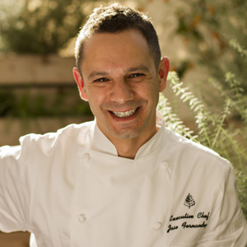 | March 14, 2017, Los Angeles, Westlake Village, U.S.A.  Four Seasons Hotel Westlake Village Welcomes Acclaimed Executive Chef Jose Fernandez  http://publish.url/westlakevillage/hotel-news/2017/new-executive-chef-jose-fernandez.html
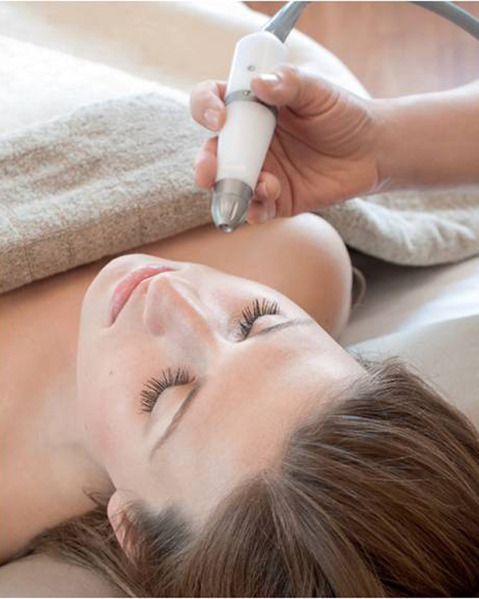 | December 22, 2016, Los Angeles, Westlake Village, U.S.A.  New In-Skin Facial Machine at The Spa - Four Seasons Hotel Westlake Village  http://publish.url/westlakevillage/hotel-news/2016/in-skin-facial.html

PRESS CONTACTS

Erin Bina
Public Relations and Social Media Manager
Two Dole Drive
Westlake Village
U.S.A.
erin.bina@fourseasons.com

+1 (818) 575-1423

Stuart Burdette
Director of Marketing
Two Dole Drive
Westlake Village
U.S.A.
stuart.burdette@fourseasons.com

+1 (818) 575-3009

