Easter Egg-stravaganza at Four Seasons Hotel Cairo at The First Residence

April 5, 2017, Cairo at The First Residence, Egypt

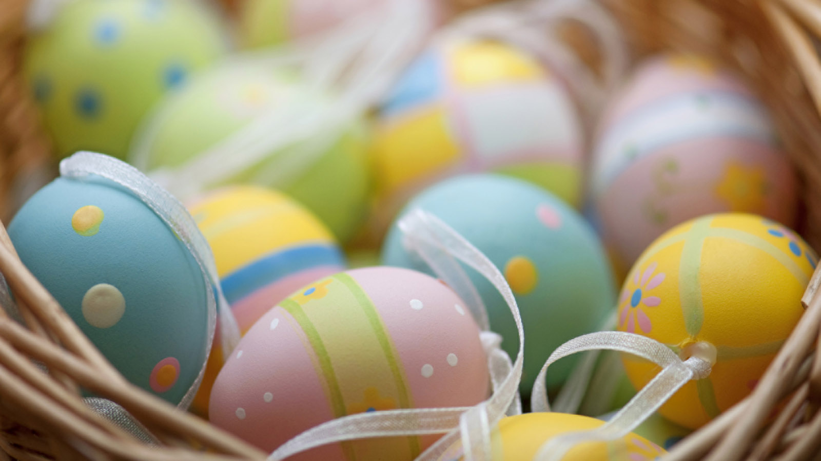
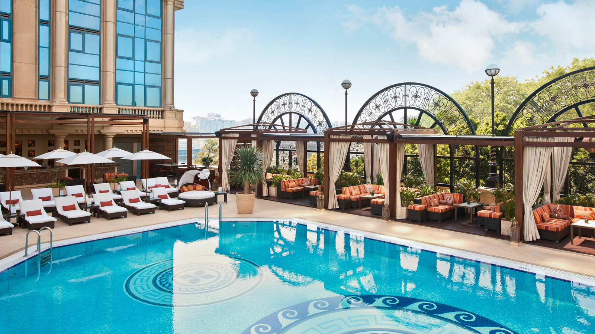
Four Seasons
Hotel Cairo at The First Residence, a luxury boutique hotel in Cairo, is welcoming spring with a lavish Easter brunch on Monday, April 17, 2017 from 12:00 noon to 7:00 pm. Excellent food, personalised service, great ambiance with friends and family are the sum of a perfect dining experience, and with its spectacular Nile views ensures guests feel at home.
STRADA will feature a brunch-style buffet with all the delicious traditional Easter specials including smoked herring and mackerel, a variety of salads and more, plus all-time Egyptian favourites and a chickpea and a lupin bean cart to top it all off.
And what is Easter without making it fun for the little ones? There will be cool activities for kids, including an egg hunt, egg painting and face painting, and the fun does not stop there: a live band will be performing throughout to get the lively Easter atmosphere going.
Families can also spend their day out poolside at Aura, indulging in authentic Lebanese cuisine and enjoying the buzzing atmosphere with music, exotic shisha and a dazzling Nile view in the heart of Cairo.
For reservations, call the Hotel directly on +202 3567 1600.

RELATED

March 15, 2017, Cairo at The First Residence, Egypt
Mother's Day Celebrations at Four Seasons Hotel Cairo at The First Residence
http://publish.url/cairofr/hotel-news/2017/mothers-day.html

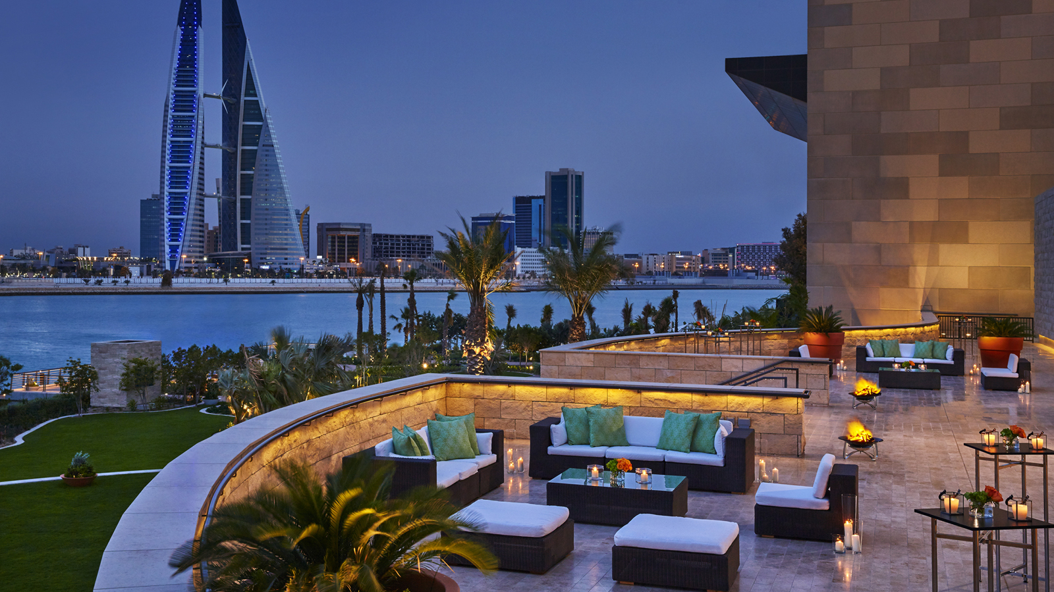 | February 27, 2017, Dubai, U.A.E.  Get Ready for Unforgettable Spring Stays with Four Seasons  http://publish.url/news-releases/2017/gcc-spring-holiday-promotion.html

PRESS CONTACTS

Mariam Mohsen
Digital Marketing Executive
35 El Giza Street
Cairo
Egypt
mariam.mohsen@fourseasons.com

+20 2 3567 1600

Hibba Bilal
Public Relations Director
35 El Giza Street
Cairo
Egypt
hibba.bilal@fourseasons.com

+ 20 2 3567 1600

