Experience Summer Access to Seattle's Only Infinity-Edged Outdoor Pool at Four Seasons Hotel Seattle

June 1, 2016, Seattle, U.S.A.

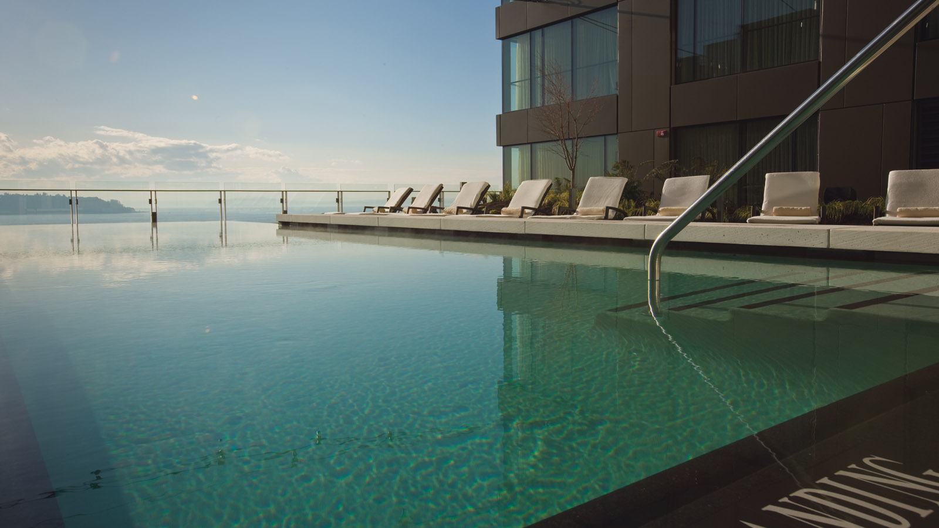
Four Seasons
Hotel Seattle opens access to the resort-style outdoor infinity pool deck with a special summer spa promotion. Originally reserved for guests of the Hotel, entry to the pool and fitness centre can be gained with any 80-minute or more treatment from The Spa.
Available Monday through Thursday, from June 1 through September 5, 2016, the same-day pool access is an urban escape in the heart of downtown Seattle. Consistently ranked among the best hotel pools in the nation, the terrace also offers al fresco dining and drinks from Bar 84, named after the temperature of the heated pool.
While taking in breathtaking views of Elliott Bay, pool attendants provide complimentary Evian spritzes, scented cold towels, sunglasses cleaning and sunscreen.
Also available in the summer are mini spa treatments from the comfort of a deck chair by the pool. Each 20, 30 or 40-minute service begins with aromatic chilled towels and features luxury body care followed by a reapplication of Coola SPF. Enjoy a relaxing neck, shoulder and décolletage massage featuring Eminence Apricot Body Oil; or a hand, arm and décolletage scrub. Extend the experience with a 10-minute spa tapas treatment or enhancement.
Guests can combine any in-spa treatment with a poolside treatment to make 80-minutes for pool access. Valet parking is also included.
To reserve a treatment at Seattle’s only Forbes Travel Guide Four-Star spa call 206 749 7077 or visit the spa online.

RELATED

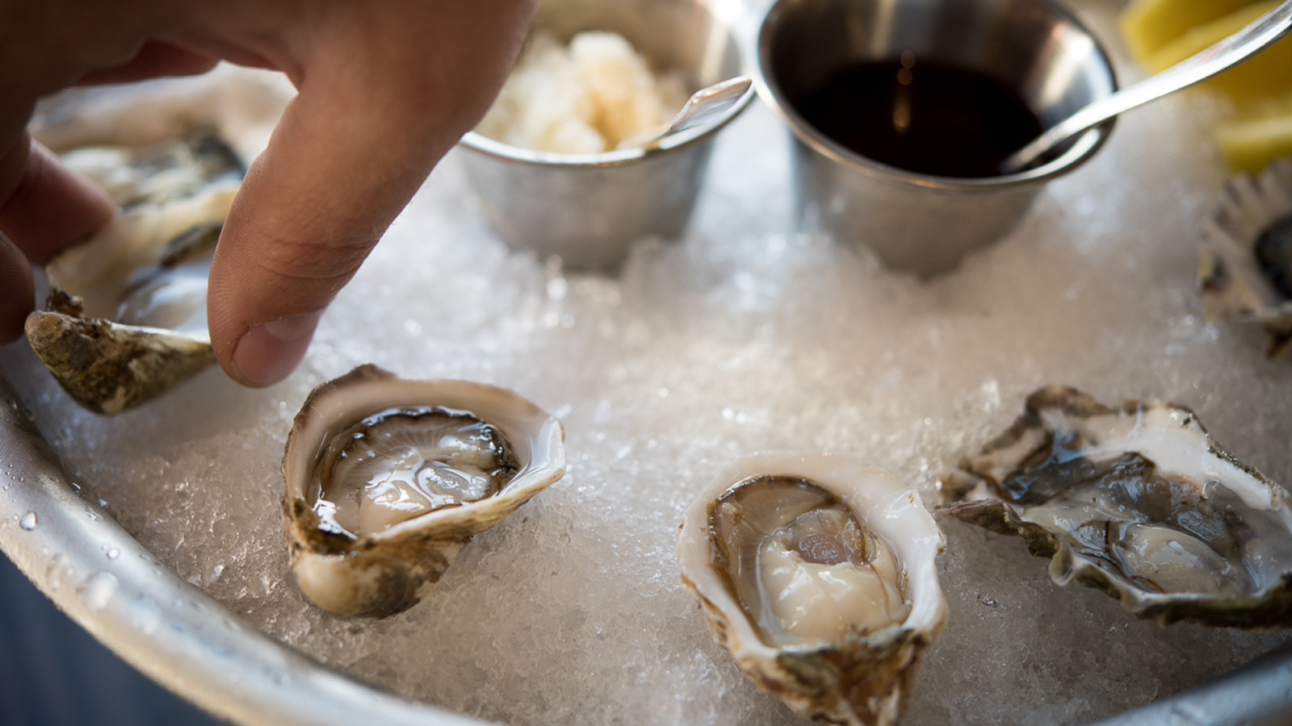 | February 27, 2017, Seattle, U.S.A.  Tableside Service and Happy Hour Oyster Shucking Pop-Up Launch at Goldfinch Tavern at Four Seasons Hotel Seattle  http://publish.url/seattle/hotel-news/2017/goldfinch-tavern-dining-options.html
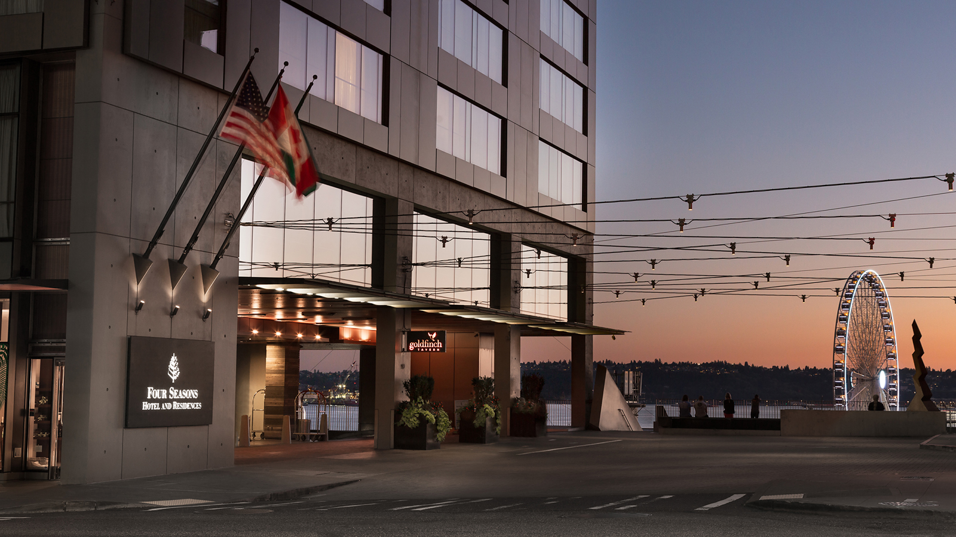 | February 22, 2017, Seattle, U.S.A.  Forbes Travel Guide Recognises Four Seasons Hotel Seattle as the Best in Washington State  http://publish.url/seattle/hotel-news/2017/forbes-five-star-hotel.html

PRESS CONTACTS

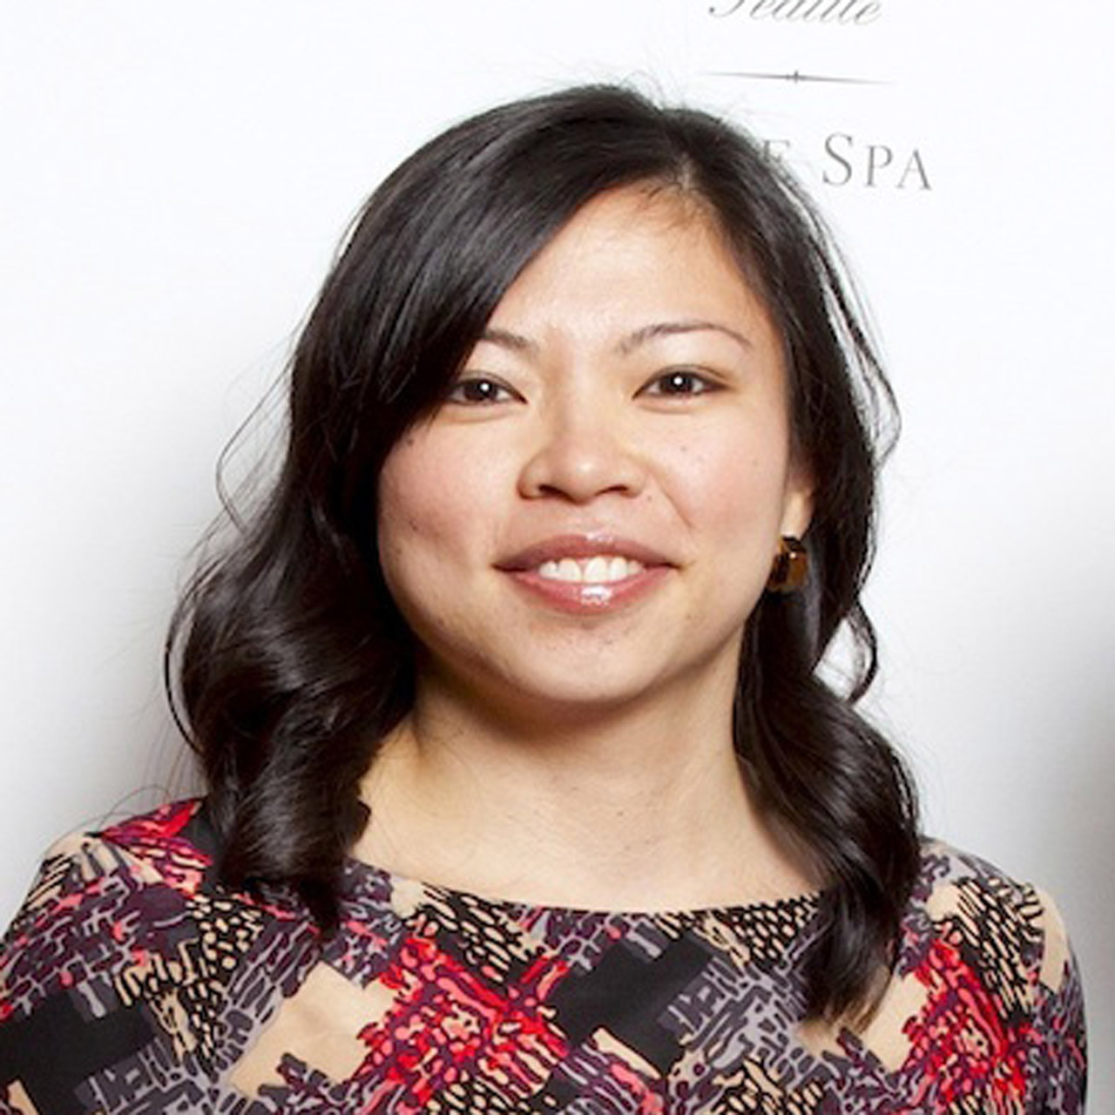 | Meg Paynor  PR Consultant  99 Union Street  Seattle  U.S.A.  meg@paynorpr.com  1 (206) 913-3848
Crystal Southcote
Digital Media Manager
99 Union Street
Seattle
U.S.A.
crystal.southcote@fourseasons.com

+1 (206) 749-3909

