Four Seasons Hotel Hampshire Unveils Wild Carrot Restaurant and Bar

September 6, 2017, Hampshire, England

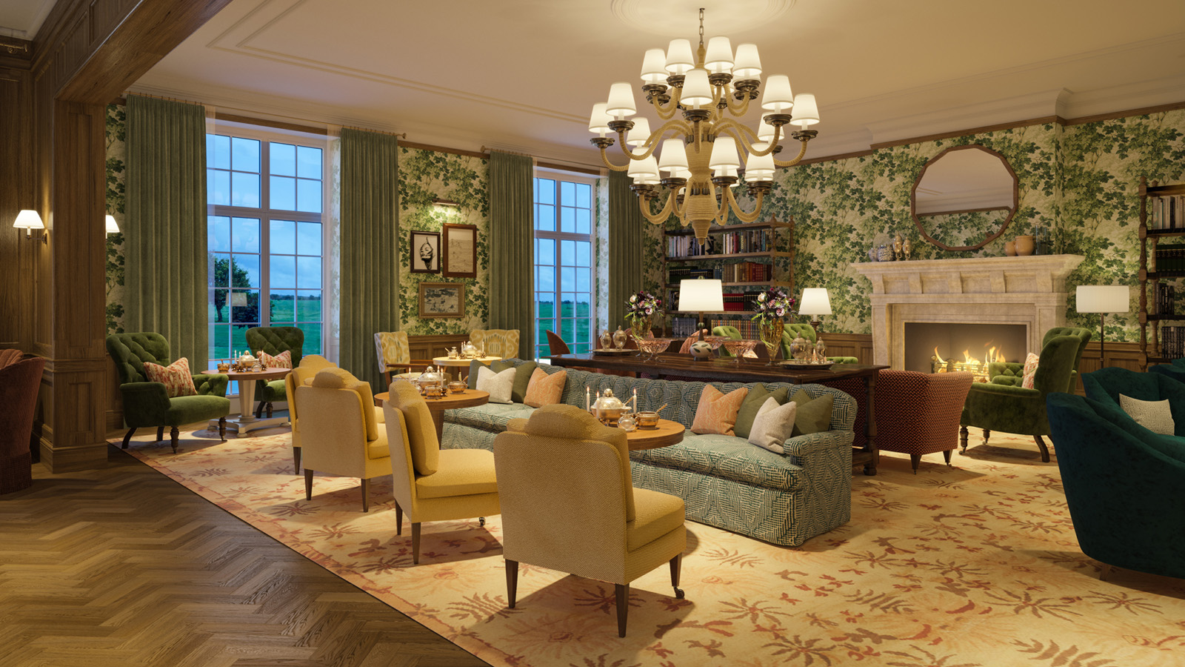
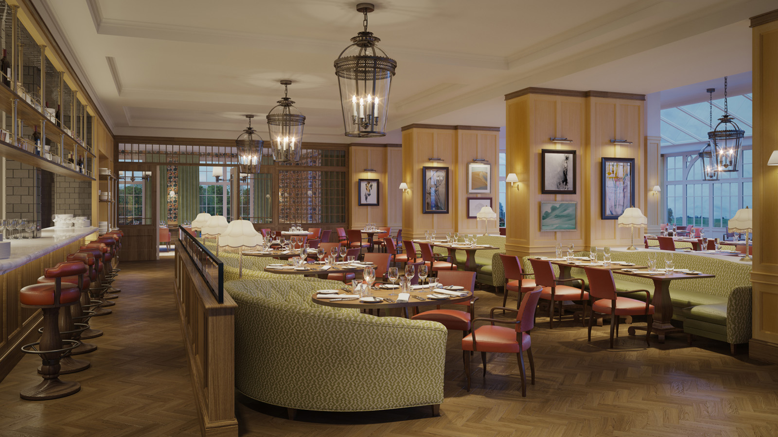 | 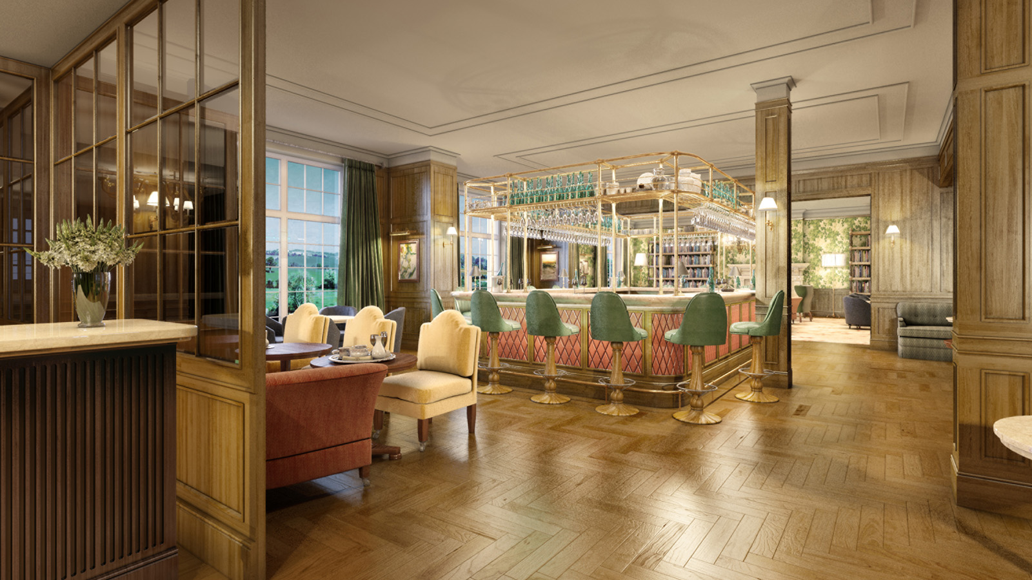
Following an extensive enhancement program,
Four Seasons
Hotel Hampshire is set to open the doors to its brand new restaurant and bar Wild Carrot, created under the helm of acclaimed designer Martin Brudnizki, on September 22, 2017.
Named after the dainty white wildflower found plentifully in the fields that make up Dogmersfield Park, the Hotel’s Estate, Wild Carrot will be overseen by Executive Chef Dirk Gieselmann, alongside newly appointed Restaurant Chef Adam Falgrin.
Distinctly British in design and incorporating rich colours, textures and fabrics, the dining room at Wild Carrot plays with classic detailing alongside subtle contemporary pieces, adding a touch of eccentric character and charm to the quintessential country house. Offering rolling countryside views framed beautifully by large floor-to-ceiling windows, the spacious dining room exudes a stylish yet unpretentious and relaxed feel.
The menu at Wild Carrot will feature Chef Dirk’s signature dishes, reflecting his culinary journey and experiences, harmoniously sitting alongside Chef Adam’s contemporary take on British classics. Main courses will include a sharing beef Wellington, with rich mushroom duxelle, cabbage and truffle sauce; and a Surrey beef gourmet burger, with seasonal blackberry chutney and caramelised onions in a brioche bun. All dishes will be crafted with locally sourced ingredients, and seasonal produce from farms and markets further afield. Boasting an open kitchen, Wild Carrot will invite guests to openly interact with the Hampshire chefs, and enjoy the spectacle of their cooking.
In addition, Wild Carrot will also feature a private dining area sitting up to 25 guests, and an outdoor terrace that will reflect the natural lushness of an English garden, draping with green foliage entwined with statement pendant lighting.
Alongside the Restaurant, The Bar at Wild Carrot will feature an exceptional menu of classic cocktails and artisanal concoctions, inspired by seasonal ingredients and the intriguing history of the local area, such as The Garden - inspired by the Hotel’s 17th century Walled Garden - incorporating Silent Pool gin, crème de violette, lemon and lavender grown on the Estate. A selection of fine wines and craft beers will also be available.
Adjacent to the Bar, the Lounge will feature a playful edge in design, with decorative foliage wallpaper, bringing the freshness of the countryside into the room, where guests will be able to unwind on comforting deep sofas and chairs.
As part of the enhancement program, the Hotel also unveils a charmingly redesigned Library, where guests can delight in traditional afternoon tea, and the addition of a striking Drawing Room, exuding a classic country house sitting room with wooden walls and contemporary furnishings, situated in the heart of the historic Manor House.
For reservations, call +44 (0)1252 853100.

RELATED

September 6, 2017, Hampshire, England
Four Seasons Hotel Hampshire Unveils Wild Carrot Restaurant and Bar
https://publish.url/hampshire/hotel-news/2017/new-wild-carrot-restaurant-and-bar-test.html

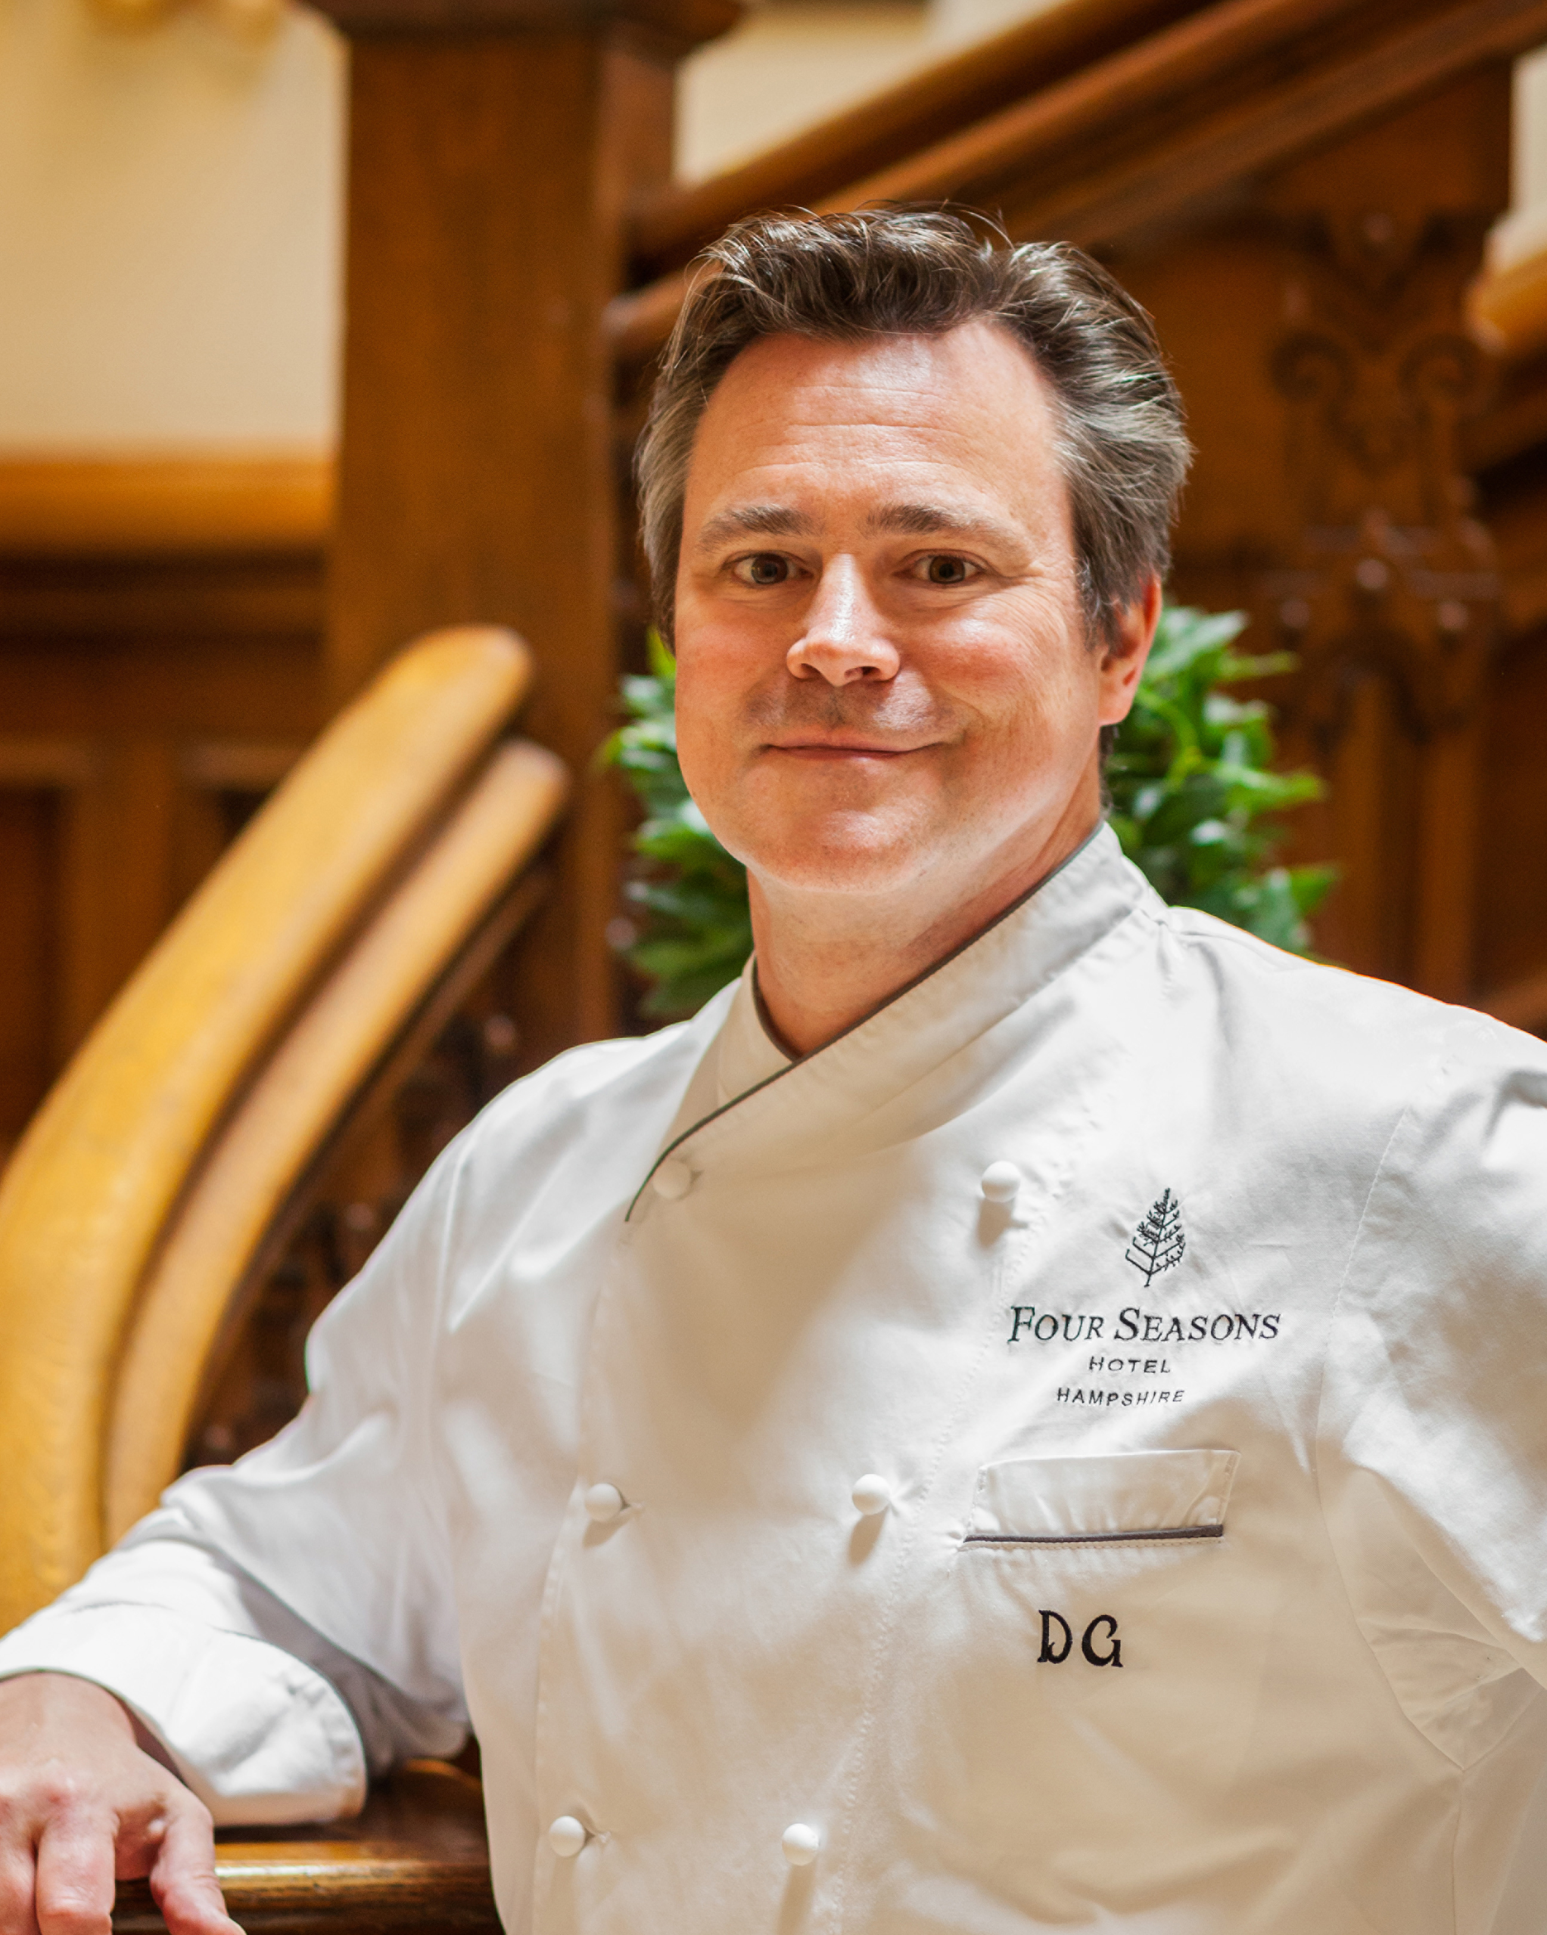 | May 23, 2017, Hampshire, England  Four Seasons Hotel Hampshire Welcomes Executive Chef Dirk Gieselmann  https://publish.url/hampshire/hotel-news/2017/new-executive-chef-dirk-gieselmann.html

PRESS CONTACTS

Alie Barbieri
Public Relations Coordinator
Dogmersfield Park, Chalky Lane, Dogmersfield
Hampshire
United Kingdom
alie.barbieri@fourseasons.com

+44 1252 583 008

Ilse Van Steen
Director of Communications UK Collection
Hamilton Place, Park Lane
London
United Kingdom
ilse.vansteen@fourseasons.com

44 (20) 749 90 888

