Four Seasons Resort Rancho Encantado Welcomes Equus Santa Fe

Equine assisted learning and leadership development program offers guests and groups innovative approach to personal and professional enrichment
March 1, 2017, Santa Fe, U.S.A.

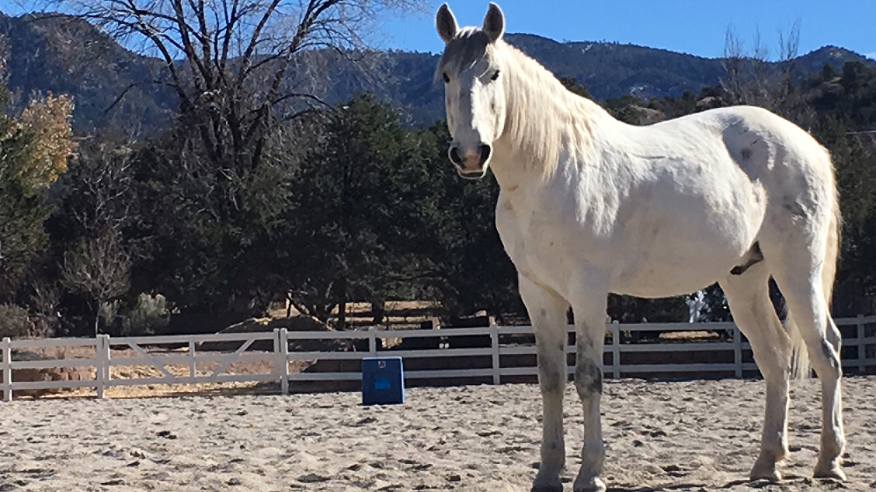
Four Seasons
Resort Rancho Encantado Santa Fe, located 10 minutes from downtown Santa Fe, announces a partnership with EQUUS, developers of The EQUUS Experience, an innovative self-mastery and inspired leadership program for individuals and organisations co-facilitated by horses. The new onsite location for EQUUS, in what was once the home of the Resort’s exuberant founder Betty Egan on the Resort’s 57 acres (23 hectares), allows guests to enjoy an immersive experience steps from their casita accommodations. Perfect for guests looking to find clarity, couples that want to reconnect and a unique opportunity for groups to come together and problem solve, The EQUUS Experience is a welcomed addition to the Resort’s holistic approach to wellness that includes restorative spa healing therapies, invigorating adventure escapes and more.
“Our guests come to Santa Fe seeking the healing and spiritual traditions the destination has long been known for,” says Meredith Macfarlane, General Manager,
Four Seasons
Resort Rancho Encantado Santa Fe. “EQUUS brings an exciting opportunity for us to take personal enrichment and healing a step further, with an innovative program that also speaks to our origins as a dude ranch.”
The EQUUS Experience engages horses to inspire lasting change and breakthrough learning in individuals, families and organisations in a joyful and memorable yet powerful way. Each experience is custom-designed to serve the individual needs and desires of guests.
Horses are one of the most successful mammals due to their agility, sensitivity, sociability and resilience. Horses use invisible cues and non-verbal communication to elude predators, retain order and safety, regulate each other’s nervous systems, and maintain peace, so that they can thrive. This intuition is what guests will experience firsthand as they connect with the horse pushing through boundaries to connect to deeper sources of knowing.
“EQUUS and The EQUUS Experience are consistently delivered with the highest level of quality and integrity to ensure a guest experience second to none," said Scott Strachan, Co-founder and CVO, EQUUS. "We wish to collaborate only with those of similar mind set and who share philosophies with focus on excellence in customer service, which is what makes us so proud to be in partnership with
Four Seasons
Resort Rancho Encantado Santa Fe.”
The new EQUUS centre at
Four Seasons
Resort Rancho Encantado Santa Fe houses offices and stables where groups or individuals can hold hourly or multi-day sessions. For reservations with EQUUS and The EQUUS Experience call 505 946 5700.

RELATED

January 17, 2017, Santa Fe, U.S.A.
New Director of Adventure Programming Hans Loehr at Four Seasons Resort Rancho Encantado Santa Fe
http://publish.url/santafe/hotel-news/2017/adventure-programming.html

November 1, 2016, Toronto, Canada
Winter Mountain Experiences at Four Seasons Mountain Resorts
http://publish.url/news-releases/2016/winter-promotion.html

PRESS CONTACTS

Stephanie Senter
Murphy O'Brien PR
11444 Olympic Boulevard, Suite 600
Los Angeles
U.S.A.
fsranchoencantado@murphyobrien.com

(310) 586-7193

