Four Seasons Hotel St. Louis Presents Summer Activities 2017

From sunset swims to cooking classes and seasonal spa treatments, Four Seasons Hotel St. Louis is the premier urban oasis

STL539
STL537
STL522
April 18, 2017, St. Louis, U.S.A.

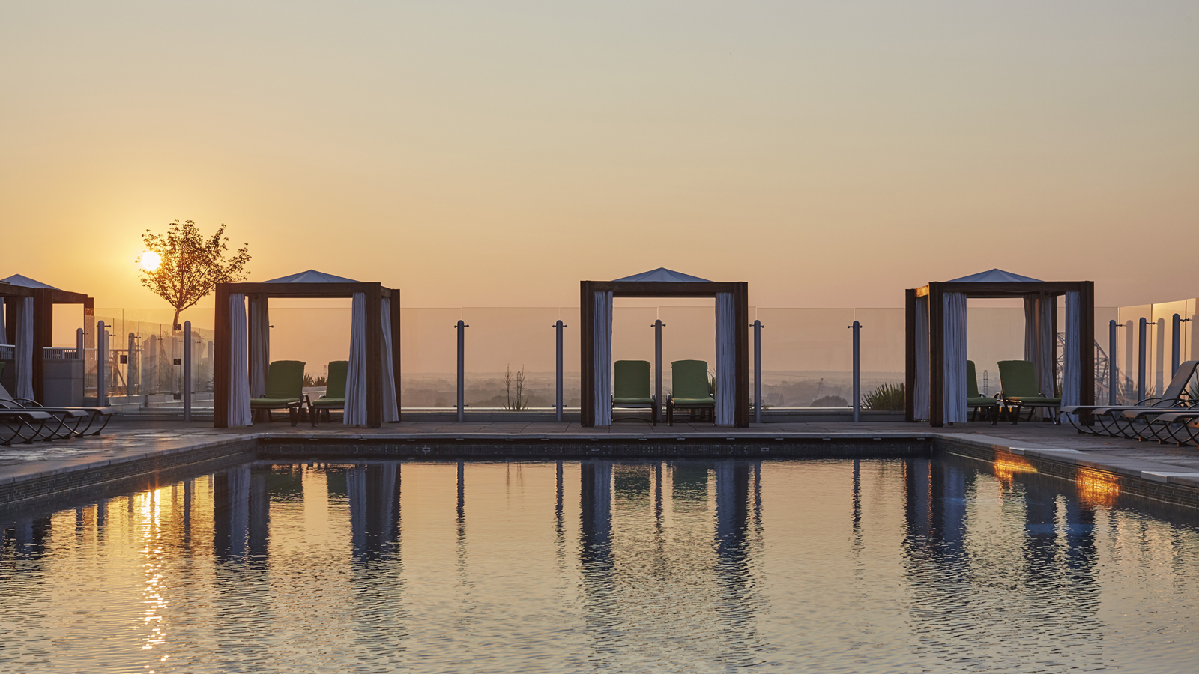
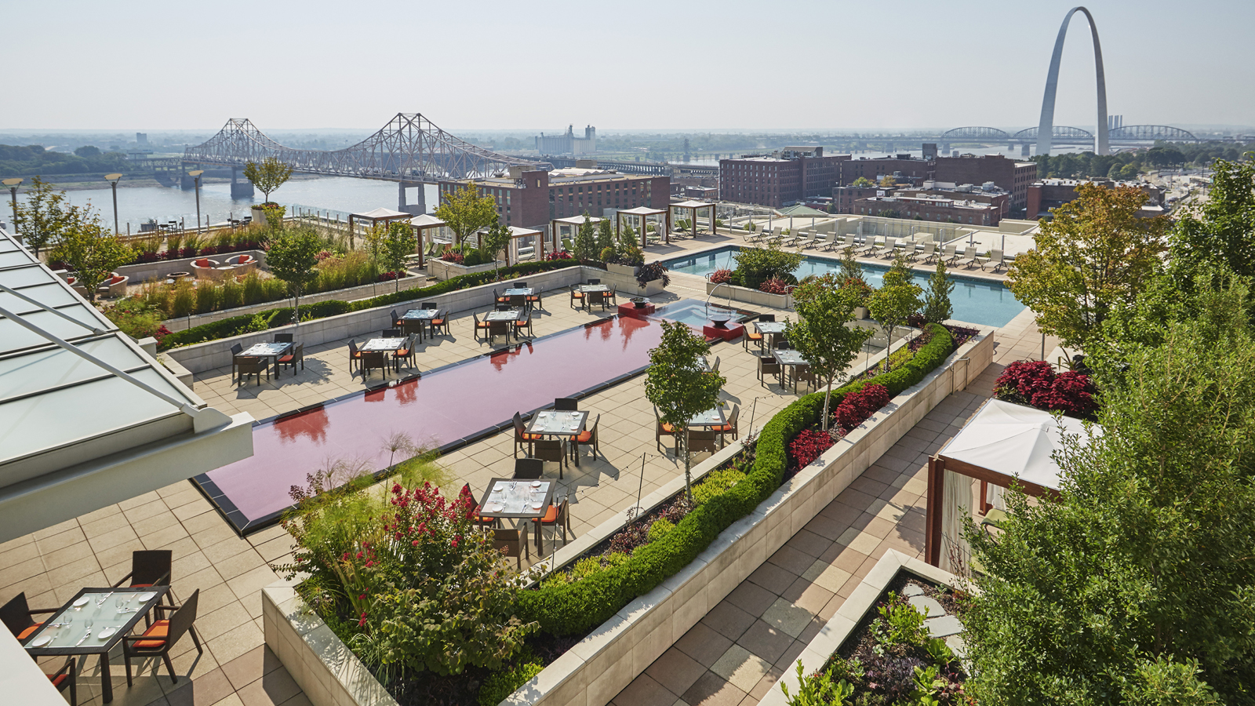 | 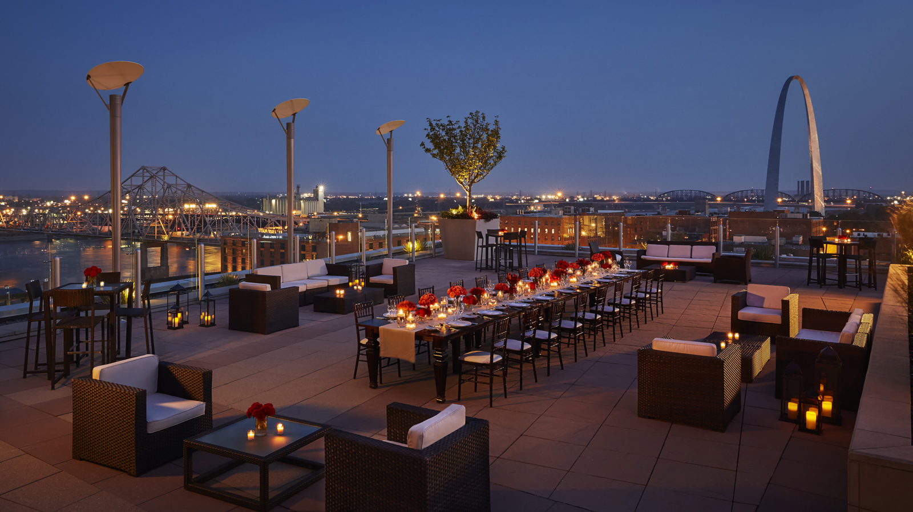
Four Seasons Hotel St. Louis offers a host of activities this summer, including new spa treatments, weekly events on the Arch-view Sky Terrace, and a special package for the upcoming solar eclipse.
Sunday Brunch at Cielo Restaurant & Bar
Sunday Brunch: Upgrade your Sunday and join Cielo for an incredible brunch that happens to feature one of the best views in town.
The extensive buffet features warm donuts made-to-order, a fresh juice bar, a raw seafood bar, boozy milk shake station and a sliders station. View additional details here. Brunch is available every Sunday from 10:30 am- 2:30 pm.
The Spa
Director of The Spa, Erin Stewart, ushers in the following new treatments at our 12,000 square-foot spa and salon:
- Complete Indulgence Massage - Indulge your body and soul with the essences of coconut and exotic tiare flower with this signature massage. Soothing hot stones melt away stress from head to toe while your senses delight in our luxuriously scented and richly hydrating body oil. This full-body massage concludes with a relaxing hot oil scalp massage (50 minutes, USD 165).
- Lavender Lemonade Pedicure - Experience the ultimate pampering foot treatment. Feet and legs are exfoliated with lavender infused pure sugar cane crystals, then hydrated with a cold-pressed coconut and sweet almond oil soufflé that includes lemon essential oils to invigorate, nourish and deeply moisturize the legs and feet before nails are polished to perfection. (50 minutes, USD 70).
Hotel
On August 21, 2017, the Solar Eclipse path crosses St. Louis, making it one of the optimal viewing areas in North America.
Secure your spot to view the first total solar eclipse in 38 years by booking the ‘Perfect Eclipse’ overnight room package that features the following:
- One-night stay deluxe Arch View accommodations
- Two pairs of solar viewing glasses
- Gourmet picnic basket to-go for two adults, USD 15 extra per child (picnic basket offerings can be seen here)
- Overnight valet parking
Package starting at USD 550. Locals and guests can also order the gourmet picnic, which is USD 85 for 2 adults.
Spring / Summer Events
From Four Seasons Fridays (live music on the Sky Terrace) to kid's pastry tours to fireworks, there's something for everyone as the weather warms in the "Gateway to the West." See the full array of activities here.

RELATED

April 10, 2017, St. Louis, U.S.A.
Four Seasons Hotel St. Louis Celebrates Solar Eclipse with Hotel Stay Package
http://publish.url/stlouis/hotel-news/2017/solar-eclipse.html

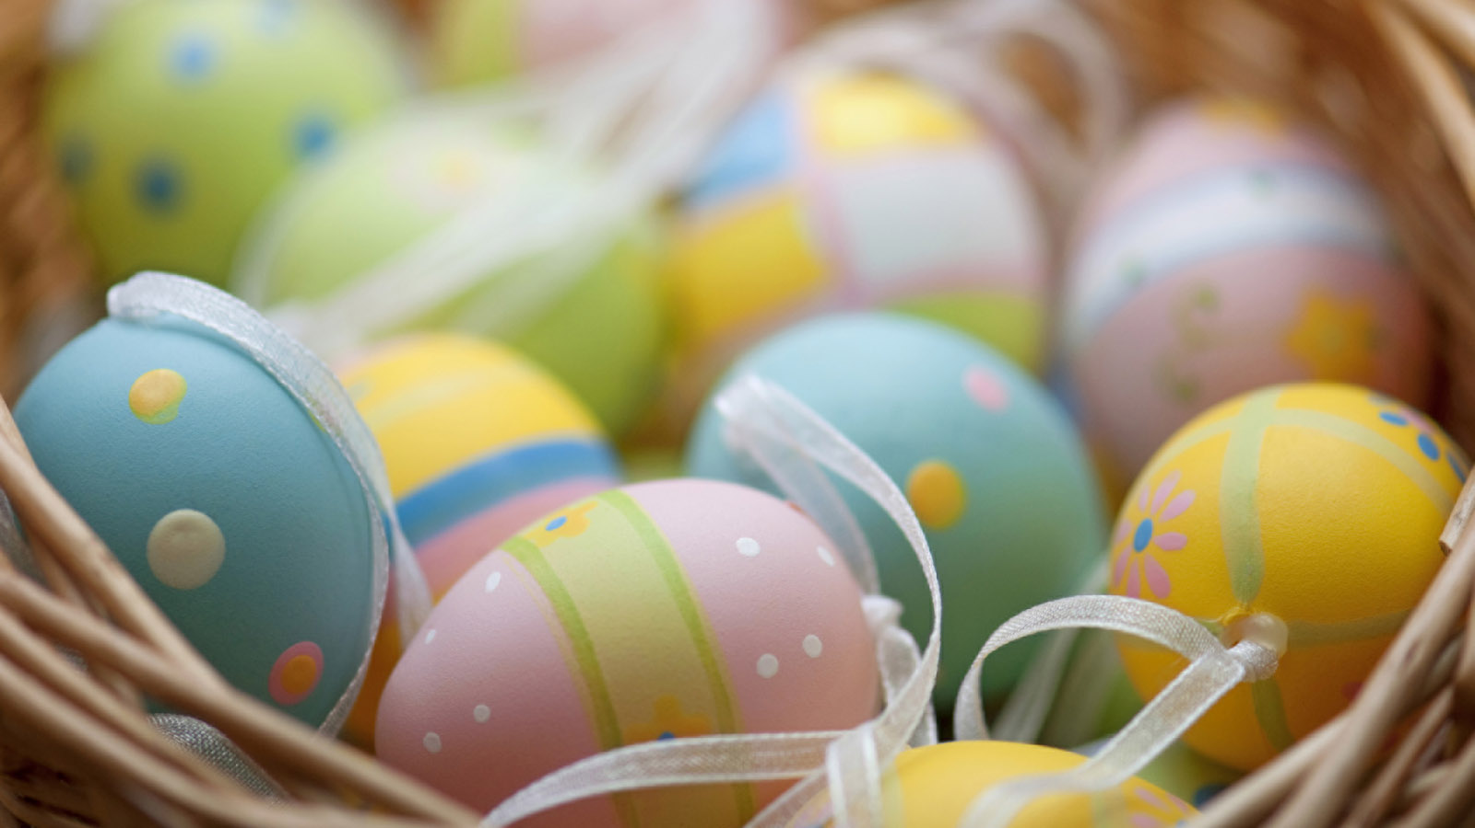 | March 10, 2017, St. Louis, U.S.A.  Four Seasons Hotel St. Louis Announces City's Most Sumptuous Easter Brunch  http://publish.url/stlouis/hotel-news/2017/easter-brunch.html

PRESS CONTACTS

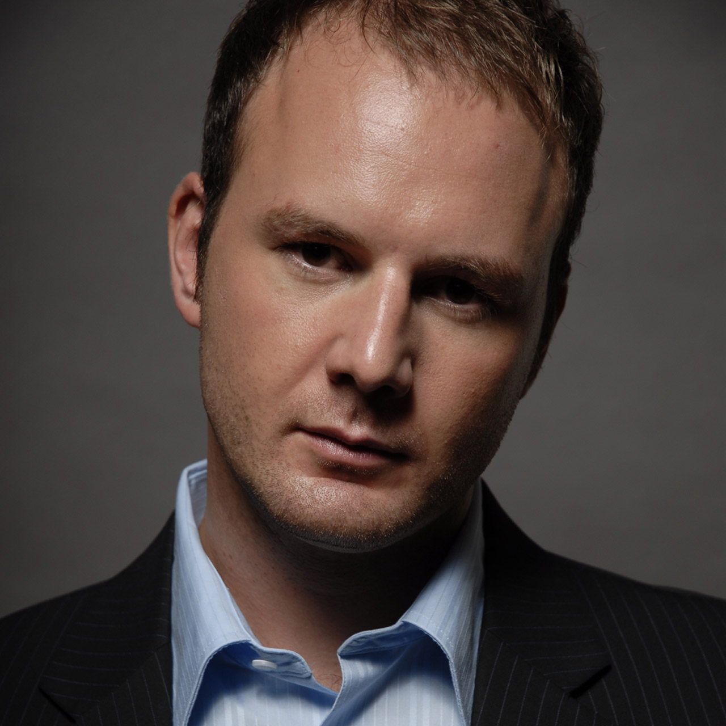 | Jim Guttau  Director of Public Relations and Communications  999 North 2nd Street  St. Louis  U.S.A.  jim.guttau@fourseasons.com  +1 (303) 389-3132
Chloe Caylor
Public Relations and Communications Manager
999 North 2nd Street
St Louis
USA
Chloe.Caylor@fourseasons.com

+1 (314) 881-2021

